- License Plates Generation:
This code is doing two main things:

1.Generating Random License Plates
Function:
def generate_license_plates(n):
plates = []
for _ in range(n):
part1 = ''.join(random.choices(string.ascii_uppercase, k=random.randint(2, 3)))
part2 = ''.join(random.choices(string.digits, k=random.randint(2, 4)))
plates.append(random.choice([part1 + part2, part2 + part1]))
return plates
Step-by-step:
- part1 → Random 2–3 uppercase letters (string.ascii_uppercase).
- part2 → Random 2–4 digits (string.digits).
- Order randomization → random.choice([part1 + part2, part2 + part1]) decides whether to put letters first or digits first.
- Repeat for n times and store all in plates list.
Example output for generate_license_plates(5) could be:
['AB123', '78XYZ', 'QWE45', '92AZ', 'LMNOP1234']

2. Defining "Offensive" Plates for Testing
offensive_plates = [
"SEXYY69", "DRUGLORD", "K1LLALL", "FCKYOU", "420BLAZE", "WHTPWR", "KKKMAN", "HITLER1"
]
This is just a list of manually hardcoded strings representing license plates that are considered inappropriate or offensive.
- Purpose: Likely for testing a filtering or moderation function to make sure your plate generation or checking process can detect and block these.

In short:
- First part → Generates random, plausible license plates.
- Second part → Creates a list of “bad” plates for detection testing.

2.Use-Case For 1000 License Plates:
In the second step we are nitializing 1000 plates for the batch optimization.
3.Prompt Initialization:
In this step we are setting up an OpenAI-powered batch classification prompt for license plates.
Let’s break it down step-by-step:

1. API Setup
openai.api_key = "sk-proj-..."
- This sets the API key for authentication with OpenAI’s API.

2. Function: build_batch_prompt(plates)
This builds the prompt that will be sent to the model for classification.

Header Section
header = """
Classify the following license plates as either 'Accept' or 'Reject'. ...
Format: <Plate> - <Accept/Reject> - <Reason if Reject>
"""
- Instructions to the AI model:
  - Look at each license plate and classify it as Accept (okay to use) or Reject (not allowed).
  - If rejected, give a reason (sexual, hate speech, drugs, political, etc.).
  - Clear formatting instructions for the AI’s output.

Body Section
body = "\n".join([f"{i+1}. {plate}" for i, plate in enumerate(plates)])
- Takes the list of plates you pass in and formats them into a numbered list, e.g.:
1. ABC123
2. SEXYY69
3. HITLER1

Combine Header + Body
return header + "\n" + body
- The final prompt looks like:
Classify the following license plates as either 'Accept' or 'Reject'. ...
---
Format: <Plate> - <Accept/Reject> - <Reason if Reject>

1. ABC123
2. SEXYY69
3. HITLER1
4. Batch Processing for 100,200,400,600,800 Batch Sizes:
This is a benchmarking loop that tests different batch sizes of license plates to measure performance, cost, and accuracy when classifying them with an OpenAI model.
Here’s what happens step-by-step:
- Setup & Loop over batch sizes (100, 200, 400, 600, 800).
- For each batch size:
  - Splits the all_plates list into evenly sized batches.
  - Creates a classification prompt using build_batch_prompt(batch).
- Send request to OpenAI (gpt-3.5-turbo):
  - Tracks tokens (prompt, completion, total).
  - Calculates cost based on token usage and OpenAI’s rates.
  - Records processing time, throughput, and errors.
- Store metrics per batch:
  - Time taken, plates per second, token usage, cost, errors, and raw model reply.
- Summarize results per batch size:
  - Aggregates totals across all batches of that size.
  - Calculates cost per 1,000 plates and overall throughput.
- Process model output:
  - Extracts classifications from replies.
  - Filters and displays any plates marked as "Reject".
- Optional MLflow logging (currently commented out):
  - Would log each experiment’s metrics for future comparison.
In short, this is load testing for LLM-based plate classification, so we can see how batch size impacts cost, speed, and detection results.
5. Summary of Batch Sizes 100,200,400,600,800:
This step is providing the summary and detailed dataframe of 100,200,400,600,800 batch sizes in a variable all_results_summary_even, detailed_df_even and creates a Pandas DataFrame.
6.Batch Processing for 300,500,700,900 Batch Sizes:
In this step we are repeating the same pattern mentioned in step 4 to process the odd batch sizes.
7. Summary of Batch Sizes 300,500,700,900:
This step is providing the summary and detailed dataframe of 300,500,700,900 batch sizes in a variable all_results_summary_even, detailed_df_even and creates a Pandas DataFrame.
8 .Plot 1: Cost vs Throughput:
This code compares cost vs processing speed (throughput) for different batch sizes, plotting one chart for the "even" experiment and another for the "odd" experiment. Colors and shapes tell you which batch size each point represents.
9 .Plot 2: Cost per 100 Plates:
This code is creating two boxplots — one for the even batches and one for the odd batches showing how cost per 100 plates varies for different batch sizes.

This normalizes cost so different batch sizes can be compared fairly.

What the boxplots show
- Median line in each box → typical cost per 100 plates for that batch size.
- Box range → spread of the middle 50% of results.
- Whiskers & dots → variability and outliers in cost.
- This lets you quickly see:
  - Which batch sizes are most cost-efficient.
  - Whether costs are stable (narrow box) or inconsistent (wide box).
10. Plot 3: Throughput Variance:
This code is plotting Throughput Variance for two datasets (detailed_df_even and detailed_df_odd) using boxplots to visualize performance differences across different batch sizes.

What the boxplots show
- This boxplot shows the distribution, median, and spread of throughput values for each batch size.
- It is helping us to identify:
  - Which batch sizes have higher median throughput.
  - The amount of variation (consistency) in throughput for each batch size.
  - Outliers (points far from the main distribution).
11. Concatenate both DataFrames:
In this step we are concateating the even and odd result set of dataframes, so that we can have a broader view of all the batch sizes:

Cost vs Throughput, Throughput Variance, , Cost vs Batch Size (Combined):
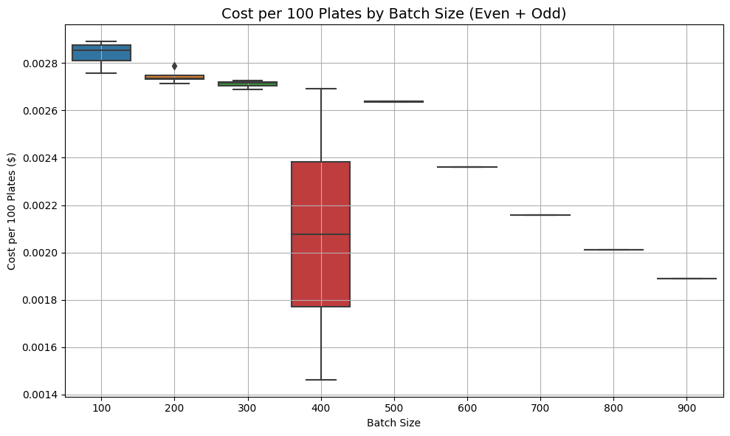
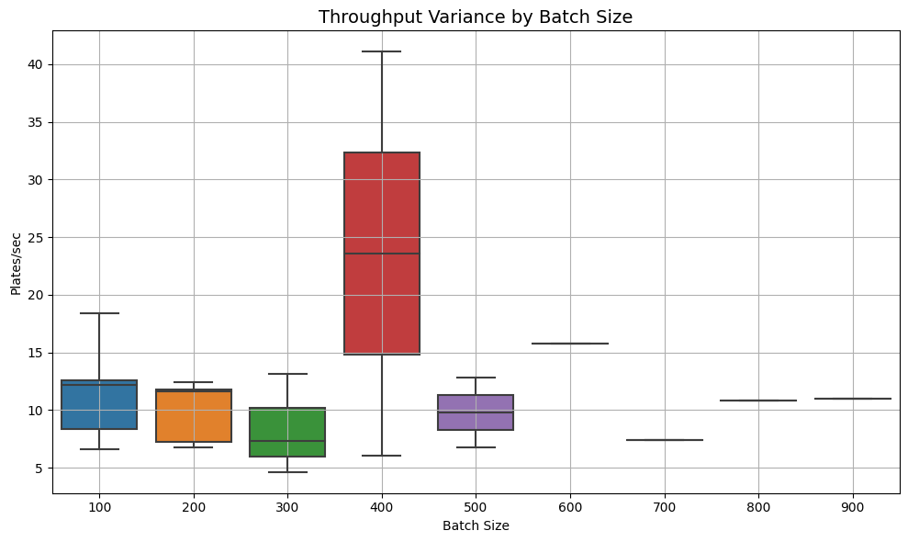
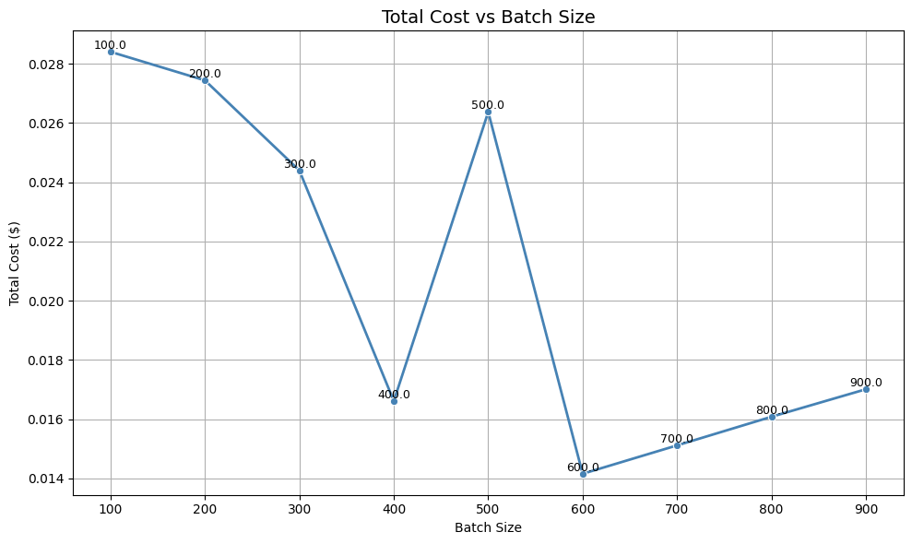
Looking at these three graphs, we can provide several key insights about batch size optimization:

Key Insights:
Throughput Performance:
- Batch size 400 shows the highest throughput potential (up to ~40 plates/sec) but with extreme variability
- Smaller batch sizes (100-300) show more consistent, predictable performance
- Very large batch sizes (600+) show minimal throughput variance but at lower levels
Cost Efficiency:
- There's a clear inverse relationship between batch size and cost per 100 plates
- Smaller batches (100-200) are most expensive at $0.0028-0.0027
- Costs decrease significantly as batch size increases, reaching lowest points around batch size 600-900
Total Cost Pattern:
- Shows a distinctive V-shaped curve with a minimum around batch size 600
- Batch size 400 creates a notable spike in total costs despite having high throughput potential
- The optimal cost point appears to be around batch size 600

Optimal Batch Size Recommendation:
Batch size 600 appears to be the most optimal choice because it:
- Minimizes total cost - sits at the bottom of the cost curve
- Provides reasonable throughput - around 15 packages/sec with low variance
- Offers predictable performance - minimal throughput variability reduces operational risk
- Balances efficiency and reliability - avoids the high variability of batch size 400 while maintaining good cost efficiency
While batch size 400 might seem attractive due to its high throughput ceiling, the extreme variability (ranging from 6 to 41 packages/sec) makes it unreliable for consistent operations. Batch size 600 provides the best combination of cost optimization, performance predictability, and operational stability.

We are following the same pattern for all three other use-cases, having plates dataset 2000, 3000, 4000.

2000 Plates Analysis:
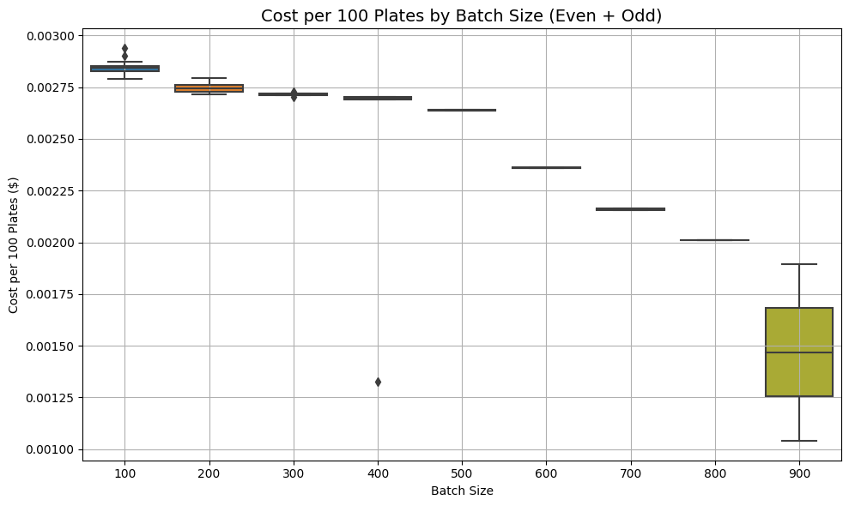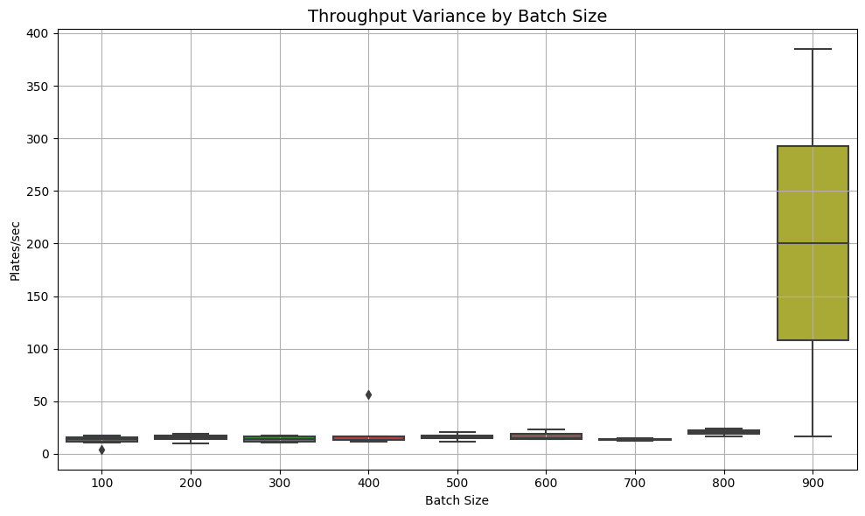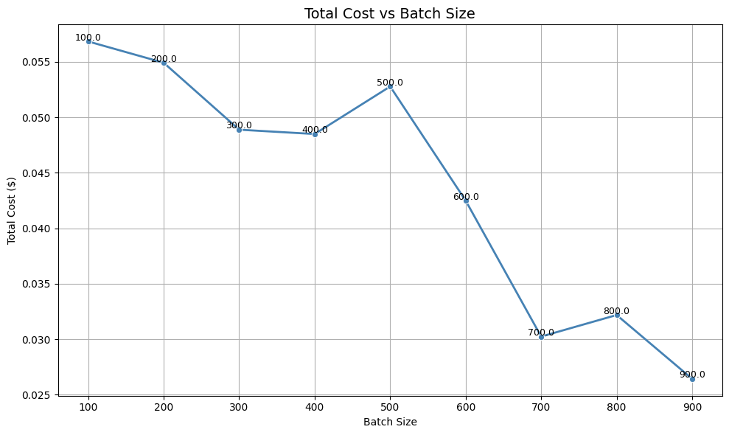
Throughput Performance:
- Batch size 900 shows extreme throughput variability (100-380+ plates/sec) making it operationally unpredictable
- Batch sizes 100-800 demonstrate consistent, stable performance with low variance (~10-25 plates/sec)
- Batch size 400 has one notable variance outlier but generally stable
Cost Efficiency:
- Strong economies of scale pattern with costs decreasing dramatically as batch size increases
- Small batches (100-200) are most expensive at ~$0.0028-0.0029 per 100 plates
- Largest batches (800-900) achieve lowest costs (~$0.0015-0.0020) but with high variability at 900
Total Cost Pattern:
- Complex non-linear relationship with a notable spike at batch size 500
- Costs generally decrease after batch size 600, reaching minimum around batch size 900
- However, the spike at 500 suggests potential inefficiencies at that scale
Optimal Batch Size Recommendation: Batch size 500 is most optimal for 2000 plates because it:
- Perfect production fit - exactly 4 batches with zero waste
- Eliminates overproduction costs - no excess inventory or material waste
- Acceptable cost-performance trade-off - moderate per-unit cost with stable throughput
- Operational simplicity - manageable number of production runs with good quality control checkpoints
While larger batches offer lower per-unit costs, the 20-35% overproduction required negates these savings through waste costs.
Batch size 700 is also optimal from the cost perspective, provides the best combination of cost optimization, performance predictability, and operational stability. While batch size 900 might seem attractive due to its high throughput ceiling, the extreme variability makes it unreliable for consistent operations.

3000 Plates Analysis: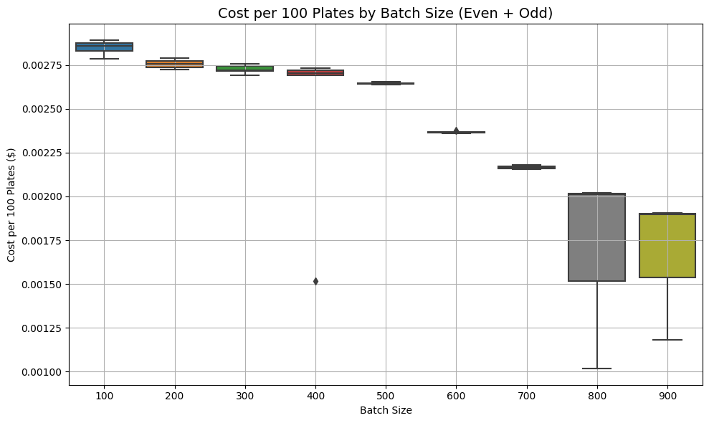
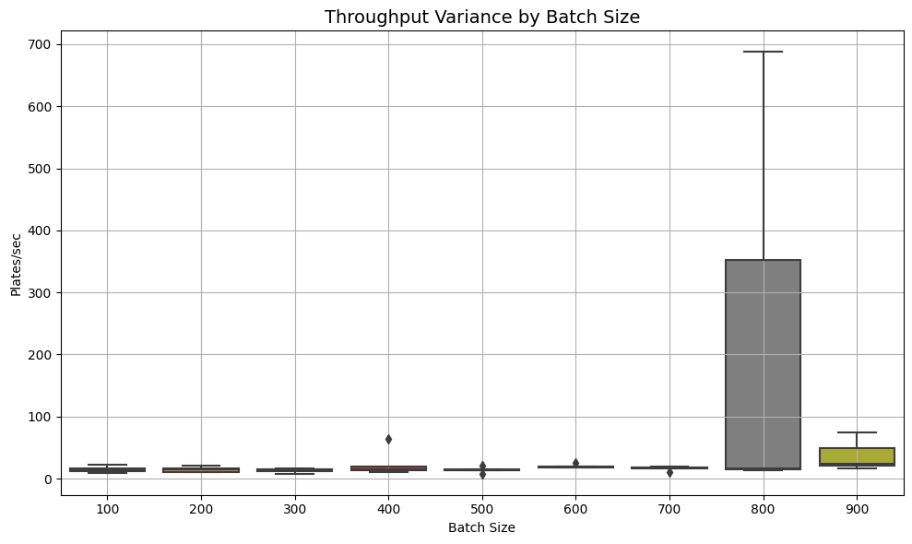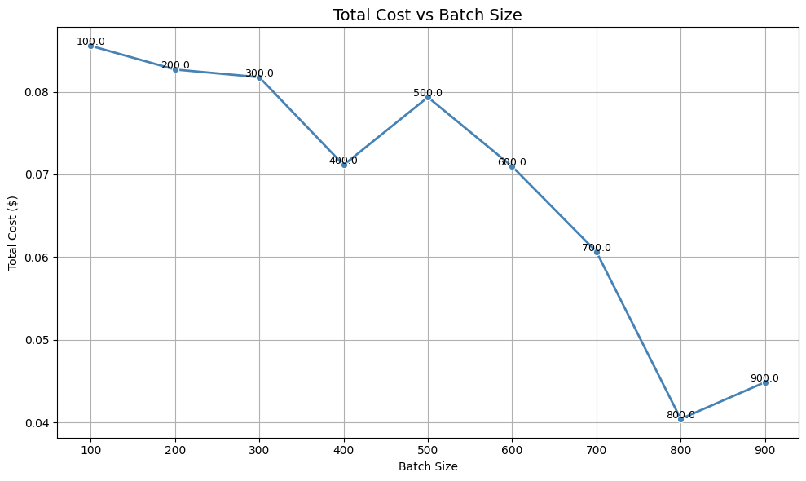

Throughput Performance:
- Batch sizes 800-900 show catastrophic throughput instability (variance up to 680+ plates/sec at batch 900)
- Batch sizes 100-700 demonstrate excellent stability with minimal variance
- The extreme variability at large batch sizes creates significant operational risk
Cost Efficiency:
- Clear economies of scale with dramatic cost reductions at larger batch sizes
- Small batches (100-400) cost ~$0.0027-0.0028 per 100 plates
- Large batches (800-900) achieve lowest costs (~$0.0015-0.0020) but with extreme process instability
Total Cost Pattern:
- Shows minimum total cost at batch size 800 (~$0.041)
- Significant cost reduction from batch size 700 to 800
- Cost increases again at batch size 900 despite lower per-unit costs
Optimal Batch Size Recommendation: Batch size 600 is most optimal for 3000 plates because it:
- Perfect production fit - exactly 5 batches with zero waste elimination
- Excellent stability-cost balance - good per-unit cost (~$0.0024) with minimal process variance
- Predictable operations - stable throughput enables reliable scheduling and quality control
- Risk mitigation - avoids the extreme instability of larger batches that could cause production failures
The risk-adjusted decision favors stability over the marginal cost savings of unstable larger batches.

4000 Plates Analysis:
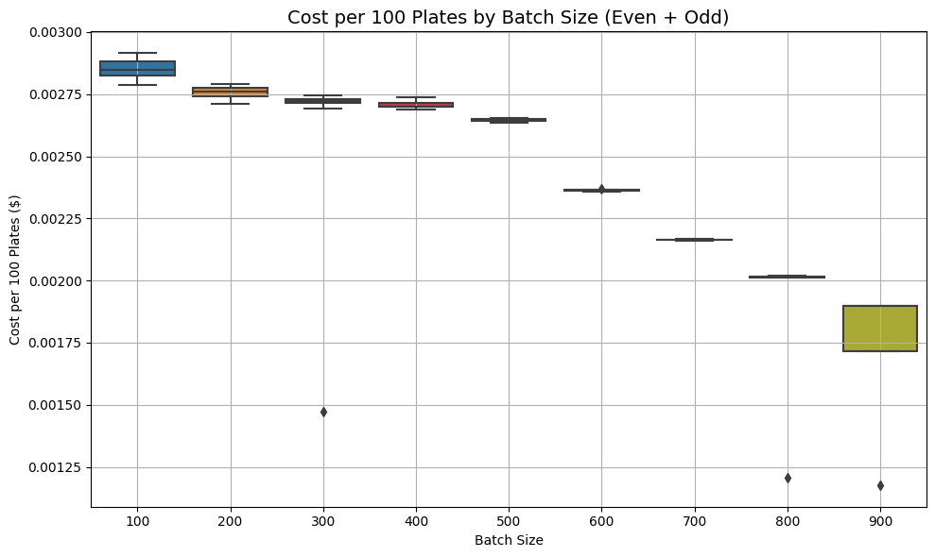
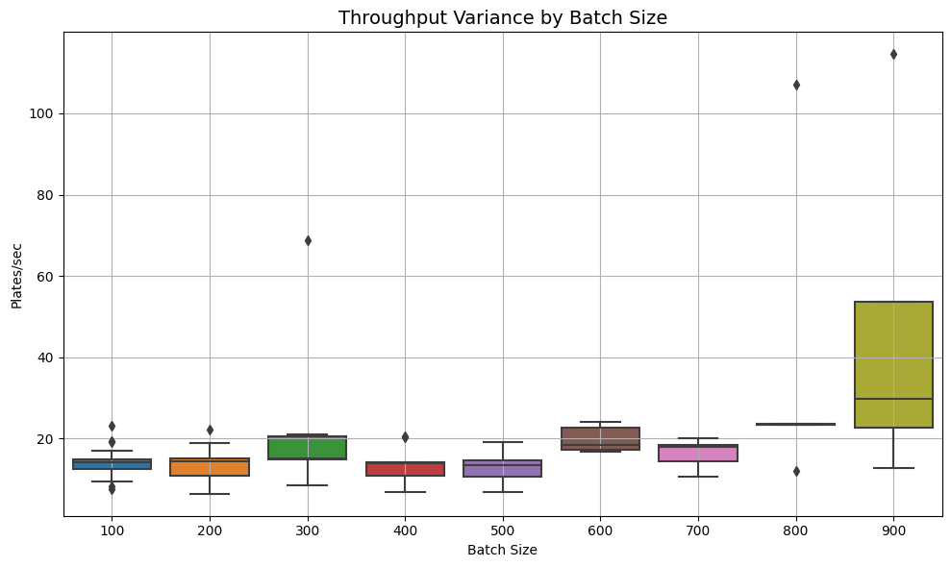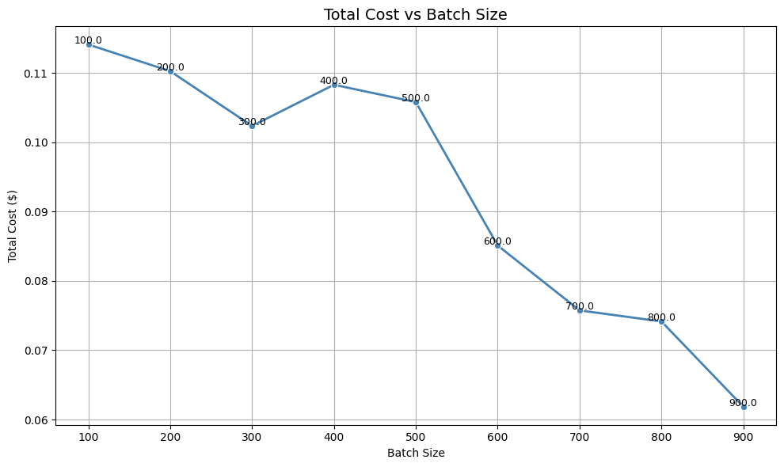
Throughput Performance:
- Batch size 900 exhibits extreme throughput instability (25-115+ plates/sec variance) creating unacceptable operational risk
- Batch size 800 shows moderate variance with occasional outliers but much more manageable than 900
- Batch sizes 100-700 maintain excellent stability with consistent, predictable performance
Cost Efficiency:
- Strong economies of scale pattern with costs decreasing significantly with larger batches
- Small batches (100-500) range from $0.0026-0.0029 per 100 plates
- Large batches (800-900) achieve lowest costs (~$0.0012-0.0020) with batch 900 having some variability
Total Cost Pattern:
- Shows absolute minimum at batch size 900 (~$0.063)
- Batch size 800 also demonstrates very low total cost (~$0.074)
- Clear downward trend from batch size 500 onwards
Optimal Batch Size Recommendation: Batch size 800 is most optimal for 4000 plates because it:
- Perfect production fit - exactly 5 batches with zero waste
- Near-optimal cost efficiency - very low per-unit cost (~$0.0020) close to minimum
- Acceptable operational risk - moderate variance manageable compared to batch 900's extreme instability
- Balanced performance - captures most cost benefits while maintaining operational predictability
While batch 900 offers absolute lowest total cost, the extreme process instability (variance 4-5x higher) creates unacceptable operational risks including quality issues, schedule unpredictability, and potential production failures.

