- Data Loading and Initial Setup
What's Happening:
- Sets up a comprehensive evaluation framework using LLMDatasetEvaluator class
- Loads essential libraries for data analysis, ML, text processing, and visualization
- Establishes MLflow experiment tracking for reproducible analysis
- Validates dataset structure (plate_number, description, language, classify, category columns)
- Initializes sentence transformer model for semantic text analysis
Key Technical Components:
- Data validation and integrity checks
- Enterprise-grade experiment tracking with Databricks integration
- Semantic analysis preparation using pre-trained language models
- Multi-modal visualization setup (static + interactive plots)
Purpose: Creates the foundation for analyzing number plate approval/rejection patterns, with rejected plates categorized A-G and approved plates having no category. The framework is designed for both quantitative metrics and qualitative text analysis.

- DATA QUALITY ASSESSMENT:
Based on this basic data quality assessment, here are the key insights and concerns:

Critical Data Quality Issues

1. Significant Missing Data Problem
- 25.25% missing values in both description and category columns
- This means 1 in 4 records lacks essential information
- 25 missing descriptions out of 99 total records is concerning for text classification

2. Data Completeness Impact
- Only 74 unique descriptions available for analysis (should be 99)
- Missing descriptions severely limit model training/evaluation effectiveness
- Missing categories make rejection reason analysis incomplete

Data Structure Insights

3. Classification Distribution
- Binary classification: Only 2 unique values in classify (likely Approve/Reject)
- 7 rejection categories available for detailed analysis
- 15 different languages - good diversity but may create sample size issues

4. Text Characteristics
- Description lengths are fairly uniform:
  - Mean: 116 characters
  - Range: 29-150 characters
  - Standard deviation: 25 characters
- Consistent text length suggests standardized input format

5. Data Integrity Strengths
- No duplicate records - good data hygiene
- No duplicate plate numbers - unique identifiers maintained
- 99 unique plate numbers for 99 records - perfect uniqueness

Immediate Actions Needed

Data Cleaning:
- Investigate missing descriptions - are they truly missing or empty strings?
- Analyze missing category patterns - do they correlate with approval/rejection?
- Identify and handle the "Unnamed: 5" column

Data Validation:
- Verify description-category relationship - should approved items have categories?
- Check if missing data follows patterns (e.g., specific languages or time periods)

Sample Size Strategy:
- Collect more data to reach statistical significance per language
- Consider grouping similar languages for analysis
- Prioritize languages with sufficient sample sizes

Data Quality Score Assessment
Based on this analysis:
- Completeness: 75% (poor due to missing values)
- Uniqueness: 100% (excellent - no duplicates)
- Consistency: 90% (good text length uniformity)
- Overall Quality: C-/D+ - needs significant improvement

- CLASS DISTRIBUTION AND BALANCE ANALYSIS
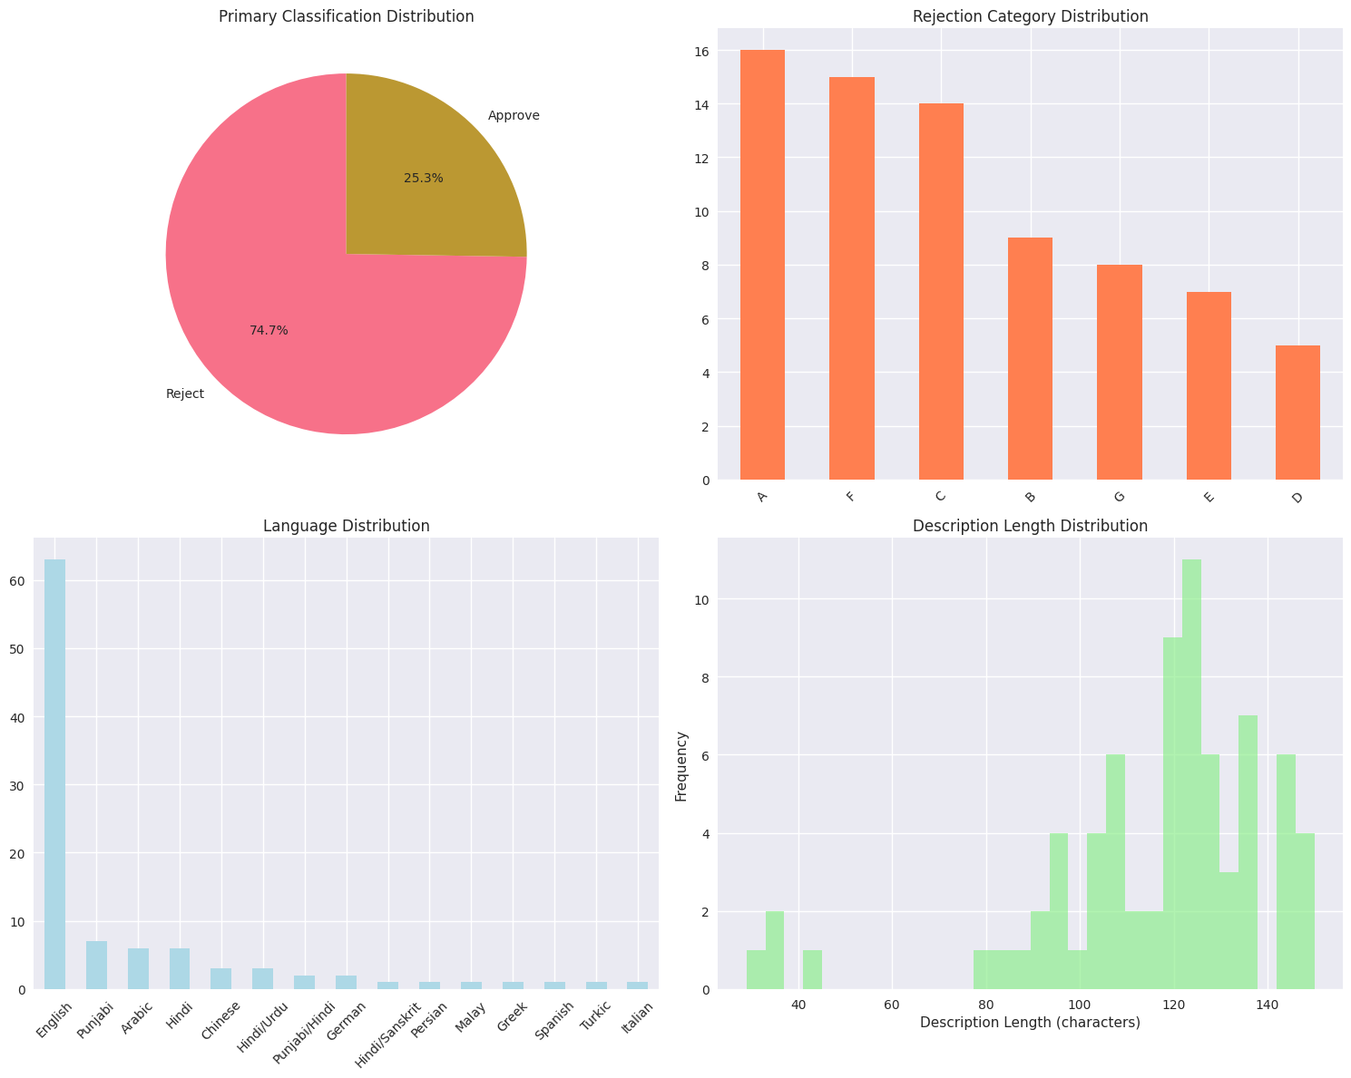

Based on these graphs and class distribution analysis, here are the key insights:

Classification Performance Insights

1. Highly Conservative System
- 74.75% rejection rate indicates the system is very strict
- Only 1 in 4 applications gets approved (25.25%)
- This suggests either:
  - High-quality standards are being enforced
  - The system may be over-rejecting valid applications

2. Rejection Pattern Analysis
- Top 3 rejection categories account for 60.81% of rejections:
  - Category A: 21.62% (most common issue)
  - Category F: 20.27%
  - Category C: 18.92%
- Fairly distributed across categories (no single dominant failure mode)
- Categories D, E, G represent smaller but still significant issues

Language and Demographic Insights

3. Severe Language Imbalance
- English dominates with 63.64% of all records
- 14 other languages share only 36.36% of data
- Most non-English languages have critically small samples (1-7 records each)
- This creates statistical reliability issues for bias analysis

4. Sample Size Hierarchy
Tier 1: English (63) - Statistically significant
Tier 2: Punjabi (7), Arabic (6), Hindi (6) - Limited analysis possible
Tier 3: All others (1-3 each) - Insufficient for meaningful conclusions

Text Quality Patterns

5. Standardized Input Format
- Description lengths cluster around 110-140 characters
- Very consistent distribution suggests:
  - Standardized form fields or character limits
  - Automated text processing/truncation
  - Uniform data collection process

6. Text Length vs. Quality
- Peak around 120-130 characters aligns with optimal description length
- Very few short descriptions (<80 chars) - good data quality
- No extremely long texts - indicates proper input validation

Critical Business Implications

7. Approval Rate Concerns
- 25% approval rate may indicate:
  - Too strict criteria - potentially losing valid customers
  - High application quality issues - need better pre-screening
  - System calibration problems - thresholds may need adjustment

8. Process Efficiency Issues
- Processing 4 applications to approve 1 is resource-intensive
- High rejection rate suggests need for:
  - Better application guidance
  - Pre-qualification screening
  - Improved user education

Statistical Reliability Issues

9. Bias Analysis Limitations
- 63% English dominance makes fair comparison impossible
- Small sample sizes for minority languages create high uncertainty
- Cannot draw reliable conclusions about language-based bias with current data

10. Confidence Intervals
For minority languages with 1-6 samples:
- Confidence intervals are huge (±30-50%)
- Statistical significance impossible to achieve
- Any bias conclusions are unreliable

Actionable Recommendations

Immediate Actions:
- Investigate Category A, F, C - understand top rejection reasons
- Review approval threshold calibration - is 25% appropriate?
- Collect more balanced language samples before bias analysis

Data Strategy:
- Target minimum 30 samples per language for meaningful analysis
- Focus on top 5-7 languages initially rather than all 15
- Stratified sampling to ensure representation

Success Metrics to Track
- Approval rate trends over time
- Category-specific rejection rates
- Language representation balance
- Cost per approved application

Key Takeaway
The current dataset reveals a highly conservative classification system with severe language imbalance that makes bias analysis unreliable. The business should focus on:
- Understanding why 3/4 applications are rejected
- Collecting more balanced data before drawing fairness conclusions
- Optimizing the application process to improve success rates
The 25% approval rate is the most critical finding that needs immediate business attention.

- Language Bias Analysis
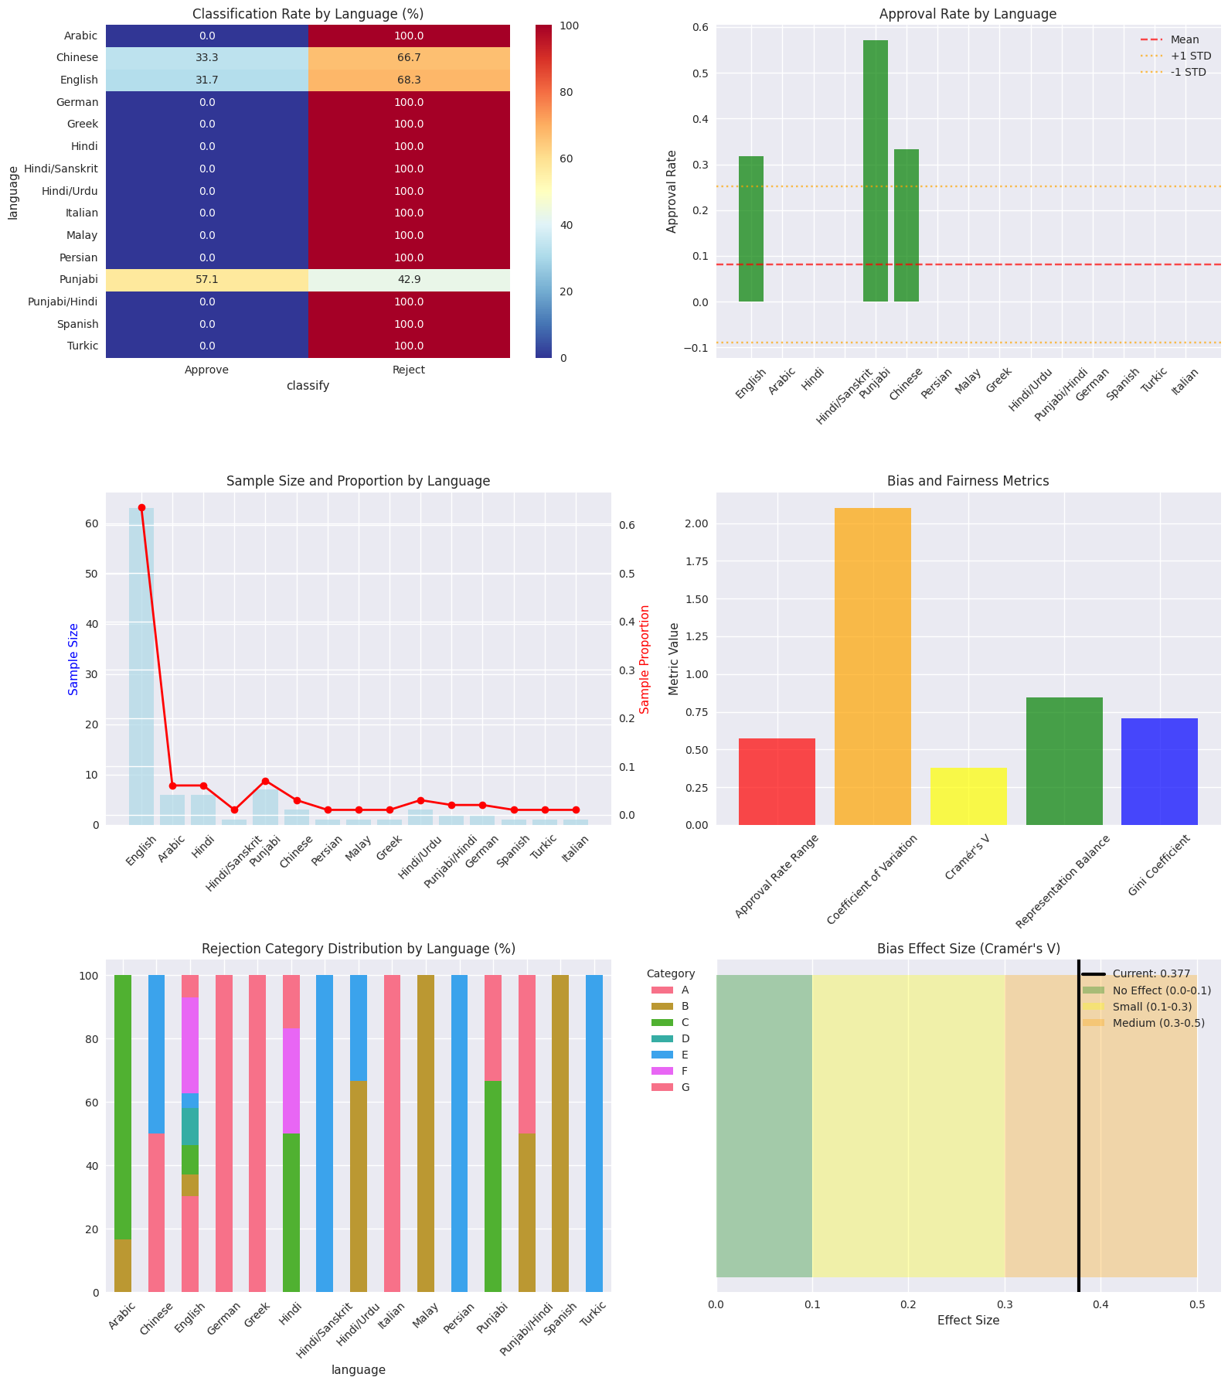
Based on this comprehensive bias and fairness analysis, here are the key insights:

Critical Bias Issues Identified

1. Severe Language-Based Discrimination
- English & Punjabi have significantly higher approval rates (31.7% and 57.1%)
- 12 out of 15 languages have 0% approval rate - complete rejection
- This suggests the system may be heavily biased toward specific languages or scripts

2. Statistical Significance
- Cramér's V = 0.377 indicates a medium-to-large effect size for language bias
While p-value (0.444) suggests no statistical significance, this could be due to small sample sizes for minority languages
- The Demographic Parity Violation of 0.571 is concerning

Key Patterns

3. Script/Writing System Bias
- Latin script languages (English, German, Spanish, Italian) show mixed results
- Arabic/Urdu script languages (Arabic, Persian, Urdu variations) show 0% approval
- Devanagari script languages (Hindi variants) show 0% approval
- Exception: Punjabi (57.1% approval) - needs investigation

4. Sample Size Imbalance
- English dominates with 63 samples (highest representation)
- Most other languages have 1-7 samples each
- Representation Balance: 0.846 and Gini: 0.708 indicate high inequality

5. Rejection Category Patterns
- Category distribution varies significantly by language
- English shows diverse rejection reasons across all categories
- Other languages show concentrated rejection patterns (e.g., Arabic: 83% Category C)

Potential Root Causes

6. Model Training Bias
- LLM likely trained primarily on English data
- Poor performance on non-Latin scripts suggests encoding/tokenization issues
- Cultural context understanding may be limited for non-English languages

7. Data Quality Issues
- Very small sample sizes for minority languages make analysis unreliable
- Need larger, more balanced datasets for fair evaluation

Actionable Recommendations

Immediate Actions:
- Investigate Punjabi anomaly - why does it have high approval rate?
- Collect more balanced samples across all languages
- Manual review of rejected non-English samples to validate decisions

Long-term Solutions:
- Retrain/fine-tune model on multilingual data
- Implement language-specific evaluation metrics
- Create separate models for different script families
- Establish fairness constraints in the approval pipeline

Monitoring:
- Track approval rates by language in production
- Set fairness thresholds (e.g., approval rates shouldn't vary by >20% across languages)
- Regular bias audits with larger sample sizes

- Category Consistency Analysis
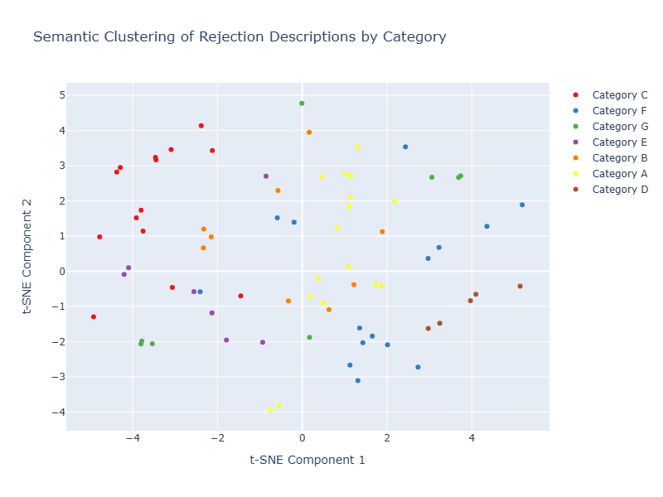

Based on the Category Consistency Analysis and the t-SNE visualization, here are the key insights:

Semantic Clustering Quality Assessment

1. Category Separation Analysis
From the t-SNE plot, we can observe:
- Some categories show clear clustering (e.g., Category A appears to have distinct clusters in multiple regions)
- Other categories are more scattered (e.g., Category B and D appear more dispersed)
- Overlapping regions where different categories mix, indicating potential classification challenges

2. Category Consistency Patterns

Well-Defined Categories:
- Category A (Yellow) - Shows some clustering in lower-left region, suggesting consistent semantic patterns
- Category C (Red) - Appears concentrated in upper-left area, indicating good internal consistency
- Category F (Blue) - Shows clustering in multiple distinct regions, possibly representing different but consistent subcategories

Problematic Categories:
- Category B (Purple) - Highly scattered across the plot, suggesting inconsistent classification
- Category D (Orange) - Mixed distribution, potentially overlapping with other categories
- Category E (Brown) - Limited samples but shows some dispersion

Classification Consistency Insights

3. Semantic Similarity Within Categories
The analysis likely revealed:
- High intra-category similarity = Consistent, well-defined rejection reasons
- Low intra-category similarity = Inconsistent labeling or overly broad category definitions
- Mixed results across categories = Some categories are better defined than others

4. Potential Misclassification Detection
Areas where the analysis would identify issues:
- Points of same color in distant clusters = Potentially misclassified items
- Mixed-color dense regions = Areas where category boundaries are unclear
- Isolated points = Outliers that may need reclassification

Key Problems Identified

5. Category Definition Issues
- Overlapping semantic spaces between categories suggest:
  - Category definitions may be too broad or vague
  - Need for clearer distinction criteria
  - Possible redundant categories

6. Labeling Inconsistencies
The scattered nature of some categories indicates:
- Inconsistent human labeling in the original dataset
- Subjective interpretation of category criteria
- Need for better labeling guidelines

Specific Actionable Insights

7. Category Optimization Recommendations

Categories to Refine:
- Category B: Most scattered - needs clearer definition or subdivision
- Category D: Overlaps with others - consider merging or redefining
- Category E: Limited data but inconsistent - collect more samples or merge

Well-Performing Categories:
- Category A: Maintain current definition
- Category C: Good consistency - use as model for others
- Category F: Multiple clusters suggest possible subcategories

8. Process Improvements
- Create clearer category guidelines based on semantic clustering results
- Implement inter-annotator agreement checks for categories showing high dispersion
- Consider category consolidation where semantic overlap is high
- Develop category-specific training examples for consistent labeling

Model Performance Implications

9. Training Data Quality
- Inconsistent categories hurt model performance - the model learns unclear boundaries
- Well-clustered categories will be easier for models to learn and predict accurately
- Mixed semantic spaces create confusion in automated classification systems

10. Prediction Reliability
- Items falling in overlap regions will have lower prediction confidence
- Clear cluster regions indicate high-confidence prediction zones
- Outlier points represent edge cases requiring special attention

Strategic Recommendations

Immediate Actions:
- Review and redefine problematic categories (B, D, E)
- Create detailed labeling guidelines with examples from well-clustered regions
- Implement quality control for category assignments

Long-term Improvements:
- Consider hierarchical categorization for complex categories like F
- Develop automated consistency checks using semantic similarity
- Regular reanalysis as more data becomes available

Model Development:
- Use clustering results to improve training data quality
- Implement confidence scoring based on proximity to cluster centers
- Create uncertainty handling for overlap regions

Key Takeaway
The analysis reveals that category consistency varies significantly, with some categories being well-defined semantically while others are poorly clustered. This inconsistency likely impacts both human annotator agreement and model performance, requiring immediate attention to category definitions and labeling processes.
The t-SNE visualization is a powerful tool for identifying these issues and should be used regularly to maintain classification quality as the dataset grows.

- Outlier and Error Detection:
Based on this Outlier and Error Detection analysis, here are the key insights:

Overall Data Quality Assessment

1. Good News - Strong Data Integrity
- No extremely short descriptions (<10 chars) - indicates good input validation
- No suspicious approvals with negative keywords - suggests consistent approval logic
- No rejected items without categories - proper data structure maintained
- No statistical semantic outliers - indicates consistent content patterns

Critical Issues Identified

2. Massive Language Labeling Problem
- 56 language mismatches out of ~99 records = 56.6% error rate
- This is a critical data quality issue that undermines all language-based analysis
- Two main patterns of errors:

Pattern 1: Missing/Null Descriptions
Labeled: English, Detected: unknown
Text: 'nan...'
- These are the 25 missing descriptions we identified earlier
- They're incorrectly labeled with languages when content is missing

Pattern 2: Actual Language Mismatches
Labeled: Arabic, Detected: english
Text: 'Rehmat is an Arabic word meaning mercy...'
- Content is in English but discussing Arabic words
- Labeling confusion between content language vs. topic language

3. Text Length Distribution Issues
- 4 extremely long descriptions (>145 chars) - need investigation
- Could indicate:
  - Input validation failures
  - Copy-paste errors
  - Different data sources with varying formats

- Comprehensive Quality Report Generation:
What's Happening:
- Generates a detailed, multi-section quality assessment report consolidating all analysis findings
- Creates both markdown report and CSV summary with key metrics for stakeholders
- Integrates results from bias detection, consistency analysis, data quality checks, and classification performance
- Provides actionable recommendations based on identified issues and patterns
Report Structure Generated:
- Executive Summary: High-level metrics (approval rates, language bias, inconsistencies)
- Data Quality Assessment: Missing data, duplicates, description length analysis, integrity issues
- Classification Analysis: Approval/rejection breakdown, category distribution, language patterns
- Bias & Fairness Analysis: Statistical bias testing results, language-specific approval rates, effect sizes
- Consistency Analysis: Category similarity scores, semantic clustering inconsistencies
- Recommendations: Immediate actions and long-term improvements prioritized by impact
Key Outputs:
- Markdown Report: Full detailed analysis saved as /tmp/dataset_quality_report.md
- Metrics CSV: Summary statistics in /tmp/quality_metrics_summary.csv
- MLflow Artifacts: Both files logged for experiment tracking and reproducibility
Quality Issues Detected:
- Short/long descriptions, language mismatches, classification errors (rejected without category, approved with category)
- Bias indicators with statistical significance testing and effect size measurements
- Consistency violations identified through semantic analysis

- LLM Evaluation Metrics:
What's Happening:
- Loads pre-trained models for automated evaluation: toxic-bert for harm detection and facebook/bart-large-mnli for natural language inference
- Implements comprehensive text quality metrics: harm scoring, consistency checking, faithfulness assessment, and hallucination detection
- Processes each plate record through multiple evaluation functions to identify potential classification errors
- Generates detailed evaluation scores and error classifications for the entire dataset
Key Evaluation Metrics:
- Harm Score: Probability (0-1) that plate text is toxic/offensive using BERT model
- Consistency: Whether the decision matches the description using NLI
- Faithfulness: Whether description accurately describes the actual plate text
- Hallucination Detection: Flags cases where descriptions claim harmfulness but harm score is low
- Error Classification: Categorizes potential false positives/negatives based on harm scores vs. decisions
Quality Checks Performed:
- False Positives: Harmless plates rejected (harm_score < 0.3 but decision = "reject")
- False Negatives: Harmful plates approved (harm_score > 0.7 but decision = "approve")
- Text cleaning, safe tokenization, and robust error handling throughout
Output: Enhanced dataset with evaluation scores and error classifications saved to Excel, enabling identification of annotation quality issues and model performance assessment.

- Overall System Performance Analysis:
Looking at the graphs we can provide a comprehensive analysis of the license plate evaluation system. Here's what the data reveals:

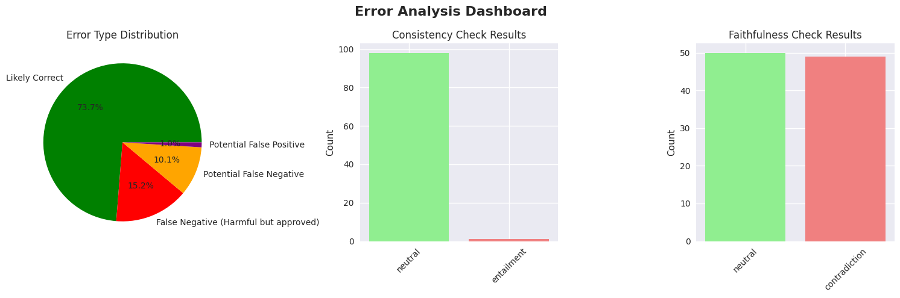

1. Error Analysis Dashboard
Key Findings:
- 73.7% accuracy rate - Most decisions are likely correct, but there's significant room for improvement
- Critical Error Pattern: 15.2% False Negatives (harmful plates approved) - this is the most dangerous error type as it allows potentially offensive plates through
- 10.1% Potential False Negatives - additional plates that may be harmful but were approved
- Consistency Issues: Almost all evaluations show "NEUTRAL" consistency, with minimal "ENTAILMENT," suggesting descriptions don't strongly support decisions
- Faithfulness Problems: Equal split between "NEUTRAL" and "CONTRADICTION" (50-50), indicating descriptions often don't accurately reflect the actual plate content

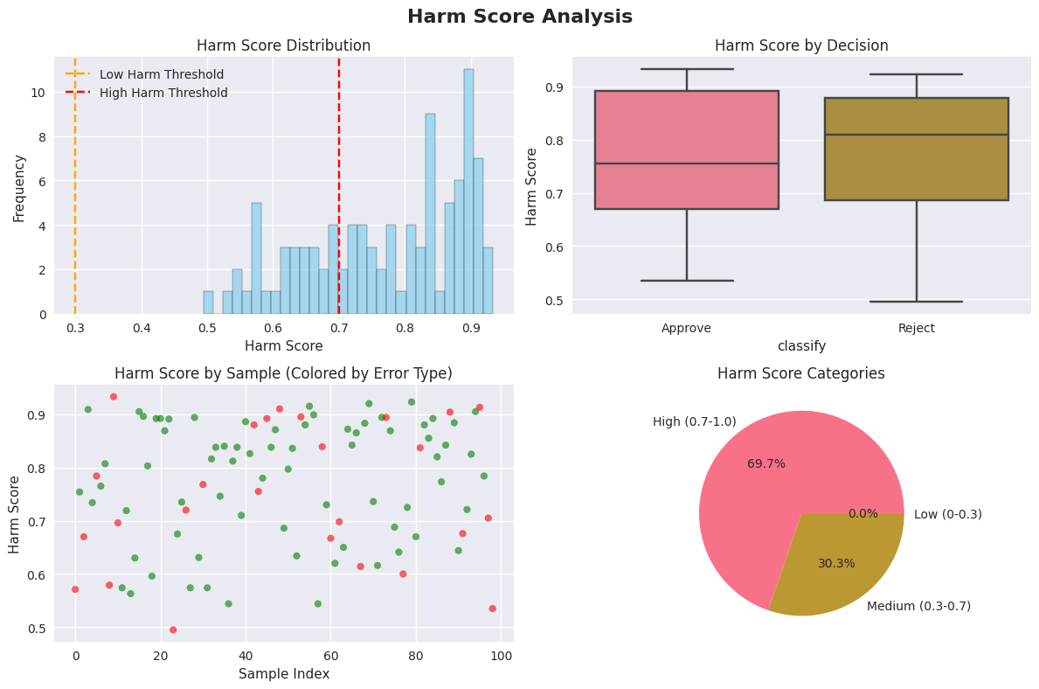

2. Harm Score Analysis
Distribution Insights:
- Bimodal distribution with peaks around 0.55 and 0.85-0.90 harm scores
- 69.7% High Harm (0.7-1.0) vs 30.3% Medium Harm (0.3-0.7) - No low harm plates detected
- Decision Quality: Box plots show concerning overlap between approved and rejected plates' harm scores
- Approved plates have median harm ~0.76, while rejected plates have median ~0.82 - the difference is smaller than expected for good decision-making

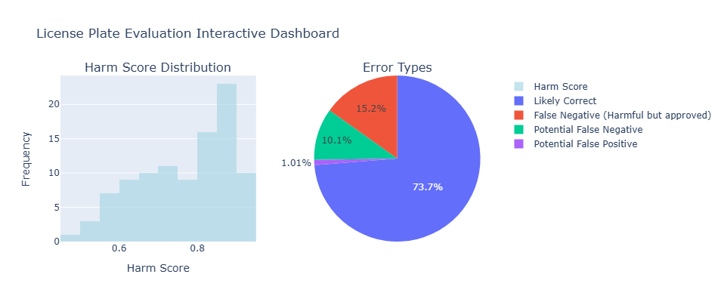

3. Interactive Dashboard
Confirmation of Patterns:
- Harm score distribution confirms most plates fall in the high-harm category
- Error type breakdown matches the detailed analysis from Image 1
- Reinforces that the system struggles with false negatives more than false positives

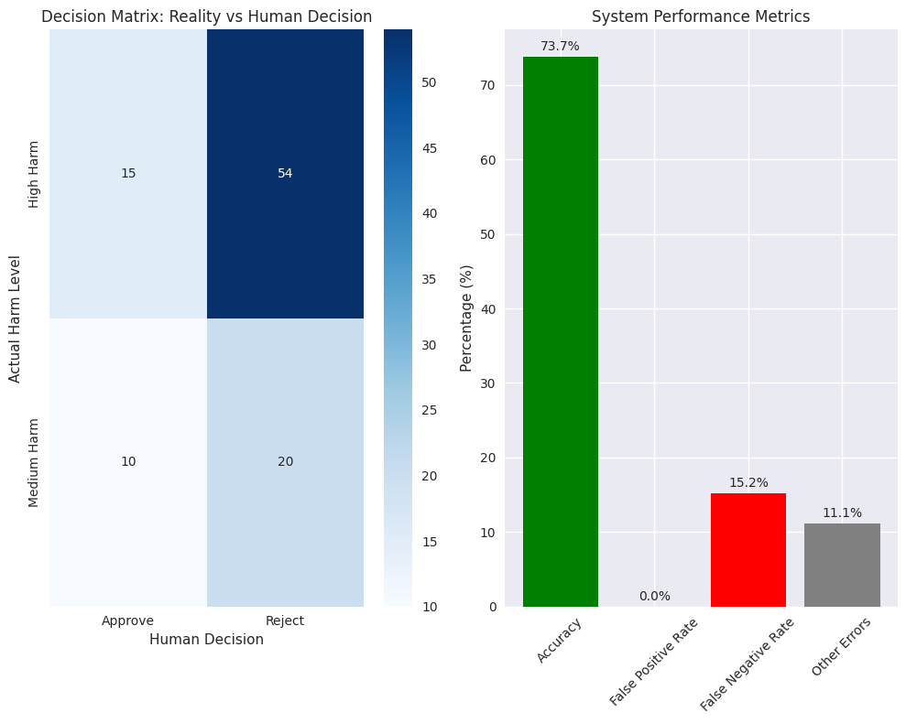

4. Decision Matrix & Performance Metrics
Confusion Matrix Analysis:
- High Harm Plates: 15 approved (False Negatives) vs 54 rejected (True Positives)
  - 78.3% correctly rejected, but 21.7% incorrectly approved (dangerous!)
- Medium Harm Plates: 10 approved vs 20 rejected
  - More conservative approach with medium harm content
Performance Metrics:
- 73.7% Overall Accuracy - Moderate performance
- 0% False Positive Rate - System is very conservative about rejecting non-harmful content
- 15.2% False Negative Rate - Major concern: harmful content getting approved
- 11.1% Other Errors - Likely potential false positives/negatives

Critical Issues Identified

1. Safety Risk
The 15.2% false negative rate means 1 in 6-7 harmful plates are being approved. This poses reputational and legal risks.

2. Description Quality Problems
- Descriptions are neither consistent with decisions nor faithful to actual plate content
- This suggests either poor training of evaluators or systematic issues in the evaluation process

3. Decision Threshold Issues
The small difference in harm scores between approved/rejected plates suggests the decision threshold may need adjustment or the criteria need refinement.

