Experiment: First Web API using ASP.NET Core
1. Concept of Microservice
A Microservice is an architectural style in which an application is divided into small, independent services. Each service performs a specific business function and communicates with other services using APIs over HTTP. Microservices can be developed, deployed, and maintained independently, making applications more scalable and flexible.
2. Difference between Web Service and Web API
Web Service | Web API
Uses SOAP protocol | Uses HTTP/REST protocol
Returns XML only | Returns JSON, XML, HTML, Text, Images, etc.
Requires WSDL | Does not require WSDL
Heavyweight | Lightweight
Slower | Faster
Note: Web API is not restricted to sending XML. It can return JSON, XML, HTML, text, images, and files. JSON is the default response format in ASP.NET Core Web API.
3. HTTP Request and HTTP Response
HTTP Request:
An HTTP Request is sent by the client to the server to request data or perform an operation. It contains the URL, HTTP method, headers, and request body (if required).
HTTP Response:
An HTTP Response is sent by the server back to the client. It contains the status code, response headers, and the requested data.
4. HTTP Action Verbs
HttpGet: Used to retrieve (read) data from the server.
HttpPost: Used to create or insert new data into the server.
HttpPut: Used to update existing data.
HttpDelete: Used to delete data from the server.
In ASP.NET Core Web API, these action verbs are declared using attributes such as:
- [HttpGet]
- [HttpPost]
- [HttpPut]
- [HttpDelete]
5. HTTP Status Codes Used in Web API
200 OK: Indicates that the request was successful.
400 Bad Request: Indicates that the request contains invalid data.
401 Unauthorized: Indicates that the user is not authorized to access the resource.
500 Internal Server Error: Indicates that an unexpected error occurred on the server.
6. Demonstration of a Simple Web API
A simple Web API was created using ASP.NET Core. The project contains a controller named WeatherForecastController with Read (GET) and Write (POST) action methods.
- GET action retrieves the list of students.
- POST action adds a new student to the list.
The controller inherits from ControllerBase and uses the [ApiController] attribute.
7. Structure of a Web API
A Web API project consists of:
- Controllers
- Action Methods
- Program.cs
- appsettings.json
- launchSettings.json
- Models (if required)
The controller handles incoming HTTP requests, and action methods perform operations based on HTTP verbs.
8. Configuration Files
Program.cs / Startup.cs
Used to configure services, dependency injection, middleware, and routing.
appsettings.json
Stores application settings such as connection strings, logging information, and other configuration values.
launchSettings.json
Stores launch settings such as application URL, environment variables, and launch profiles.
RouteConfig.cs (.NET Framework 4.5)
Defines routing for MVC applications.
WebApiConfig.cs (.NET Framework 4.5)
Configures Web API routes and enables attribute routing.
Practical: First Web API using .NET Core
Steps Performed
- Opened Visual Studio.
- Created a new ASP.NET Core Web API project.
- Selected the API template.
- Used the default WeatherForecastController.
- Added GET and POST action methods.
- Ran the application.
- Swagger UI opened successfully.
- Executed the GET request and received the expected response.
- Executed the POST request to add a new student.
- Executed the GET request again and verified that the new student was added successfully.
Output
Screenshot 1: Visual Studio Project with Swagger UI
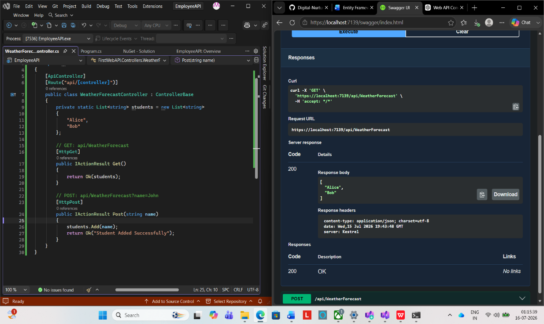

Screenshot 2: Visual Studio Project with GET Request Execution (200 OK)
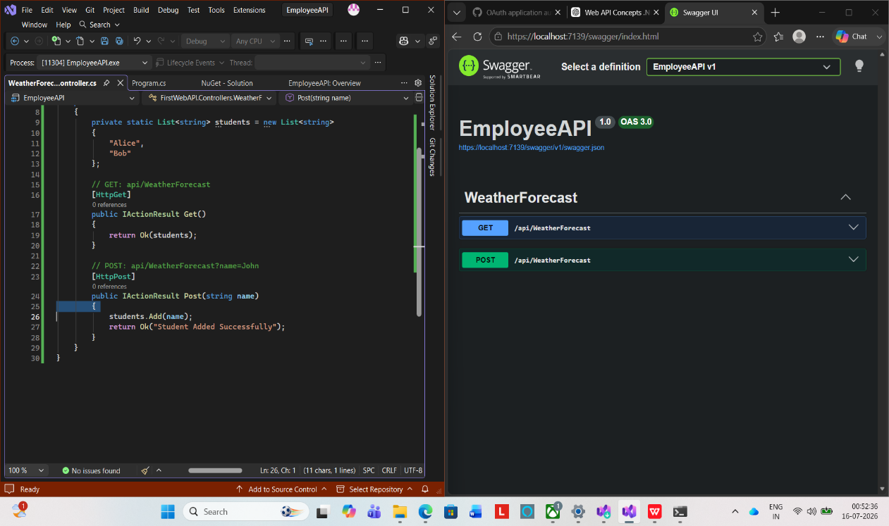

Screenshot 3: Visual Studio Project with POST Request Execution
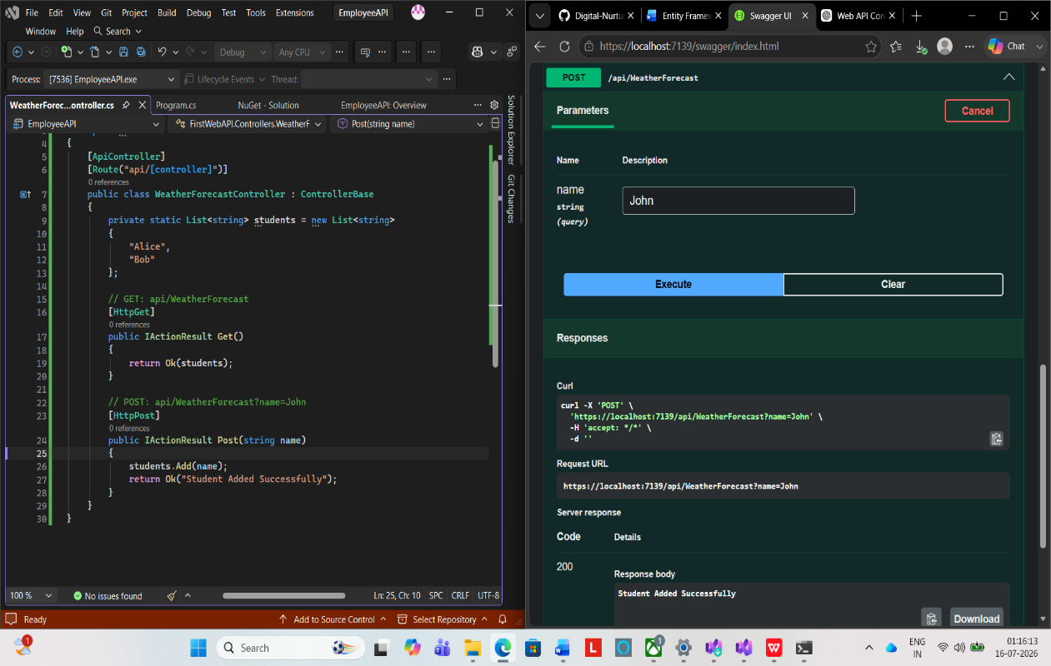

Screenshot 4: Visual Studio Project with GET Request After POST
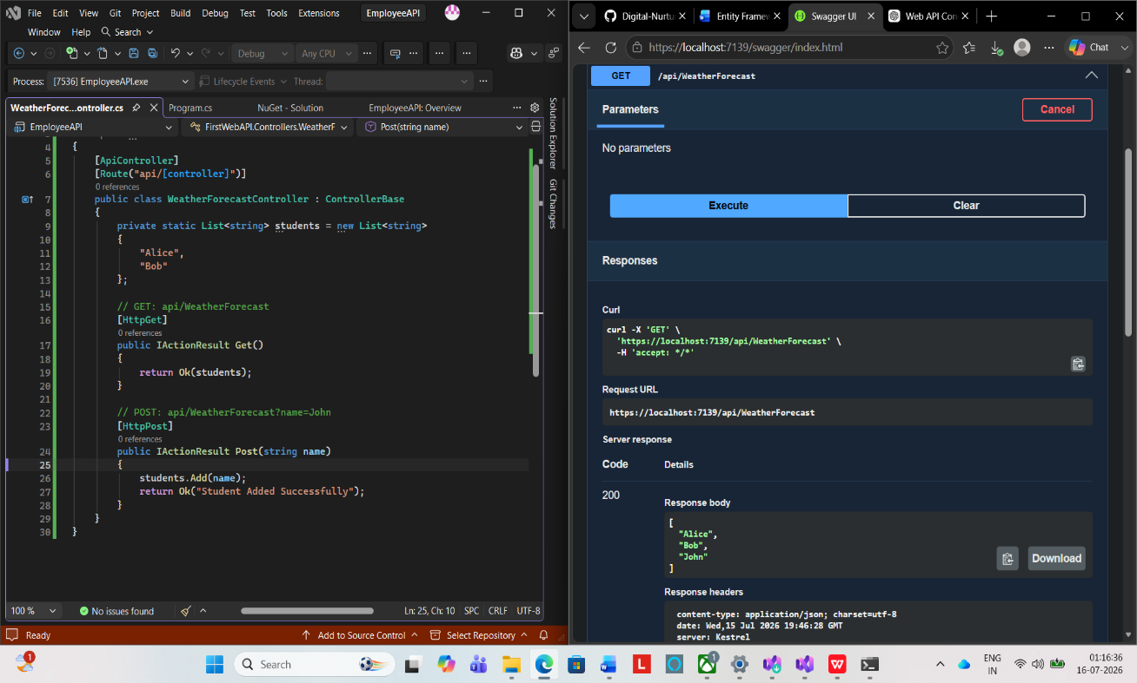

Result
The ASP.NET Core Web API was created successfully. The GET request returned the expected data, and the POST request successfully added a new record. The API was tested using Swagger UI, and all operations were executed successfully.

