**EXPERIMENT NO - 2** BUSHRA SHAHZAD

20BCS046

31st January, 2024

**AIM**

Design and implement Embedded System for blinking two LEDs alternately with some delay in between, using 8051 Microcontroller and Keil.

**Hardware Used** - Computer System, 8051 Microcontroller kit, USB connectors.

**Software Used** - Keil Micro-vision IDE, Flash Magic tool.

**Pins Used -**

|  |  |  |  |
| --- | --- | --- | --- |
| LED | PORT | VARIABLE | USE |
| D1 | P3.0 | RxD | Serial Data Receive Pin |
| D2 | P3.1 | TxD | Serial Data Transmit Pin |

**C Code**

#include "p89v51rx2.h"

sbit buzz = P0 ^ 3;

void delay(unsigned int x)

{

    unsigned int i, j;

    for (i = 0; i <= 1000; i++)

    {

        for (j = 0; j <= x; j++)

        {

        }

    }

}

void main(void)

{

    while (1)

    {

        buzz = 0;

        RxD = 0;

        TxD = 1;

        delay(30);

        TxD = 0;

        RxD = 1;

        delay(30);

        buzz = 1;

        delay(30);

    }

}

**Result**

The C program to implement two alternately blinking LEDs with delay in between is verified using the 8051 micro-controller with the help of appropriate software.

**Output**

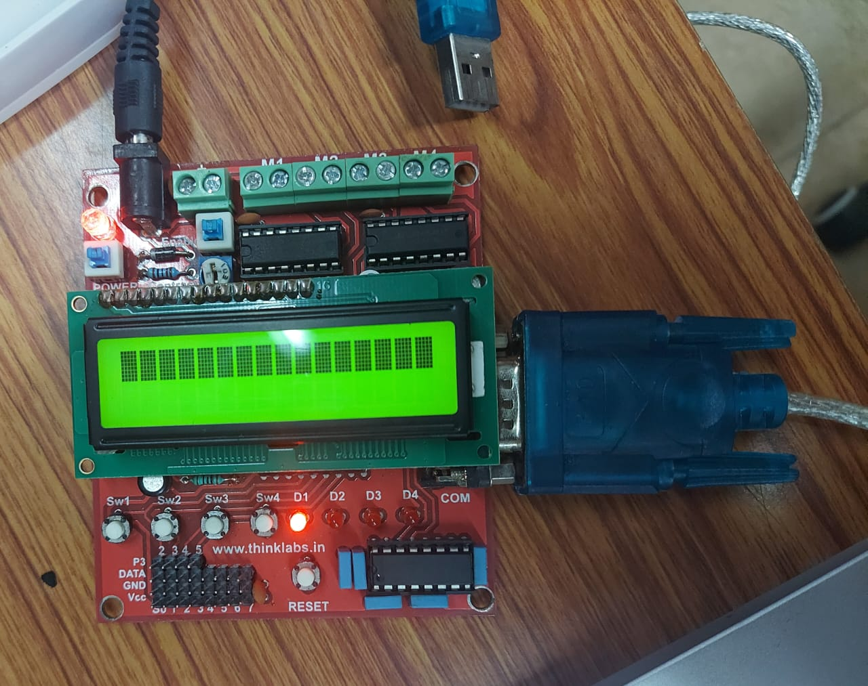 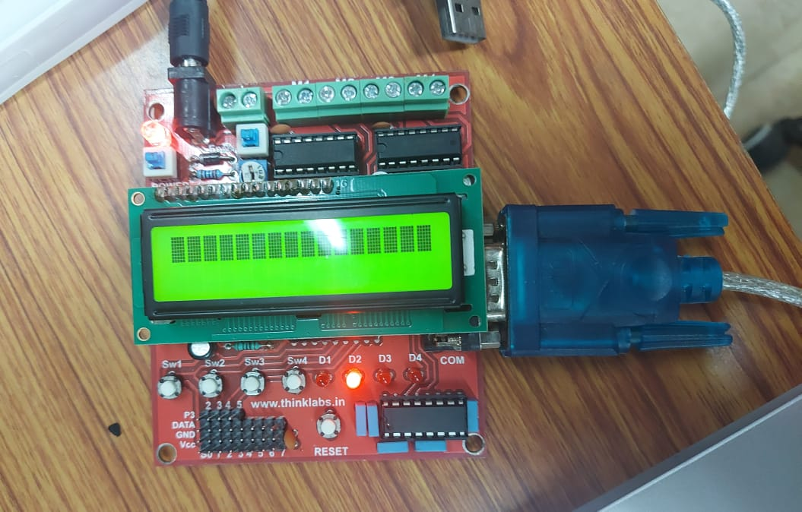

D1 On, D2 Off D1 Off, D2 On