**EXPERIMENT NO - 3** BUSHRA SHAHZAD

20BCS046

7th Feb, 2024

**AIM-**

To design counter based on four switches as input using 8051 board.

**Hardware Used** - Computer System, 8051 Microcontroller kit, USB connectors.

**Software Used** - Keil Micro-vision IDE, Flash Magic tool.

**Pins Used -**

|  |  |  |  |
| --- | --- | --- | --- |
| LED | PORT | VARIABLE | USE |
| D1 | P3.0 | RxD | Serial Data Receive Pin |
| D2 | P3.1 | TxD | Serial Data Transmit Pin |
| D3 | P3.6 | WR | External Memory Read |
| D4 | P3.7 | RD | External Memory Write |
| SW1 | P3.2 | INT0 | Switch 1 |
| SW2 | P3.3 | INT1 | Switch 2 |
| SW3 | P3.4 | T0 | Switch 3 |
| SW4 | P3.5 | T1 | Switch 4 |

**Procedure -**

* The C Code checks for the switch configuration on the 8051 micro-controller.
* If Switch 1 is on, it executes the code for 1-bit counter with some delay.
* If Switch 2 is on, it executes the code for 2-bit counter with some delay.
* If Switch 3 is on, it executes the code for 3-bit counter with some delay.

**C Code**

#include <p89v51rx2.h>

sbit l1 = P3 ^ 0;

sbit l2 = P3 ^ 1;

sbit l3 = P3 ^ 6;

sbit l4 = P3 ^ 7;

sbit s0 = P3 ^ 2;

sbit s1 = P3 ^ 3;

sbit s2 = P3 ^ 4;

sbit s3 = P3 ^ 5;

void delay(unsigned int x)

{

    unsigned int i, j;

    for (i = 0; i <= 1000; i++)

    {

        for (j = 0; j <= x; j++)

        {

        }

    }

}

void counter(unsigned int n)

{

    int i = 0;

    for (i = n - 1; i >= 0; i--)

    {

        if(i & (1){

            l1 = 0;

        }else{

            l1 = 1;

        }

        if(n>=4){

            if (i & (2))

            {

                l2 = 0;

            }

            else

            {

                l2 = 1;

            }

    }

        if(n>=8){

            if (i & (8))

            {

                l3 = 0;

            }

            else

            {

                l3 = 1;

            }

    }

if(n>=16){

            if (i & (16))

            {

                l4 = 0;

            }

            else

            {

                l4 = 1;

            }

    }

delay(200);

    }

}

void main(void)

{

    while (1)

    {

        if (s0 == 0)

            counter(2);

        if (s1 == 0)

            counter(4);

        if (s2 == 0)

            counter(8);

        if (s3 == 0)

            counter(16);

    }

}

**Result**

The C program for counters based on corresponding switches as input is implemented and verified using appropriate software.

**Output**

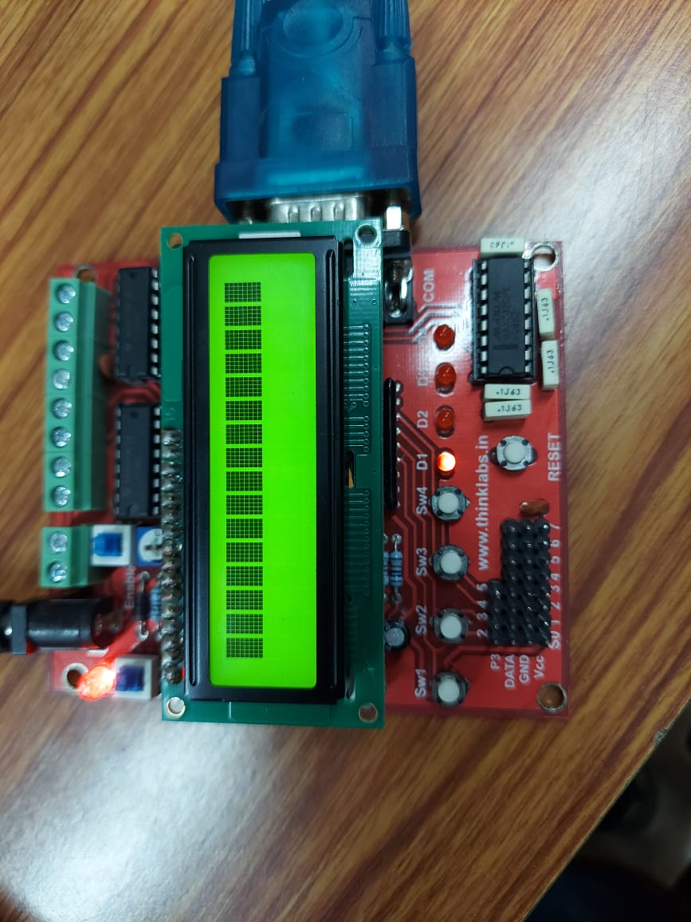 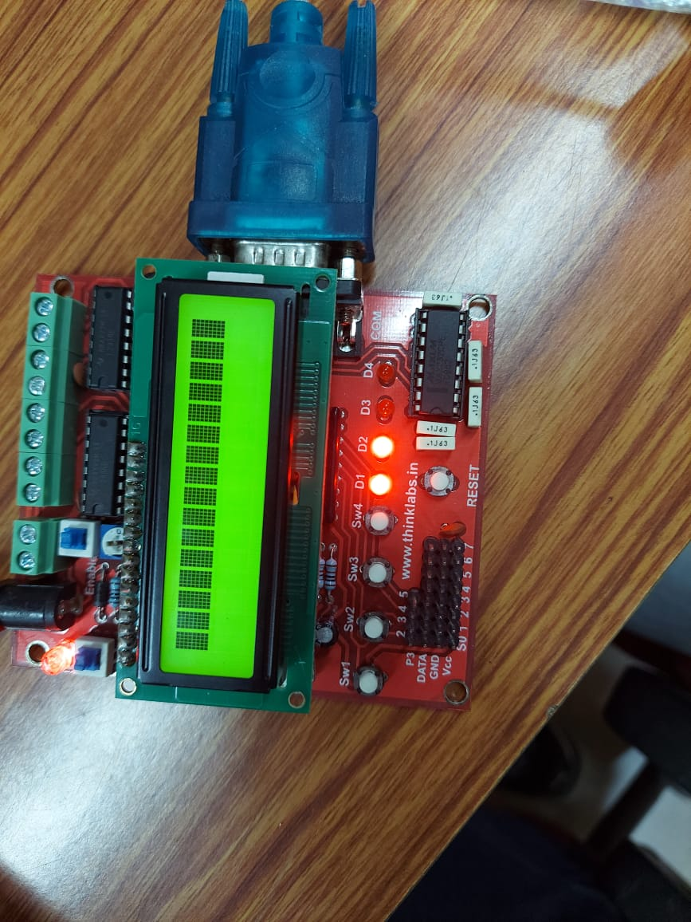

1-bit Counter for switch 1 2-bit Counter for switch 2

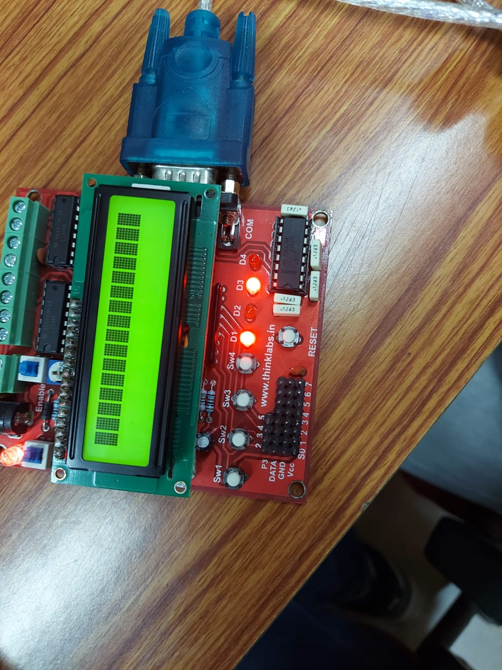 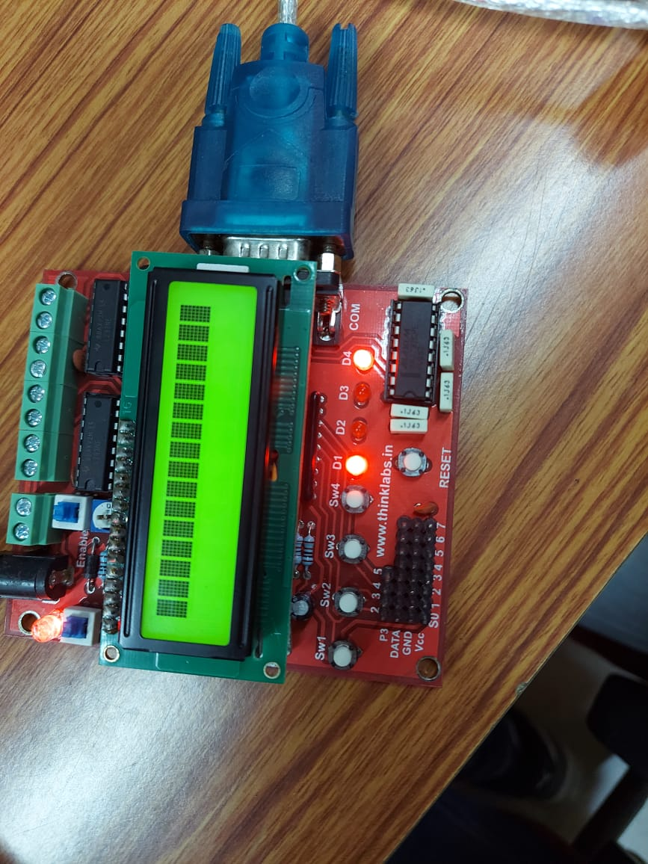

3-bit Counter for switch 3 4-bit Counter for switch 4