Software Design Document
AI Disease Prediction System



Submitted by
Bushra Zafar (F22BINFT1E02018)
Submitted to
Mam Kainat

Department of Information Technology
Faculty of Computing
The Islamia University of Bahawalpur

Revision History

Date | Description | Author | Comments

Document Approval
The following Software Design Document (SDD) has been accepted and approved by the following:
Signature |  | Printed Name | Title | Date
 | .

Supervised by
Mam Kainat

Signature______ _____

Summary
This Software Design Document presented the complete design and working of the MediCare AI Disease Prediction System. The document explained the purpose, architecture, and internal structure of the system in a clear and organized manner. It described how user input flows through the system, how machine learning models are integrated, and how prediction results are generated and stored. The system was shown to follow a simple, modular, and consistent design suitable for academic evaluation. Security, validation, and testing strategies were discussed to ensure safe and reliable system behavior. Database design and data flow were explained to demonstrate traceability and record management. System limitations and ethical considerations were clearly defined to avoid misuse. Overall, this document provides a solid foundation for understanding, evaluating, and maintaining the MediCare AI system as an awareness-based disease risk prediction application.

Contents
1. INTRODUCTION 4
1.1. Purpose 4
1.2. Background and Motivation 4
1.3. System Overview 4
1.4. Objectives of the System 5
1.5. Scope of the System 5
1.6. User Categories 5
1.7. Design Constraints and Assumptions 6
2. SYSTEM ARCHITECTURE DESIGN 7
2.1. Architectural Style 7
2.2. High-Level Architecture Overview 7
Figure 2.2 High Level Architecture Overview 7
2.3. Presentation Layer 8
2.4. Login and Signup Interface 8
2.5. Application Logic Layer 9
2.6. Machine Learning Integration Layer 9
Figures 2.6 Machine Learning Integration Layer 10
2.7. Data Layer 11
2.8. Request–Response Flow 11
Figures 2.8 Request Response Follow 12
3. MODULE & PREDICTION ENGINE DESIGN 13
3.1. Overview of Module Design 13
3.2. End-to-End User Interaction Flow 13
3.3. Disease Module Structure 13
3.4. Input Forms Design 14
3.4.1 Purpose of Forms 14
3.4.2 Diabetes Prediction Form 14
3.4.3 Cardiovascular Disease Form 14
3.4.4 Kidney Disease Form 14
3.4.5 Breast Cancer Form 15
3.5. Prediction Form User Interface 15
Figures 3.5 Prediction Form User Interface 16
3.6. View Layer Design 16
3.6.1 Role of Views 16
3.6.2 Form Submission Handling 16
3.7. Machine Learning Engine Design 17
3.7.1 Centralized Prediction Engine 17
3.7.2 Model Loading and Execution 17
Figures 3.7.2 Model Loading & Execution 18
3.7.3 Prediction Output 19
3.8. Result Interpretation 19
3.9. Prediction Result User Interface 19
Figures 3.9 Prediction Result User Interface 20
Figures 3.9 Prediction Result User Interface 21
3.10. Prediction Storage 21
3.11. Prediction History Interface 21
Figures 3.11 Prediction History Interface 22
3.12. Error Handling and Validation 23
4. DATABASE DESIGN, DATA FLOW & STORAGE 24
4.1. Purpose of Database Design 24
4.2. Database Architecture Overview 24
4.3. Core Data Entities 24
4.4. User Entity Design 25
Figures 4.4 User Entity Diagram 25
4.5. Prediction Entity Design 26
Figures 4.5 Prediction Entity Diagrams 26
4.6. Relationship Between User and Prediction 27
4.7. Disease Identification in Database 27
4.8. Storage of Prediction Results 27
4.9. Timestamp and Record Tracking 27
4.10. Data Flow Within Database 28
4.11. Prediction History Retrieval 28
Figures 4.11 Prediction History Retrieval 29
4.12. Data Integrity and Validation 29
4.13. Backup and Maintainability Considerations 29
5. SECURITY, TESTING & SYSTEM LIMITATIONS 30
5.1. Purpose of Security and Testing Design 30
5.2. Security Design Overview 30
Figures 5.2 Security Design Overview 30
5.3. User Authentication and Authorization 31
5.4. Session Management and Access Control 31
5.5. Input Validation and Data Protection 31
5.6. Protection Against Common Risks 31
5.7. Error Handling Strategy 32
5.8. Testing Strategy Overview 32
5.9. Functional Testing 32
5.10. Validation and Boundary Testing 32
5.11. Integration Testing 33
5.12. Performance Considerations 33
Figures 5.12 Performance Consideration 34
5.13. System Maintenance 34
5.14. Ethical Considerations 34
5.15. System Limitations 35
5.16. Future Improvement Scope 35
6. REFERENCES 35

1. INTRODUCTION

Purpose
This Software Design Document (SDD) describes the design and structure of the MediCare AI Disease Prediction System. It explains how the system is built, how its parts work together, and how disease risk predictions are generated through a web application. The document focuses on explaining the internal working of the system in a clear and organized way.
The document also acts as a reference for understanding system behavior during development, evaluation, and future improvement. It helps readers clearly see how data flows through the system and how different modules are connected.
Key purposes:
- Describe system design and structure
- Support academic evaluation and maintenance

Background and Motivation
Many serious diseases become difficult to manage when they are detected late. A common reason for late detection is that people avoid regular health checkups due to lack of time, cost, or awareness. Because of this, early warning signs are often ignored.
The MediCare AI Disease Prediction System is developed to help users understand possible health risks at an early stage. By using a simple web interface, users can enter basic health information and receive an instant risk result generated by machine learning models. This encourages users to take timely action.
The system is meant to support awareness only. It clearly informs users that the results are not medical diagnoses and professional medical advice is always required.
Main motivation:
- Improve early health awareness
- Encourage medical consultation

System Overview
MediCare AI is a web-based application developed using the Django framework. The system provides disease risk prediction for four common health conditions: Diabetes, Cardiovascular Disease, Kidney Disease, and Breast Cancer.
Each disease follows the same processing flow. Users select a disease, fill in a related form, and submit their data. The system then uses a trained machine learning model to generate a risk result, which is shown in a clear and easy-to-understand format.
The system design focuses on simplicity and consistency so that it can be easily understood and evaluated in an academic setting.
System features:
- Four disease prediction modules
- One consistent prediction process

Objectives of the System
The main objective of MediCare AI is to provide a secure and user-friendly platform that allows users to check disease risk easily. Users can create accounts, log in securely, and access disease prediction features without technical knowledge.
After form submission, the system processes the data and generates a prediction result. This result may include a risk indication and a confidence value if available. All predictions are saved so users can review their past results at any time. Administrators can manage system data through a management interface.
Primary objectives:
- Secure user access
- Accurate prediction and record keeping

Scope of the System
The system is designed only for disease risk prediction through a web application. Its purpose is awareness and academic demonstration, not full medical support.
Features such as hospital systems, live monitoring, and mobile applications are not part of this system.
Included in scope:
- User login and registration
- Disease prediction and history
Out of scope:
- Hospital or wearable device integration

User Categories
The system supports two types of users. General users interact with the system to submit health information and view prediction results. They do not require technical knowledge.
Administrators use the backend interface to manage users and prediction records. This role requires basic system understanding.
User roles:
- General users
- Administrators

Design Constraints and Assumptions
The system assumes that machine learning models are trained before deployment and are only used for prediction. The quality of prediction depends on the accuracy of these models and the correctness of user input.
The system clearly states that it is a support tool and not a replacement for medical professionals.
Assumptions:
- Models are pre-trained
- Input quality affects results

SYSTEM ARCHITECTURE DESIGN

Architectural Style
MediCare AI follows the Model–View–Template (MVT) architecture provided by Django. This architecture separates the system into different layers so that each layer handles a specific responsibility.
By separating user interface, application logic, and data storage, the system becomes easier to understand, test, and maintain. Each layer communicates with others in a controlled and structured manner.
Architecture layers:
- Templates for user interface
- Views and Forms for logic

High-Level Architecture Overview
At a high level, the system works by receiving user input from the web interface, processing it through backend logic and machine learning models, storing results in the database, and then displaying the output to the user.
This step-by-step process ensures that data is validated and safely handled at each stage.
High-level flow:
- User input → Processing → Result
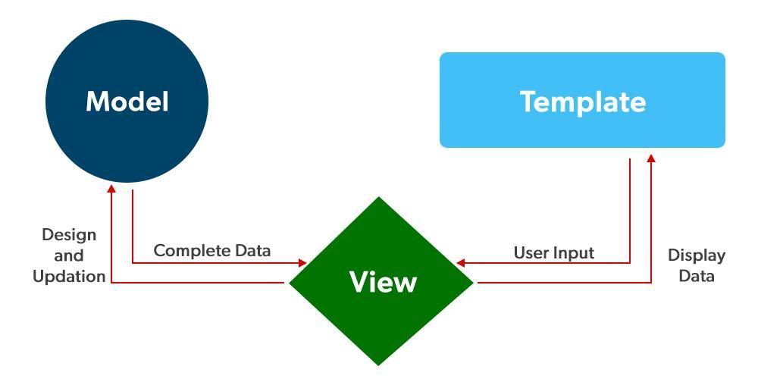

Figure 2.2 High Level Architecture Overview

Presentation Layer
The presentation layer includes all pages that users interact with. It is developed using HTML templates and basic styling to keep the interface simple and readable.
Pages are arranged in a logical order so users can move easily from login to prediction results without confusion.
Main pages:
- Login and registration
- Prediction forms and results

Login and Signup Interface
The login and signup interface allows users to securely create accounts and access the system. Secure sessions are used to protect user identity after login.
Clear error messages are shown if incorrect login information is entered.
Authentication features:
- Secure login
- Session control
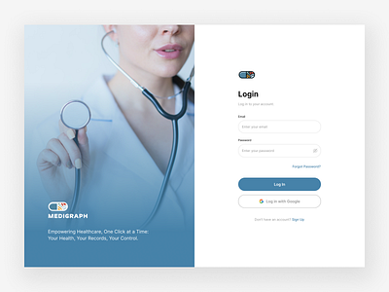
Figure 2.4 Login page

Figure 2.4 Sign Up page

Application Logic Layer
The application logic layer manages how the system behaves. Views handle requests and responses, while forms collect and validate user input.
This structure ensures that only valid data is sent to the prediction engine.
Logic components:
- Views for processing
- Forms for validation

Machine Learning Integration Layer
The machine learning layer is responsible for loading the correct model and generating predictions. The selected model depends on the disease chosen by the user.
The system only performs prediction and does not retrain or modify models during execution.
ML tasks:
- Load model
- Generate result

Diagrams
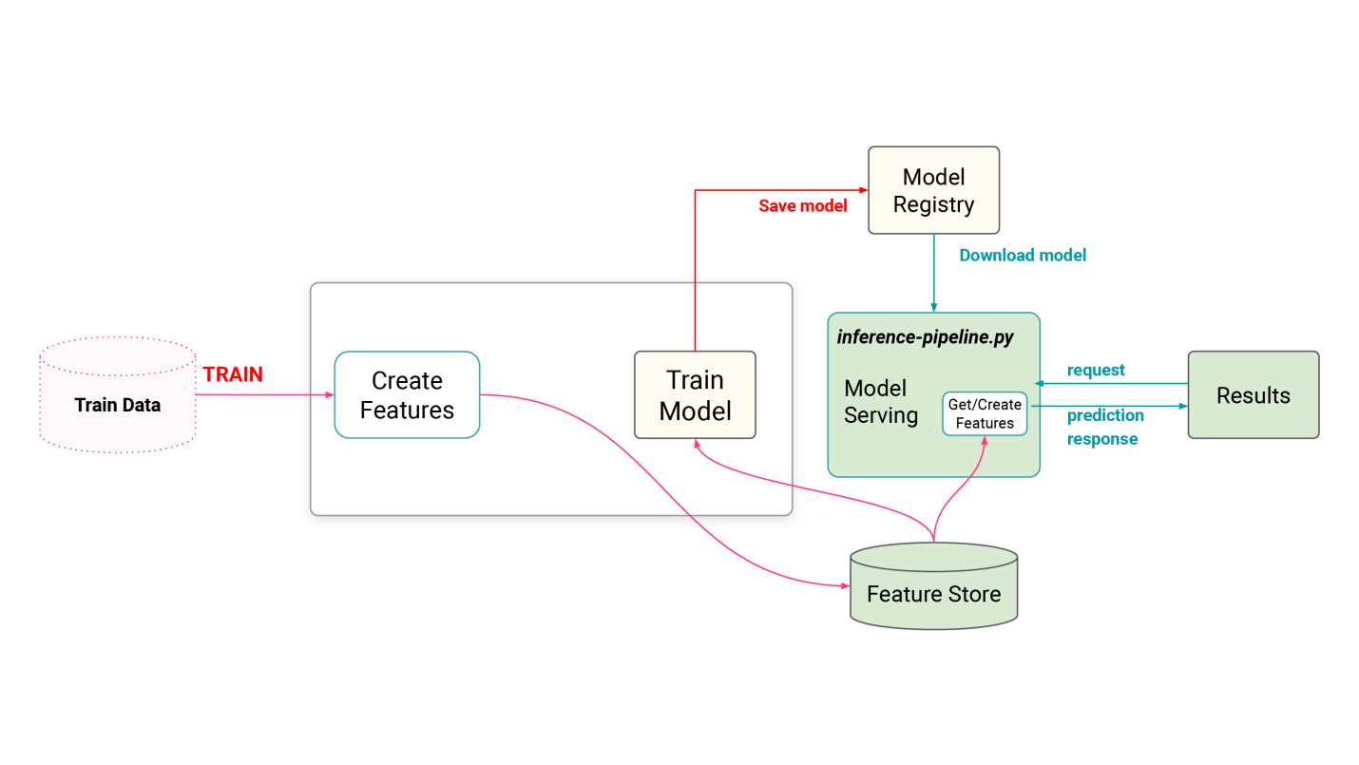

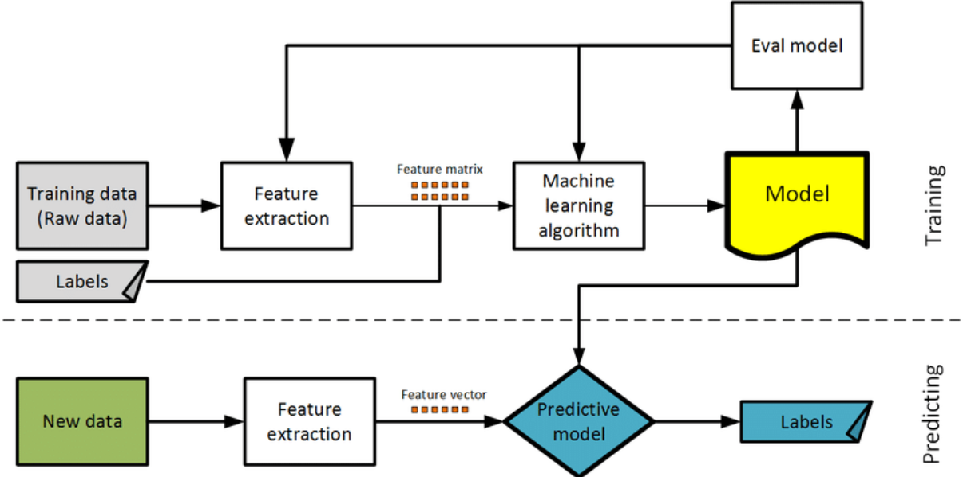

Figures 2.6 Machine Learning Integration Layer

Data Layer
The data layer stores user accounts and prediction records using a relational database. Each prediction is linked to a user and includes result and time details.
This allows users to view previous predictions and supports system monitoring.
Stored data:
- Users
- Prediction records

Request–Response Flow
Every request follows a fixed flow: data submission, validation, prediction, storage, and response display.
This structured flow ensures system stability and predictable behavior.
Flow steps:
- Submit → Validate → Predict → Store → Display

Diagrams
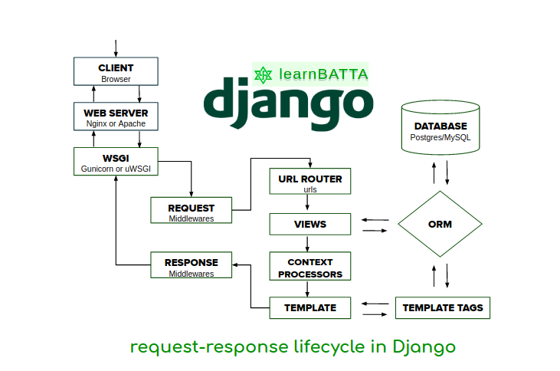
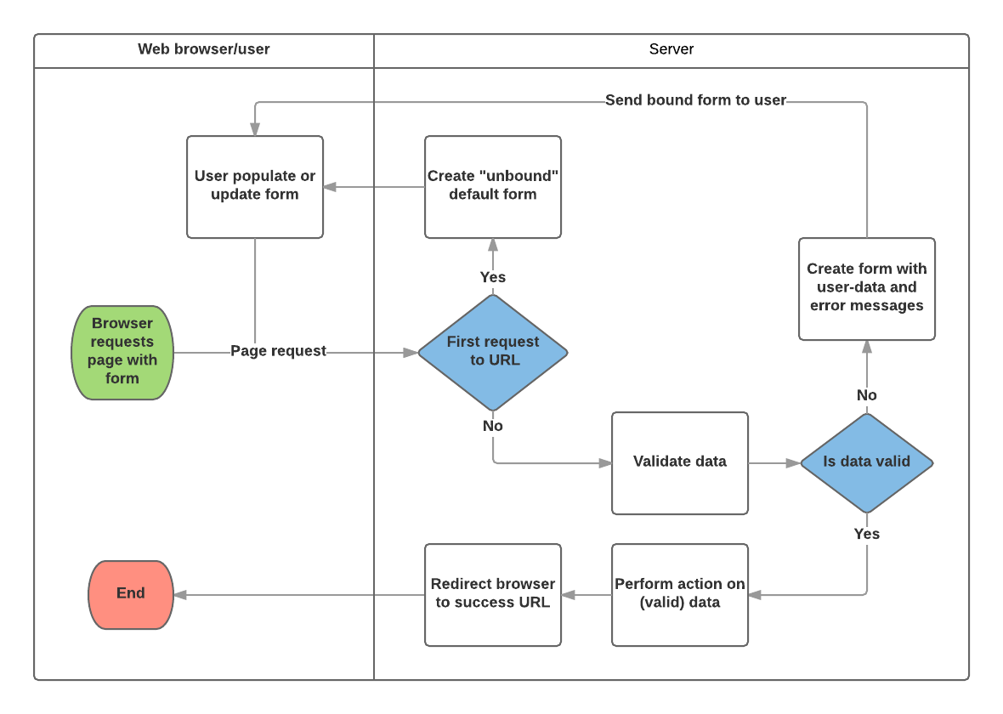

Figures 2.8 Request Response Follow

MODULE & PREDICTION ENGINE DESIGN

Overview of Module Design
The module design of the MediCare AI Disease Prediction System is structured in such a way that every disease prediction follows a clear and repeatable structure. The system contains a central application that manages all disease-related logic. The benefit of this approach is that the system remains simple and each disease behaves in a predictable manner.
Although each disease module is separate, they all follow a common workflow. This ensures consistency across the system and makes the code easier to understand and test. The main focus of the module design is to ensure that there is no ambiguity between user input and prediction output.
Main points of this design:
• Same logical structure for every disease
• Simple and consistent workflow

End-to-End User Interaction Flow
The user interaction flow is designed so that even a non-technical user can easily use the system. At every step, the user receives clear guidance, and the system automatically handles the next step.
When the user logs in, the system redirects them to the disease selection page. After selecting a disease, the relevant form is displayed. Once the form is submitted, backend validation and the prediction process begin, and finally, the result is displayed.
User flow summary:
• Login → Disease selection → Form submission → Result
• Manual steps are kept to a minimum

Disease Module Structure
Each disease module is based on three fundamental components. Together, these components make the complete prediction process possible. This type of structure keeps the code organized and easy to understand.
The first component is the input form, which collects the required medical values from the user. The second component is the view, which controls the request and response. The third component is the machine learning model, which generates the actual prediction.
Each disease module contains:
• Input Form
• View Logic
• Machine Learning Model

Input Forms Design

3.4.1 Purpose of Forms
Input forms are a very important part of the system because the machine learning model only works correctly when it receives accurate and structured data. The purpose of the forms is to ensure that users can only enter allowed and valid values.
Forms provide server-side validation. If the user enters an incorrect or missing value, the prediction process does not start. This prevents system crashes and incorrect predictions.
Role of forms:
• Data validation
• Input structure control

3.4.2 Diabetes Prediction Form
The diabetes prediction form collects health parameters that reflect diabetes risk. These parameters are numeric, and acceptable ranges are defined for them.
The form ensures that no field is left blank and that all values are usable for the machine learning model.
Form focus:
• Numeric inputs
• Enforcement of required fields

3.4.3 Cardiovascular Disease Form
The cardiovascular disease form is based on heart- and blood-related risk factors. Some inputs are numeric, while others are selected through predefined options to prevent users from entering incorrect values.
This design maintains input consistency and provides standardized data to the model.
Key characteristics of this form:
• Controlled choices
• Risk-focused parameters

3.4.4 Kidney Disease Form
The kidney disease form collects indicators related to renal health. The form structure is designed so that each parameter is clearly defined and its value range is validated.
This ensures that kidney prediction is performed only on valid data.
Purpose of the form:
• Accuracy of health indicators
• Rejection of invalid data

3.4.5 Breast Cancer Form
The breast cancer form collects tumor measurement and shape-related values. All inputs are numeric and match the features used during model training.
Form validation ensures that no unexpected values reach the prediction engine.
Form priority:
• Feature consistency
• Strict validation

Prediction Form User Interface
The user interface of the prediction form is kept simple and clean. Fields are arranged in a logical order so that users can easily understand what needs to be filled.
Error messages are displayed near the relevant fields, allowing users to correct mistakes immediately.
UI focus:
• Clarity
• Ease of use
Diagrams

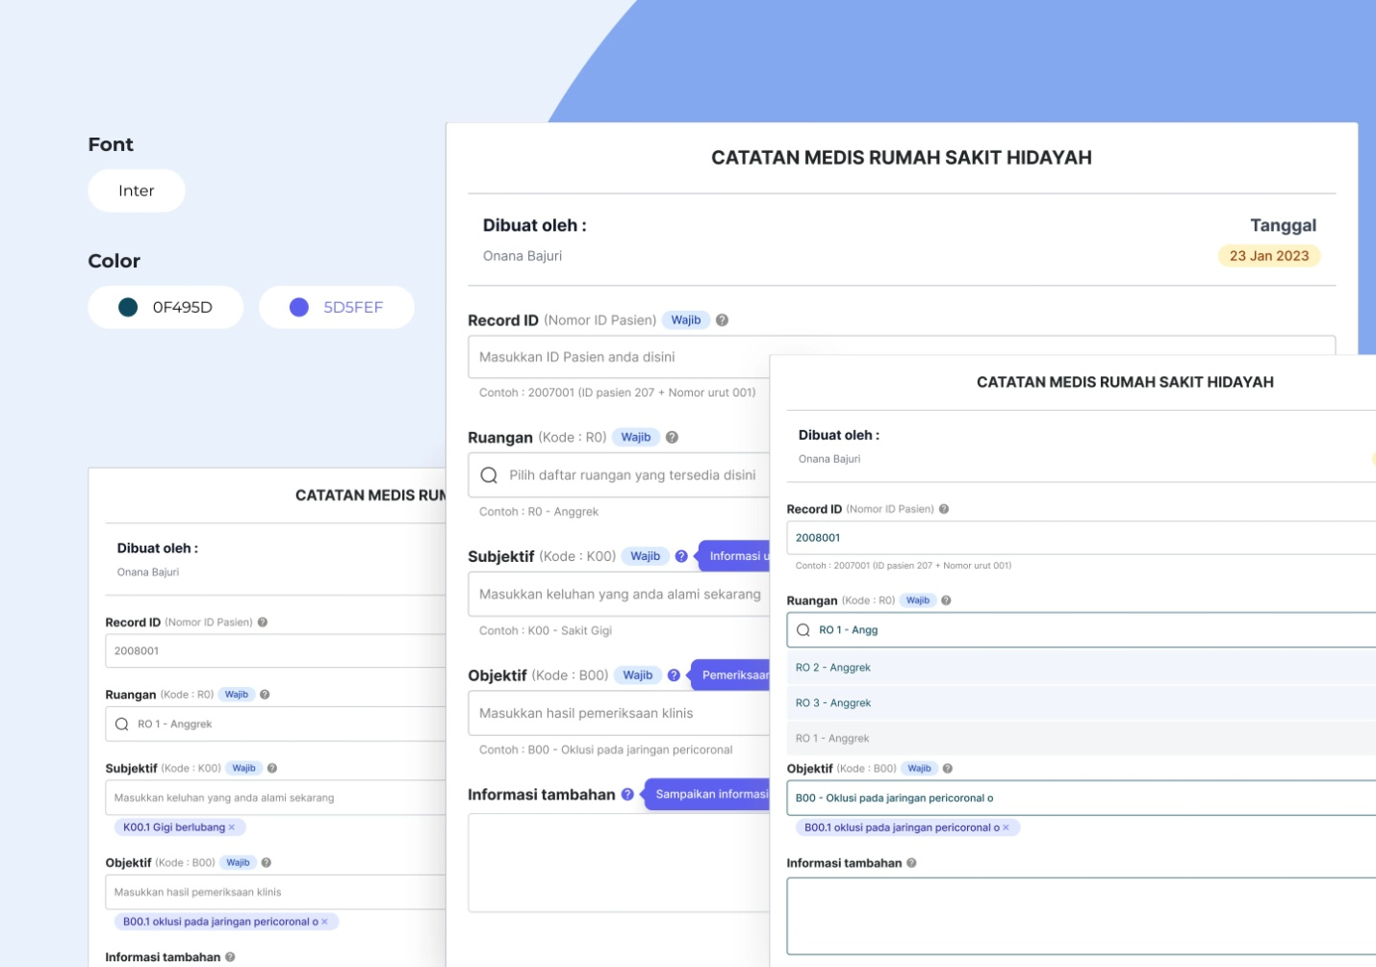

Figures 3.5 Prediction Form User Interface

View Layer Design

3.6.1 Role of Views
Views act as the control center of the system. They receive user requests, handle forms, and call the prediction engine.
Views also decide which page to display to the user—either the form page or the result page.
Responsibilities of views:
• Request handling
• Response rendering

3.6.2 Form Submission Handling
When a form is submitted, the view first checks validation. If the data is incorrect, the form is shown again with errors. If the data is correct, it is sent to the prediction engine.
This step-wise process keeps the system reliable and stable.
Submission process:
• Validate → Predict → Display

Machine Learning Engine Design

3.7.1 Centralized Prediction Engine
The prediction engine is centralized so that separate prediction logic does not need to be written for each disease. This approach reduces code duplication.
The engine is responsible only for prediction, not training.
Benefits of the central engine:
• Consistency
• Easy maintenance

3.7.2 Model Loading and Execution
The engine loads the correct model based on the selected disease. It arranges input values in the correct order and then runs the prediction.
After prediction, the engine returns the result in a readable format.
Engine process:
• Model loading
• Prediction execution

Diagrams


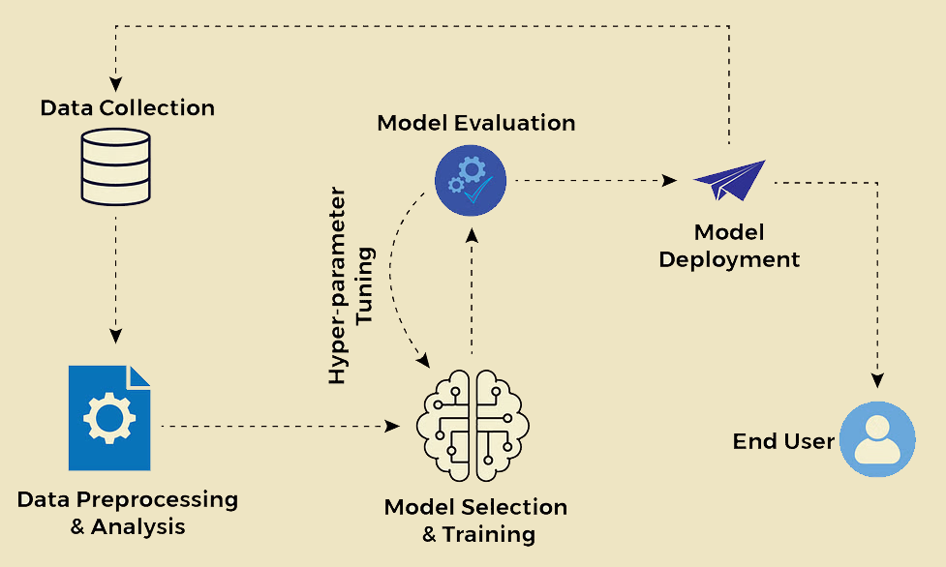

Figures 3.7.2 Model Loading & Execution

3.7.3 Prediction Output
Prediction output is simple and easy to understand. The user is informed only whether risk is present or not, and if available, a confidence value is also shown.
Technical numbers are not directly exposed to the user.
Output includes:
• Risk result
• Confidence (if available)

Result Interpretation
The system does not directly display raw machine learning output. Instead, it explains the result in simple language so that the user does not feel anxious and can understand it in the correct context.
Each result includes a disclaimer clearly stating that it is not a medical diagnosis.
Goal of interpretation:
• User understanding
• Responsible usage

Prediction Result User Interface
The result page displays the disease name, risk status, and guidance. The language used is neutral and professional.
This provides clarity to the user and avoids confusion.
Result page includes:
• Clear message
• Professional tone

Diagrams
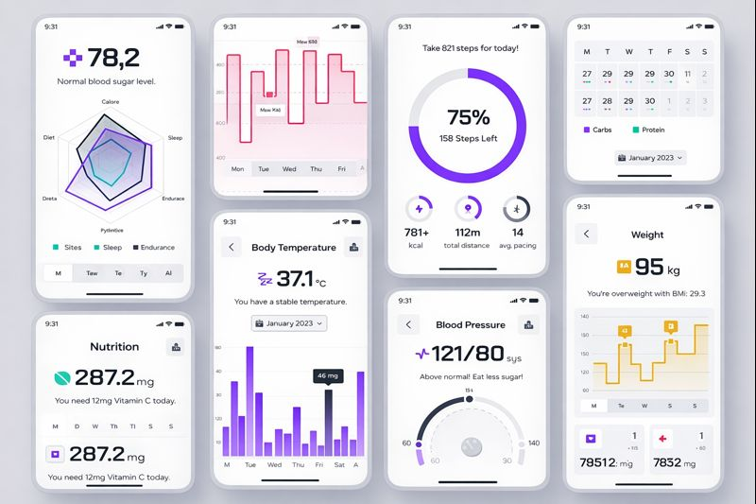

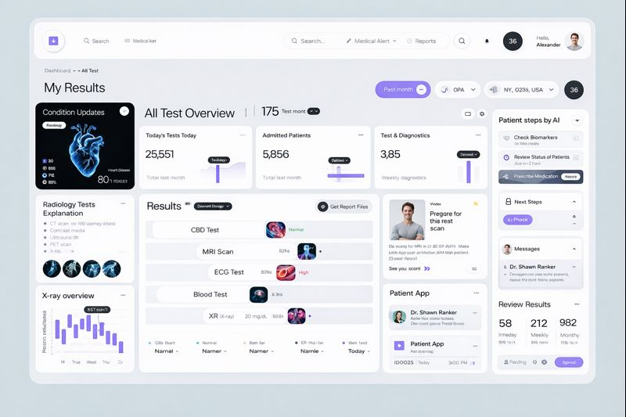

Figures 3.9 Prediction Result User Interface

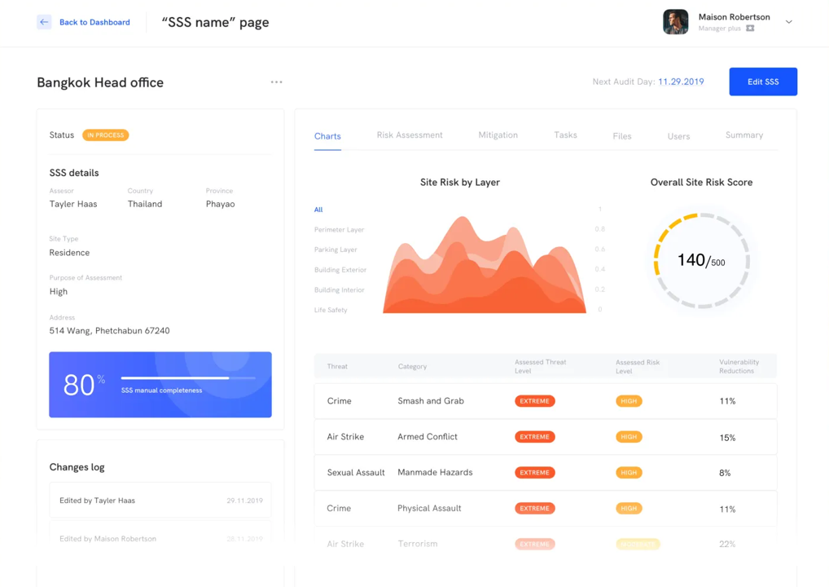

Figures 3.9 Prediction Result User Interface

Prediction Storage
Each prediction is saved in the database. The record includes the user, disease type, result, and time.
This allows users to view their history and enables system auditing.
Stored data includes:
• User reference
• Timestamped result

Prediction History Interface
The prediction history page displays previous predictions in a table format. Records are ordered by date.
This feature helps users track their health awareness over time.
History features:
• Chronological order
• Easy review

Diagrams

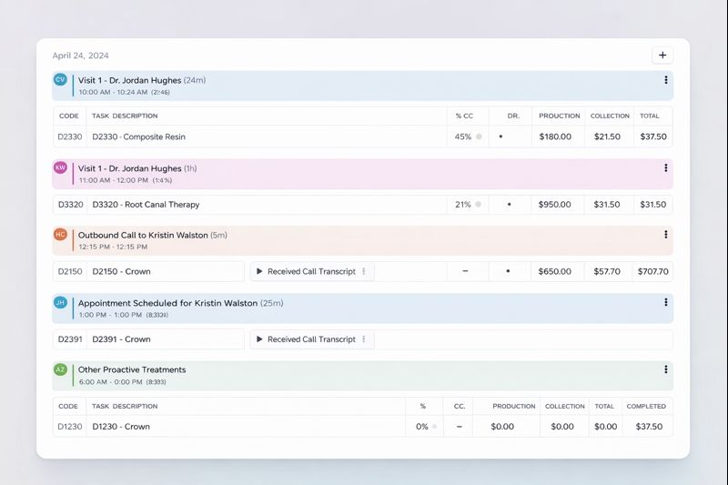
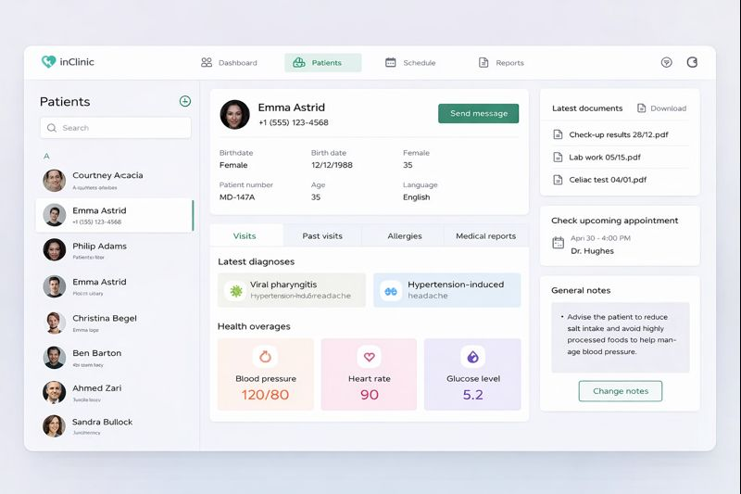

Figures 3.11 Prediction History Interface

Error Handling and Validation
The system is designed to safely handle errors. When an error occurs, a simple message is shown to the user, and internal system details remain hidden.
This maintains both trust and stability.
Error handling focus:
• Safe failure
• User-friendly messages

DATABASE DESIGN, DATA FLOW & STORAGE

Purpose of Database Design
Database design is a very important part of the MediCare AI system because it is where user data and prediction results are permanently stored. The database is designed to keep data secure, consistent, and easily retrievable.
The database does not only store data but also maintains user prediction history and makes system results traceable. This improves system reliability and provides clear evidence for academic evaluation.
Role of the database:
• Store prediction records
• Maintain user history

Database Architecture Overview
MediCare AI uses a relational database architecture managed through the Django ORM. A relational design means data is stored in structured tables, each with a clear purpose.
This architecture reduces data duplication and clearly defines relationships. The database structure is kept simple to make the system easy to understand and maintain.
Architecture highlights:
• Relational structure
• Django ORM–based management

Core Data Entities
The database contains several core entities that together form the complete data structure. These entities support basic system operations and form the foundation of the prediction workflow.
The most important entities are related to users and predictions. The relationship between them defines system data flow.
Core entities:
• User
• Prediction

User Entity Design
The user entity represents all individuals who use the system. Each user has a unique account used to log in and generate predictions.
User information is securely stored and integrated with the authentication system. The user entity is directly linked to prediction records.
Purpose of the user entity:
• Maintain user identity
• Define prediction ownership
Diagrams

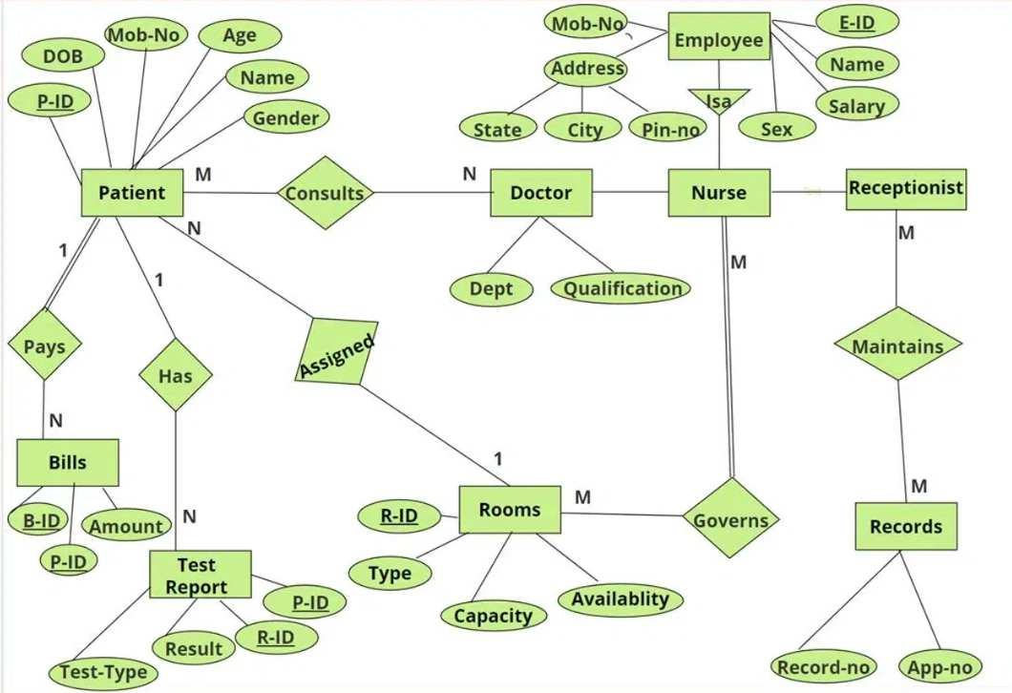

Figures 4.4 User Entity Diagram

Prediction Entity Design
The prediction entity is the central data component of the system. Each time a user performs a disease prediction, a record is stored in the database containing disease type, prediction result, and time.
The purpose of this entity is not only to store results but also to make the system traceable and auditable. Users can view their past predictions through this entity.
Prediction entity stores:
• Disease type and result
• Prediction timestamp
Diagrams
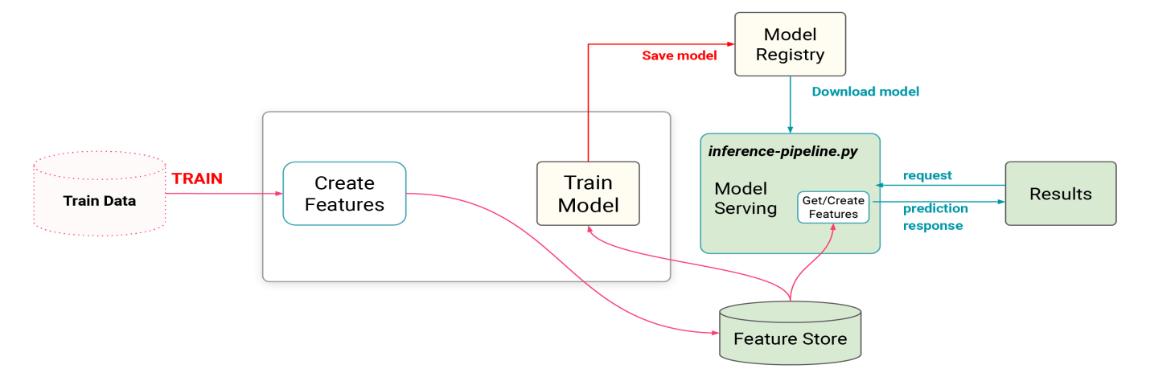
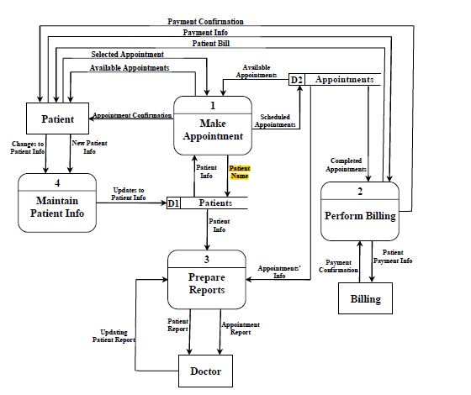

Figures 4.5 Prediction Entity Diagrams

Relationship Between User and Prediction
The relationship between user and prediction is one-to-many. This means one user can generate multiple predictions, but each prediction belongs to only one user.
This relationship allows prediction history to be displayed user-wise and avoids data duplication.
Relationship type:
• One user → many predictions

Disease Identification in Database
Diseases are managed in the database using identifiers. Each prediction record stores a disease name or code, indicating which disease the prediction belongs to.
This approach keeps the database flexible and makes it easy to add new diseases in the future.
Disease handling:
• Disease identifier stored
• Linked with prediction

Storage of Prediction Results
Prediction results are stored in a simple and readable format. The result indicates whether disease risk is present or not. If a confidence value is generated, it is also stored.
This design makes results easy to display and analyze.
Stored result data:
• Risk outcome
• Confidence (if available)

Timestamp and Record Tracking
Each prediction record includes a timestamp that indicates the exact time of prediction. This timestamp is used to display prediction history in chronological order.
This provides a clear timeline for both users and administrators.
Benefits of timestamps:
• Maintain prediction order
• Clear history

Data Flow Within Database
When a user submits a form, validated data is sent to the prediction engine. After prediction, the result is saved in the database and then displayed on the UI.
The database plays a central role in reading and writing data throughout this process.
Data flow:
• Input → Prediction → Database → Display

Prediction History Retrieval
The prediction history page retrieves user records directly from the database. Queries are designed to show only records belonging to the current user.
This ensures that users can only view their own prediction history.
History retrieval focus:
• User-specific data
• Secure access
Diagrams
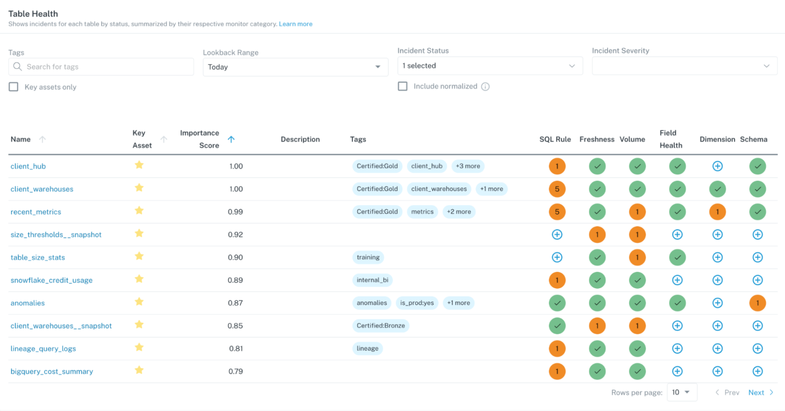
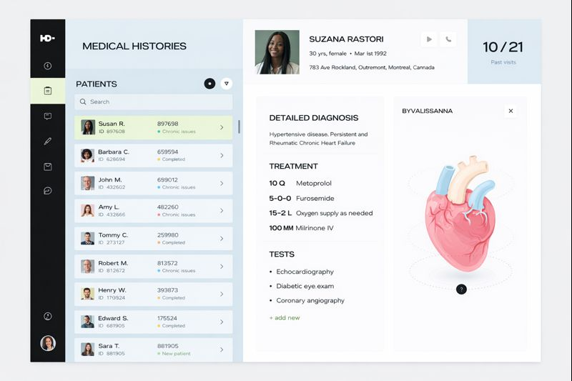

Figures 4.11 Prediction History Retrieval

Data Integrity and Validation
Only validated data is stored in the database. Validation occurs at the application level, and the database receives only clean data.
This approach protects the database from corrupted data and maintains system reliability.
Data integrity is ensured through:
• Server-side validation
• Controlled data flow

Backup and Maintainability Considerations
Because the database structure is simple, backup and maintenance are easy. Prediction records and user data can be easily exported or migrated.
This design is suitable for academic and small-scale deployment.
Maintainability points:
• Simple structure
• Easy backup

SECURITY, TESTING & SYSTEM LIMITATIONS

Purpose of Security and Testing Design
Security and testing are critical for the MediCare AI system because it processes health-related information. If the system is not secure or properly tested, user data may be at risk and prediction results may be unreliable.
This chapter explains how the system protects user data, handles errors, and ensures reliability through testing. It also clearly defines system limitations.
Focus of this chapter:
• Data protection and reliability
• System boundaries and limits

Security Design Overview
The security design of MediCare AI is based on basic but effective principles. The system ensures that only authorized users can access prediction features and that sensitive data is not accessed improperly.
Security is considered at all important stages, including login, prediction submission, and history access.
Security goal:
• Prevent unauthorized access
• Protect user data
Diagrams
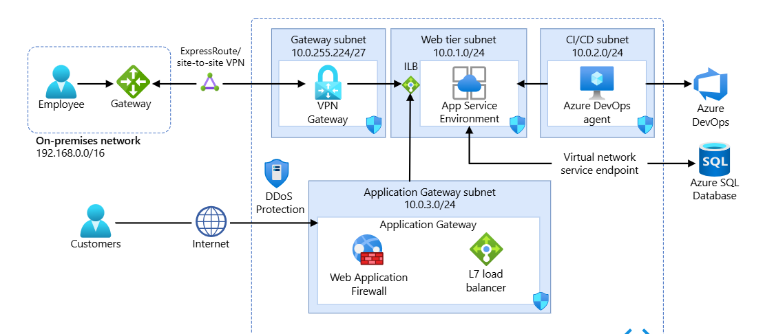

Figures 5.2 Security Design Overview

User Authentication and Authorization
The system uses a secure login mechanism for user authentication. Each user has a unique account, and prediction forms and history pages are accessible only after login.
Authorization ensures that users only see features allowed for their role. General users and administrators have different access rights.
Authentication ensures:
• Secure login
• Role-based access

Session Management and Access Control
Session management is an important security feature. When a user logs in, a secure session is created to maintain identity. The session is terminated upon logout.
This prevents misuse of the user account through the browser.
Session control benefits:
• User identity protection
• Prevention of unauthorized reuse

Input Validation and Data Protection
All user input is validated before processing. Forms ensure that only allowed data types and values are accepted. If incorrect or incomplete data is provided, the prediction process does not start.
Validation not only improves prediction accuracy but also reduces security risks.
Role of input validation:
• Rejection of invalid data
• System safety

Protection Against Common Risks
The system is designed to protect against common web risks. Controlled forms, server-side validation, and restricted access prevent misuse.
Internal files, models, and configuration details are not directly exposed.
Risk protection includes:
• Controlled data flow
• Restricted internal access

Error Handling Strategy
Error handling is a critical part of the system. If an issue occurs during prediction, such as invalid input or model loading failure, the system handles it gracefully.
Users see simple and clear messages, while internal details remain hidden.
Error handling goal:
• Safe system behavior
• User-friendly messages

Testing Strategy Overview
Testing ensures that the system works as expected. It verifies that each module performs its function correctly.
The system is tested under different scenarios to identify errors early.
Testing focus:
• System correctness
• Prediction flow verification

Functional Testing
Functional testing checks each feature individually, including login, form submission, prediction generation, and history display.
The goal is to ensure each function meets its requirements.
Functional tests include:
• Login and logout
• Prediction submission

Validation and Boundary Testing
Validation testing ensures the system does not accept invalid input. Boundary testing checks extreme values to prevent system crashes.
This improves system stability.
Testing ensures:
• Input limit handling
• Stable behavior

Integration Testing
Integration testing verifies that all modules work together correctly. Coordination between forms, views, prediction engine, and database is tested.
This ensures a smooth end-to-end prediction workflow.
Integration testing purpose:
• Module coordination
• End-to-end reliability

Performance Considerations
The system is kept lightweight to ensure quick prediction results. Machine learning models are efficiently loaded, and database queries are simple.
This design is suitable for academic and small-scale usage.
Performance focus:
• Fast response
• Efficient processing
Diagrams
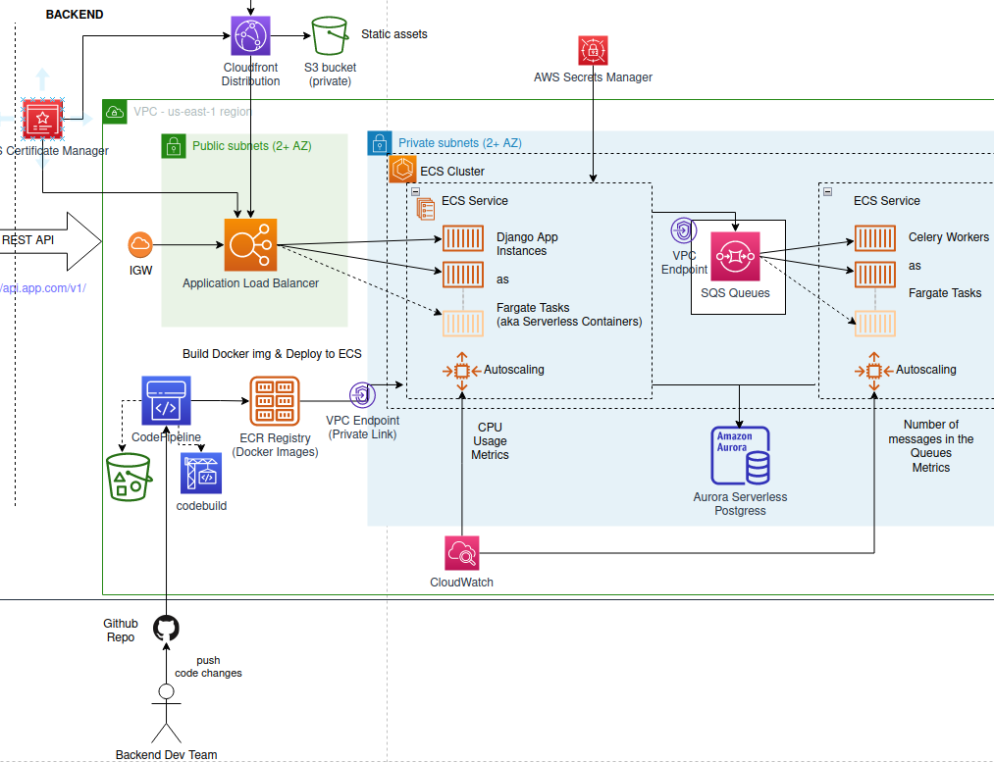

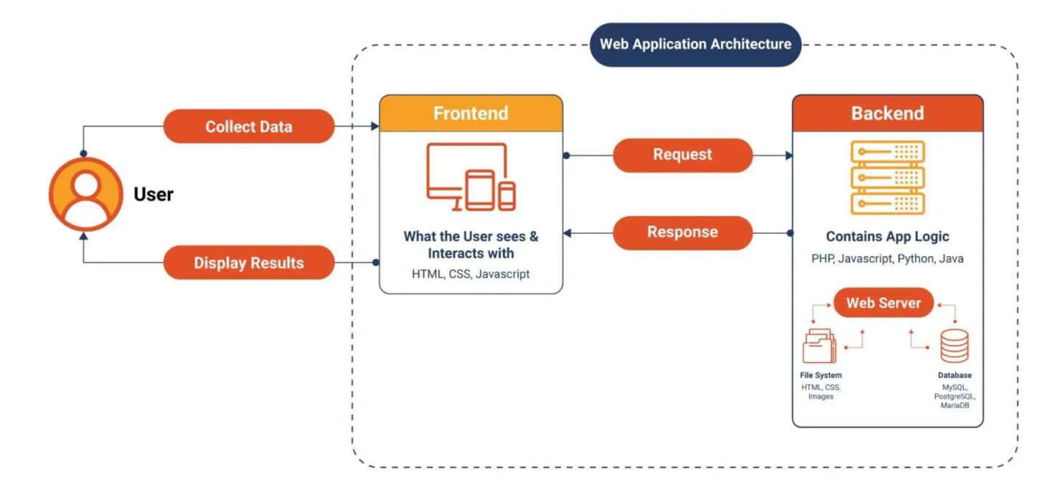

Figures 5.12 Performance Consideration

System Maintenance
The modular design makes maintenance easy. New disease modules or model updates can be added without major changes to the core system.
Maintenance tasks are manageable.
Maintenance benefits:
• Easy updates
• Modular structure

Ethical Considerations
The system is designed with ethical principles in mind. Users are clearly informed that predictions are for awareness only and not medical diagnoses.
This prevents misuse and misunderstanding.
Ethical focus:
• User awareness
• Responsible usage

System Limitations
The MediCare AI system has practical limitations. It does not use real-time medical data and is not connected to external hospital systems.
Machine learning models are static and do not support runtime training.
Main limitations:
• No real-time monitoring
• No live model training

Future Improvement Scope
The system can be enhanced in the future by adding new disease modules or improving models. However, these enhancements are outside the current scope.
The current design supports future growth.
Future scope:
• New diseases
• Model improvement

REFERENCES
- Django Software Foundation. Django Documentation.
https://docs.djangoproject.com/
- Mitchell, T. M. (1997). Machine Learning. McGraw-Hill.
- Han, J., Kamber, M., & Pei, J. (2011). Data Mining: Concepts and Techniques. Morgan Kaufmann.
- ISO/IEC/IEEE 1016:2017. Systems and Software Engineering — Software Design Descriptions.
- World Health Organization (WHO). Ethical Considerations in Artificial Intelligence for Health.
https://www.who.int/

