Design Document of Coal Yard Management System for GMR Kamalanga Energy Ltd.

**Version – 1.1**

**Date – 29-01-2025**

**Table of Content**

1.Purpose and Objective 2

2.High-Level Architecture 3

3.Table structure design 5

4.Business Logic 6

5. UI Implementation 9

**Purpose and Objective:**

The Coal Yard Management System digital dashboard will provide a real-time, datadriven approach to manage coal stockpiling, blending, and quality control at the GMR Kamalanga Energy Ltd coal yard. The company plans to implement the entire CSYM in 3 iterations – in a Multi Generation Plan (MGP). In iteration 1 - The system will enable operators to effectively monitor coal quality, make informed decisions regarding blending or direct feeding, and maintain operational efficiency, while reducing aging and intermixing issues in the stockyard.

**Objectives of a Coal Yard Management System**

* **Efficient Inventory Management**
* Track and manage coal stock levels accurately.
* Achieve and maintain the desired GCV for feeding coal.
* Manage coal GCV proportions effectively to reduce aging and intermixing of coal.
* **Real-Time Monitoring and Reporting**
* Provide real-time data on coal movement, stock levels, and operational performance.
* Generate automated reports for compliance, audits, and managerial decision-making.
* **Scalability and Integration**
* Build the application with an eye towards integrating future Machine Learning models for forecasting, predictive analytics, running advanced optimization algorithms and enabling integration with SAP if needed.

High-Level Architecture:

**Workflow Overview**

1. **Sensors and Devices:** Collect real-time data (e.g., stacking date, rake no, spur, sub pile) via dashboards and send it to the system through UI gateways.
2. **Application:** Processes this data for updates, management, and reporting with the customize logic.
3. **Data storage:** All data is stored within tables in database.
4. **Integration Layer:** Exchanges data with data-base and tables.
5. **User Interface Layer:** Displays processed data to users via dashboards or reports.

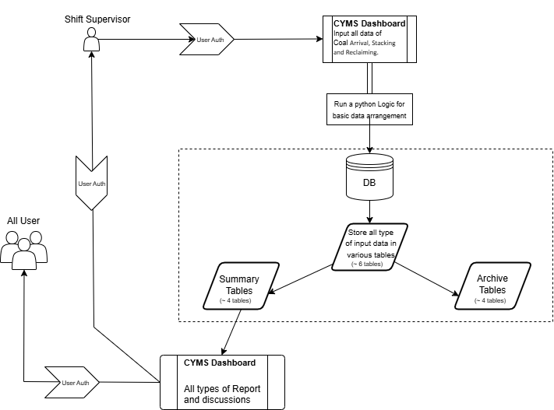

The architecture of a Coal Yard Management System can be broken down into the following key components :-

**1. User Interface Layer**

* **Purpose**: Provides access to system functionality and data for various user roles (e.g., operators, managers, maintenance staff).
* **Components**:
  + Web-based dashboard (accessible from PCs, tablets, or mobile devices).
  + Mobile applications for on-site personnel.
  + Role based access control.
* **Software stack:** Python Dash and FastAPI.

**2. Application Layer**

* **Purpose**: Manages business logic and controls the core operations of the coal yard.
* **Components**:
  + **Inventory Management Module**: Tracks stockpile locations, volumes, and quality.
  + **Transport Management Module**: Manages the scheduling and tracking of coal transport (trucks, rail).
  + **Analytics and Reporting Module**: Provides insights through real-time and historical data visualization.
* **Software stack:** Python Dash.

**3. Data Storage**

* **Purpose**: Stores and organizes all the data generated and consumed by the system.
* **Components**:
  + **Database Management System (DBMS)**: Centralized storage for inventory, equipment status, transaction logs, and user activity.
  + **Data Warehouse**: Stores historical data for analytics and reporting.
  + **Cloud/On-Premises Storage**: Based on the deployment, securely stores system data in AWS, Azure, or an on-premises database.
* **Software stack:** PostgreSQL/MySql.

**4. Security Layer**

* **Purpose**: Ensures data integrity, user authentication via API.
* **Components**:
  + **Access Control**: Role-based access to system features and data.
  + **Data Encryption**: Protects sensitive information in transit and at rest.
* **Software stack:** OAuth/ JWT.

# Table structure design:

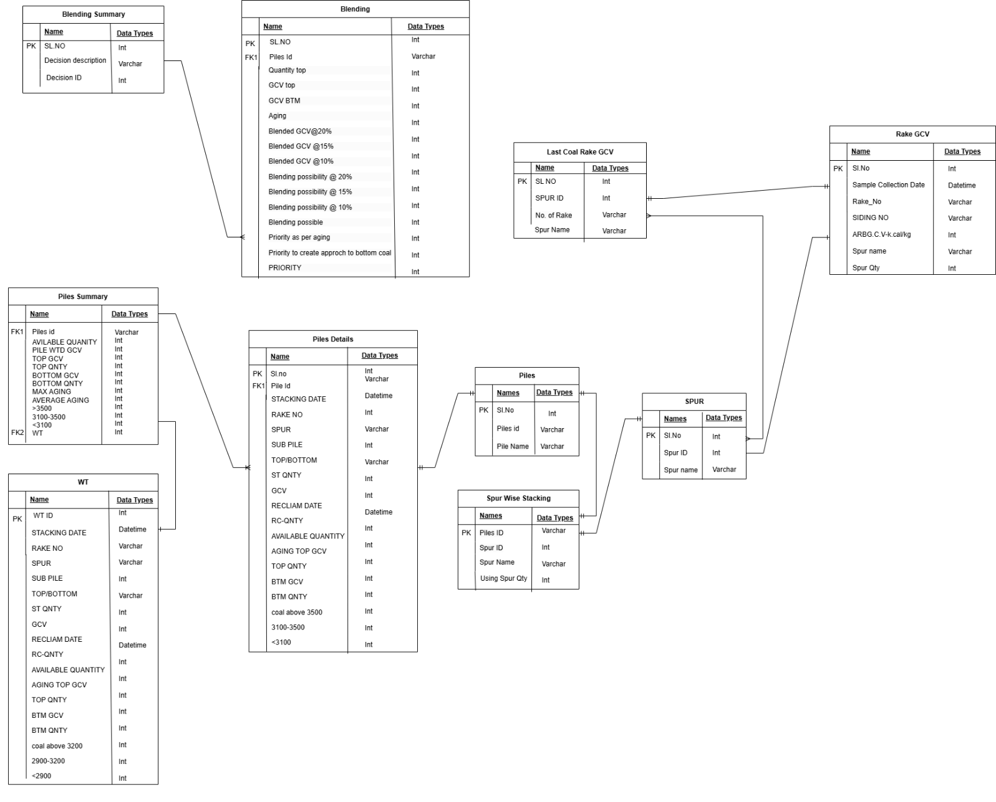

**Data Flow**

1. **Data Capture (Raw Data):**
   * Data is stored in transactional tables as operations occur.
2. **Data Processing:**
   * Scheduled jobs or triggers aggregate data from the raw tables to update the summary tables.
3. **Dashboard Visualization:**
   * The dashboard queries summary tables for real-time aggregated data to visualize stock levels, equipment performance, and transport activity.

# Business Logic:

**Data Flow Diagram**

**Input Data:**

* The supervisor enters data (stacking, reclaiming, arrival), which is then stored in the database tables **‘Pile_details’**, **’WT’,** **‘Rake_gcv’**, and **‘Blending’**.

**Data Storage:**

* The database archives all coal yard data in tables **‘Pile_archive’**, **‘WT_archive’** and **‘Rake_gcv_archive’**, while storing master data in tables **‘Pile’** and **‘Spur’**.

**Data Access:**

* The dashboard retrieves data for feeding operations, the view/analyze tab, and reporting from the tables **‘Pile_Summary’, ‘Blending_Summary’, ‘Last_Coal_Rake_GCV’**, and **‘Spur_Wise_Stacking’**.

**Output:**

* Supervisors and managers view updated coal yard status, reports, and GCV trends.

**1. Coal Stacking Operations**

* **Data Input**:
  + Each day, during each shift, the **supervisor inputs coal stacking data** into the system via the dashboard.
  + The coal yard has **16 sub-piles** where coal is stacked.
  + Supervisors will record details like:
    - Sub-pile ID (1–16).
    - Weight/volume of coal stacked.
    - Timestamp of stacking.
    - Additional data (e.g., coal type, quality).
* **Database Storage**:
  + This stacking data is immediately **stored in the ‘Pile_details’, ’WT’, ‘Rake_gcv’,** **‘Pile’** and **‘Spur’** for tracking and future reporting.
* **Reporting Integration**:
  + Data from stacking is visible in the **Reporting dashboard**, which can be accessed by relevant stakeholders.
  + Key metrics include:
    - Daily/shift-wise stacking reports.
    - Total coal inventory in each sub-pile.

**2. Coal Reclaiming Operations**

* **Data Input**:
  + Supervisors record **reclaiming operations** data via the dashboard.
  + Similar to stacking, the data includes:
    - Sub-pile ID where reclaiming is performed.
    - Amount of coal reclaimed (weight/volume).
    - Timestamp of reclaiming.
* **Database Storage**:
  + Reclaiming data is **stored in the ‘Pile_details’** and **’WT’** for real-time tracking of coal utilization.
* **Reporting Integration**:
  + Reclaiming data can also be analysed in the **Reporting dashboard**, alongside stacking data.
  + Metrics include:
    - Shift-wise/daily reclaiming reports.
    - Remaining inventory in sub-piles.

**3. Coal Arrival Data (Train/Truck Input)**

* **Data Input by Supervisors**:
  + When coal arrives via **trains or trucks**, supervisors enter details such as:
    - Source of the coal (e.g., mine, supplier).
    - GCV (Gross Calorific Value) of the coal.
    - Timestamp of arrival.
* **Database Integration**:
  + This data is **stored in the ‘Blending’** for tracking the incoming coal's quality and quantity.
* **Usage in Feeding Operations**:
  + The system fetches the GCV and weight data from the database during feeding operations, ensuring accurate allocation of coal.
  + Feeding operations are managed via the **dashboard's feeding option**, where supervisors can:
    - Select the coal pile.
    - Allocate specific quantities for feeding into the boiler or other destinations.

**4. Dashboard Features**

* **Input Section**:
  + Dedicated one tab for:
    - Coal stacking data input.
    - Coal reclaiming data input.
    - Coal arrival data (train/truck) input, including GCV values.
* **View and Analyse Tab**:
  + There are 4 tabs provides an **overview of the coal yard status**, including:
    - Sub-pile-wise coal inventory (current volume and GCV).
    - Daily and shift-wise coal Aging data.
    - Rake-wise GCV values for all incoming coal shipments.
* **Reporting Section**:
  + Reports generated for:
    - Shift-wise/daily coal yard activity.
    - Sub-pile inventory levels.
    - GCV trends for incoming coal shipments.
    - Feeding records and coal utilization summaries.

**5. Data Validation and Integrity**

* **Input Validation**:
  + System ensures that all inputs from the dashboard are accurate and complete. For example:
    - Sub-pile IDs must be within the range of 1–16 with(A-D) and(T/B).
    - GCV values must fall within a predefined range based on coal type.
    - Timestamp is auto-captured to prevent errors.
* **Data Synchronization**:
  + All input data is immediately synchronized with the database to ensure consistency and real-time availability.

**6. Automation and Notifications**

* **GCV Monitoring**:
  + Automatically compare rake-wise GCV with predefined benchmarks and trigger alerts for any anomalies. [<3000, 3000-3300, 3300-3500, >3500]
* **Shift Summary Reports**:
  + At the end of each shift, automated reports are generated and made available in the reporting section to ensure real-time tracking and analysis of coal handling operations. These reports provide critical data for operational efficiency, inventory management, and quality control. The key reports include:
    - **Spur-wise Stacking –** Offers detailed insights into coal stacking across different spurs (1 to 10), as well as Silo and DB, enabling better inventory tracking, space optimization, and streamlined logistics.
    - **Coal Quantity and Quality (Pile-wise) –** Monitors coal quantity and quality across 16 sub-piles, ensuring effective stockpile management, optimal blending, and adherence to predefined quality standards.
    - **Last Coal Rake GCV –** Tracks the Gross Calorific Value (GCV) of the most recent coal rake, helping maintain consistency in fuel quality, detect anomalies, and support decision-making for coal usage.

**7. User Roles and Access Control**

* **Supervisors**:
  + Can input stacking, reclaiming, and arrival data.
  + Can access the view/analyse tab and generate reports.
* **Managers/Analysts**:
  + Have access to all data and reports for analysis.
  + Can view system-wide dashboards and historical trends.
* **Admin Users**:
  + Manage system settings, database integrity, and user permissions.

# UI Implementation:

The Coal Yard Management System is implemented using **Python Dash** for the frontend. The system is designed with a user-friendly dashboard interface, structured into **five main tabs along with a login section**. Each tab serves a specific functionality, ensuring smooth operations, data input, visualization, and reporting.

**Login Section**

* **Purpose:** Secure access to the system based on user roles (Supervisor, Manager, Admin).
* **Features:**
  + Username & Password Authentication.
  + Role-based Access Control.
  + Redirection to the main dashboard after successful login.

## **Input Section (Data Entry Tab)**

* **Purpose:** Dedicated tab for **coal data entry** by shift supervisors.
* **Components:**
  + **Coal Stacking Data Input:**
    - Form for entering sub-pile-wise coal stacking details (pile number, quantity, timestamp).
  + **Coal Reclaiming Data Input:**
    - Input fields for coal reclaiming records (sub-pile, reclaim quantity, timestamp).
  + **Coal Arrival Data Input:**
    - Entry for train/truck-based coal arrivals, including GCV values.
* **Functionality:**
  + Input validation to ensure accurate data entry.
  + Data submission is stored in the **backend database**.
  + Success/failure message prompts after each entry.

**View, Analyse and Reporting Section**

* **Purpose:** This section provides real-time **visual insights** and **detailed reports** on coal yard inventory, operations, and coal quality trends, supporting informed decision-making.
* **Components & Functionality:**
* **Sub-pile Inventory Overview:**
  + Displays **current volume & GCV** for each of the **16 sub-piles**.
* **Coal Aging Data:**
  + Tracks **how long coal has been stored** in each pile.
* **Rake-wise GCV Analysis:**
  + Provides insights into **coal quality from different sources**.
* **Interactive Visualizations:**
  + Charts, tables, and graphs for real-time updates with **filters for specific dates, shifts, or sub-piles**.
* **Reporting Features:**
* **Activity Reports:**
  + Summarizes **stacking, reclaiming, and feeding activities**.
* **GCV Trends & Utilization Reports:**
  + Tracks **GCV variations** and **coal consumption**.
* **Advanced Filters & Downloads:**
  + **Custom date ranges** and **CSV/PDF exports** for reports.

## **Blending Decision Section**

* **Purpose:** Assists in decision-making for coal blending to achieve optimal GCV.
* **Components:**
  + **Blending Recommendations:**
    - Suggests the best **coal mix** based on available GCV data.
  + **Real-time GCV Calculation:**
    - Displays the **expected GCV after blending** different coal types.
  + **Feeding Plan Optimization:**
    - Provides recommendations for the most efficient **coal utilization strategy**.
* **Functionality:**
  + **Simulation tools** to adjust blending ratios and view potential outcomes.
  + **Auto-generated blending suggestions** based on available coal stock.
  + **Historical data comparison** to improve blending accuracy over time.

## **User Experience & Navigation**

* **Navigation:** A **side navigation panel** allows users to switch between tabs easily.
* **User Roles & Permissions:**
  + **Supervisors** can enter data and view basic reports.
  + **Managers** can access analytics and decision-making tools.
  + **Admins** have full system control, including user management.