**LOGBOOK**

**Lab 1: Introduction to AWS IAM**

Task 1: Explore the Users and Groups

Task 2: Add Users to Groups

Task 3: Sign-In and Test Users

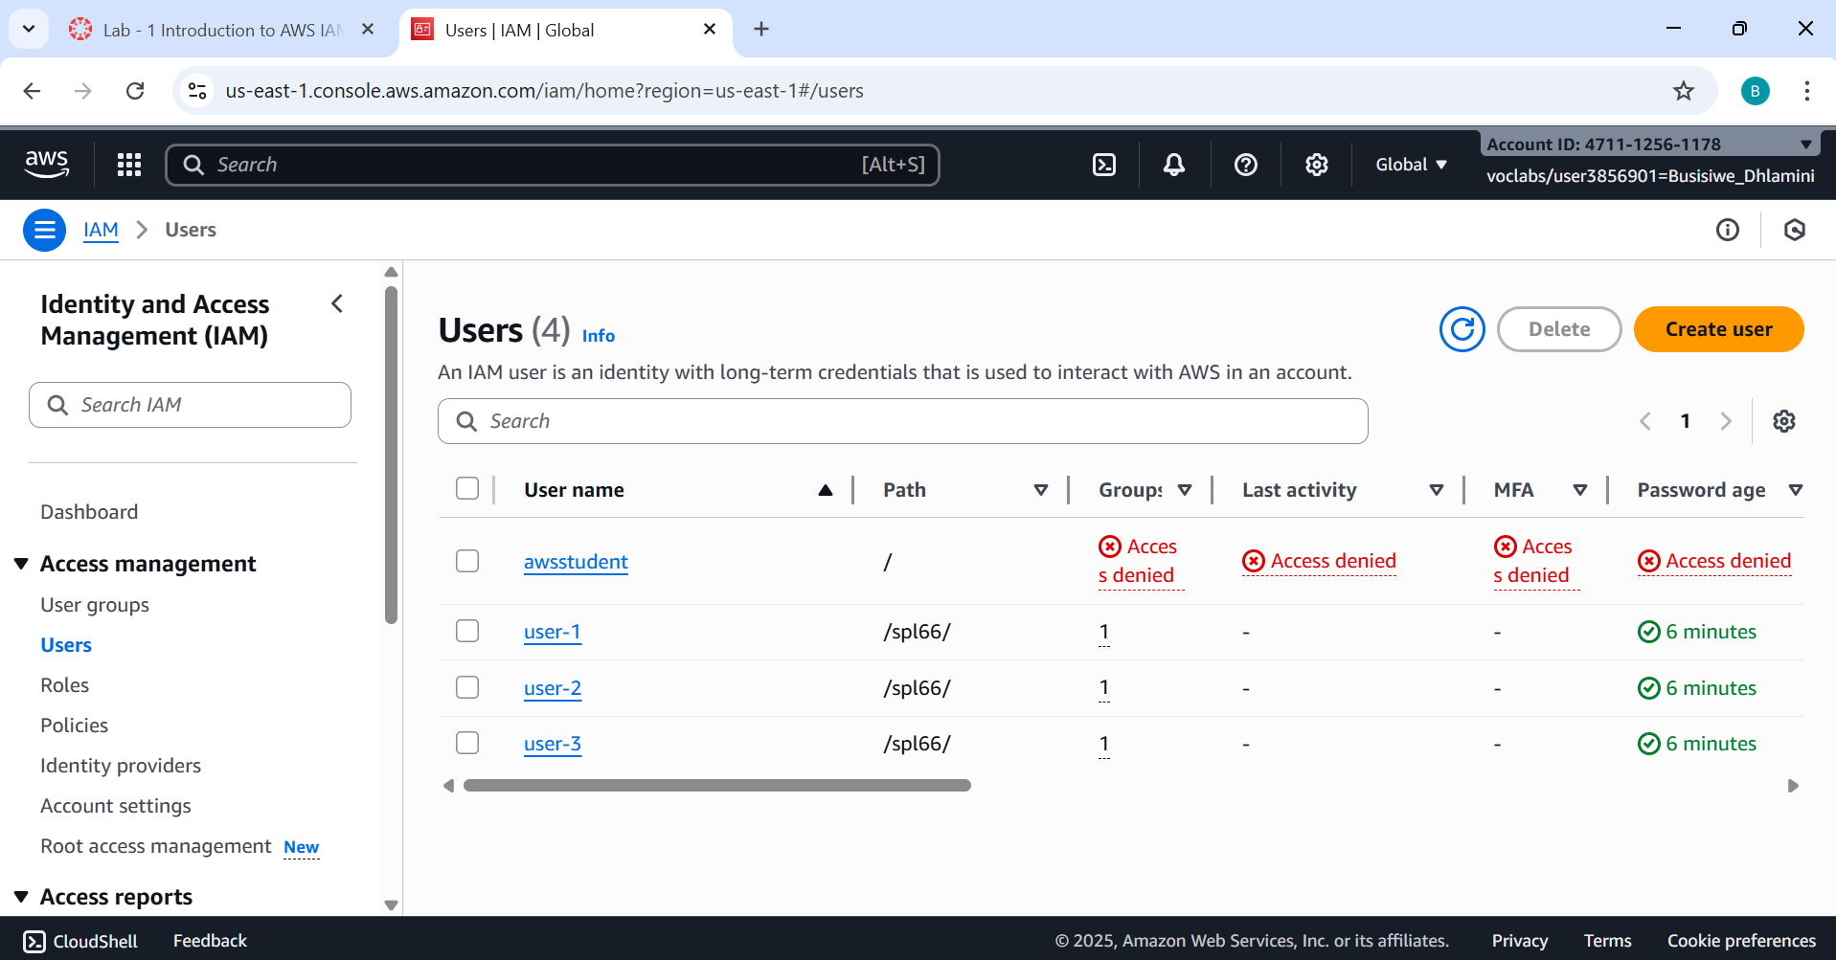

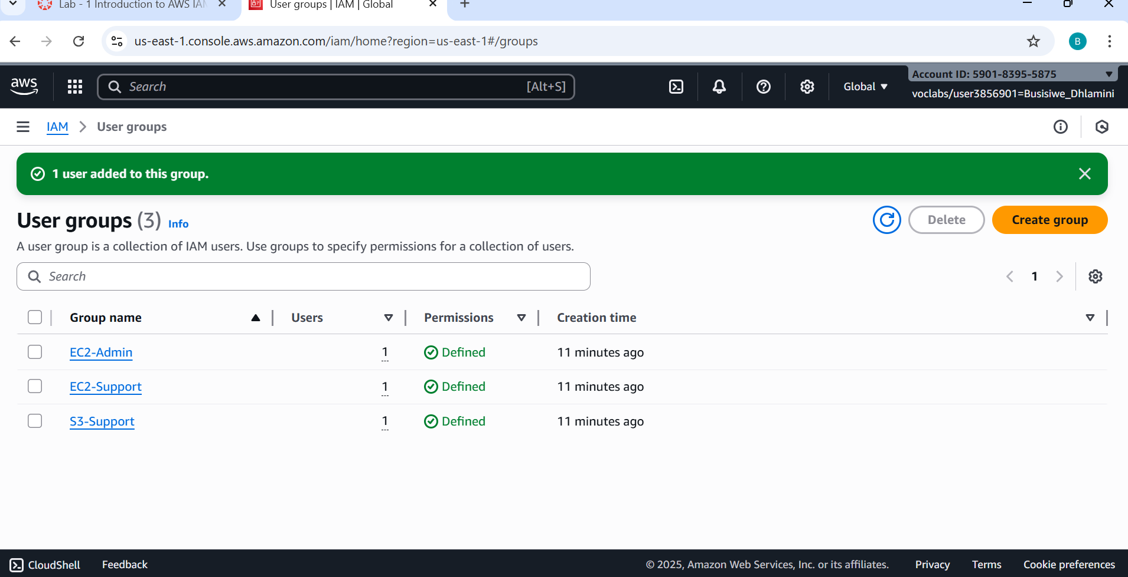

**Lab 2: Build your VPC and Launch a Web Server**

Task 1: Create your VPC

Task 2: Create Additional Subnets

Task 3: Create a VPC Security Group

Task 4: Launch a Web Server Instance

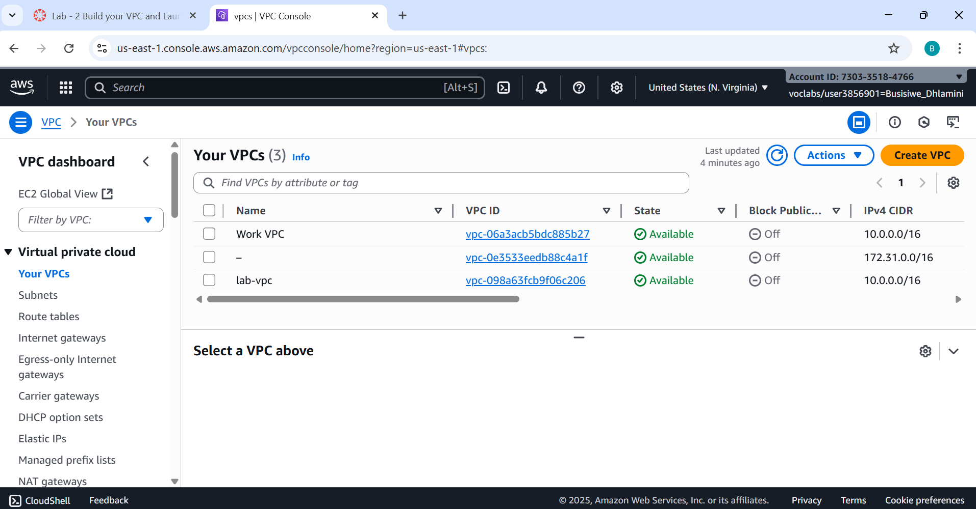

**Lab 3: Introduction to Amazon EC2**

Task 1: Launch Your Amazon EC2 Instance

Task 2: Monitor Your Instance

Task 3: Update Your Security Group & Access Your Web Server

Task 4: Resize Your Instance: Instance Type & EBS Volume

Task 5: Explore EC2 Limits

Task 6: Test Stop Protection

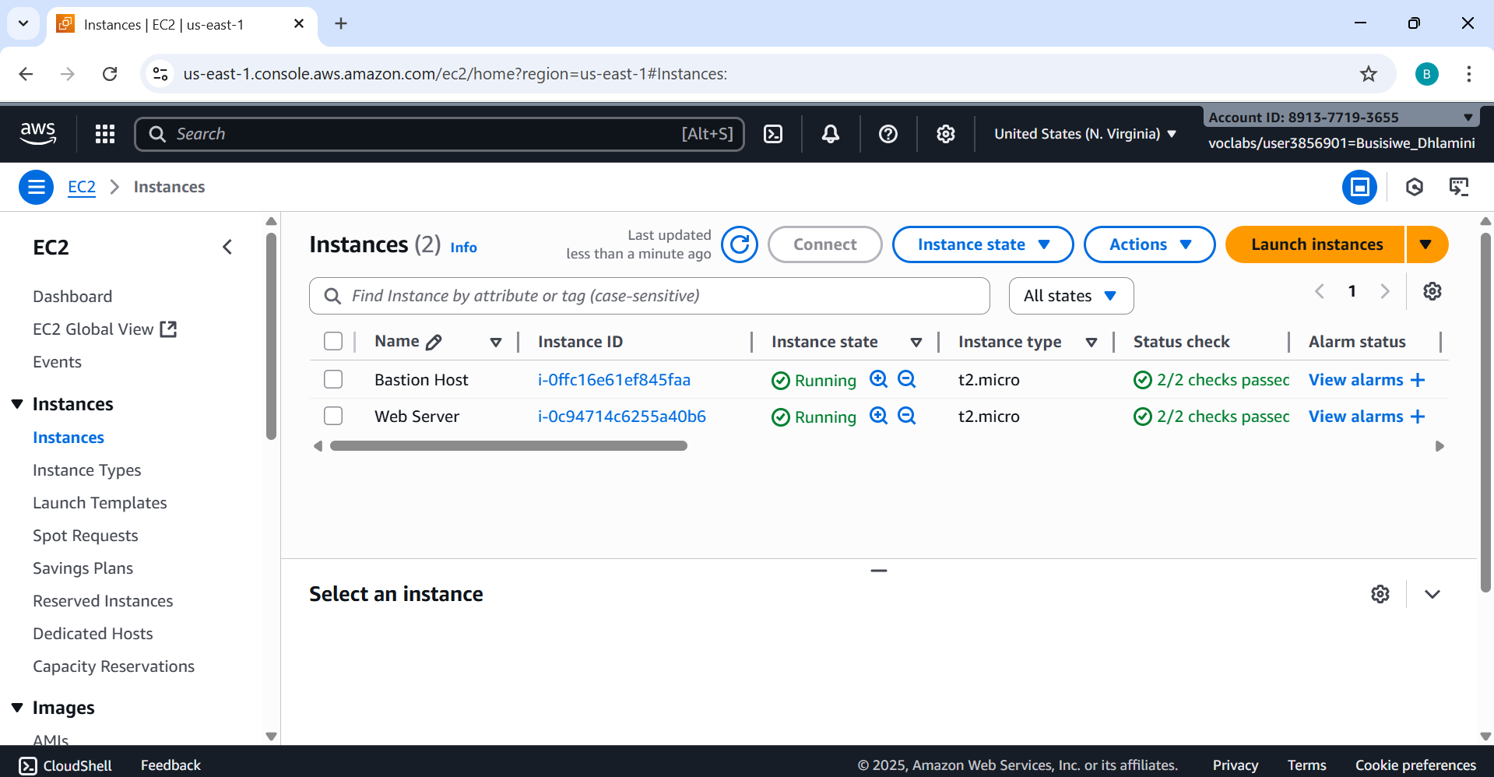

**Activity: AWS Lambda**

● Task 1: Create a lambda function

● Task 2: Configure the trigger

● Task 3: Configure the Lambda function

● Task 4: Verify that the lambda function worked

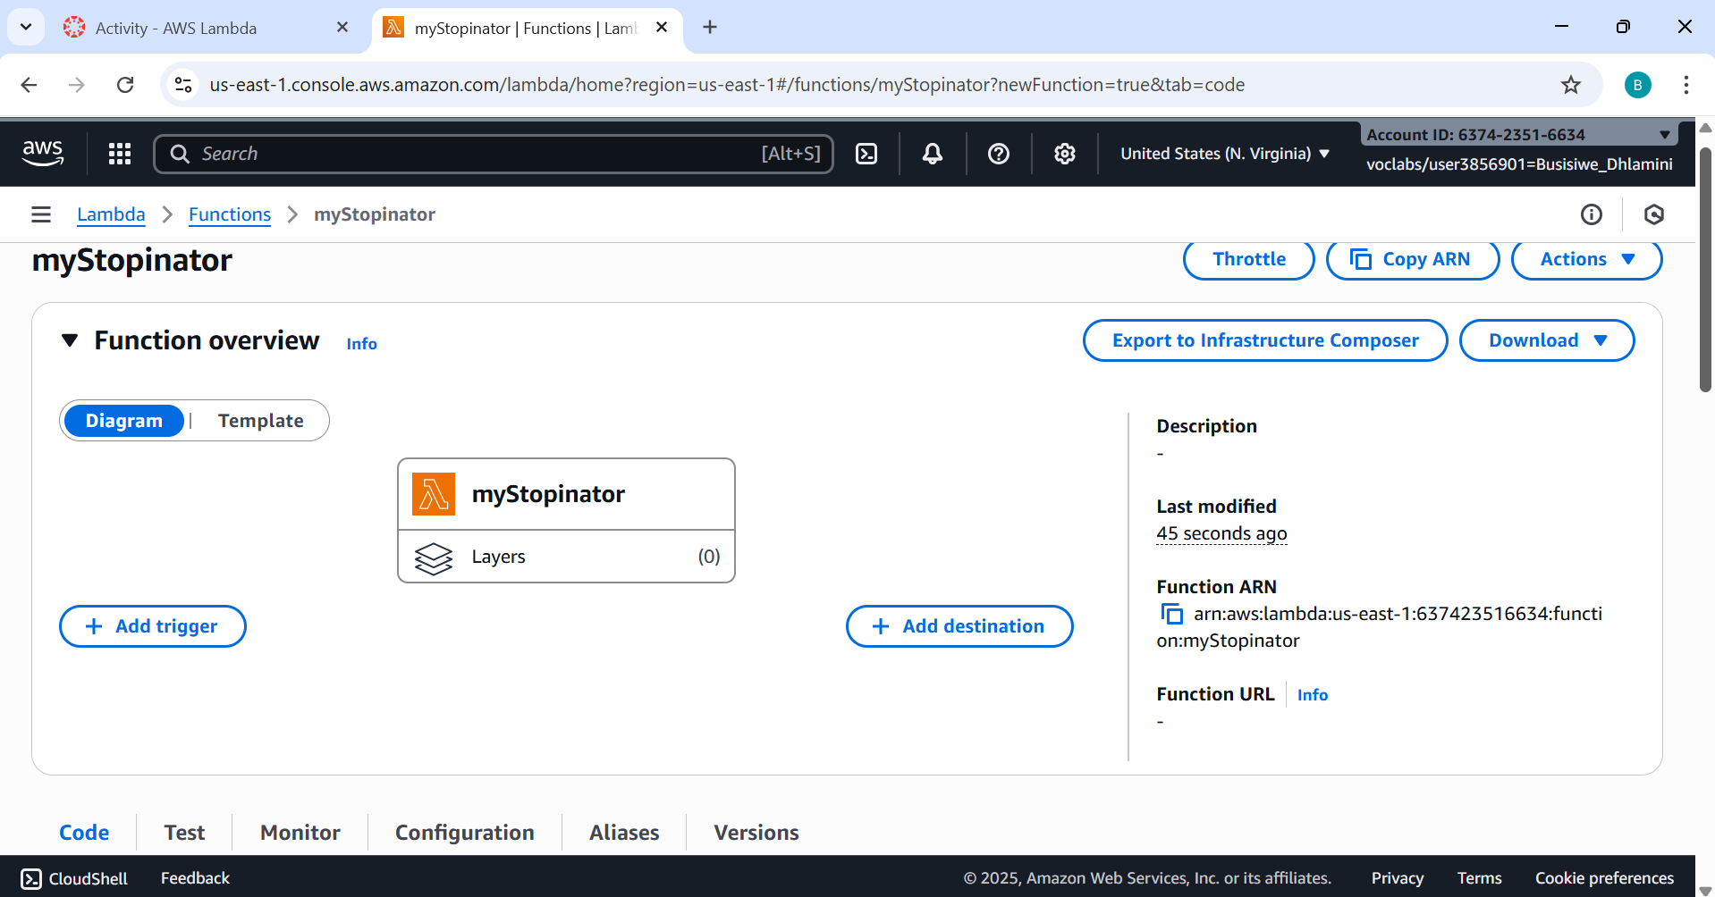

**Activity: AWS Elastic Beanstalk**

Task 1: Access the Elastic Beanstalk environment

Task 2: Deploy a sample application to Elastic Beanstalk

Task 3: Explore the AWS Resources that support your application

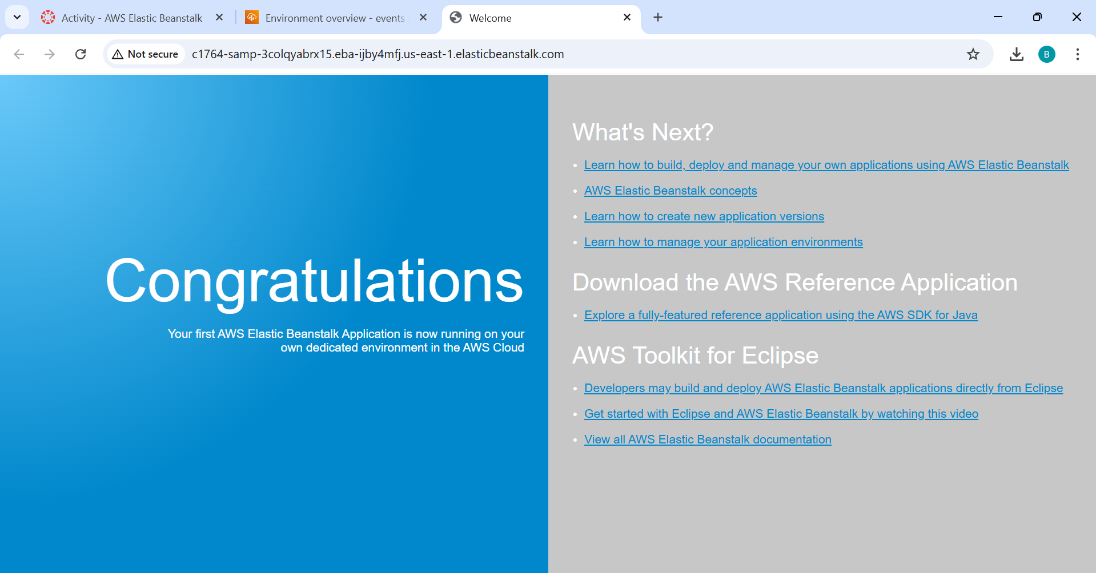

**Lab 4: Working with EBS**

Task 1: Create a New EBS Volume

Task 2: Attach the Volume to an Instance

Task 3: Connect to Your Amazon EC2 Instance

Task 4: Create & Configure Your File System

Task 5: Create the Amazon EBS Snapshot

Task 6: Restore the Amazon EBS Snapshot

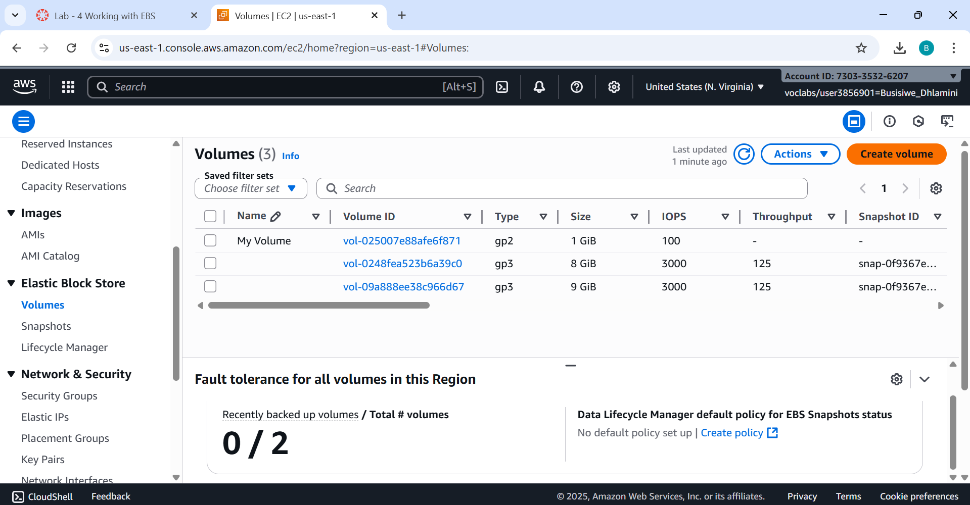

**Lab 5: Build Your DB Server and Interact with Your DB Using an App**

Task 1: Create a Security Group for the RDS DB Instance

Task 2: Create a DB Subnet Group

Task 3: Create an Amazon RDS DB Instance

Task 4: Interact with Your Database

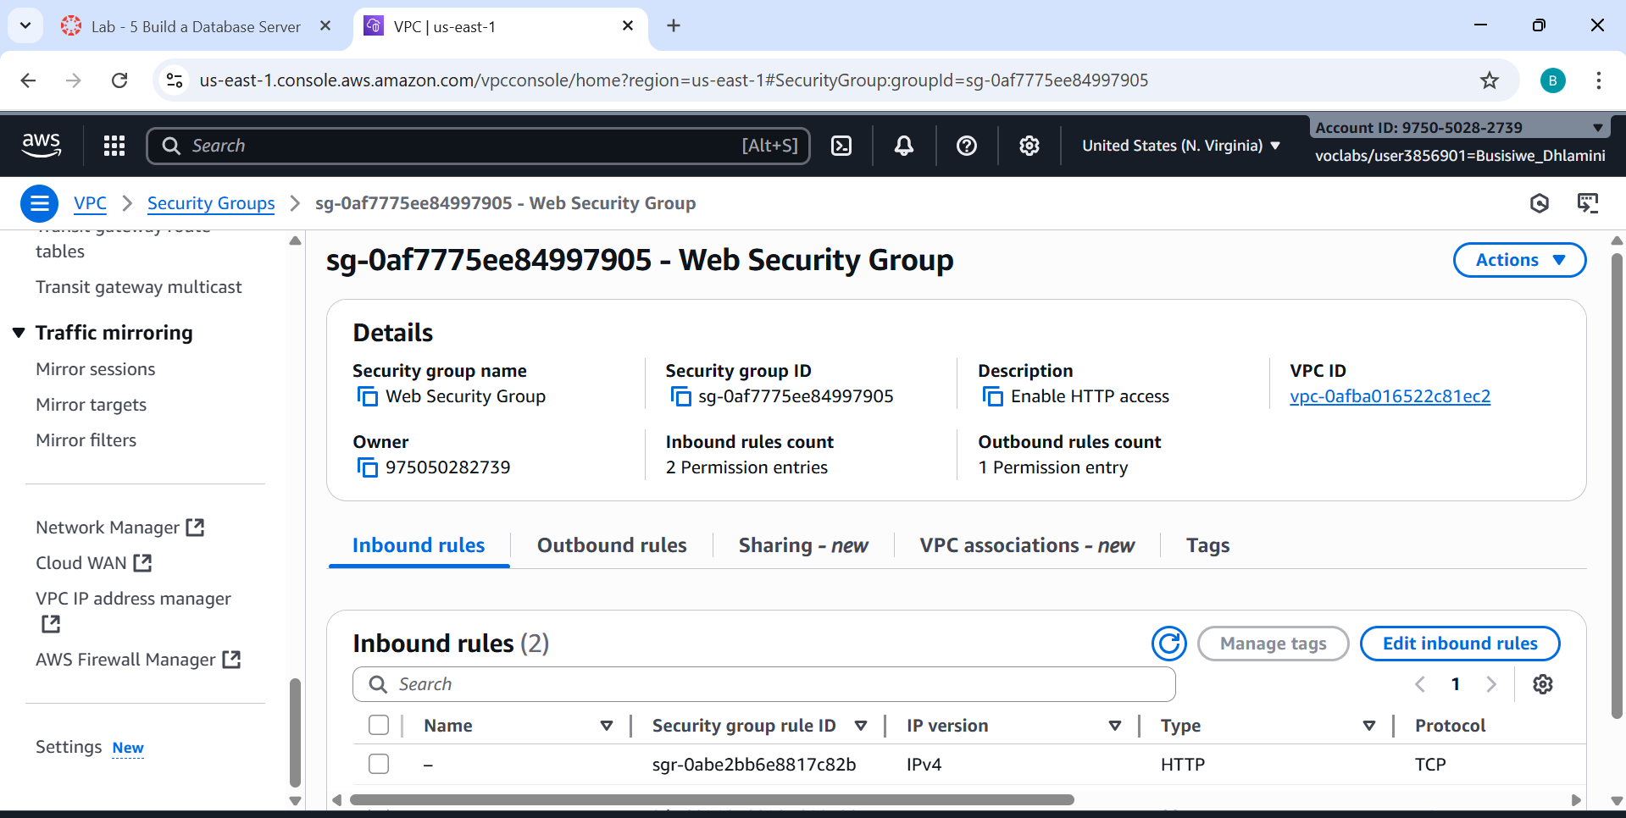

**Lab 6: Scale and Load Balance Your Architecture**

Task 1: Create an AMI for Auto Scaling

Task 2: Create a Load Balancer

Task 3: Create a Launch Template & an Auto Scaling Group

Task 4: Verify that Load Balancing is working

Task 5: Test Auto Scaling

Task 6: Terminate Web Server 1

