Network Topology Design
In the HQ(Gauteng):
- HQ hosts core services (AD DS, DNS, (File Services)
- Redundancy implemented through firewalls and routers and backup server
- The small departments are for security and easy management
The small branches:
- Firewall for redundancy and protection
- And router to route the data out of the branch to other branches
- The switch is for interconnecting all the devices 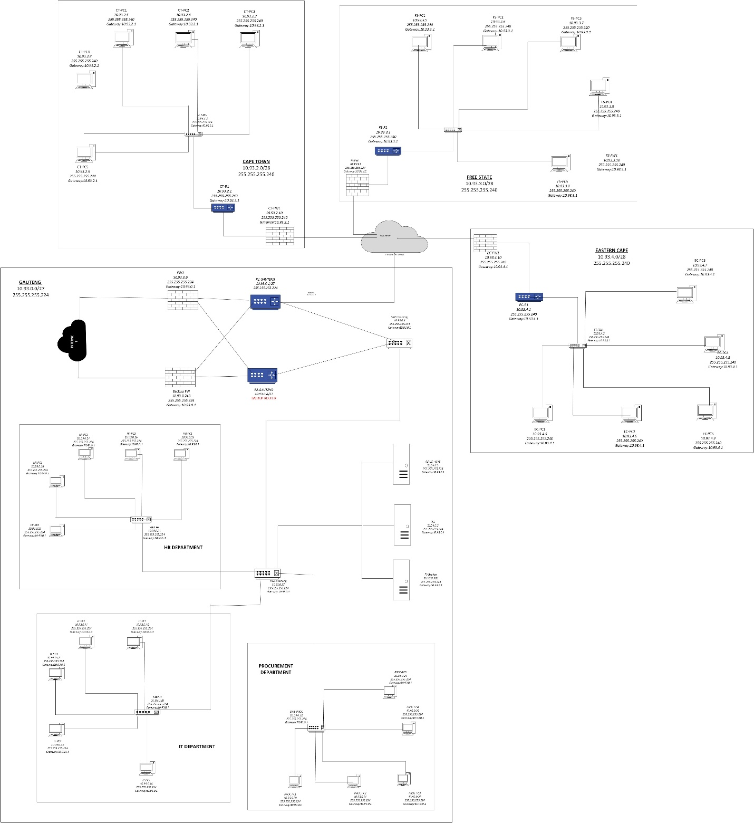

- The Head Office (Gauteng) has the main internet connection.
- Other branches connect securely to HQ using Site-to-Site VPN/WAN links
- Branches can then access:
  - Internet
  - Servers
  - Active Directory
  - Shared files
through the HQ network

Subnetting
Class A network:10.0.0.0/8
The private network that we selected: 10.93.0.0/8.
- Calculations
Head Office (Gauteng):
2^5 = 32 addresses
32-2 = 30 usable hosts
Network bits = 32 – 5= 27
Subnet mask = 255.255.255.224
Other branches (Cape Town, Free State, Eastern Cape):
Initially, the branch offices were assigned /29 but the /29 subnet was found to only accommodate the 5 practical devices and it is also too small, because the branches required additional devices.
2^4 = 16 addresses
16-2 = 14 usable hosts
Network bits = 32 – 4= 28
Subnet mask = 255.255.255.240

Location | Network | Subnet Mask | Gateway
Gauteng | 10.93.0.0/27 | 255.255.255.224 | 10.93.0.1
Cape Town | 10.93.2.0/28 | 255.255.255.240 | 10.93.2.1
Free State | 10.93.3.0/28 | 255.255.255.240 | 10.93.3.1
Eastern Cape | 10.93.4.0/28 | 255.255.255.240 | 10.93.4.1

PRACTICAL IMPLEMENTATION — GAUTENG ONLY
Virtual Machines
- Windows Server 2019
- Windows 7

STEPS
On Windows Server
Install:
- Active Directory Domain Services
- DNS Server
Add new forest: school.local
On Windows 7(Client PC)
Connect the pc to server using the domain credentials

