Death

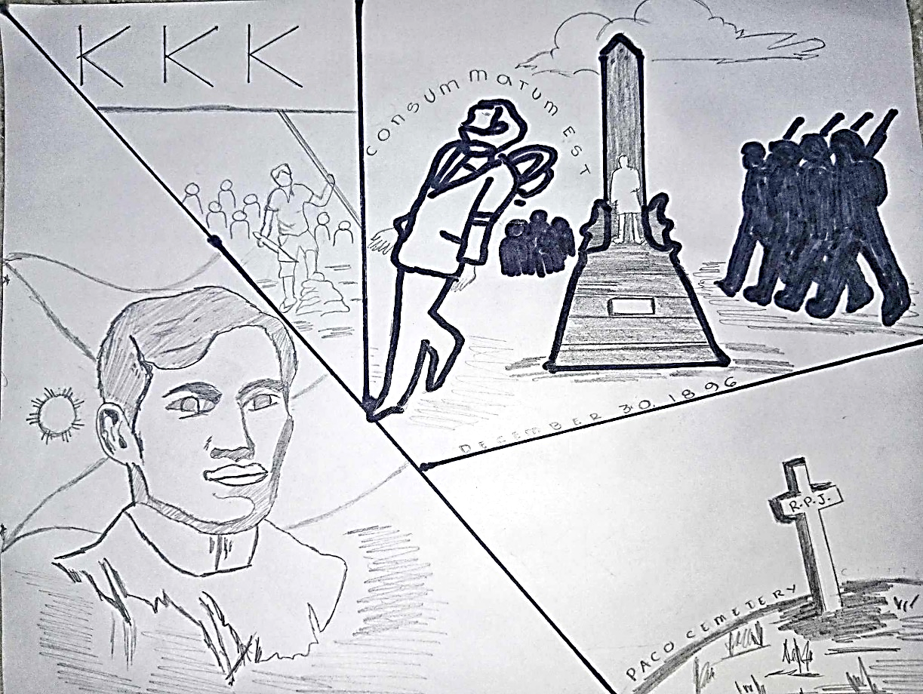

Early morning of December 30, 1896, our National Hero named Dr. Jose Rizal died for our nation. Rizal was executed in Bagumbayan Square which is now called as Luneta Park or the Rizal Park. At exactly 7:03 am Rizal shouted “Consummatum Est”. His body wasn’t surrender to his family but his sister passed to an unused cemetery and saw some civil guards and a freshly turned grave. Because of these, Narcisa realized that Rizal’s remains were buried in an unmarked grave in the nearby Paco Cemetery and plaque her brother’s initial in reverse which is the R.P.J. for Protacio Jose.

Rizal’s brutal death with the hands of spanish sparked the revolution in the country against the Spanish government which became the reason why the Kataas-taasan, Kagalang-galangang Katipunan ng mga anak na bayan (KKK) was formed. Hence, our national hero opened the eyes of our countrymen which gave them courage to fight towards the unfair treatment in the hands of the Spaniards.