Analysis

A. Data Overview & Screening
- Sample Profile: The final analysis was conducted with N=124 participants
- Data Screening: Initially, 130 responses were collected. During screening process 6 participants were excluded because they did not meet the “undergraduate student” inclusion criteria in demographic part.
- Participant Profile: All participants are undergraduate students aged 18+ who have interacted with AI at least once.
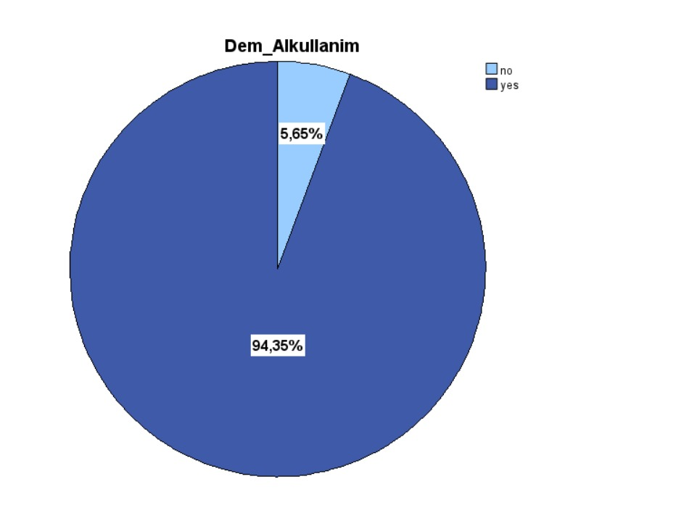
- Visual Insight: Our demographic pie charts indicate that vast majority of the final sample are active AI users and students. This ensures the data is focused on the target population.
Figure 1. Distribution of AI Interaction Experience among Participants

B. Descriptive Statistics
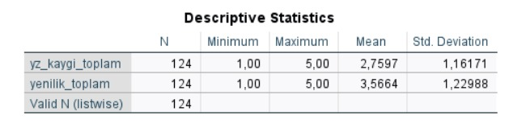
The following table summarizes the central tendencies and variability of the main research variables:
Table 1.Descriptive Statistics for AI Anxiety and Individual Innovation

C. Reliability Analysis
Scale reliability was tested to ensure internal consistency before proceeding with hypothesis testing. To ensure internal consistency, Cronbach’s Alpha was calculated for each scale:

Table 2.Reliability Coefficients (Cronbach’s Alpha) for Research Scales
 | Cronbach’s Alpha (α) | N of Items | Internal consistency
AI Anxiety Scale (DAI) | α = 0,892 | 5 | acceptable/good
Individual Innovation Scale (IC) | α = 0,984 | 12 | acceptable/good

D. Hypothesis Testing (Correlation & Regression)

1. Pearson Correlation
We examined the relationship between AI Anxiety and Individual Innovation:
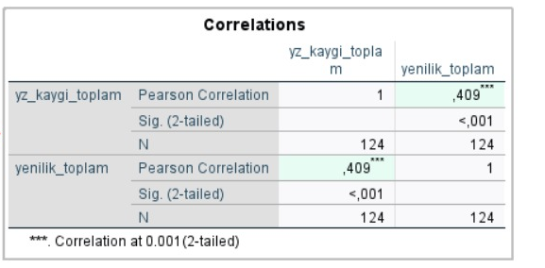
- Result: A significant positive correlation was found (r = 0.409, ρ < 0.001).
Table 3. Pearson Correlation Matrix

- Interpretation: This indicates that participants with higher AI anxiety or dependence tend to report higher levels of innovative behavior. Also the p-value ( < 0.001) confirms that this relationship is not due to chance, providing a strong basis for the subsequent regression analysis.

2. Linear Regression
Linear regression analysis was used to predict Individual Innovation based on AI Anxiety:
- Model Fit: The regression model was statistically significant ( F = 24.53, p < 0.001).
- Variance Explained ($R^{2}$): AI Anxiety explains 16.7% ($R^{2}$= 0.167) of the variance in Innovation.
- Predictive Power: The standardized coefficient ( β = 0.409, p < 0.001) confirms that AI anxiety is a significant positive predictor of innovative efforts.
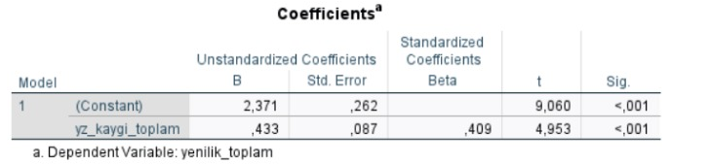
Table 4. Regression Coefficients
The R² value indicates that AI anxiety is a meaningful factor in explaining nearly 17% of the variance in how students develop new ideas and innovative solutions.
Trend Analysis: Positive Slope "The upward slope of the regression line visually illustrates that higher anxiety/dependence scores are consistently linked to higher innovation outputs among the undergraduate sample.”

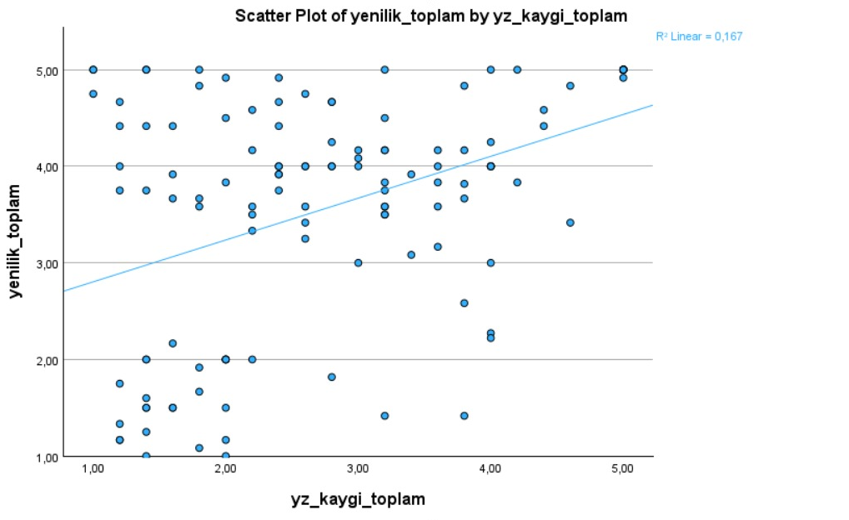
Figure 2. Scatter Plot showing the Positive Relationship between AI Anxiety and Innovation

