COEN296A HW4 Yuan-lin Hsu W1279028

This document shows the results of the homework problems, please see code directly for my modification.

1-1

Please see the jupyter notebook.

1 – 2

From left to right:

The average loss(per epoch), The testing accuracy (per epoch), The training accuracy (per batch)

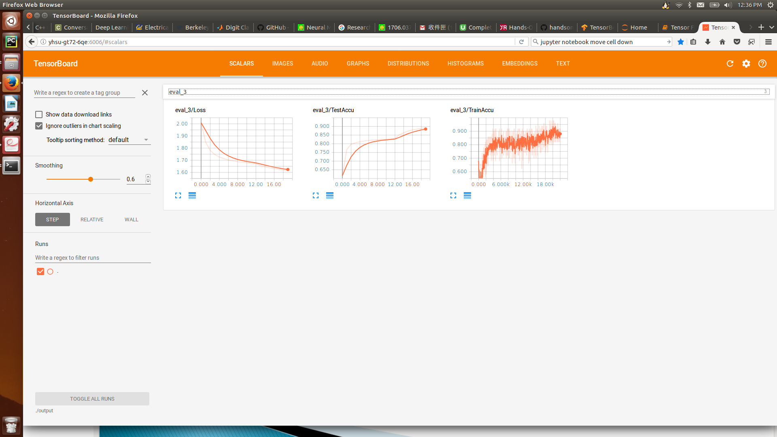

1-3

The Loss:

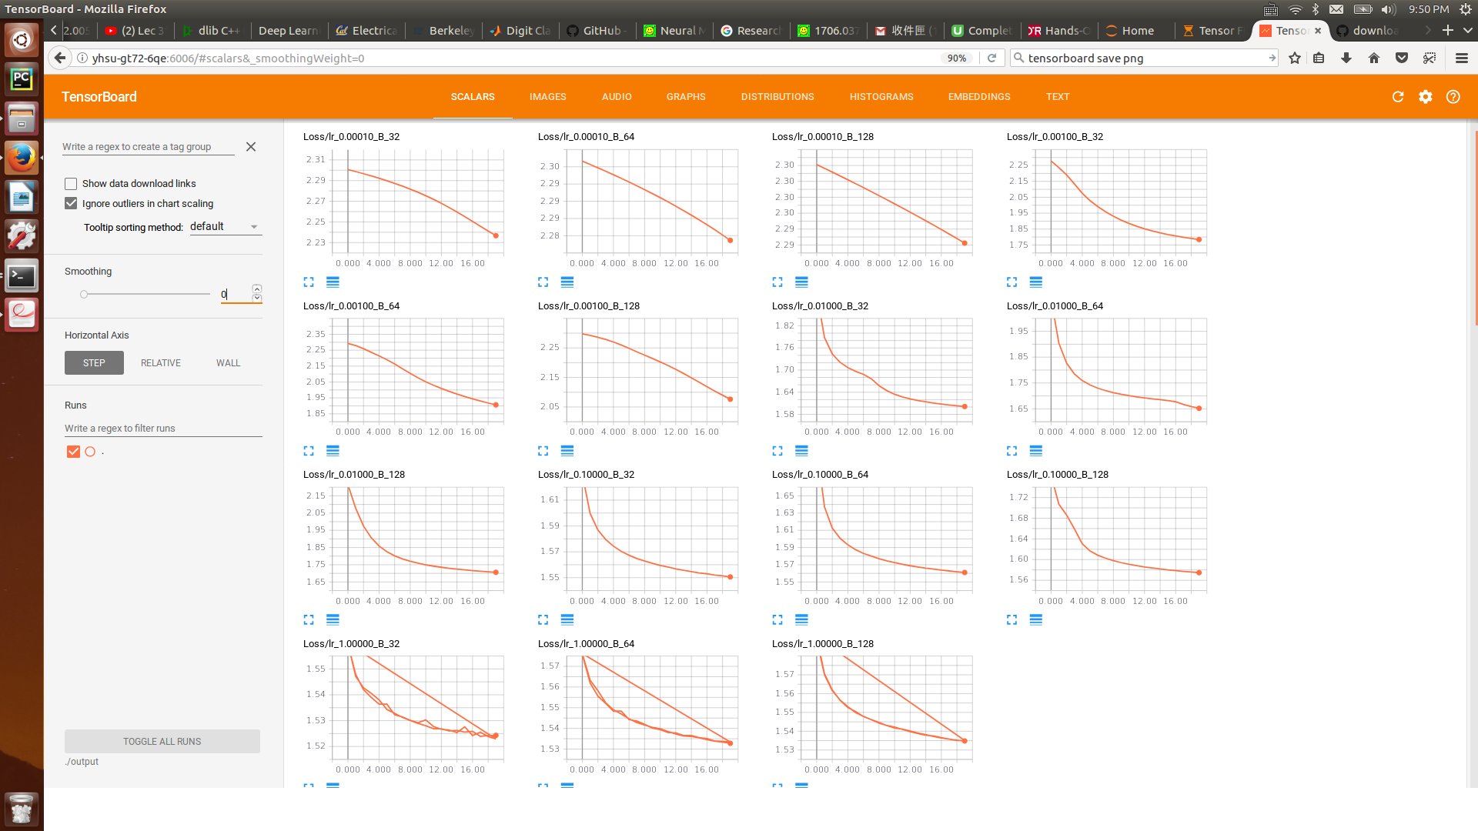

The testing accuracy:

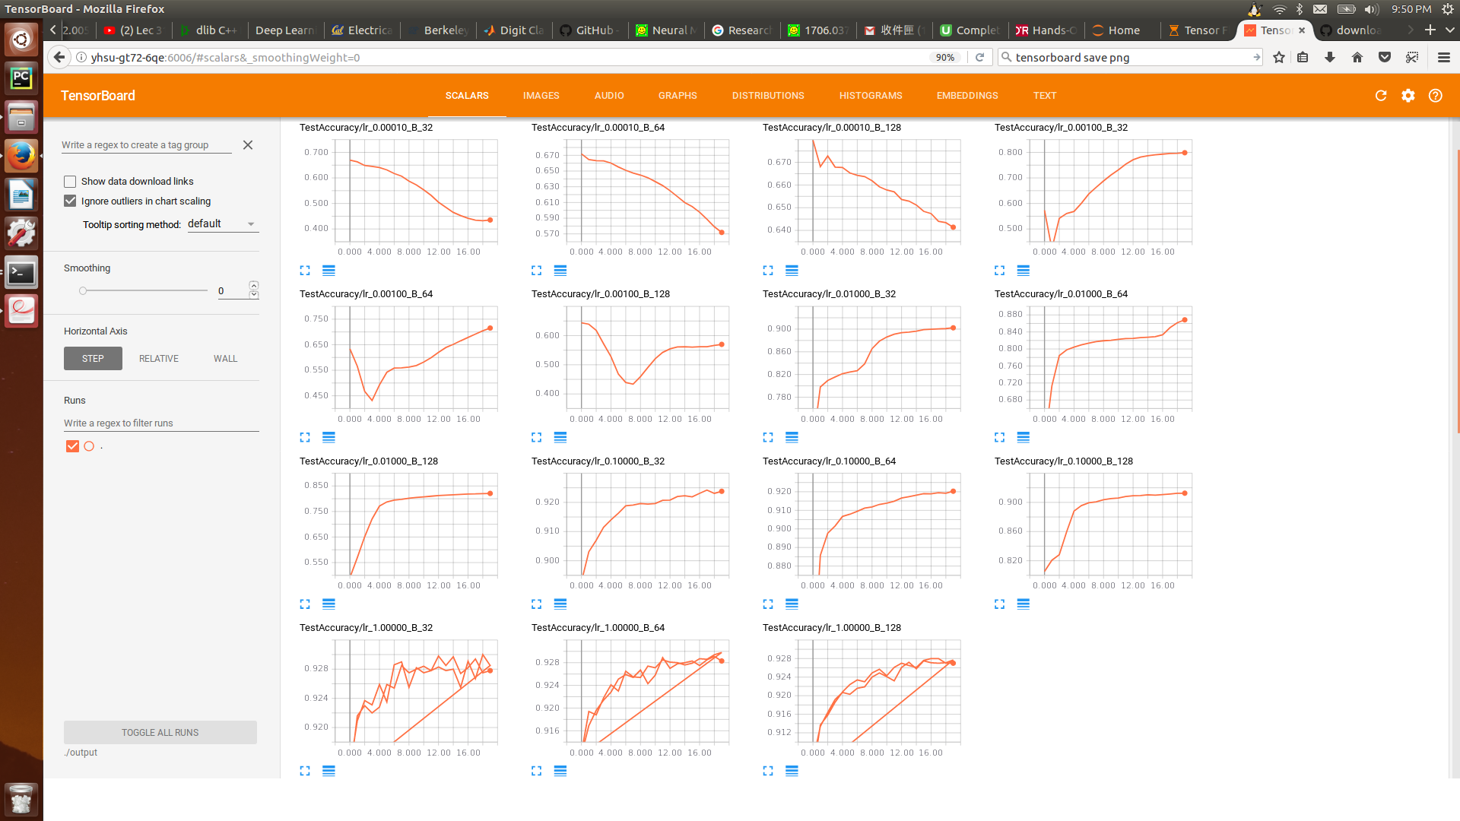

The training accuracy:

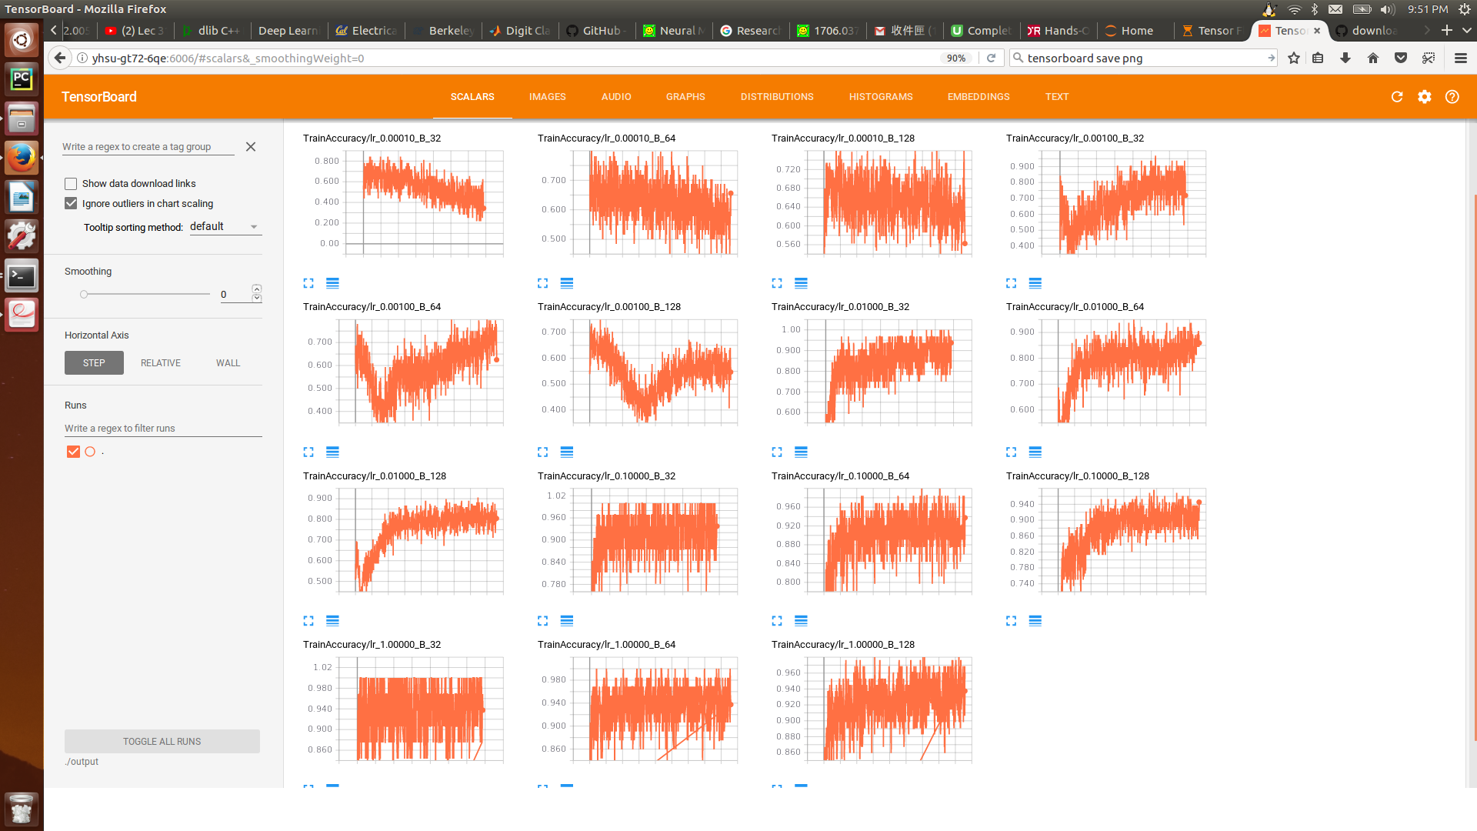

Optimal and stable hyper-parameter set: batch size = 32, learning rate = 0.1

2-1 Please see the code in jupyter notebook

2-2 Following shows the results of using 300, 600, 900 units in a single layer. It seems like all the models fit well. (around 97.8%)

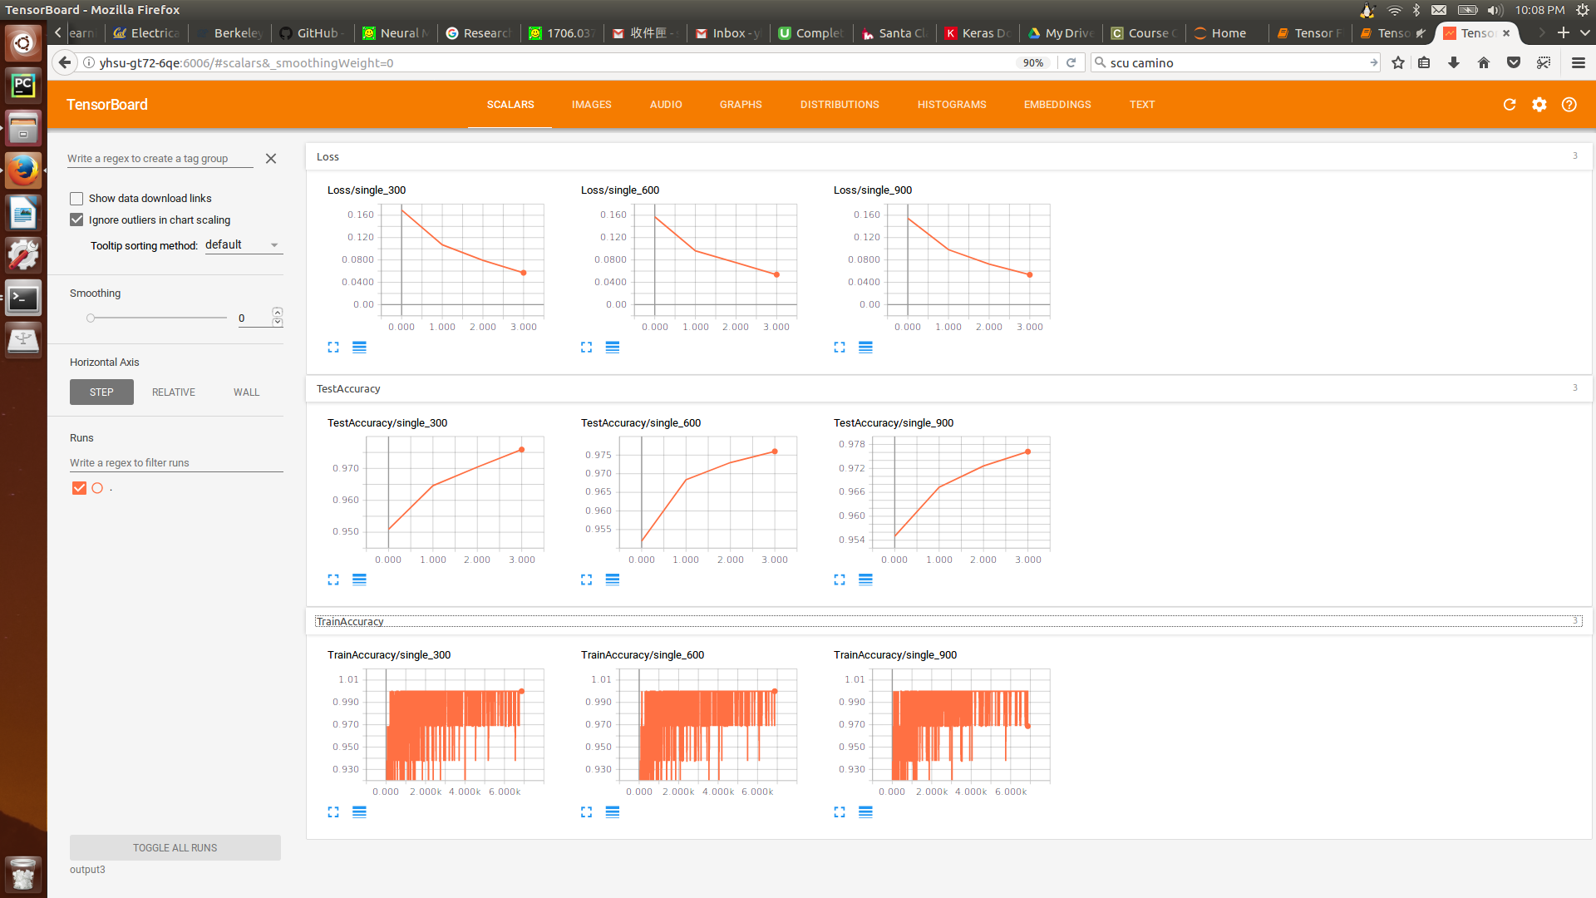

Also tested with 50, 150, 300. With 50 showing a bit decreased accuracy 96%:

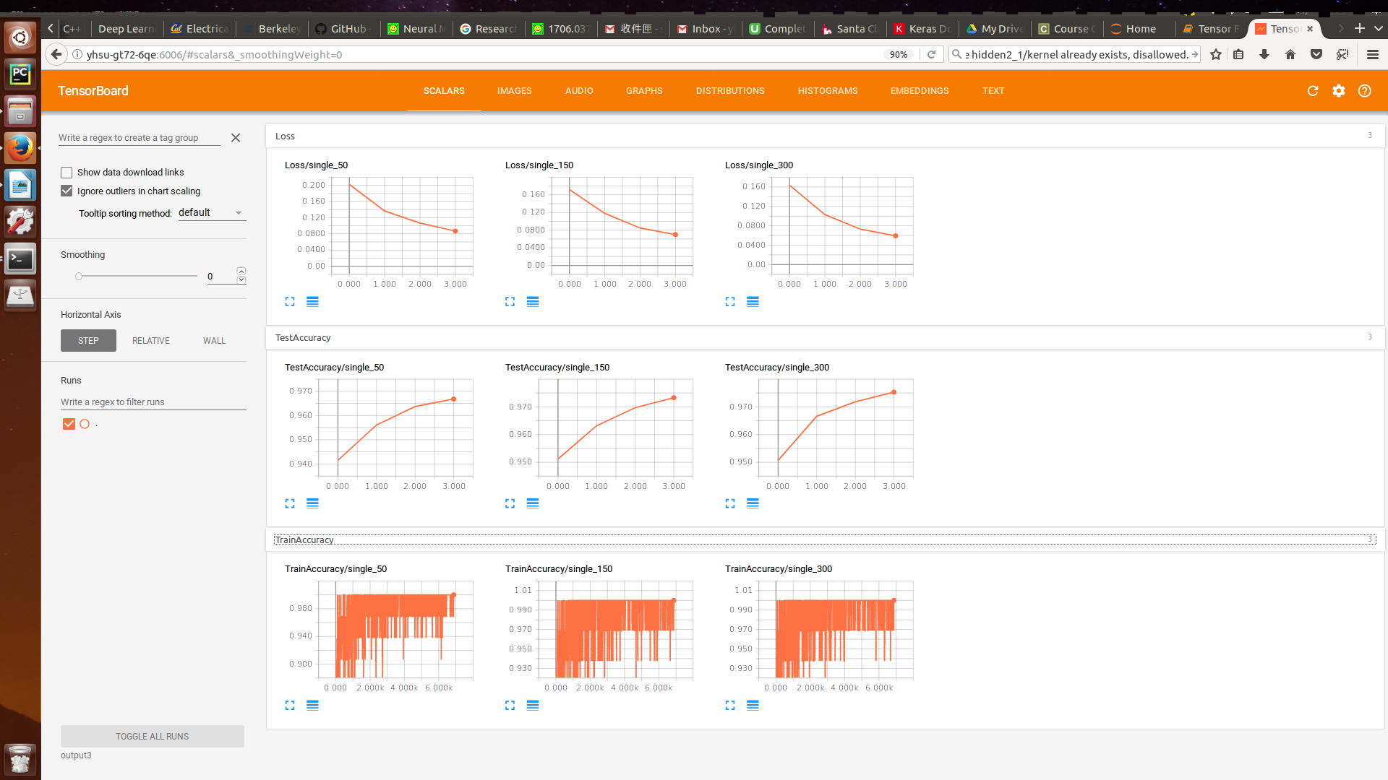

2-3 Following shows the results of using 2,3,4 hidden layer with 100 units in each layer (the titles in the figure are wrong). It seems like all the models fit well.

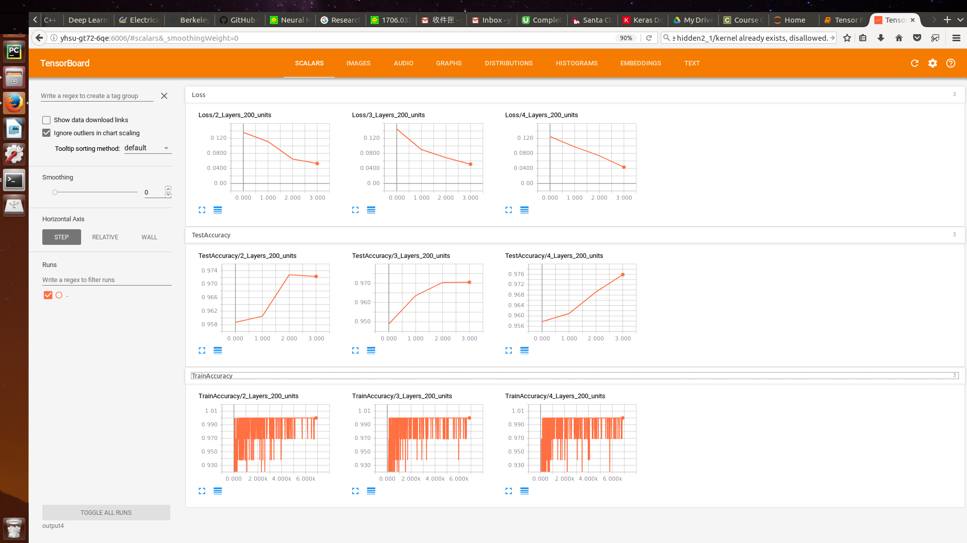

Also tested with 50 units per layer:

