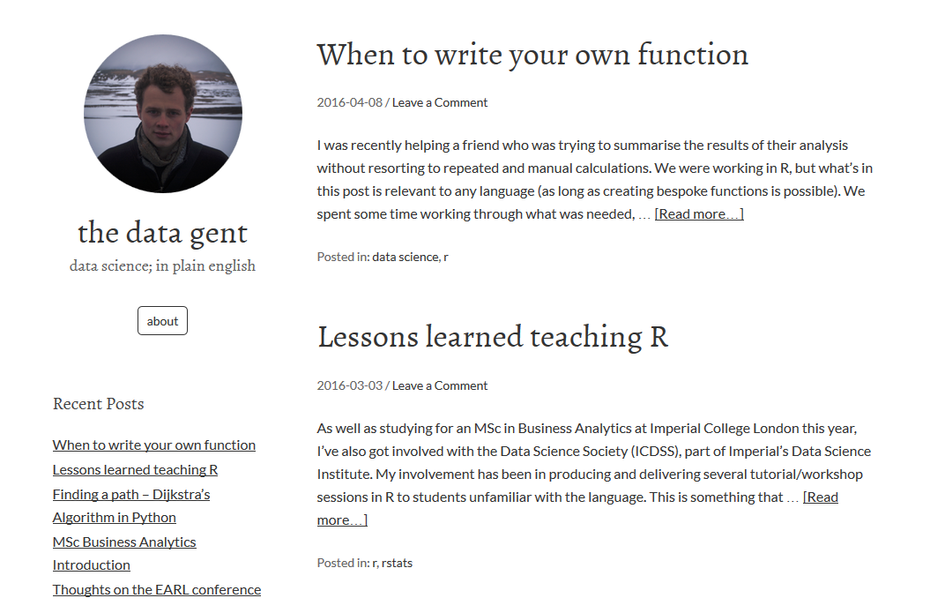Webpage ([www.thedatagent.com](http://www.thedatagent.com))

Google Analytics tracking page