**Purpose:**

**The purpose of this Software is to automate the Scanning and printing of the document of any type (Chelan, fee, etc.)**

**Starting of Software:**

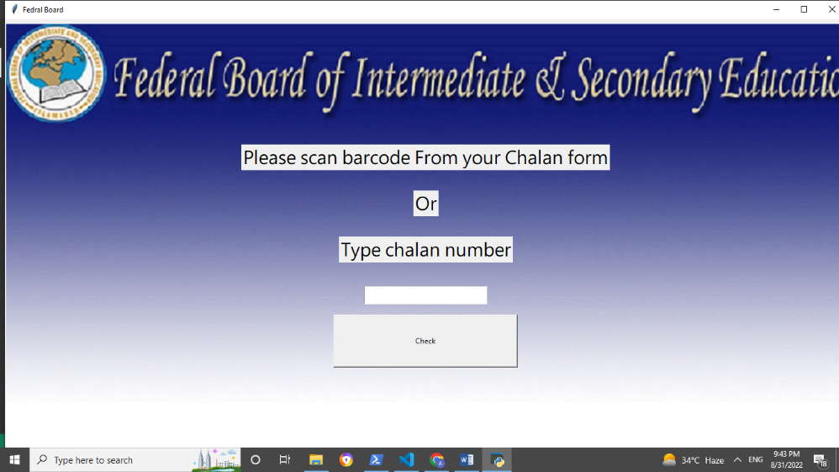

**Options:**

* **Scan your document**
* **Type Chelan number**

* **The user can scan barcode to see his document.**
* **Or user type Chelan number and press check button to see his document.**

**After Clicking Check button:**

**After Clicking check button 2 methods run**

1. **To change the screen.**
2. **To make the certificate.**

**1.** After Clicking check button first screen (Scanning Document) screen switch off and next Screen (Printing document) switch on where student will be able to print their document.

**2.** After Clicking check button it check the certificate and make a certificate by fetching all the information from the database.

**Printing of the document:**

**Working:**

On this page if the student want to print the document it can click on yes and machine can print their document. And after printing the document it can delete the file which we can print.

The page look likes:

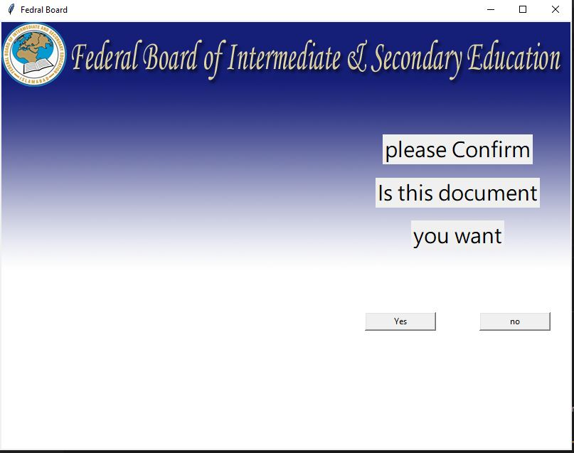

**Which Database and queries used in the software:**

**Database and tables:**

|  |  |
| --- | --- |
| **Databases** | **Tables** |
|  |  |
|  |  |
|  |  |
|  |  |

**Which queries used in the software:**

**Table and queries**

|  |  |
| --- | --- |
| **Table** | **Queries** |
|  |  |
|  |  |
|  |  |
|  |  |
|  |  |
|  |  |
|  |  |
|  |  |
|  |  |
|  |  |
|  |  |