**Quantum Computing**

**Laboratory 2**

***Tsybulko Ksenia***

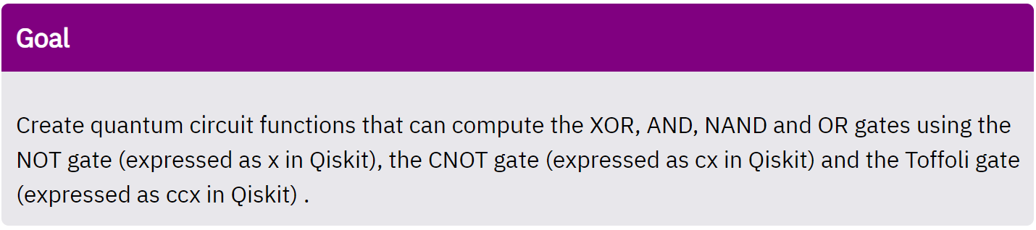

According to the goal to create logic gates we can use three base gates:

|  |  |  |
| --- | --- | --- |
| NOT | CNOT | Toffoli |
|  |  |  |
| **In Qiskit:** qc.x(gate) | **In Qiskit:** qc.cx(gate1, gate2) | **In Qiskit:** qc.cxx(gate1, gate2, gate3) |

1. ***XOR function***

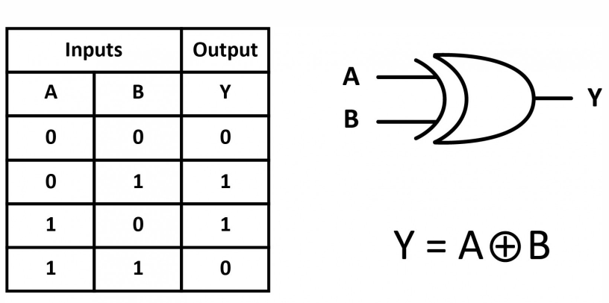

So, we can see that it is usual CNOT qiskit operation, and we just use qc.cx(…).

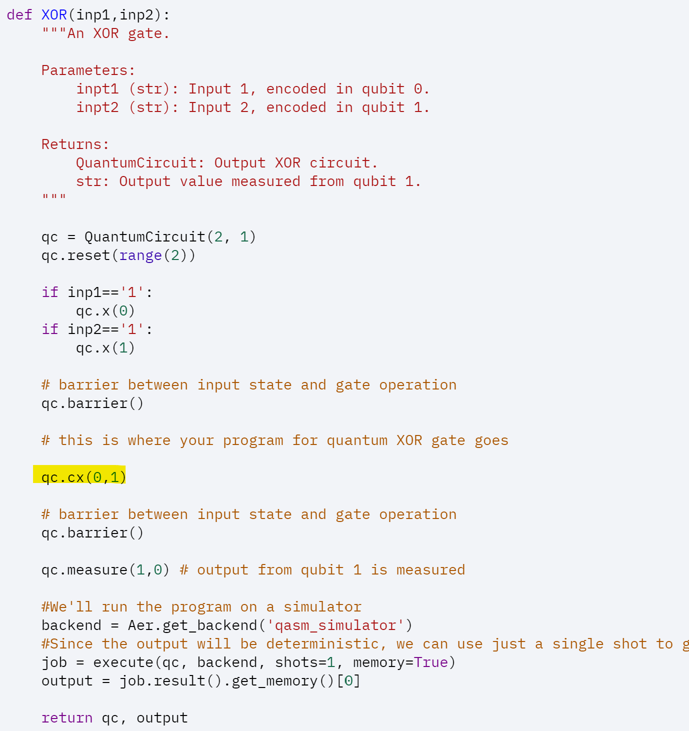

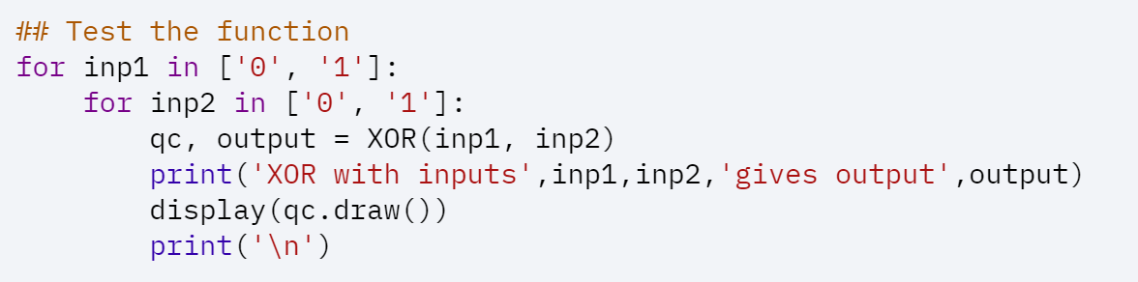

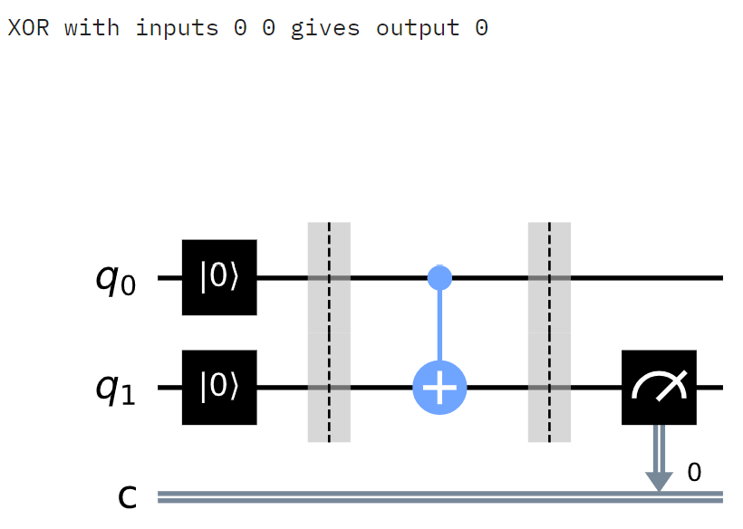

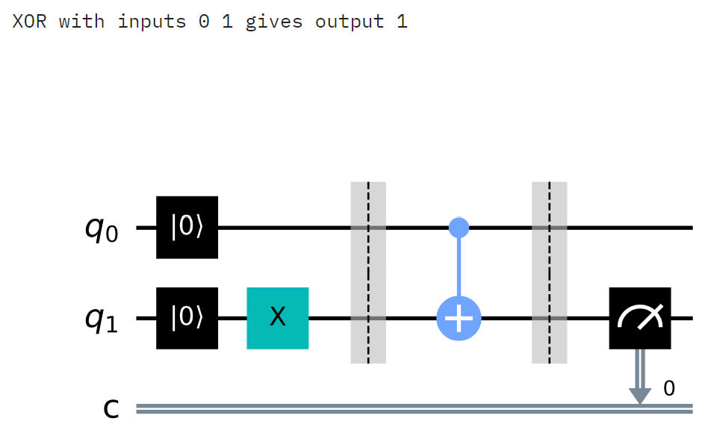

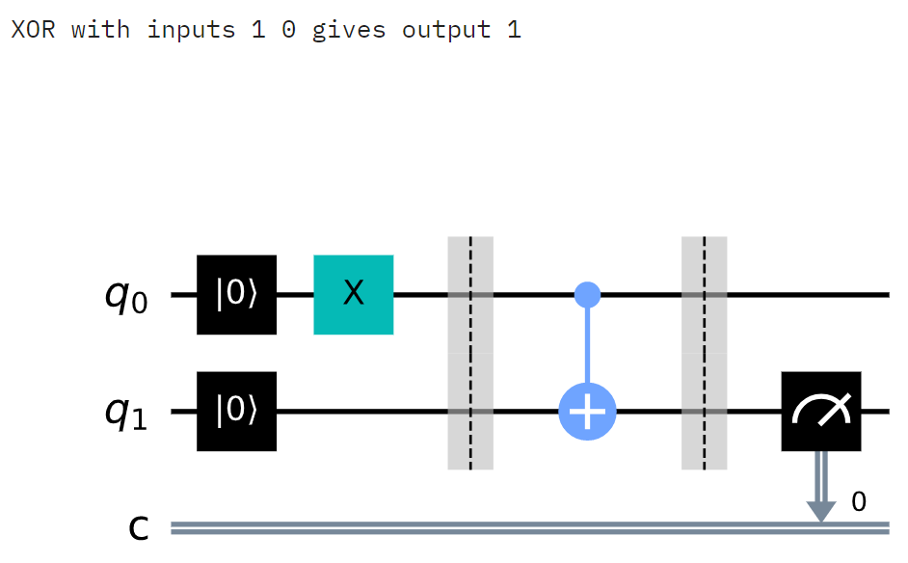

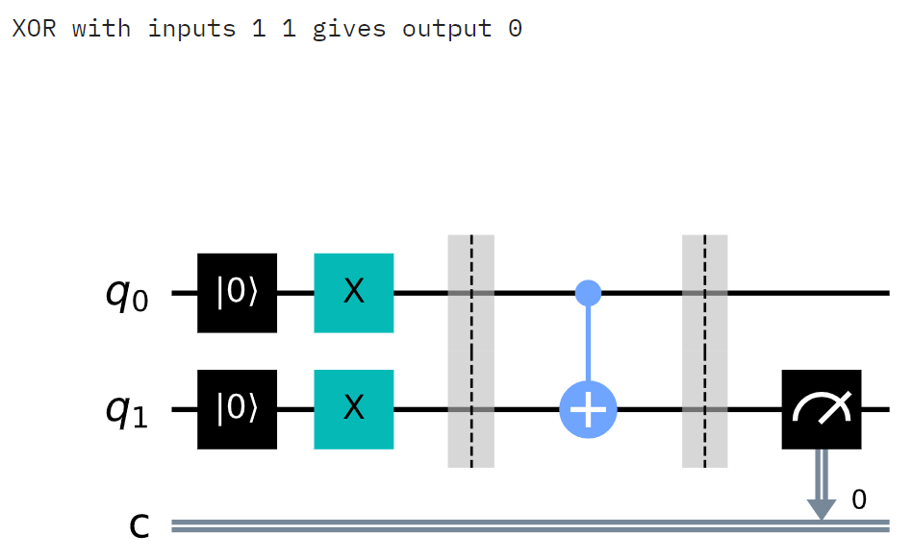

1. ***AND function***

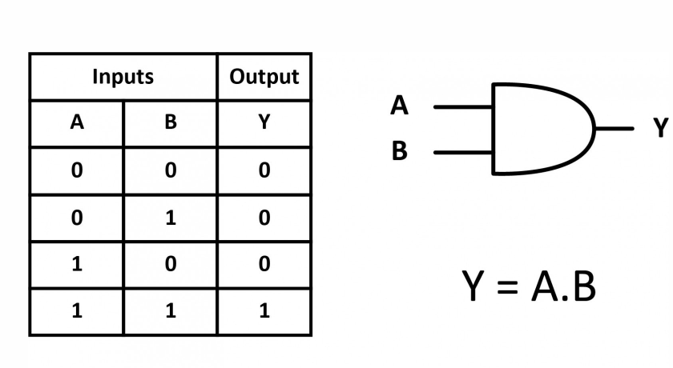

So, we can see that it is usual CNOT qiskit operation, and we just use qc.ccx(…).

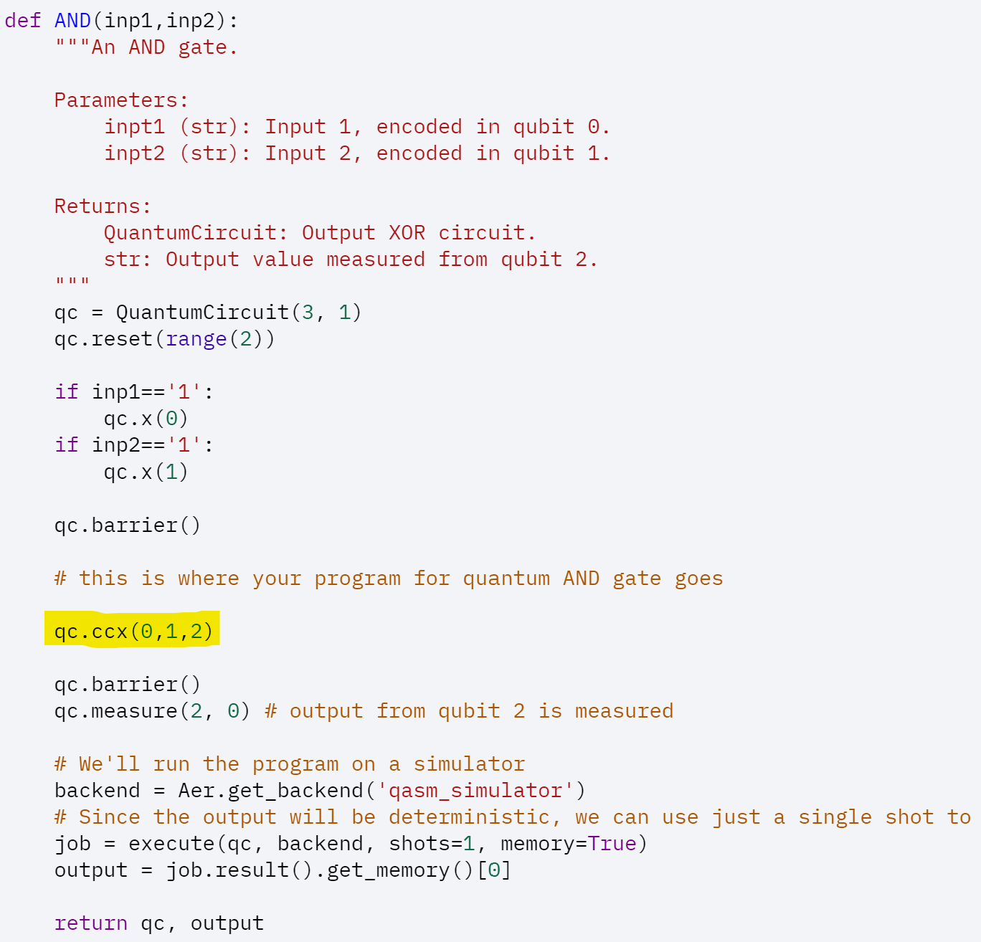

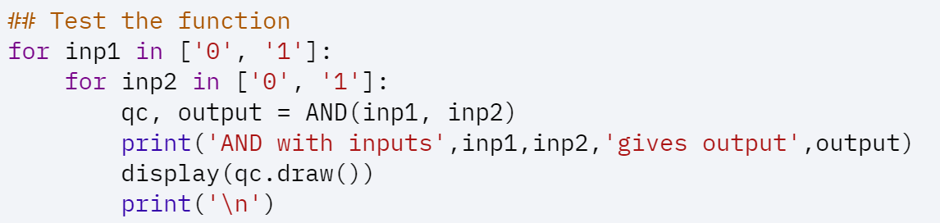

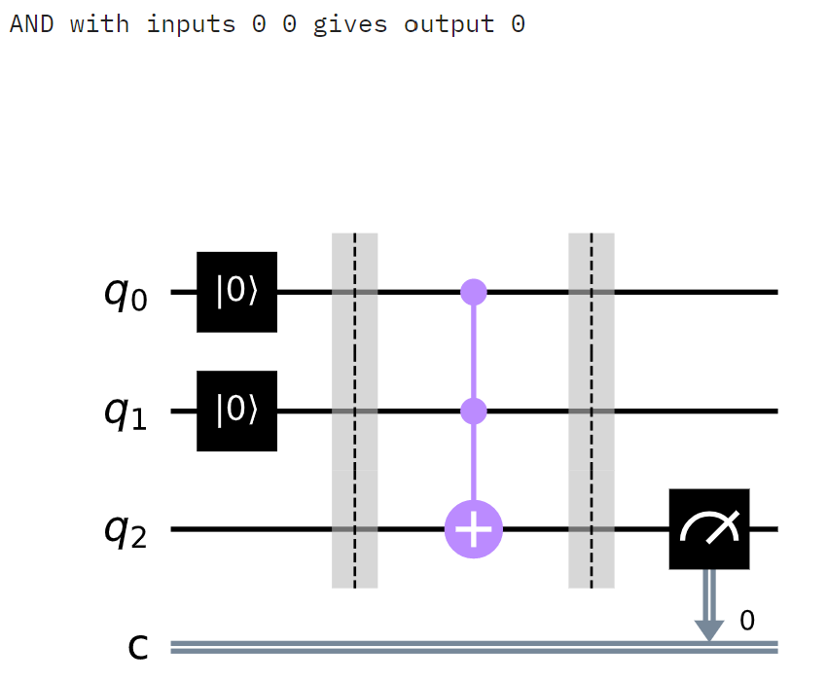

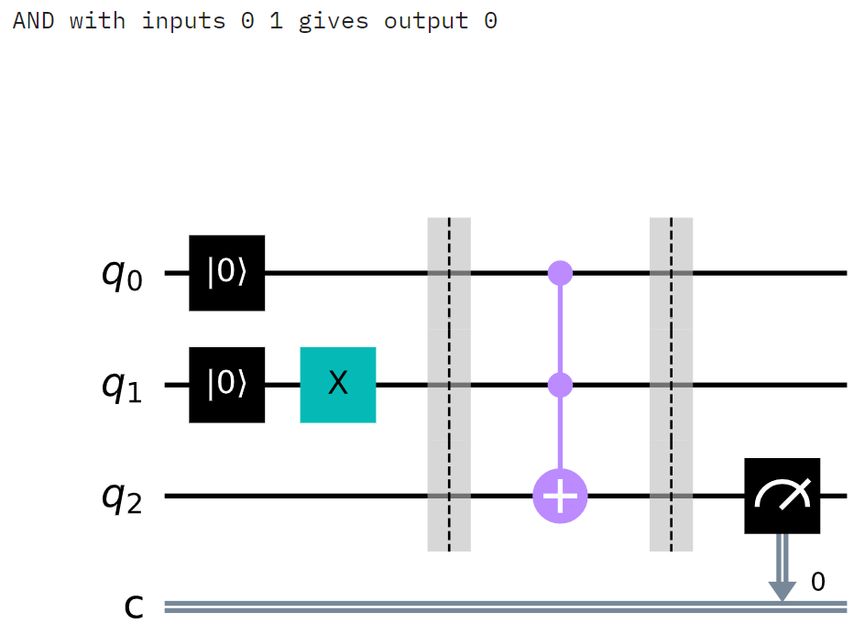

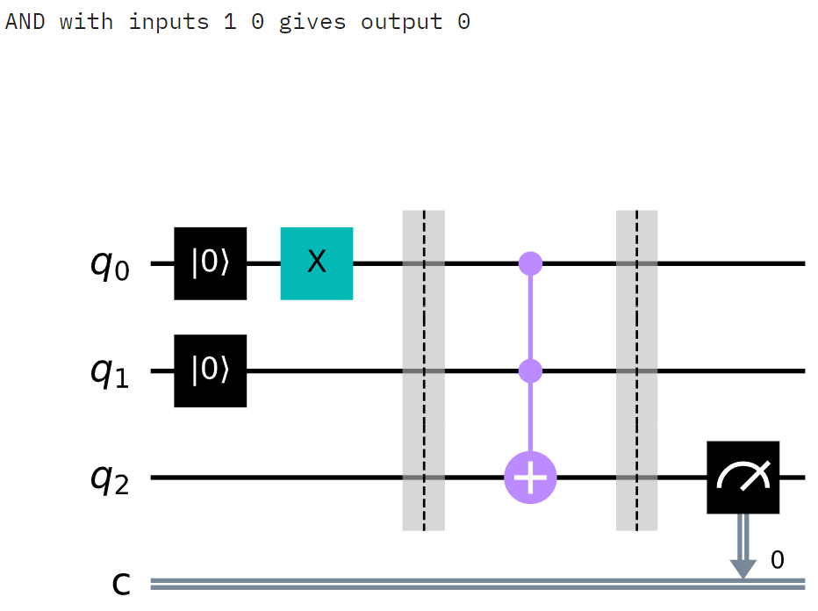

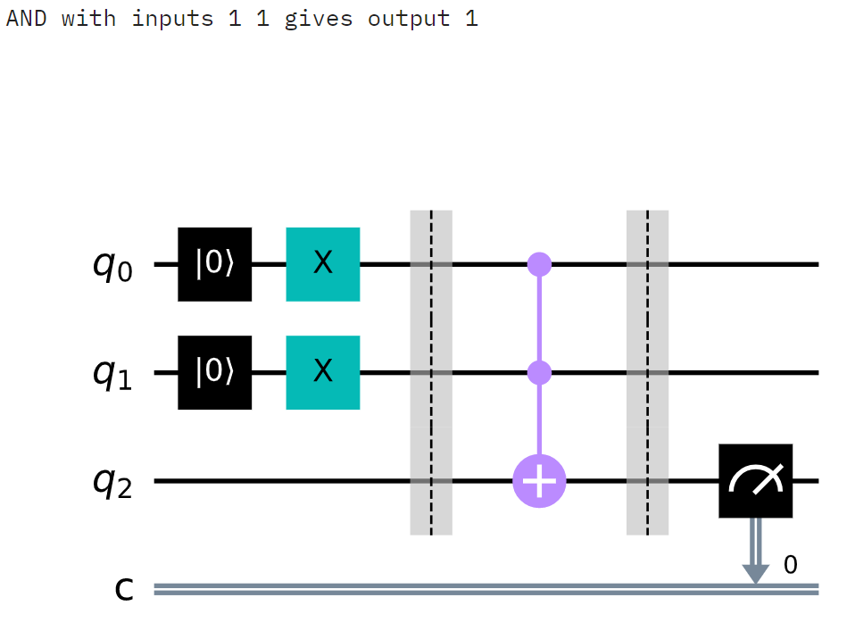

1. ***NAND function***

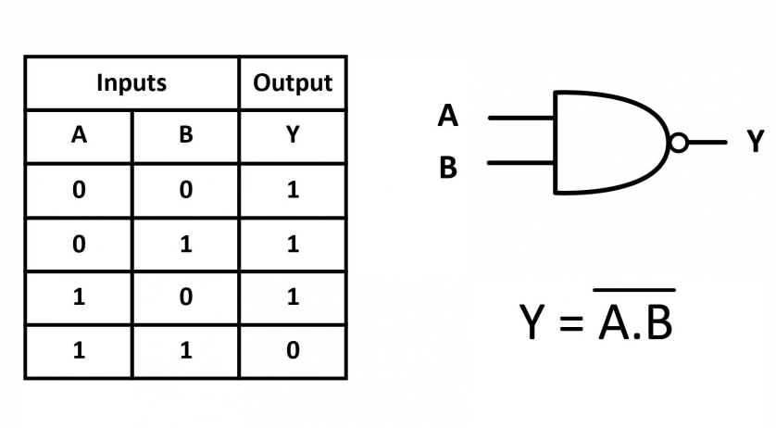

If we look at table of operation AND(Toffoli gate), we can see that to get NAND result we need just to make NOT operation with AND output. So, this function is combination of qc.ccx(…) and qc.x(…).

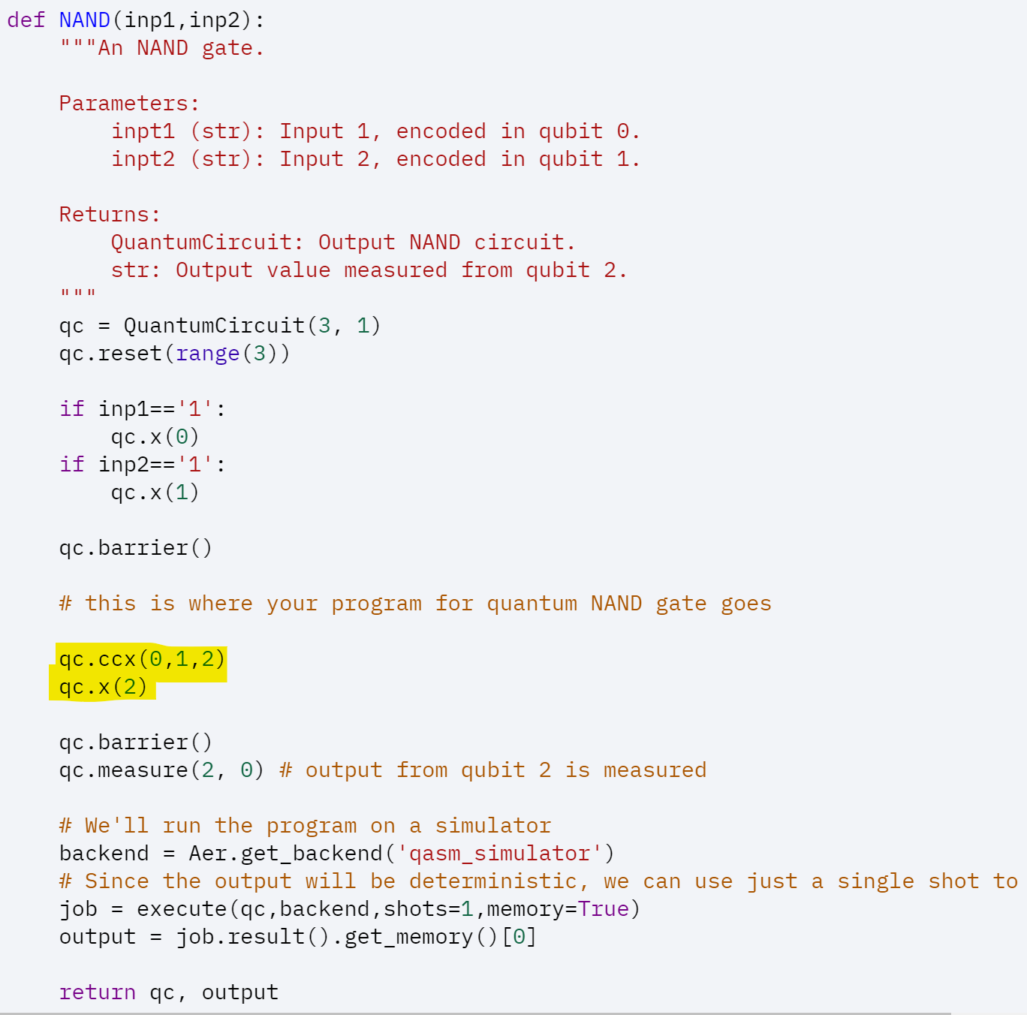

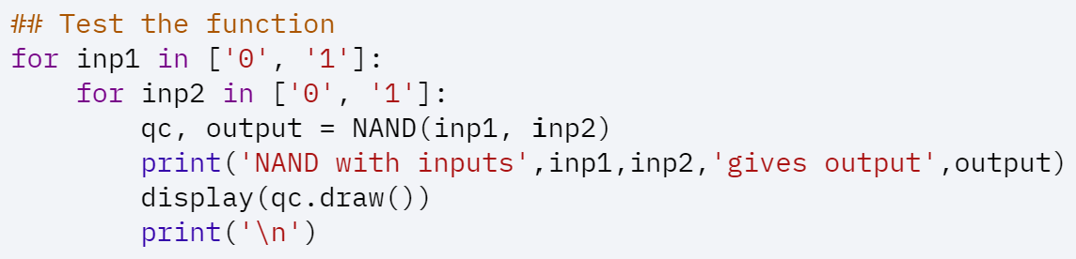

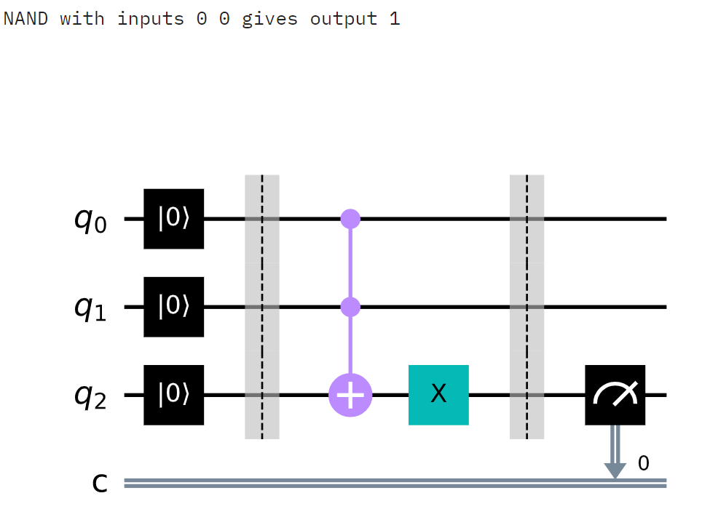

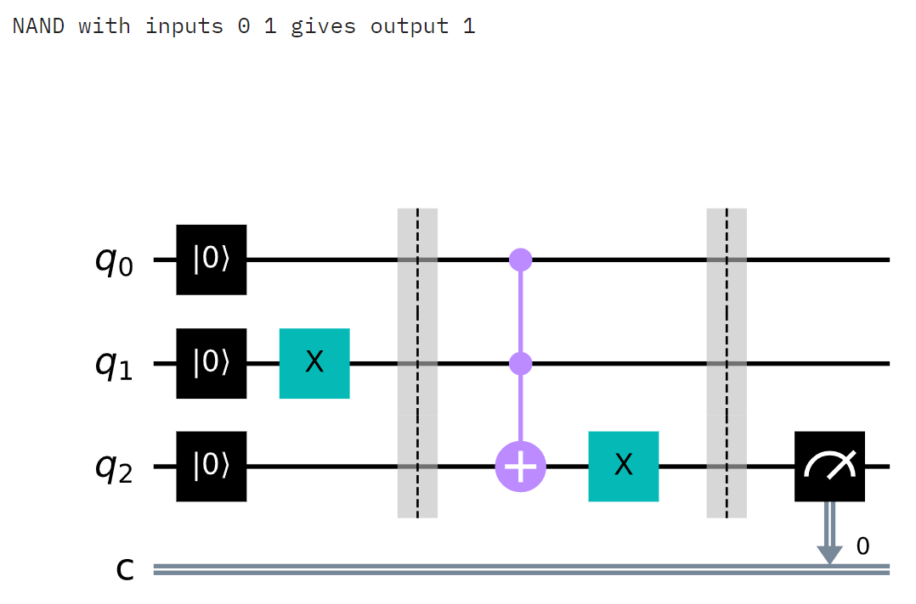

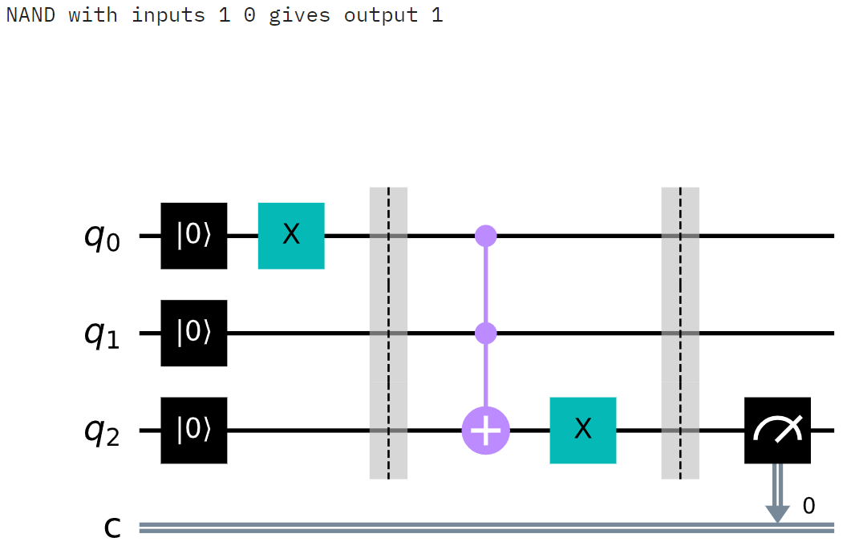

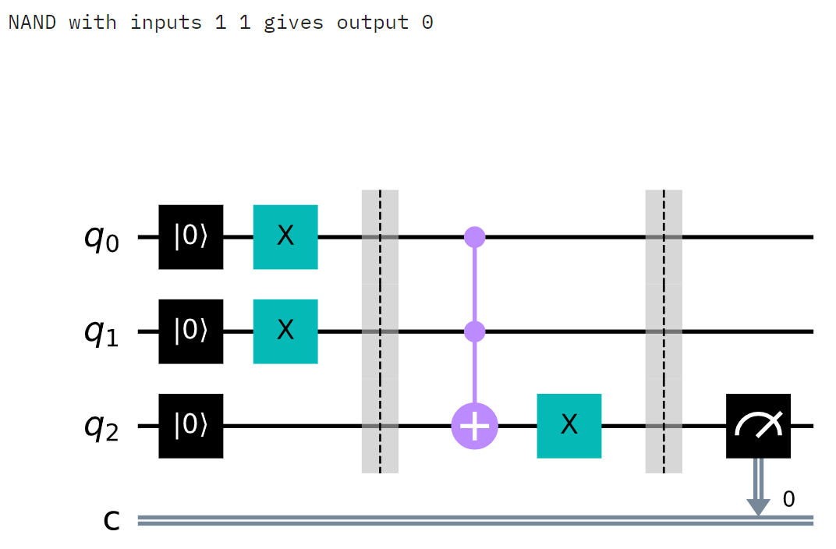

1. ***OR function***

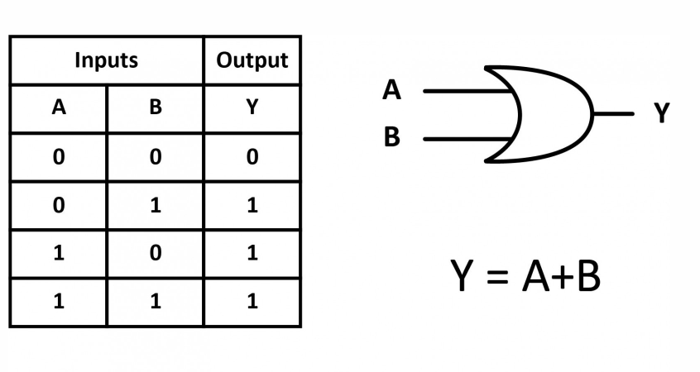

If look at NAND operation table, we can see that to get OR result we need to revert A and B inputs. So, it is needed to use first two qc.x(..) operations and then all operations for NAND.

