1 When written in standard form, the product of and is
1)
2)
3)
4)

2 Which trinomial is equivalent to ?
1)
2)
3)
4)

3 What is the product of and ?
1)
2)
3)
4)

4 When is subtracted from , the result is
1)
2)
3)
4)

5 Which expression is not equivalent to ?
1)
2)
3)
4)

6 Fred is given a rectangular piece of paper. If the length of Fred's piece of paper is represented by and the width is represented by , then the paper has a total area represented by
1)
2)
3)
4)

7 The length, width, and height of a rectangular box are represented by , , and , respectively. When the volume is expressed as a polynomial in standard form, what is the coefficient of the 2nd term?
1)
2) | 13
3)
4) | 26

8 Express the product of and in standard form.

9 Write the expression as a polynomial in standard form.

10 If the difference is multiplied by , what is the result, written in standard form?

11 Express 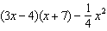 as a trinomial in standard form.
1 ANS: 2
(d) is the product, but not written in standard form.

REF: 062108ai

2 ANS: 4

REF: 081524ai

3 ANS: 3

REF: 081612ai

4 ANS: 3

REF: 011610ai

5 ANS: 2

REF: 012016ai

6 ANS: 2 REF: 011510ai

7 ANS: 3

REF: 081824ai

8 ANS:
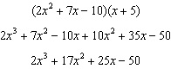
REF: 081428ai

9 ANS:
REF: 081731ai

10 ANS:
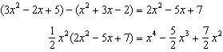
REF: 061528ai

11 ANS:
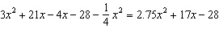
REF: 012028ai

