1 The solution to is
1)
2) | 28
3)
4)

2 The solution to is
1)
2) | 2
3)
4)

3 An equation is given below.
The solution to the equation is
1) | 8.3
2) | 8.7
3) | 3
4) | -3

4 The value of x that satisfies the equation 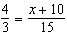 is
1)
2) | 5
3) | 10
4) | 30

5 What is the value of x in the equation 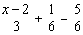?
1) | 4
2) | 6
3) | 8
4) | 11

6 Which value of x makes 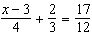 true?
1) | 8
2) | 6
3) | 0
4) | 4

7 Which value of x satisfies the equation 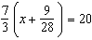?
1) | 8.25
2) | 8.89
3) | 19.25
4) | 44.92

8 Which value of x satisfies the equation 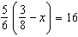?
1)
2)
3)
4)

9 The value of x which makes 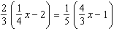 true is
1)
2)
3)
4)

10 What is the solution to the equation 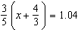?
1)
2) | 0.4
3)
4)

11 Solve the equation below algebraically for the exact value of x.
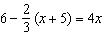

12 Solve algebraically for x:
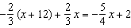
1 ANS: 4
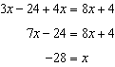

REF: 062106ai

2 ANS: 2
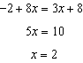

REF: 081804ai

3 ANS: 1
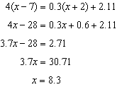

REF: 061719ai

4 ANS: 3
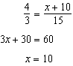

REF: 081904ai

5 ANS: 1
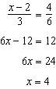

REF: 081420ai

6 ANS: 2
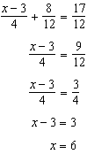

REF: 012005ai

7 ANS: 1
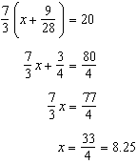

REF: 061405ai

8 ANS: 2
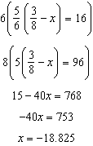

REF: 081713ai

9 ANS: 4
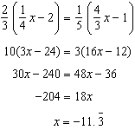

REF: 011822ai

10 ANS: 2
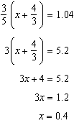

REF: 011905ai

11 ANS:
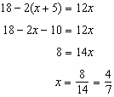

REF: 061830ai

12 ANS:
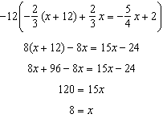

REF: 061925ai

