1 Which step can be used when solving by completing the square?
1)
2)
3)
4)

2 When solving the equation by completing the square, which equation is a step in the process?
1)
2)
3)
4)

3 The quadratic equation is rewritten in the form , where q is a constant. What is the value of p?
1)
2)
3)
4) | 9

4 Which equation has the same solution as ?
1)
2)
3)
4)

5 Which equation has the same solutions as ?
1)
2)
3)
4)

6 Which equation has the same solution as ?
1)
2)
3)
4)

7 If is solved by completing the square, one of the steps in the process is
1)
2)
3)
4)

8 If is solved by completing the square, an intermediate step would be
1)
2)
3)
4)

9 The method of completing the square was used to solve the equation . Which equation is a correct step when using this method?
1)
2)
3)
4)

10 What are the roots of the equation ?
1)
2)
3)
4)

11 What are the solutions to the equation ?
1)
2)
3)
4)

12 What are the solutions to the equation ?
1)
2)
3)
4)

13 Which value of k will make 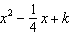 a perfect square trinomial?
1)
2)
3)
4)

14 Brian correctly used a method of completing the square to solve the equation . Brian’s first step was to rewrite the equation as . He then added a number to both sides of the equation. Which number did he add?
1)
2)
3)
4) | 49

15 When directed to solve a quadratic equation by completing the square, Sam arrived at the equation 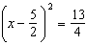. Which equation could have been the original equation given to Sam?
1)
2)
3)
4)

16 Solve the following equation by completing the square:

17 Solve the equation by completing the square.

18 Use the method of completing the square to determine the exact values of x for the equation .

19 Find the exact roots of by completing the square.

20 Solve by completing the square, expressing the result in simplest radical form.

21 A student was given the equation to solve by completing the square. The first step that was written is shown below.
The next step in the student’s process was . State the value of c that creates a perfect square trinomial. Explain how the value of c is determined.
1 ANS: 1 REF: 061408a2

2 ANS: 2
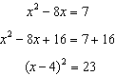

REF: 011614ai

3 ANS: 3
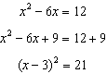

REF: 061812ai

4 ANS: 2

REF: 061408ai

5 ANS: 4
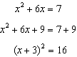

REF: 011517ai

6 ANS: 1
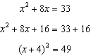

REF: 011915ai

7 ANS: 3
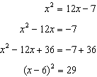

REF: 061505a2

8 ANS: 2
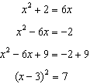

REF: 011116a2

9 ANS: 1
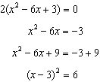

REF: 011722ai

10 ANS: 2
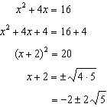

REF: 061410ai

11 ANS: 2
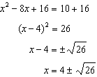

REF: 061722ai

12 ANS: 1
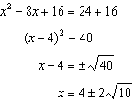

REF: 061523ai

13 ANS: 1
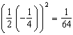

REF: 081527a2

14 ANS: 2 REF: 061122a2

15 ANS: 4
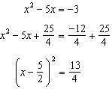

REF: 061518ai

16 ANS:
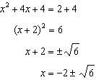

REF: 081830ai

17 ANS:
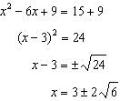

REF: 081732ai

18 ANS:
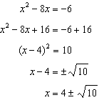

REF: 012031ai

19 ANS:
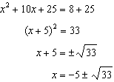

REF: 011636a2

20 ANS:
. 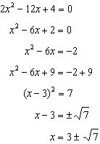

REF: fall0936a2

21 ANS:
Since , p is half the coefficient of x, and the constant term is equal to . 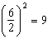

REF: 081432ai

