1 The roots of are
1) | 1 and 4
2) | 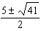
3) | and
4) | 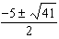

2 The roots of the equation are
1) | and
2) | and 3
3) | 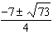
4) | 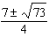

3 If the quadratic formula is used to find the roots of the equation , the correct roots are
1)
2)
3)
4)

4 A cliff diver on a Caribbean island jumps from a height of 105 feet, with an initial upward velocity of 5 feet per second. An equation that models the height, , above the water, in feet, of the diver in time elapsed, t, in seconds, is . How many seconds, to the nearest hundredth, does it take the diver to fall 45 feet below his starting point?
1) | 1.45
2) | 1.84
3) | 2.10
4) | 2.72

5 Solve for x to the nearest tenth: .

6 Solve algebraically for w, to the nearest hundredth.

7 Solve the equation and express the answer in simplest radical form.

8 Fred's teacher gave the class the quadratic function .
a) State two different methods Fred could use to solve the equation .
b) Using one of the methods stated in part a, solve for x, to the nearest tenth.

9 A rocket is shot vertically into the air. Its height, h, at any time, t, in seconds, can be modeled
by the equation . Determine algebraically, the number of seconds it will take
the rocket to reach a height of 529 feet.

10 Barb pulled the plug in her bathtub and it started to drain. The amount of water in the bathtub as it drains is represented by the equation , where L represents the number of liters of water in the bathtub and t represents the amount of time, in minutes, since the plug was pulled. How many liters of water were in the bathtub when Barb pulled the plug? Show your reasoning. Determine, to the nearest tenth of a minute, the amount of time it takes for all the water in the bathtub to drain.
1 ANS: 2
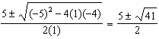

REF: 061921ai

2 ANS: 3
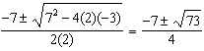

REF: 081009a2

3 ANS: 1
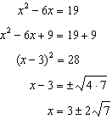

REF: fall1302ai

4 ANS: 2
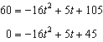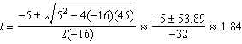

REF: 061424a2

5 ANS:
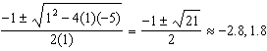

REF: 061827ai

6 ANS:
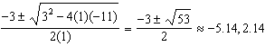

REF: 062132ai

7 ANS:
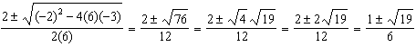

REF: 011332a2

8 ANS:
Two of the following: quadratic formula, complete the square, factor by grouping or graphically.
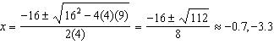

REF: 011634ai

9 ANS:
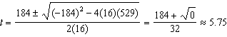

REF: 011738a2

10 ANS:
120, 4.2. Barb pulled the plug at t = 0, so there were 120 liters in the tub. 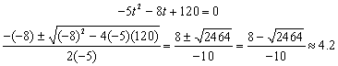

REF: 080634b

