1 The graphs of and intersect at approximately
1) | , only | 3) | and
2) | , only | 4) | and

1 ANS: 3
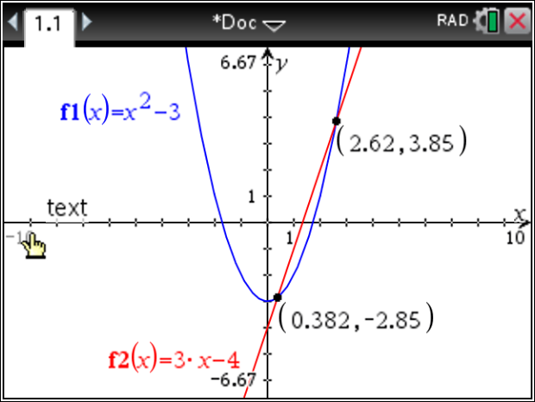

REF: 011810ai

