1 The solution of an equation with two variables, x and y, is
1) | the set of all x values that make
2) | the set of all y values that make
3) | the set of all ordered pairs, , that make the equation true
4) | the set of all ordered pairs, , where the graph of the equation crosses the y-axis

2 Which statement best describes the solutions of a two-variable equation?
1) | The ordered pairs must lie on the graphed equation.
2) | The ordered pairs must lie near the graphed equation.
3) | The ordered pairs must have for one coordinate.
4) | The ordered pairs must have for one coordinate.

3 Which linear equation represents a line containing the point ?
1)
2)
3)
4)

4 Which point lies on the line whose equation is ?
1)
2)
3)
4)

5 Which point is on the line ?
1)
2)
3)
4)

6 Which point lies on the graph represented by the equation ?
1)
2)
3)
4)

7 Which set of coordinates is a solution of the equation ?
1)
2)
3)
4)

8 Which point is not on the graph represented by ?
1)
2)
3)
4)

9 Which ordered pair below is not a solution to ?
1)
2)
3)
4)

10 Which ordered pair does not represent a point on the graph of ?
1)
2)
3)
4)

11 Which ordered pair would not be a solution to ?
1)
2)
3)
4)

12 Which point is not in the solution set of the equation ?
1)
2)
3)
4)

13 Point lies on the line whose equation is . What is the value of k?
1)
2)
3) | 6
4) | 8

14 The graph of the equation passes through point . What is the value of x?
1)
2) | 8
3) | 16
4) | 4

15 If the point lies on the line represented by the equation , the value of k is
1) | 1
2) | 2
3)
4)

16 Which ordered pair does not fall on the line formed by the other three?
1)
2)
3)
4)

1 ANS: 3 REF: 081602ai

2 ANS: 1 REF: 012011ai

3 ANS: 3
2(1)+3=5

REF: 061007ia

4 ANS: 4
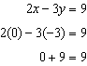

REF: 081016ia

5 ANS: 1
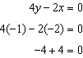

REF: 011021ia

6 ANS: 4
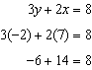

REF: 011218ia

7 ANS: 4

REF: 081217ia

8 ANS: 4 REF: 081405ai

9 ANS: 4

REF: 061808ai

10 ANS: 3

REF: 061918ai

11 ANS: 4
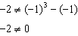

REF: 011806ai

12 ANS: 1
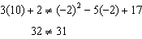

REF: 081818ai

13 ANS: 1
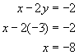

REF: 080628a

14 ANS: 2
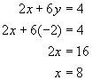

REF: 060721a

15 ANS: 3
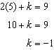

REF: 061304ia

16 ANS: 1
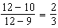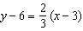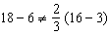

REF: 062124ai

