1 If and 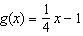, for which value of x is ?
1) | and
2) | and 4
3) | and 0
4) | 4 and 0

2 If and , determine the value(s) of x that satisfy the equation .

3 John and Sarah are each saving money for a car. The total amount of money John will save is given by the function . The total amount of money Sarah will save is given by the function . After how many weeks, x, will they have the same amount of money saved? Explain how you arrived at your answer.

4 Let and . On the set of axes below, draw the graphs of and .

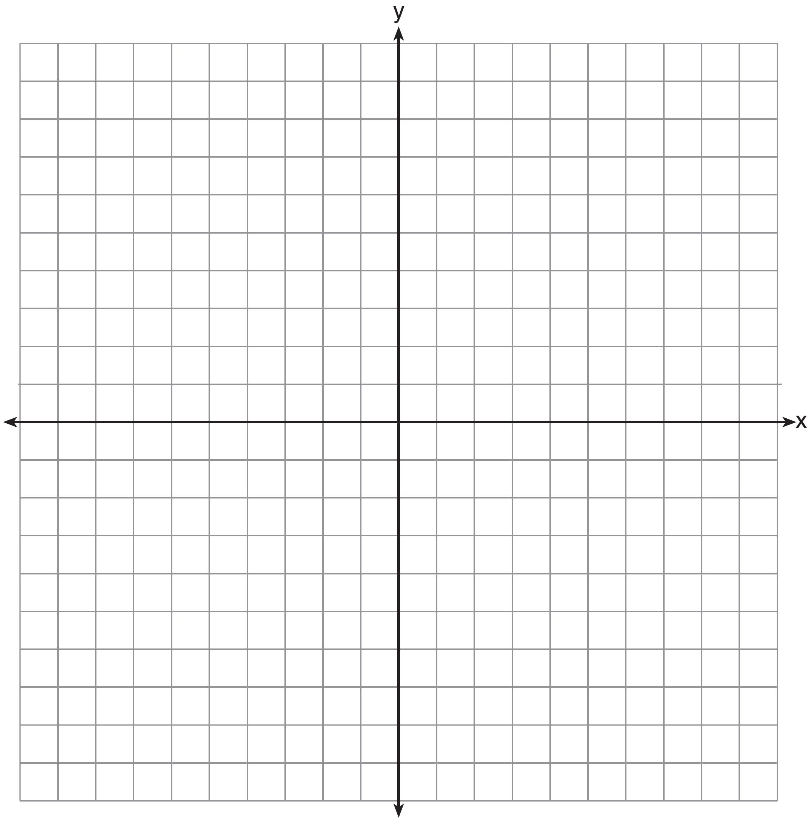

Using this graph, determine and state all values of x for which .

5 Graph and on the set of axes below.

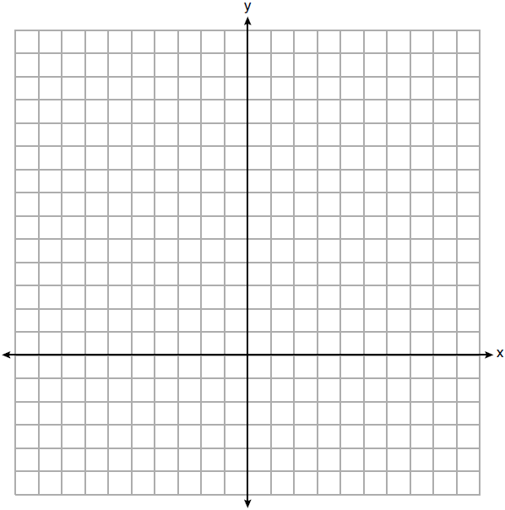

Determine and state all values of x for which .

6 A company is considering building a manufacturing plant. They determine the weekly production cost at site A to be while the production cost at site B is , where x represents the number of products, in hundreds, and and are the production costs, in hundreds of dollars. Graph the production cost functions on the set of axes below and label them site A and site B.

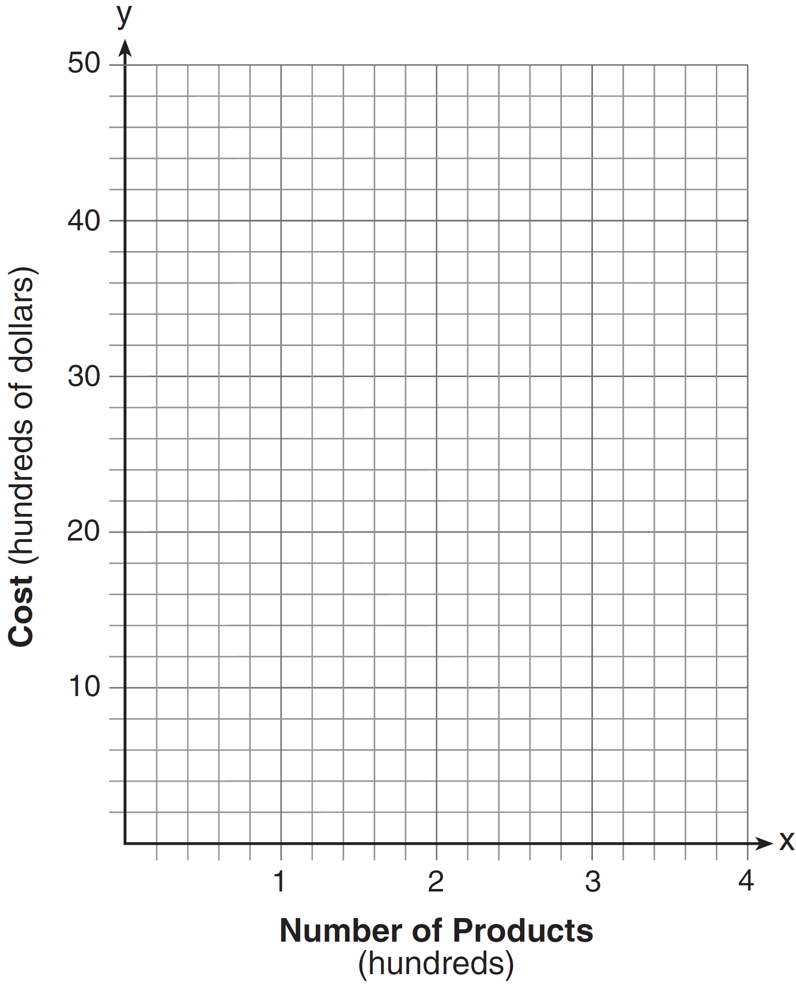

State the positive value(s) of x for which the production costs at the two sites are equal. Explain how you determined your answer. If the company plans on manufacturing 200 products per week, which site should they use? Justify your answer.

7 Given: 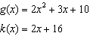
Solve the equation algebraically for x, to the nearest tenth. Explain why you chose the method you used to solve this quadratic equation.
1 ANS: 2
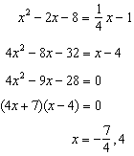

REF: 081517ai

2 ANS:
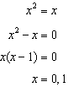

REF: 061731ai

3 ANS:
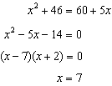 John and Sarah will have the same amount of money saved at 7 weeks. I set the expressions representing their savings equal to each other and solved for the positive value of x by factoring.

REF: 061527ai

4 ANS:
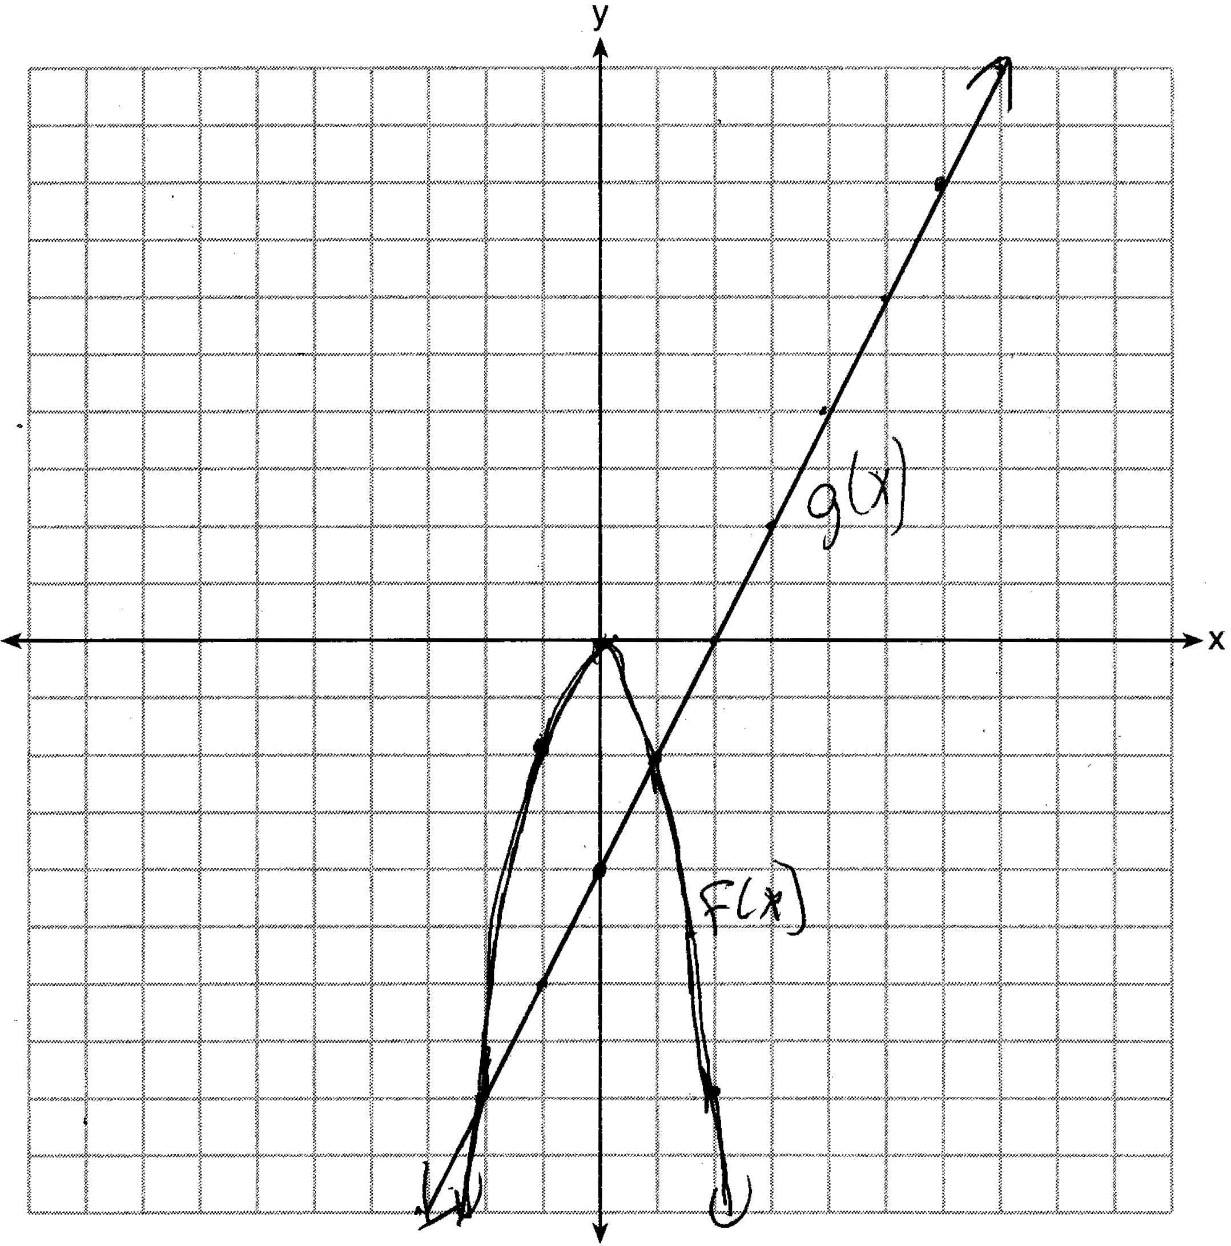

REF: 081435ai

5 ANS:
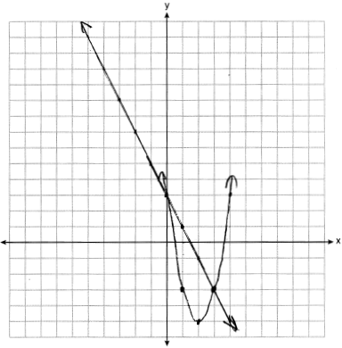

REF: 061934ai

6 ANS:
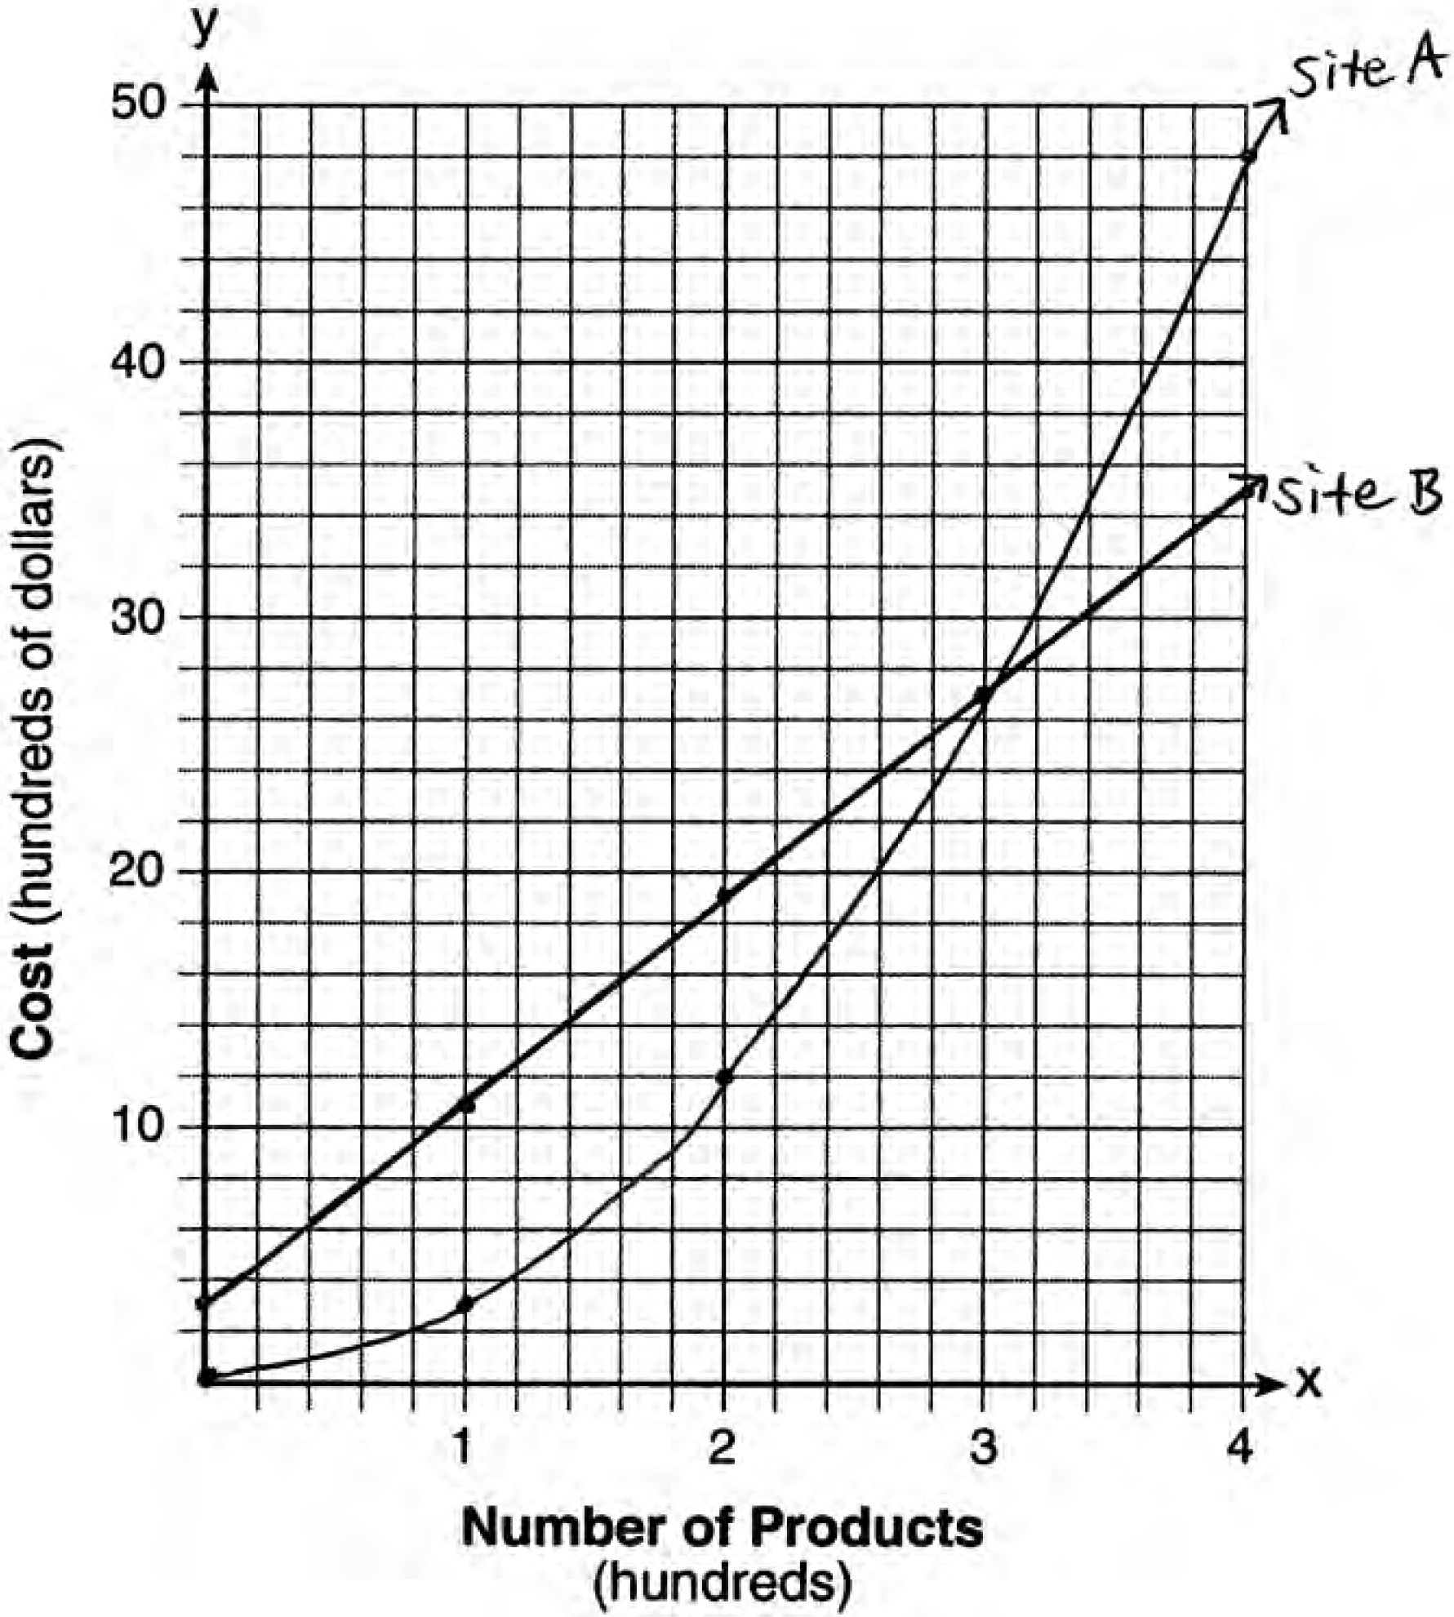The graphs of the production costs intersect at . The company should use Site A, because the cost of Site A is lower at .

REF: 061437ai

7 ANS:
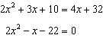 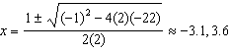. Quadratic formula, because the answer must be to the nearest tenth.

REF: 061735ai

