1 If and , which operation would not result in a polynomial expression?
1)
2)
3)
4)

2 If and , then which statement is not true?
1)
2)
3)
4) | 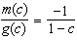

3 If and , then equals
1)
2)
3)
4)

4 Chet has $1200 invested in a bank account modeled by the function , where is the value of his account, in dollars, after n months. Chet's debt is modeled by the function , where is the value of debt, in dollars, after n months. After n months, which function represents Chet's net worth, ?
1)
2)
3)
4)

5 The revenue, , from selling x units of a product is represented by the equation , while the total cost, , of making x units of the product is represented by the equation . The total profit, , is represented by the equation . For the values of and given above, what is ?
1)
2)
3)
4)

6 A company produces x units of a product per month, where represents the total cost and represents the total revenue for the month. The functions are modeled by and . The profit is the difference between revenue and cost where . What is the total profit, , for the month?
1)
2)
3)
4)

7 A manufacturing company has developed a cost model, , where x is the number of items sold, in thousands. The sales price can be modeled by . Therefore, revenue is modeled by . The company's profit, , could be modeled by
1)
2)
3)
4)

8 The profit function, , for a company is the cost function, , subtracted from the revenue function, . The profit function for the Acme Corporation is and the revenue function is . The cost function for the Acme Corporation is
1)
2)
3)
4)

9 Given that , find if .

10 Given: and
Express as a polynomial in standard form.

11 A company calculates its profit by finding the difference between revenue and cost. The cost function of producing x hammers is . If each hammer is sold for $10, the revenue function for selling x hammers is . How many hammers must be sold to make a profit? How many hammers must be sold to make a profit of $100?

12 A small, open-top packing box, similar to a shoebox without a lid, is three times as long as it is wide, and half as high as it is long. Each square inch of the bottom of the box costs $0.008 to produce, while each square inch of any side costs $0.003 to produce. Write a function for the cost of the box described above. Using this function, determine the dimensions of a box that would cost $0.69 to produce.
1 ANS: 4 REF: 081803aii

2 ANS: 4
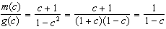

REF: 061608aii

3 ANS: 3 REF: 011710aii

4 ANS: 3 REF: 012002aii

5 ANS: 3
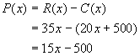

REF: 010220b

6 ANS: 2

REF: 081406ai

7 ANS: 2

REF: 061709aii

8 ANS: 1
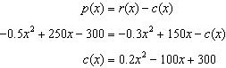

REF: 061813aii

9 ANS:

REF: 061625ai

10 ANS:
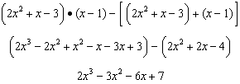

REF: 011833aii

11 ANS:
29, 45. 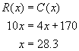. If you round down to 28 hammers, the company does not make a profit. Round up to 29. To make a profit of $100, 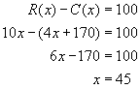.

REF: 080332b

12 ANS:
, 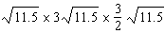. The area of the bottom is where w is the width in inches. If each square inch of the bottom costs $0.008 to produce, the cost of the bottom may be expressed as The area of the two smaller sides is 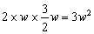 and the area of the two larger sides is 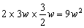 for a total area of If each square inch of a side of the box costs $0.003 to produce, the cost of the bottom may be expressed as Adding the cost of the bottom and sides equals A function for the cost of the box is A box that would cost $0.69 to produce would have the following dimensions 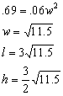

REF: 080130b

