1 The diagram below shows the graph of .

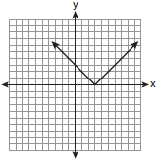

Which diagram shows the graph of ?
1) | 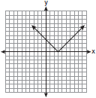
2) | 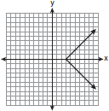
3) | 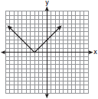
4) | 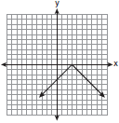

2 The graph of is shown below.

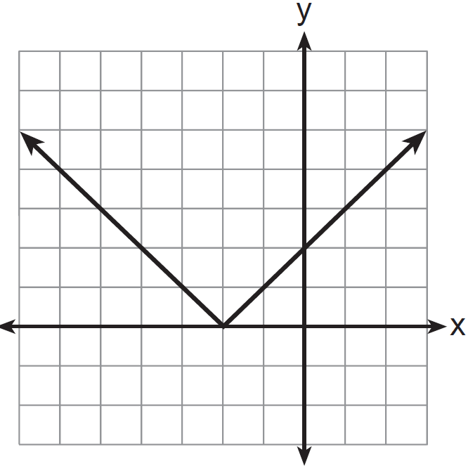

Which graph represents ?
1) | 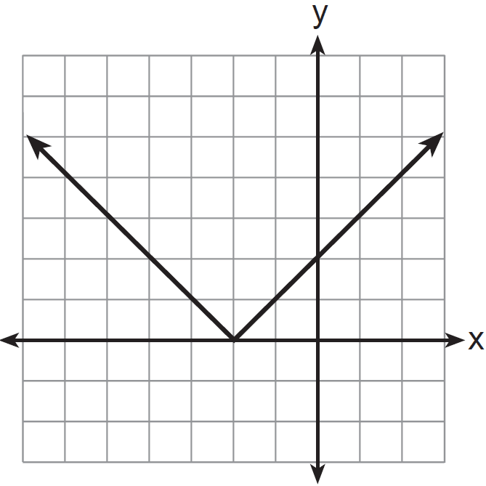
2) | 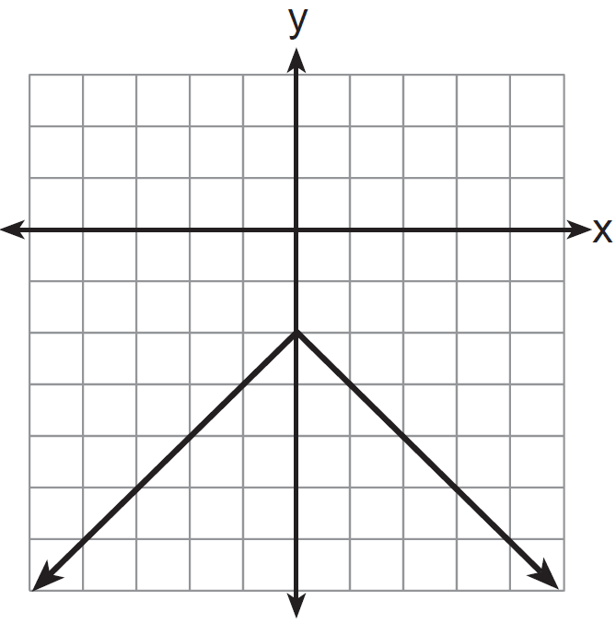
3) | 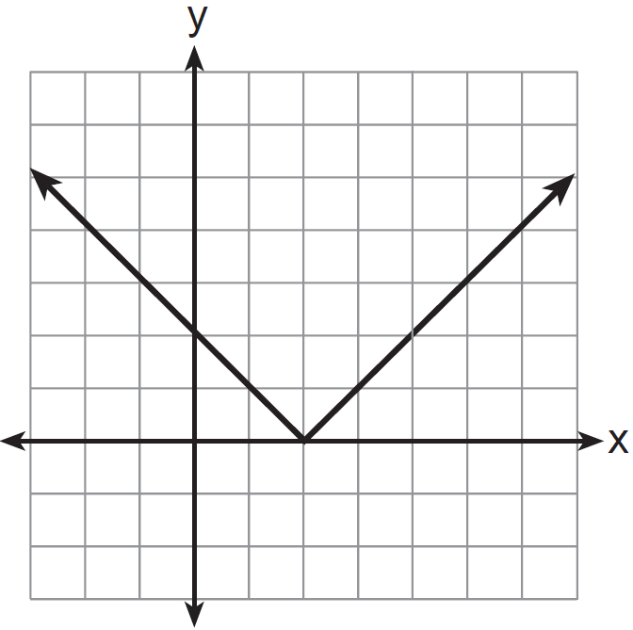
4) | 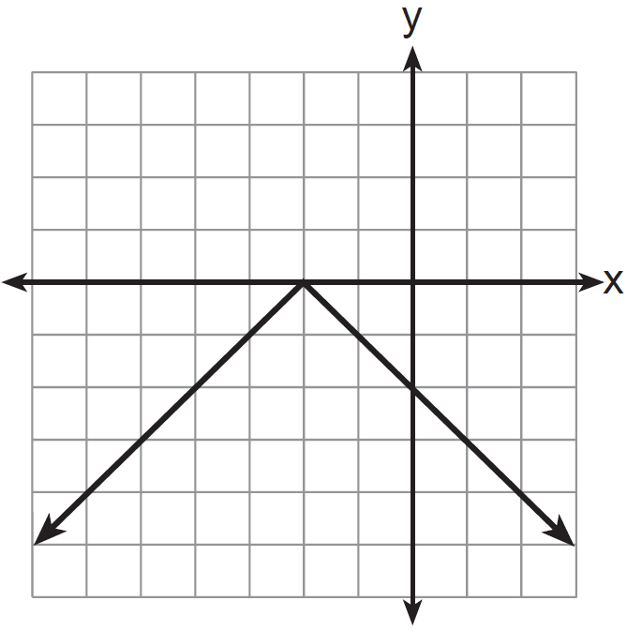

3 The graph of the equation is shown in the diagram below.

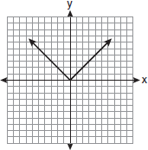

Which diagram could represent a graph of the equation when ?
1) | 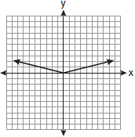
2) | 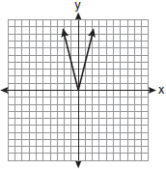
3) | 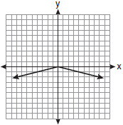
4) | 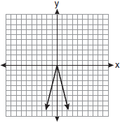

4 Dominick graphs the equation where a is a positive integer. If Gina multiplies a by , the new graph will become
1) | narrower and open downward
2) | narrower and open upward
3) | wider and open downward
4) | wider and open upward

5 Describe the effect that each transformation below has on the function , where .

6 Graph and label the functions and on the set of axes below.

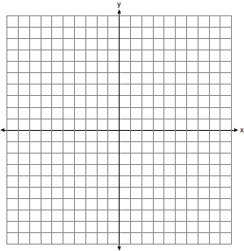

Explain how increasing the coefficient of x affects the graph of .

7 On the set of axes below, graph and label the equations and for the interval .

Explain how changing the coefficient of the absolute value from 1 to 3 affects the graph.

8 Graph the function on the set of axes below.

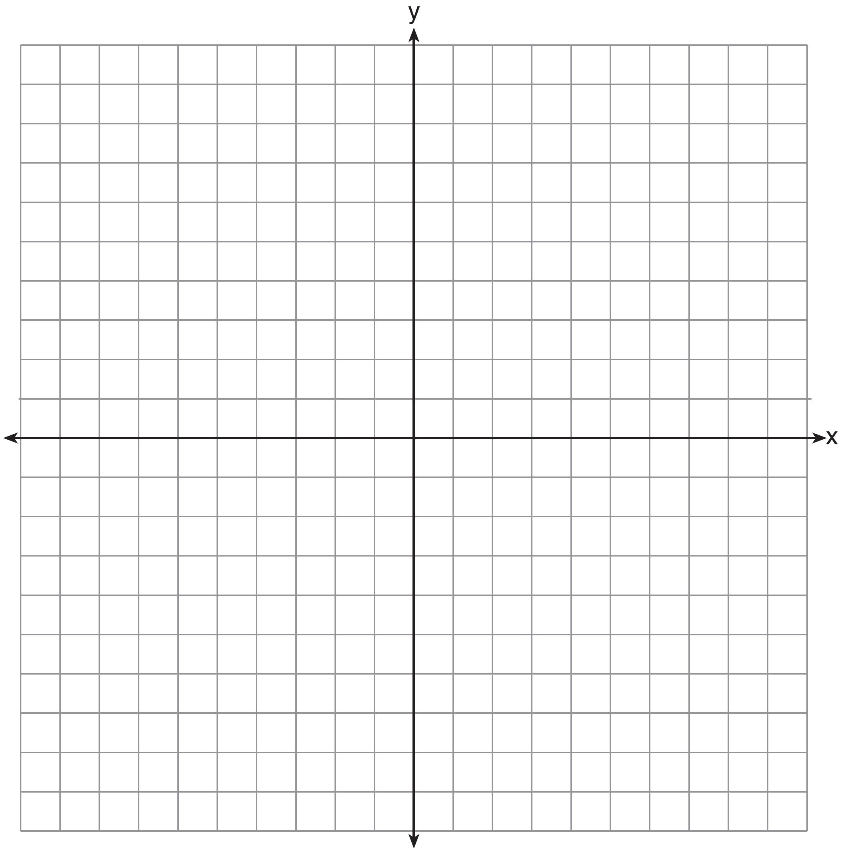

Explain how the graph of has changed from the related graph .

9 On the axes below, graph .

If , how is the graph of translated to form the graph of ? If , how is the graph of translated to form the graph of ?

10 Graph and label the following equations on the set of axes below.
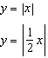
Explain how decreasing the coefficient of x affects the graph of the equation .

1 ANS: 4
The transformation is a reflection in the x-axis.

REF: fall0722ia

2 ANS: 4
The transformation is a reflection in the x-axis.

REF: 011206ia

3 ANS: 3 REF: 011017ia

4 ANS: 1 REF: 011529ia

5 ANS:
is shifted right by a, is shifted down by a.

REF: 061732ai

6 ANS:
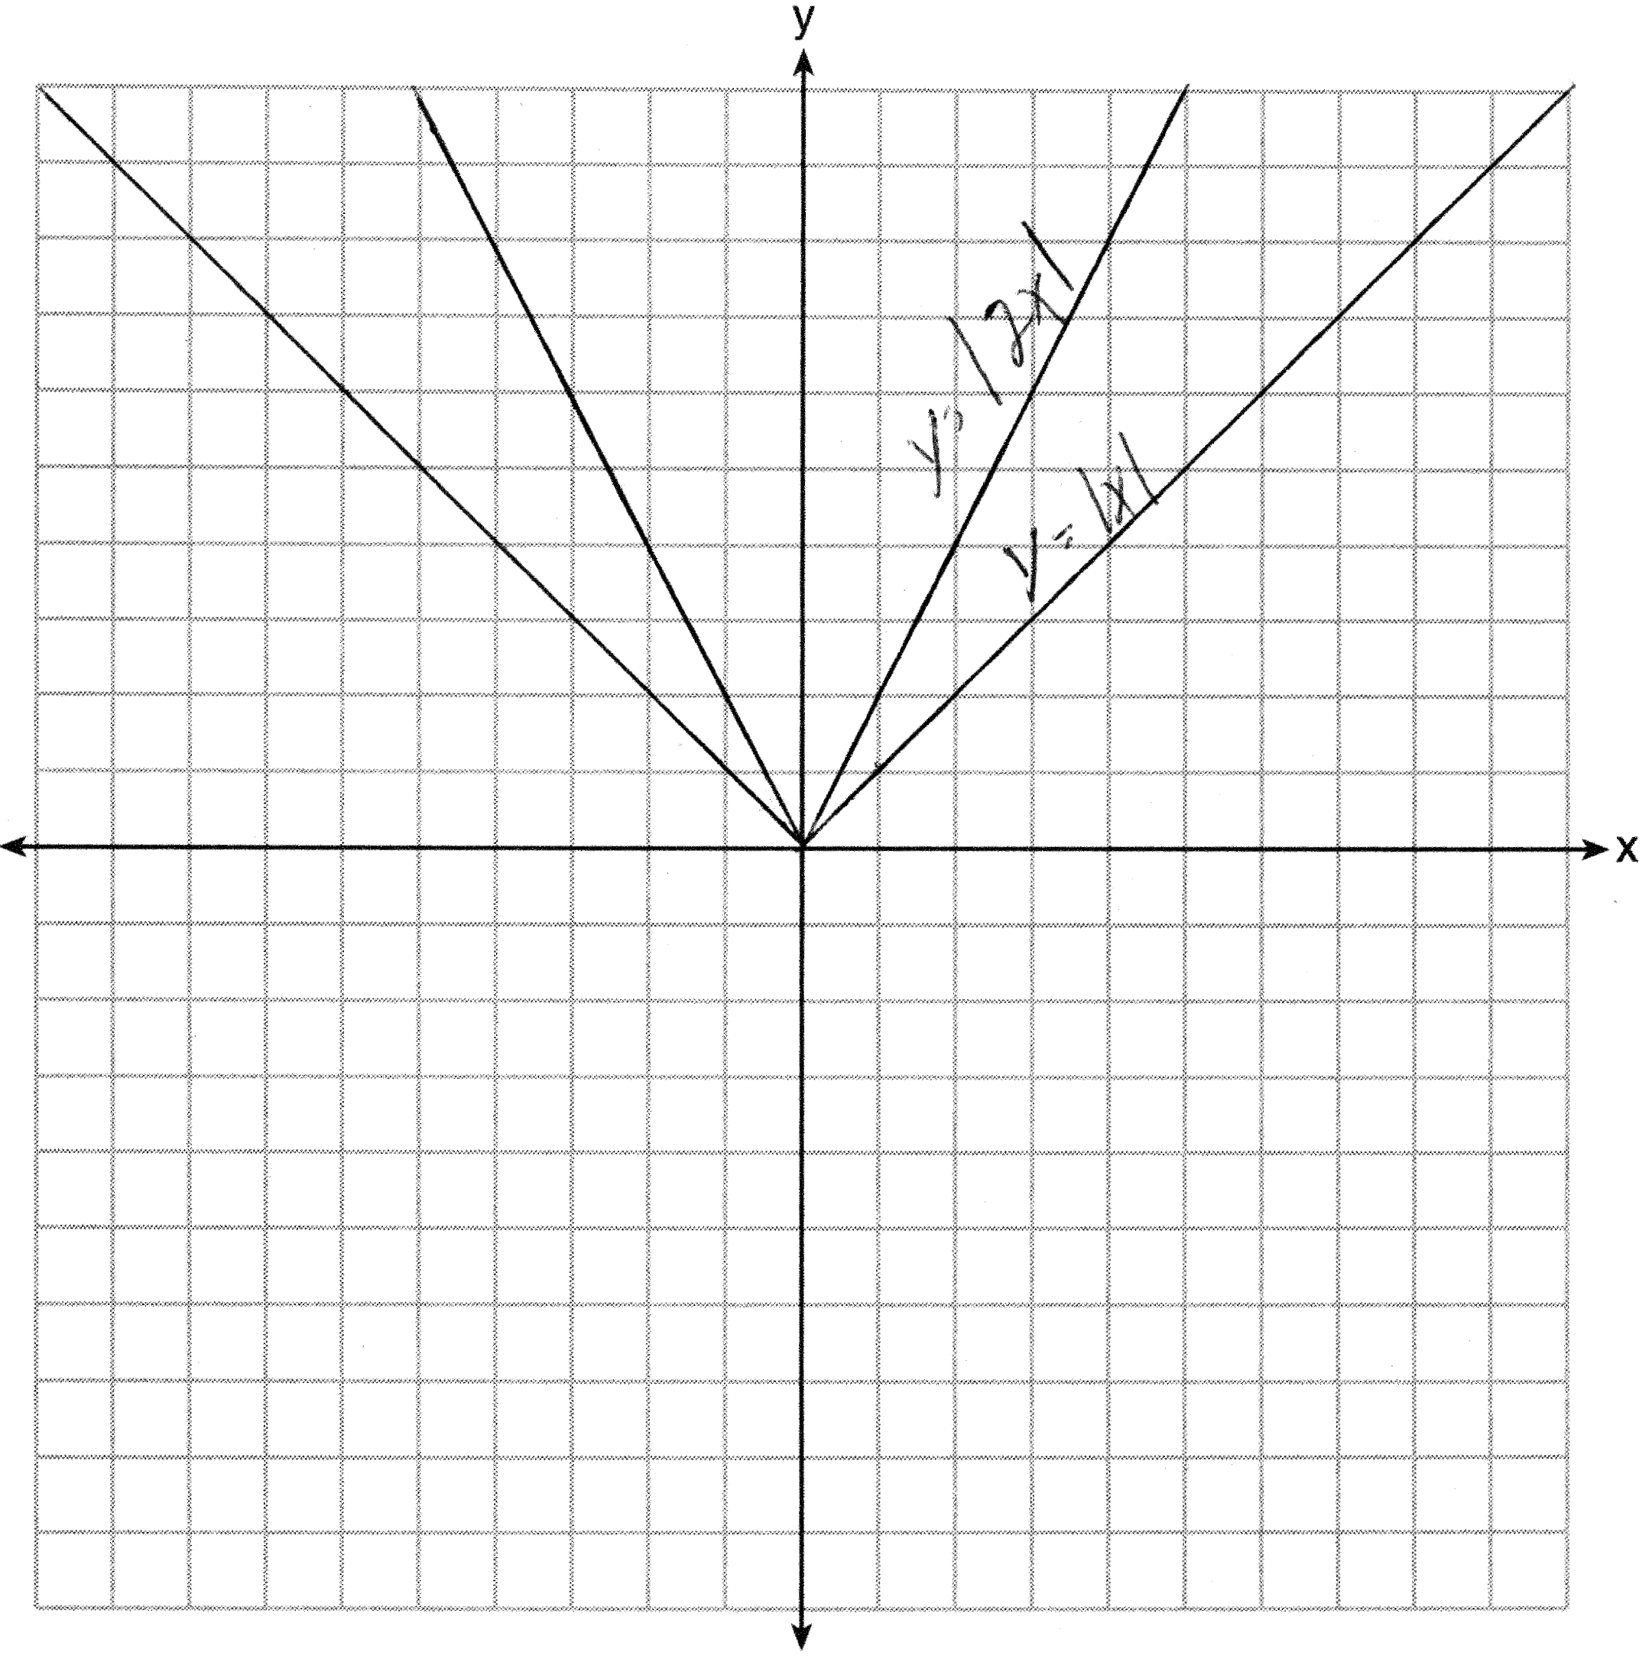. Graph becomes narrower as the coefficient increases.

REF: 011434ia

7 ANS:
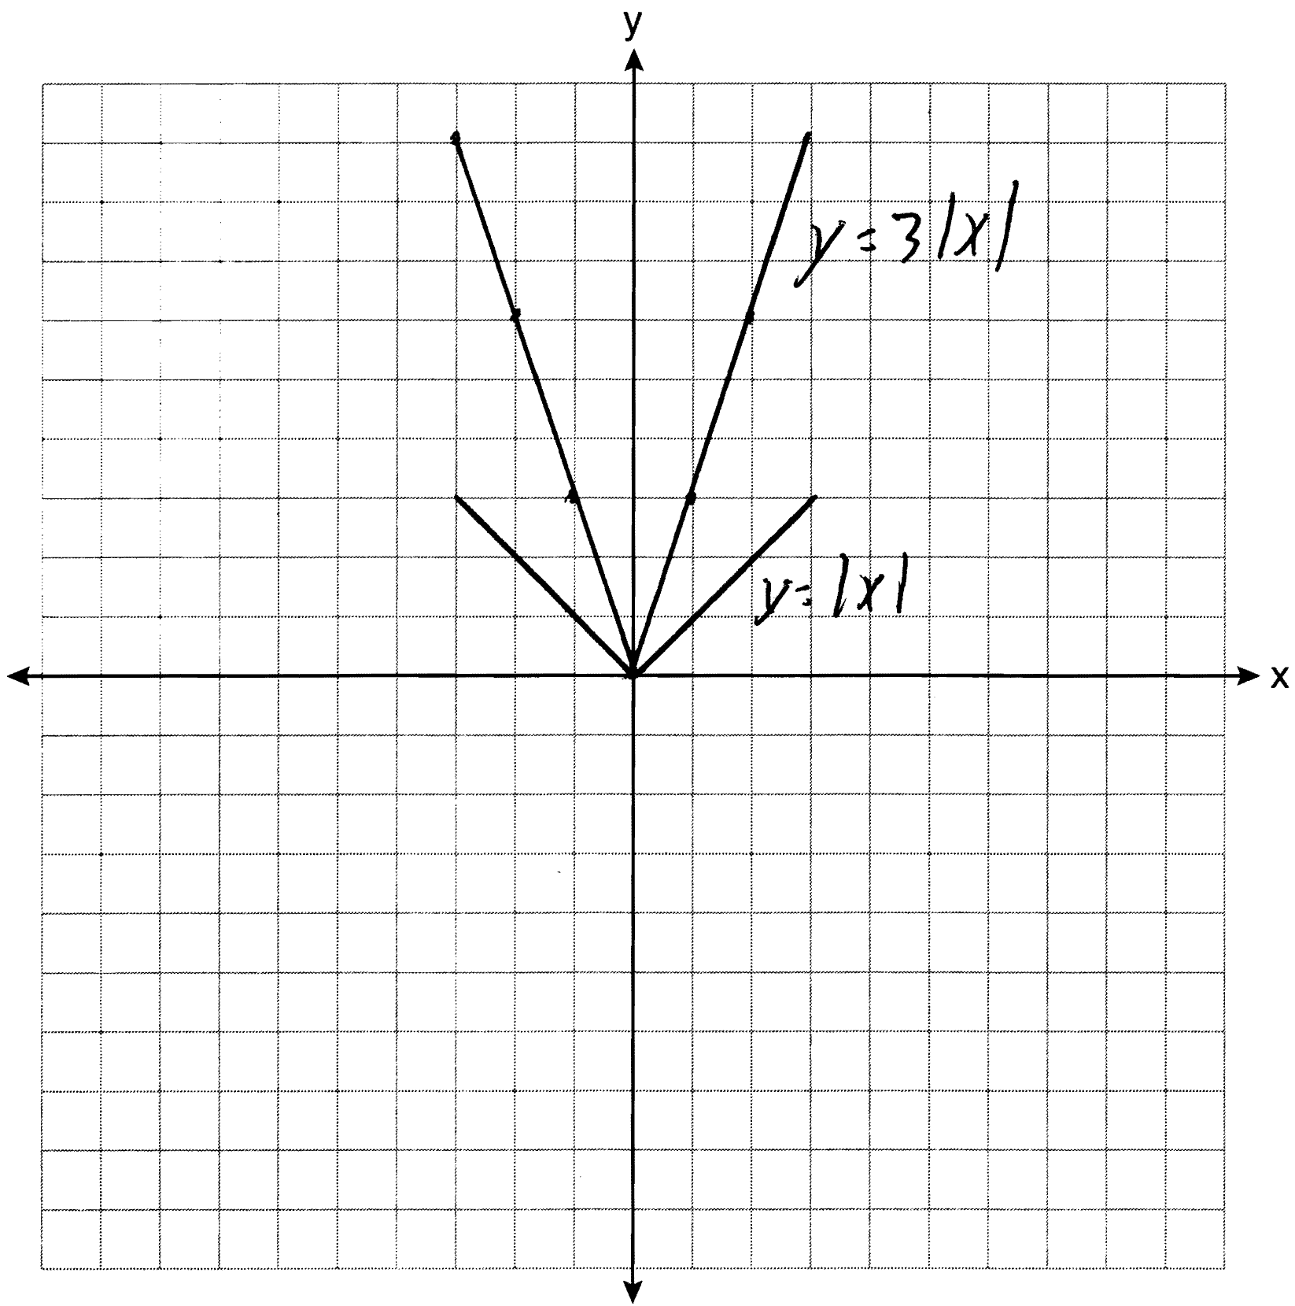 The graph becomes steeper.

REF: 081134ia

8 ANS:
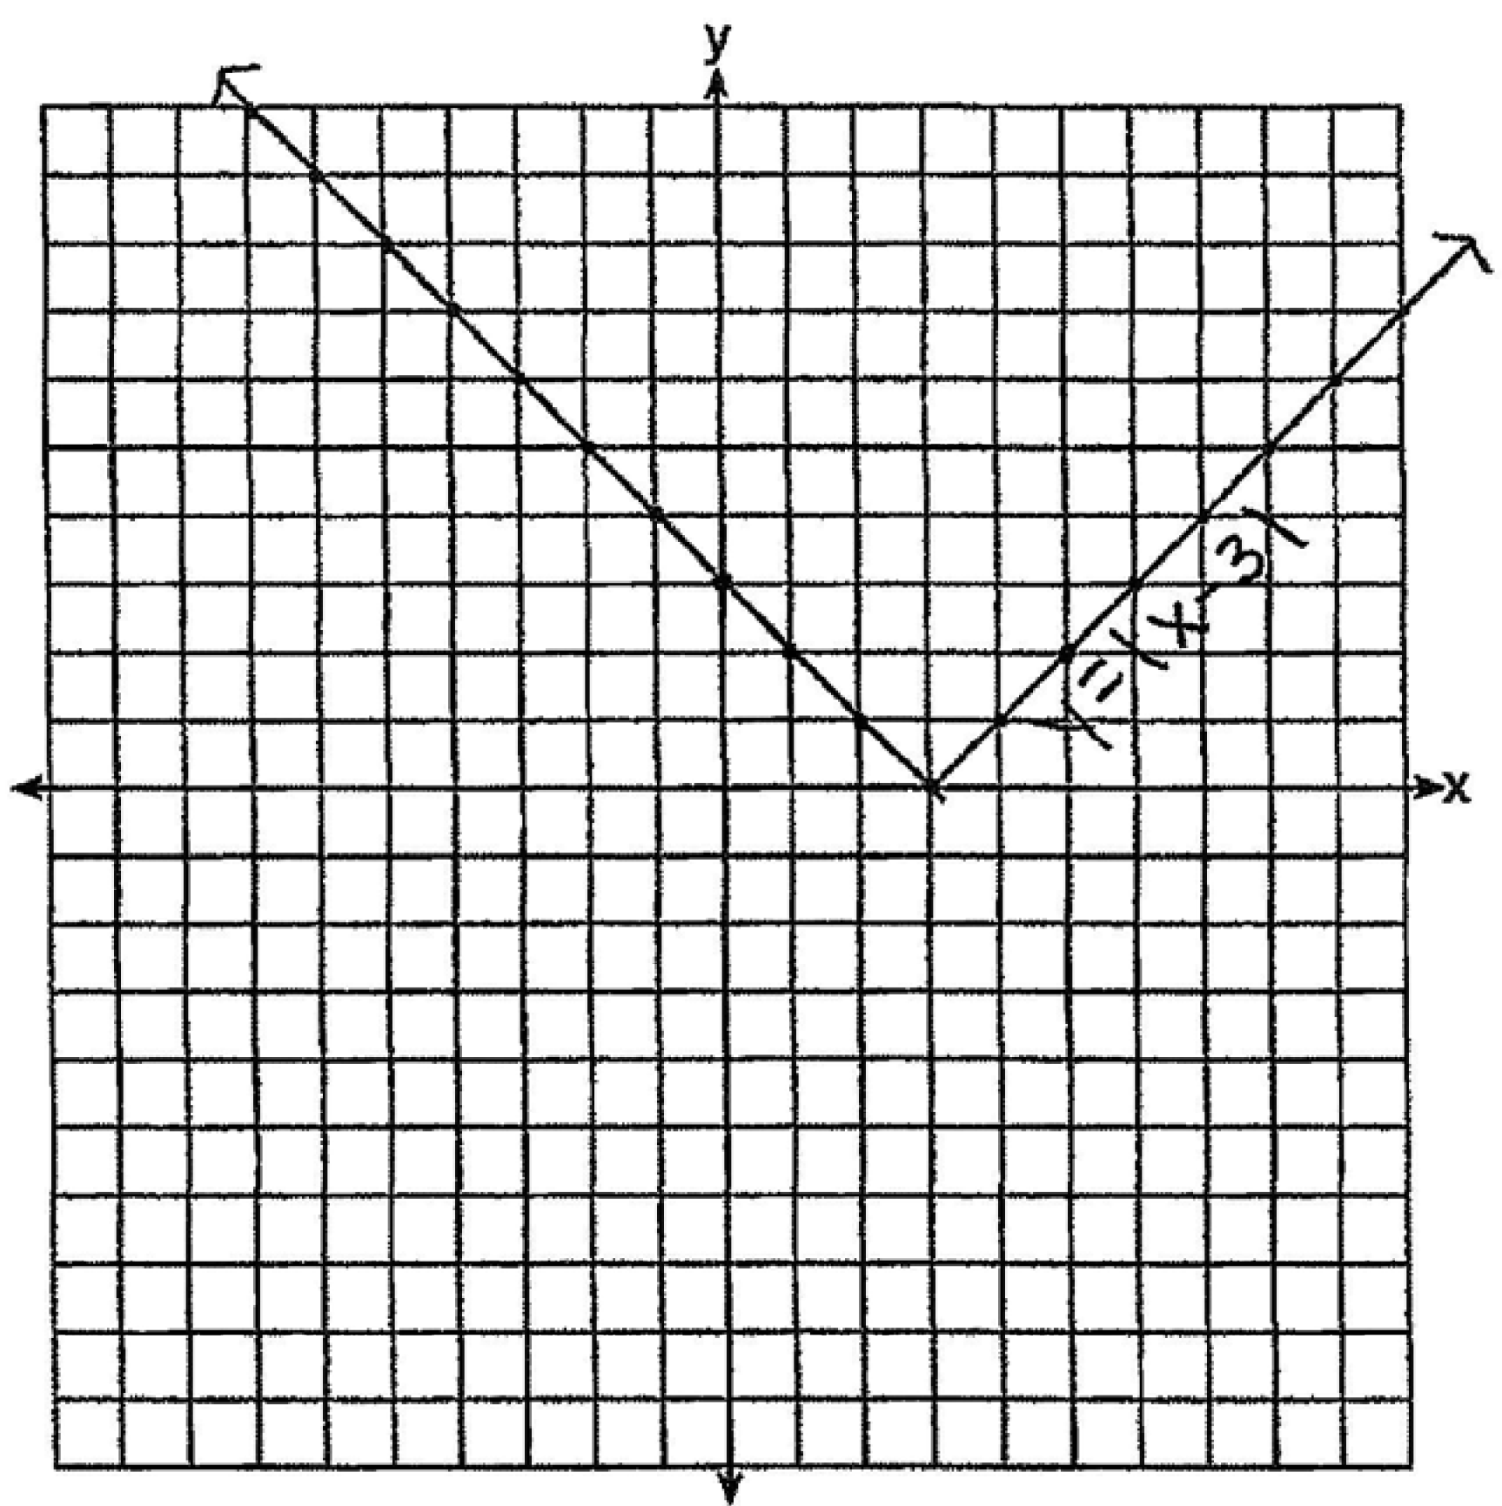 The graph has shifted three units to the right.

REF: 061525ai

9 ANS:
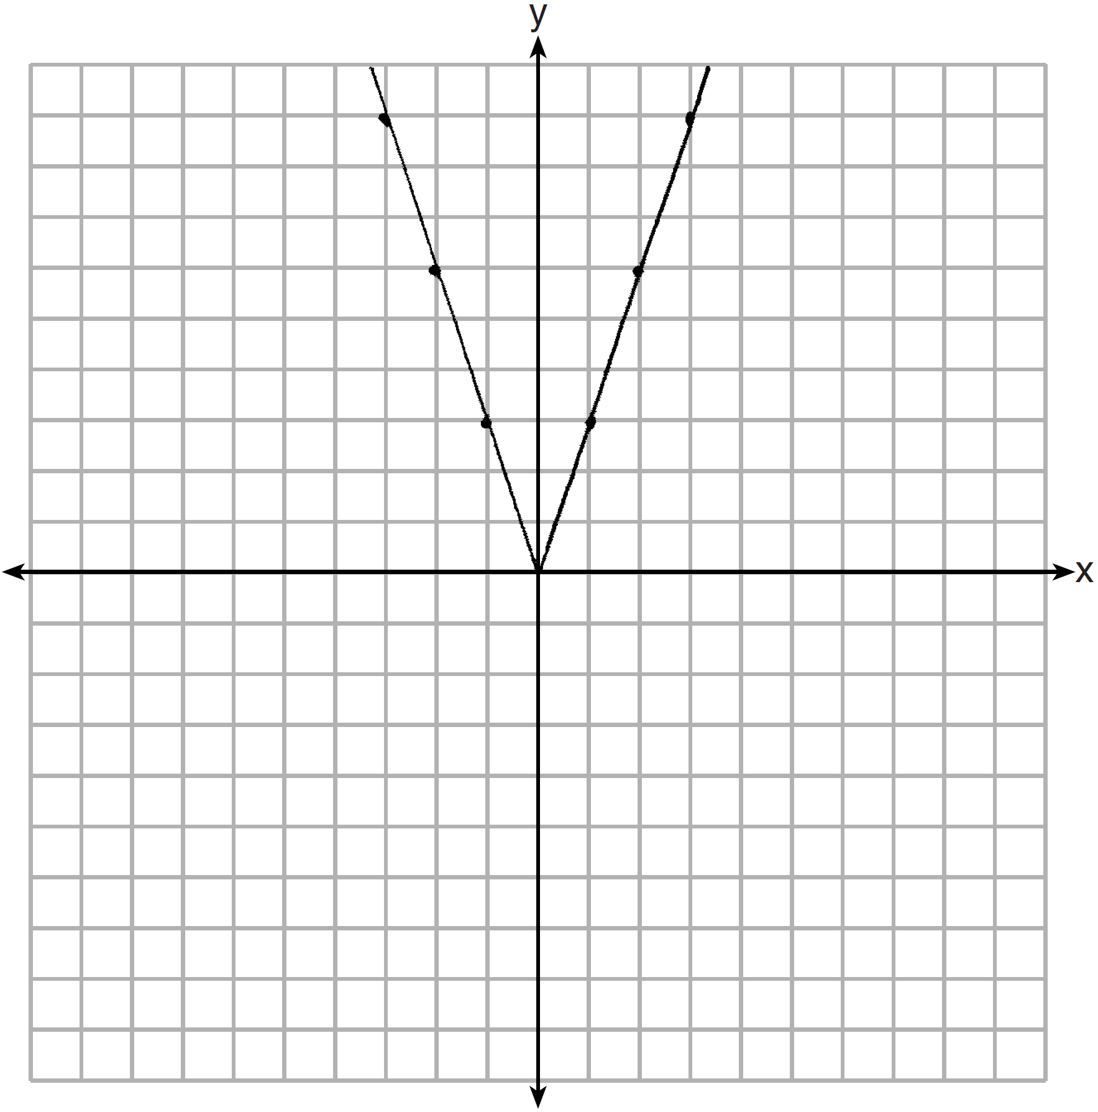 2 down. 4 right.

REF: 081433ai

10 ANS:
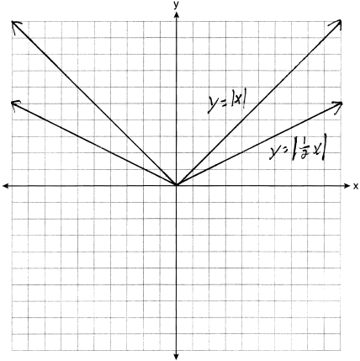. Graph becomes wider as the coefficient approaches 0.

REF: 061035ia

