1 Given the graph of the line represented by the equation , if b is increased by 4 units, the graph of the new line would be shifted 4 units
1) | right
2) | up
3) | left
4) | down

2 The functions and are graphed below.

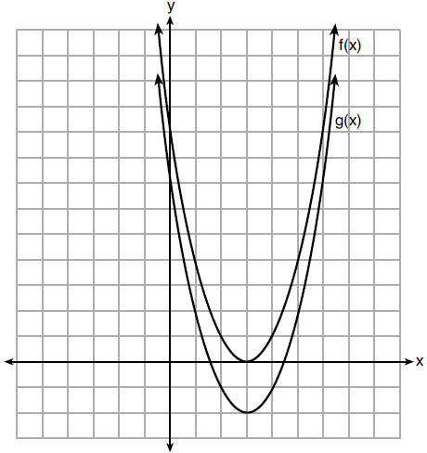

Which value of k would result in the graph of ?
1) | 0
2) | 2
3)
4)

3 The graph of the equation is shown below.

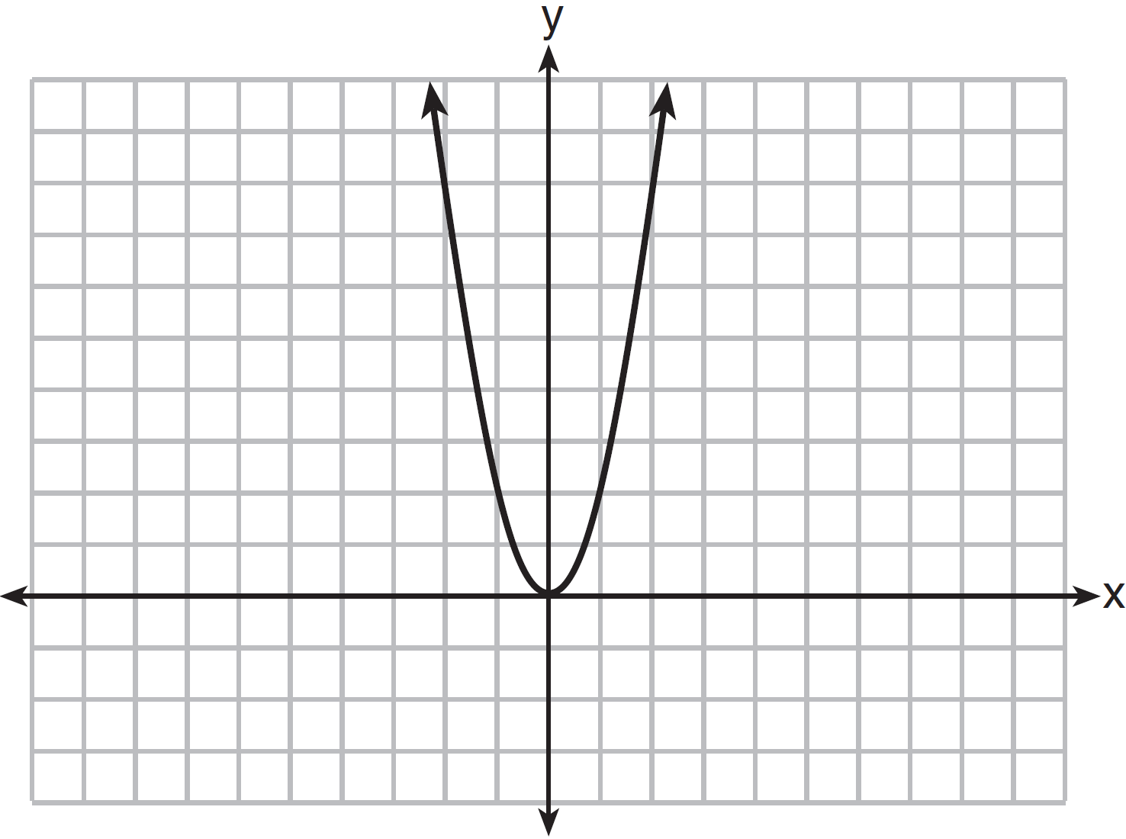

If a is multiplied by , the graph of the new equation is
1) | wider and opens downward
2) | wider and opens upward
3) | narrower and opens downward
4) | narrower and opens upward

4 Compared to the graph of , the graph of is the result of translating
1) | 2 units up and 3 units right
2) | 2 units down and 3 units up
3) | 2 units right and 3 units up
4) | 2 units left and 3 units right

5 If the original function is shifted to the left 3 units to make the function , which expression would represent ?
1)
2)
3)
4)

6 Given:
When compared to the graph of the graph of is
1) | shifted 3 units to the left
2) | shifted 3 units to the right
3) | shifted 5 units to the left
4) | shifted 5 units to the right

7 Josh graphed the function . He then graphed the function on the same coordinate plane. The vertex of is
1) | 7 units below the vertex of
2) | 7 units above the vertex of
3) | 7 units to the right of the vertex of
4) | 7 units to the left of the vertex of

8 If the parent function of is then the graph of the function where would be a shift of
1) | k units to the left and a move of 5 units up
2) | k units to the left and a move of 5 units down
3) | k units to the right and a move of 5 units up
4) | k units to the right and a move of 5 units down

9 When the function is multiplied by the value a, where , the graph of the new function,
1) | opens upward and is wider
2) | opens upward and is narrower
3) | opens downward and is wider
4) | opens downward and is narrower

10 How does the graph of compare to the graph of ?
1) | The graph of is wider than the graph of , and its vertex is moved to the left 2 units and up 1 unit.
2) | The graph of is narrower than the graph of , and its vertex is moved to the right 2 units and up 1 unit.
3) | The graph of is narrower than the graph of , and its vertex is moved to the left 2 units and up 1 unit.
4) | The graph of is wider than the graph of , and its vertex is moved to the right 2 units and up 1 unit.

11 In the functions and , k is a positive integer. If k is replaced by , which statement about these new functions is true?
1) | The graphs of both and become wider.
2) | The graph of becomes narrower and the graph of shifts left.
3) | The graphs of both and shift vertically.
4) | The graph of shifts left and the graph of becomes wider.

12 Given the parent function , the function is the result of a shift of
1) | 1 unit left and 2 units down
2) | 1 unit left and 2 units up
3) | 1 unit right and 2 units down
4) | 1 unit right and 2 units up

13 The vertex of the parabola represented by has coordinates . Find the coordinates of the vertex of the parabola defined by . Explain how you arrived at your answer. [The use of the set of axes below is optional.]

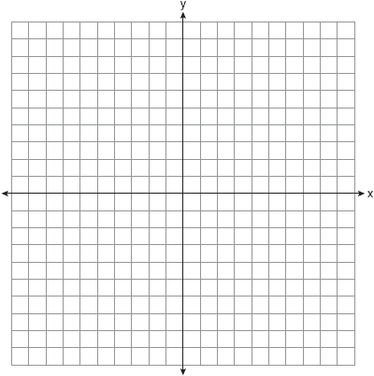

14 In the diagram below, is graphed. Also graphed is , the result of a translation of .

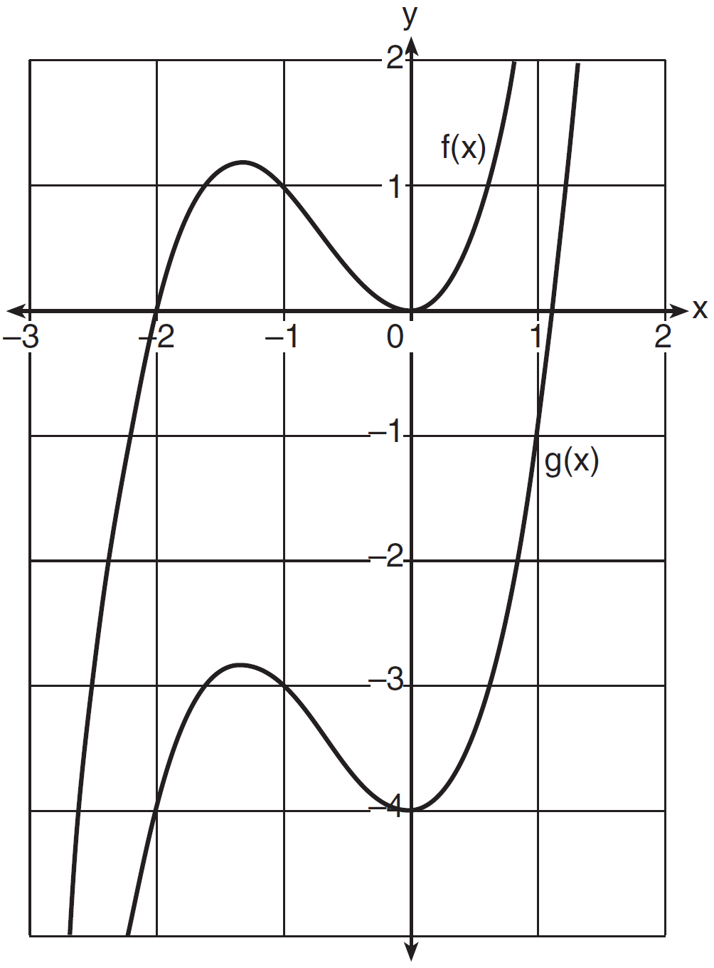

Determine an equation of . Explain your reasoning.

1 ANS: 2 REF: 081501ai

2 ANS: 4 REF: 012007ai

3 ANS: 1 REF: 081417ai

4 ANS: 3 REF: 081808ai

5 ANS: 2 REF: 011819ai

6 ANS: 2 REF: 061904ai

7 ANS: 1

REF: 081905ai

8 ANS: 3 REF: 062113ai

9 ANS: 2 REF: 011717ai

10 ANS: 2 REF: 011512ai

11 ANS: 1 REF: 081706ai

12 ANS: 3 REF: 011910ai

13 ANS:
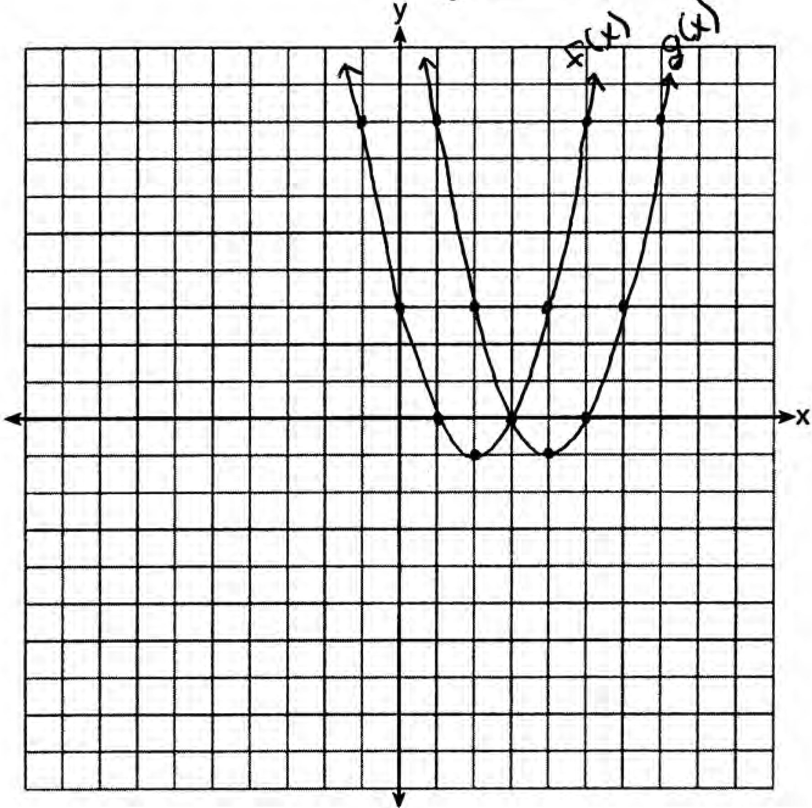 . is a horizontal shift two units to the right.

REF: 061428ai

14 ANS:
, because is a translation down 4 units.

REF: 061632ai

