1 The shaded boxes in the figures below represent a sequence.

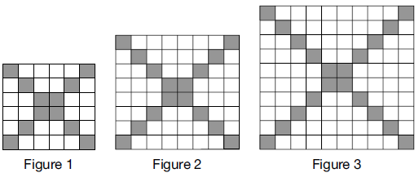

If figure 1 represents the first term and this pattern continues, how many shaded blocks will be in figure 35?
1) | 55
2) | 148
3) | 420
4) | 805

2 In a sequence, the first term is 4 and the common difference is 3. The fifth term of this sequence is
1)
2)
3) | 16
4) | 19

3 An arithmetic sequence has a first term of 10 and a sixth term of 40. What is the 20th term of this sequence?
1) | 105
2) | 110
3) | 124
4) | 130

4 On the main floor of the Kodak Hall at the Eastman Theater, the number of seats per row increases at a constant rate. Steven counts 31 seats in row 3 and 37 seats in row 6. How many seats are there in row 20?
1) | 65
2) | 67
3) | 69
4) | 71

5 What is the fifteenth term of the sequence ?
1)
2)
3) | 81,920
4) | 327,680

6 What is the fifteenth term of the geometric sequence ?
1)
2)
3)
4)

7 The eighth and tenth terms of a sequence are 64 and 100. If the sequence is either arithmetic or geometric, the ninth term can not be
1)
2)
3) | 80
4) | 82

8 When a ball bounces, the heights of consecutive bounces form a geometric sequence. The height of the first bounce is 121 centimeters and the height of the third bounce is 64 centimeters. To the nearest centimeter, what is the height of the fifth bounce?
1) | 25
2) | 34
3) | 36
4) | 42

1 ANS: 2
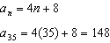

REF: 012008ai

2 ANS: 3
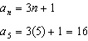

REF: 061613ai

3 ANS: 3
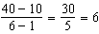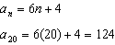

REF: 081510a2

4 ANS: 1
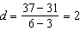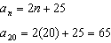

REF: 061807ai

5 ANS: 3
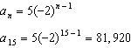

REF: 011105a2

6 ANS: 1
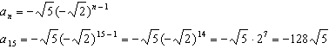

REF: 061109a2

7 ANS: 1
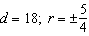

REF: 011714aii

8 ANS: 2
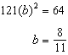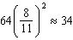
REF: 011904aii

