1 The value of Tony's investment was $1140 on January 1st. On this date three years later, his investment was worth $1824. The average rate of change for this investment was $19 per
1) | day | 3) | quarter
2) | month | 4) | year

2 An astronaut drops a rock off the edge of a cliff on the Moon. The distance, , in meters, the rock travels after t seconds can be modeled by the function . What is the average speed, in meters per second, of the rock between 5 and 10 seconds after it was dropped?
1) | 12 | 3) | 60
2) | 20 | 4) | 80

3 A population of rabbits in a lab, , can be modeled by the function , where x represents the number of days since the population was first counted. Explain what 20 and 1.014 represent in the context of the problem. Determine, to the nearest tenth, the average rate of change from day 50 to day 100.

4 The graph of models the height, in feet, that a bee is flying above the ground with respect to the time it traveled in t seconds.

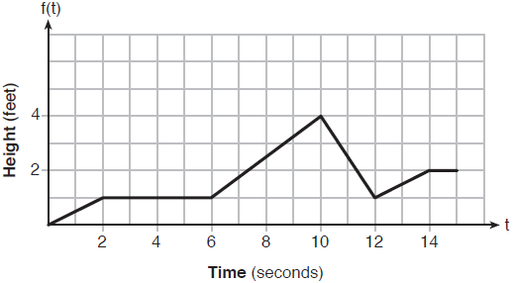

State all time intervals when the bee's rate of change is zero feet per second. Explain your reasoning.

5 The graph below shows the distance in miles, m, hiked from a camp in h hours.

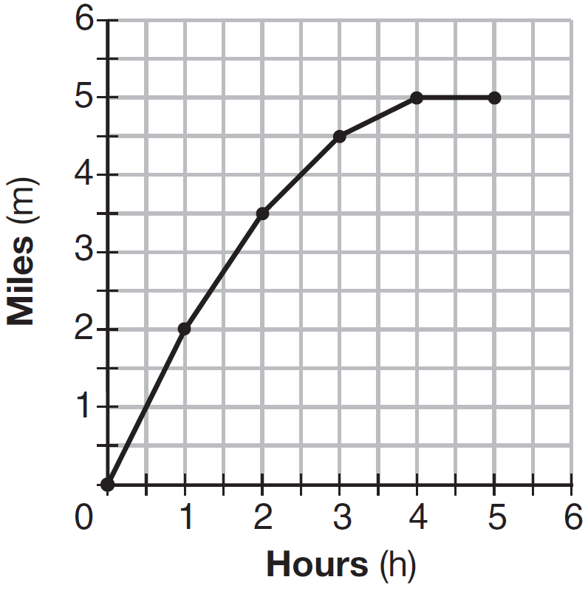

Which hourly interval had the greatest rate of change?
1) | hour 0 to hour 1 | 3) | hour 2 to hour 3
2) | hour 1 to hour 2 | 4) | hour 3 to hour 4

6 The Jamison family kept a log of the distance they traveled during a trip, as represented by the graph below.

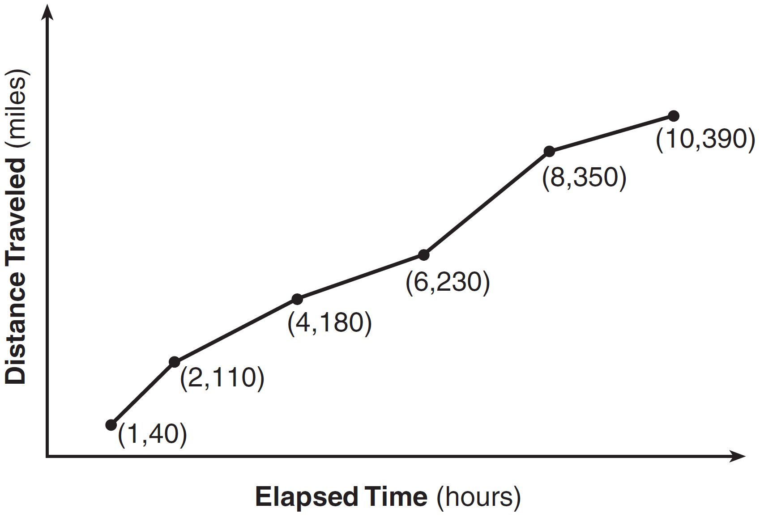

During which interval was their average speed the greatest?
1) | the first hour to the second hour | 3) | the sixth hour to the eighth hour
2) | the second hour to the fourth hour | 4) | the eighth hour to the tenth hour

7 The graph below models the height of a remote-control helicopter over 20 seconds during flight.

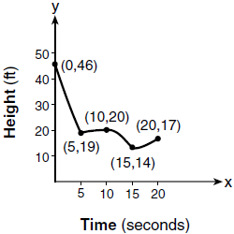

Over which interval does the helicopter have the slowest average rate of change?
1) | 0 to 5 seconds | 3) | 10 to 15 seconds
2) | 5 to 10 seconds | 4) | 15 to 20 seconds

8 Firing a piece of pottery in a kiln takes place at different temperatures for different amounts of time. The graph below shows the temperatures in a kiln while firing a piece of pottery after the kiln is preheated to 200ºF.

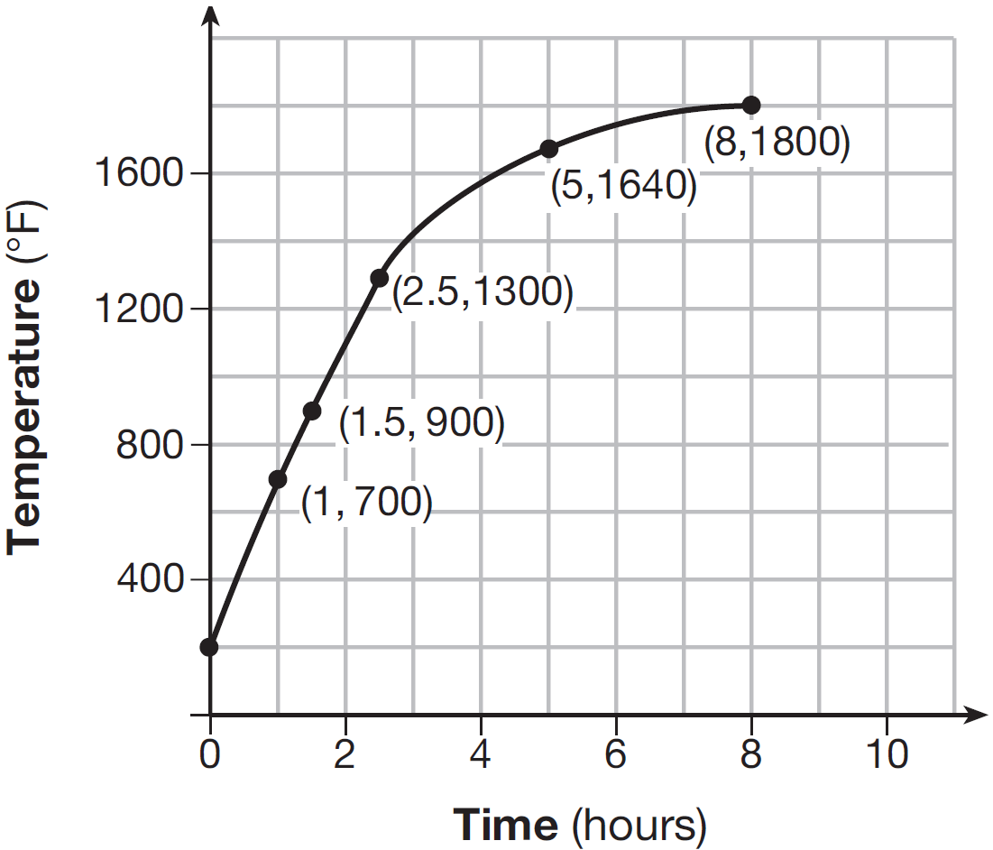

During which time interval did the temperature in the kiln show the greatest average rate of change?
1) | 0 to 1 hour | 3) | 2.5 hours to 5 hours
2) | 1 hour to 1.5 hours | 4) | 5 hours to 8 hours

9 A graph of average resting heart rates is shown below. The average resting heart rate for adults is 72 beats per minute, but doctors consider resting rates from 60-100 beats per minute within normal range.
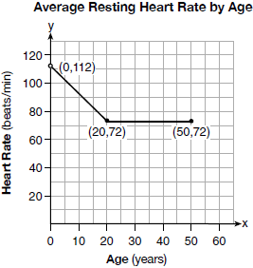
Which statement about average resting heart rates is not supported by the graph?
1) | A 10-year-old has the same average resting heart rate as a 20-year-old. | 3) | A 40-year-old may have the same average resting heart rate for ten years.
2) | A 20-year-old has the same average resting heart rate as a 30-year-old. | 4) | The average resting heart rate for teenagers steadily decreases.

10 Voting rates in presidential elections from 1996-2012 are modeled below.
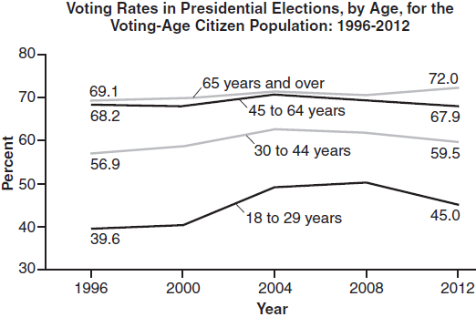

Which statement does not correctly interpret voting rates by age based on the given graph?
1) | For citizens 18-29 years of age, the rate of change in voting rate was greatest between years 2000-2004. | 3) | About 70% of people 45 and older voted in the 2004 election.
2) | From 1996-2012, the average rate of change was positive for only two age groups. | 4) | The voting rates of eligible age groups lies between 35 and 75 percent during presidential elections every 4 years from 1996-2012.

11 The graph below shows the variation in the average temperature of Earth's surface from 1950-2000, according to one source.
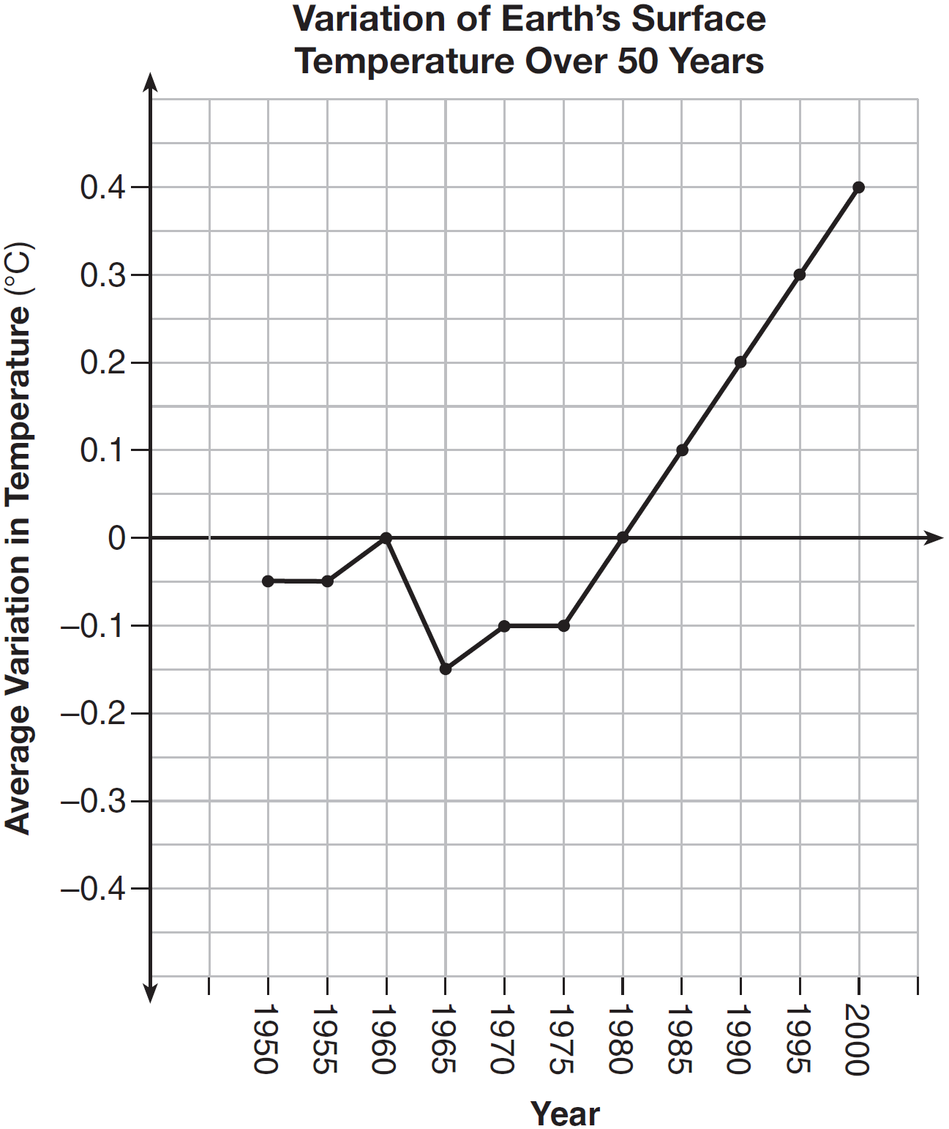

During which years did the temperature variation change the most per unit time? Explain how you determined your answer.

12 A manager wanted to analyze the online shoe sales for his business. He collected data for the number of pairs of shoes sold each hour over a 14-hour time period. He created a graph to model the data, as shown below.
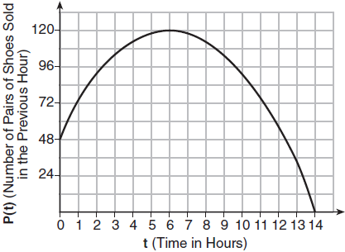

The manager believes the set of integers would be the most appropriate domain for this model. Explain why he is incorrect. State the entire interval for which the number of pairs of shoes sold is increasing. Determine the average rate of change between the sixth and fourteenth hours, and explain what it means in the context of the problem.

13 The table below shows the average diameter of a pupil in a person’s eye as he or she grows older.

Age  (years) | Average Pupil  Diameter (mm)
20 | 4.7
30 | 4.3
40 | 3.9
50 | 3.5
60 | 3.1
70 | 2.7
80 | 2.3

What is the average rate of change, in millimeters per year, of a person’s pupil diameter from age 20 to age 80?
1) | 2.4 | 3)
2) | 0.04 | 4)

14 Joey enlarged a 3-inch by 5-inch photograph on a copy machine. He enlarged it four times. The table below shows the area of the photograph after each enlargement.

Enlargement | 0 | 1 | 2 | 3 | 4
Area (square inches) | 15 | 18.8 | 23.4 | 29.3 | 36.6

What is the average rate of change of the area from the original photograph to the fourth enlargement, to the nearest tenth?
1) | 4.3 | 3) | 5.4
2) | 4.5 | 4) | 6.0

15 A family is traveling from their home to a vacation resort hotel. The table below shows their distance from home as a function of time.

Time (hrs) | 0 | 2 | 5 | 7
Distance (mi) | 0 | 140 | 375 | 480

Determine the average rate of change between hour 2 and hour 7, including units.

16 The table below represents the height of a bird above the ground during flight, with representing height in feet and t representing time in seconds.

t | P(t)
0 | 6.71
3 | 6.26
4 | 6
9 | 3.41

Calculate the average rate of change from 3 to 9 seconds, in feet per second.

17 The table below shows the year and the number of households in a building that had high-speed broadband internet access.

Number of  Households | 11 | 16 | 23 | 33 | 42 | 47
Year | 2002 | 2003 | 2004 | 2005 | 2006 | 2007

For which interval of time was the average rate of change the smallest?
1) | 2002 - 2004 | 3) | 2004 - 2006
2) | 2003 - 2005 | 4) | 2005 - 2007

18 The table below shows the cost of mailing a postcard in different years. During which time interval did the cost increase at the greatest average rate?

Year | 1898 | 1971 | 1985 | 2006 | 2012
Cost (¢) | 1 | 6 | 14 | 24 | 35

1) | 1898-1971 | 3) | 1985-2006
2) | 1971-1985 | 4) | 2006-2012

19 A blizzard occurred on the East Coast during January, 2016. Snowfall totals from the storm were recorded for Washington, D.C. and are shown in the table below.

Washington, D.C.
Time | Snow (inches)
1 a.m. | 1
3 a.m. | 5
6 a.m. | 11
12 noon | 33
3 p.m. | 36

Which interval, 1 a.m. to 12 noon or 6 a.m. to 3 p.m., has the greater rate of snowfall, in inches per hour? Justify your answer.
1 ANS: 2
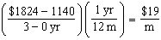

REF: 062105ai

2 ANS: 1
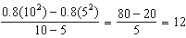

REF: 011521ai

3 ANS:
There are 20 rabbits at and they are growing 1.4% per day. 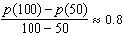

REF: 061833ai

4 ANS:
and because horizontal lines have zero slope.

REF: 011928ai

5 ANS: 1
The graph is steepest between hour 0 and hour 1.

REF: 081601ai

6 ANS: 1
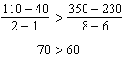

REF: 061418ai

7 ANS: 2
The slope of a line connecting and is lowest.

REF: 081705ai

8 ANS: 1 REF: 081515ai

9 ANS: 1 REF: 011721ai

10 ANS: 2
From 1996-2012, the average rate of change was positive for three age groups.

REF: 011824ai

11 ANS:
During 1960-1965 the graph has the steepest slope.

REF: 011628ai

12 ANS:
The set of integers includes negative numbers, so is not an appropriate domain for time; for , the hourly rate is increasing, or for , the total numbers of shoes is increasing; 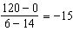, 15 fewer shoes were sold each hour between the sixth and fourteenth hours.

REF: 011836ai

13 ANS: 4
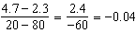.

REF: 081414ai

14 ANS: 3
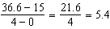

REF: 061511ai

15 ANS:
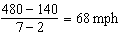

REF: 011731ai

16 ANS:
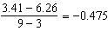

REF: 081827ai

17 ANS: 1 REF: 061603ai

18 ANS: 4
(1) 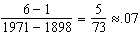 (2) 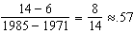 (3) 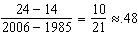 (4) 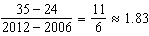

REF: 011613ai

19 ANS:
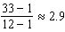 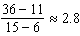 The interval 1 a.m. to 12 noon has the greater rate.

REF: 061929ai

