1 Morgan can start wrestling at age 5 in Division 1. He remains in that division until his next odd birthday when he is required to move up to the next division level. Which graph correctly represents this information?
1) | 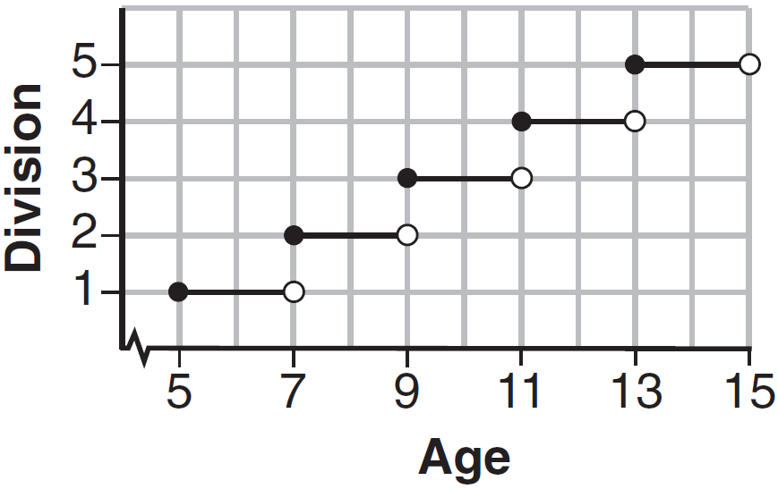
2) | 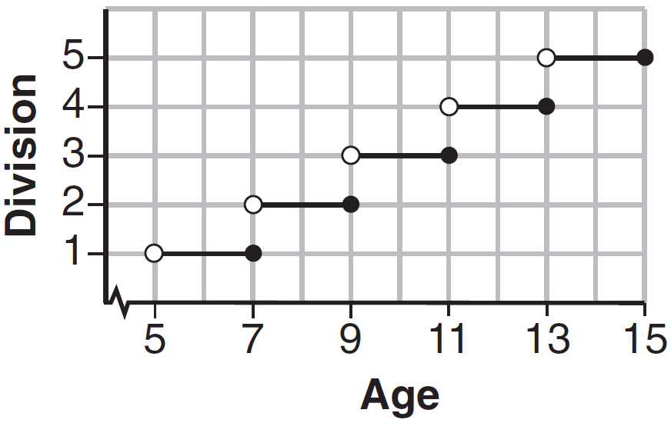
3) | 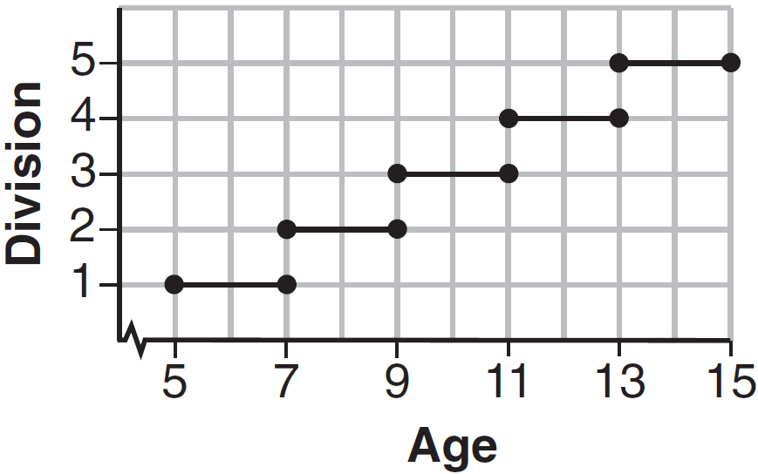
4) | 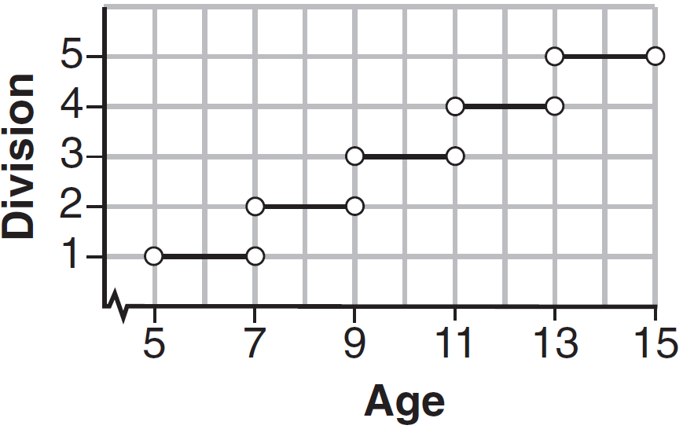

2 The table below lists the total cost for parking for a period of time on a street in Albany, N.Y. The total cost is for any length of time up to and including the hours parked. For example, parking for up to and including 1 hour would cost $1.25; parking for 3.5 hours would cost $5.75.

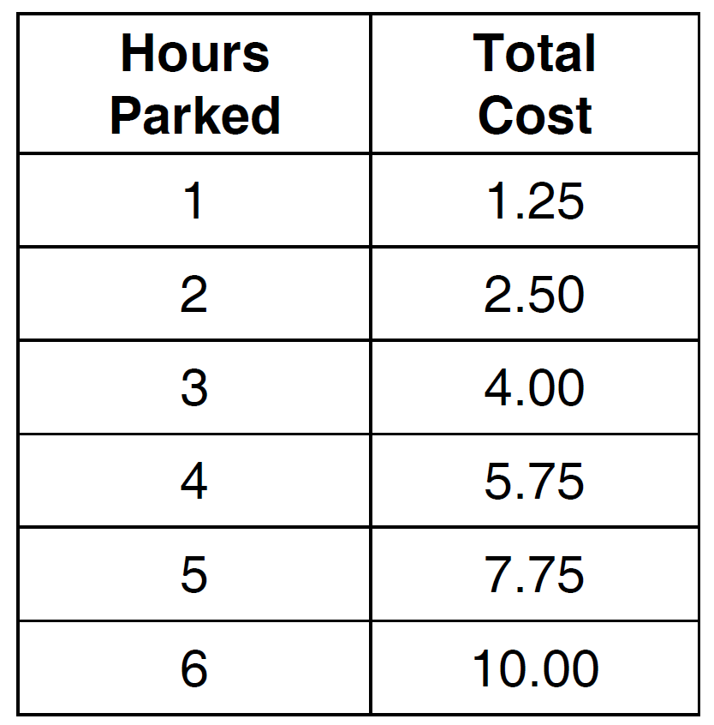

Graph the step function that represents the cost for the number of hours parked.

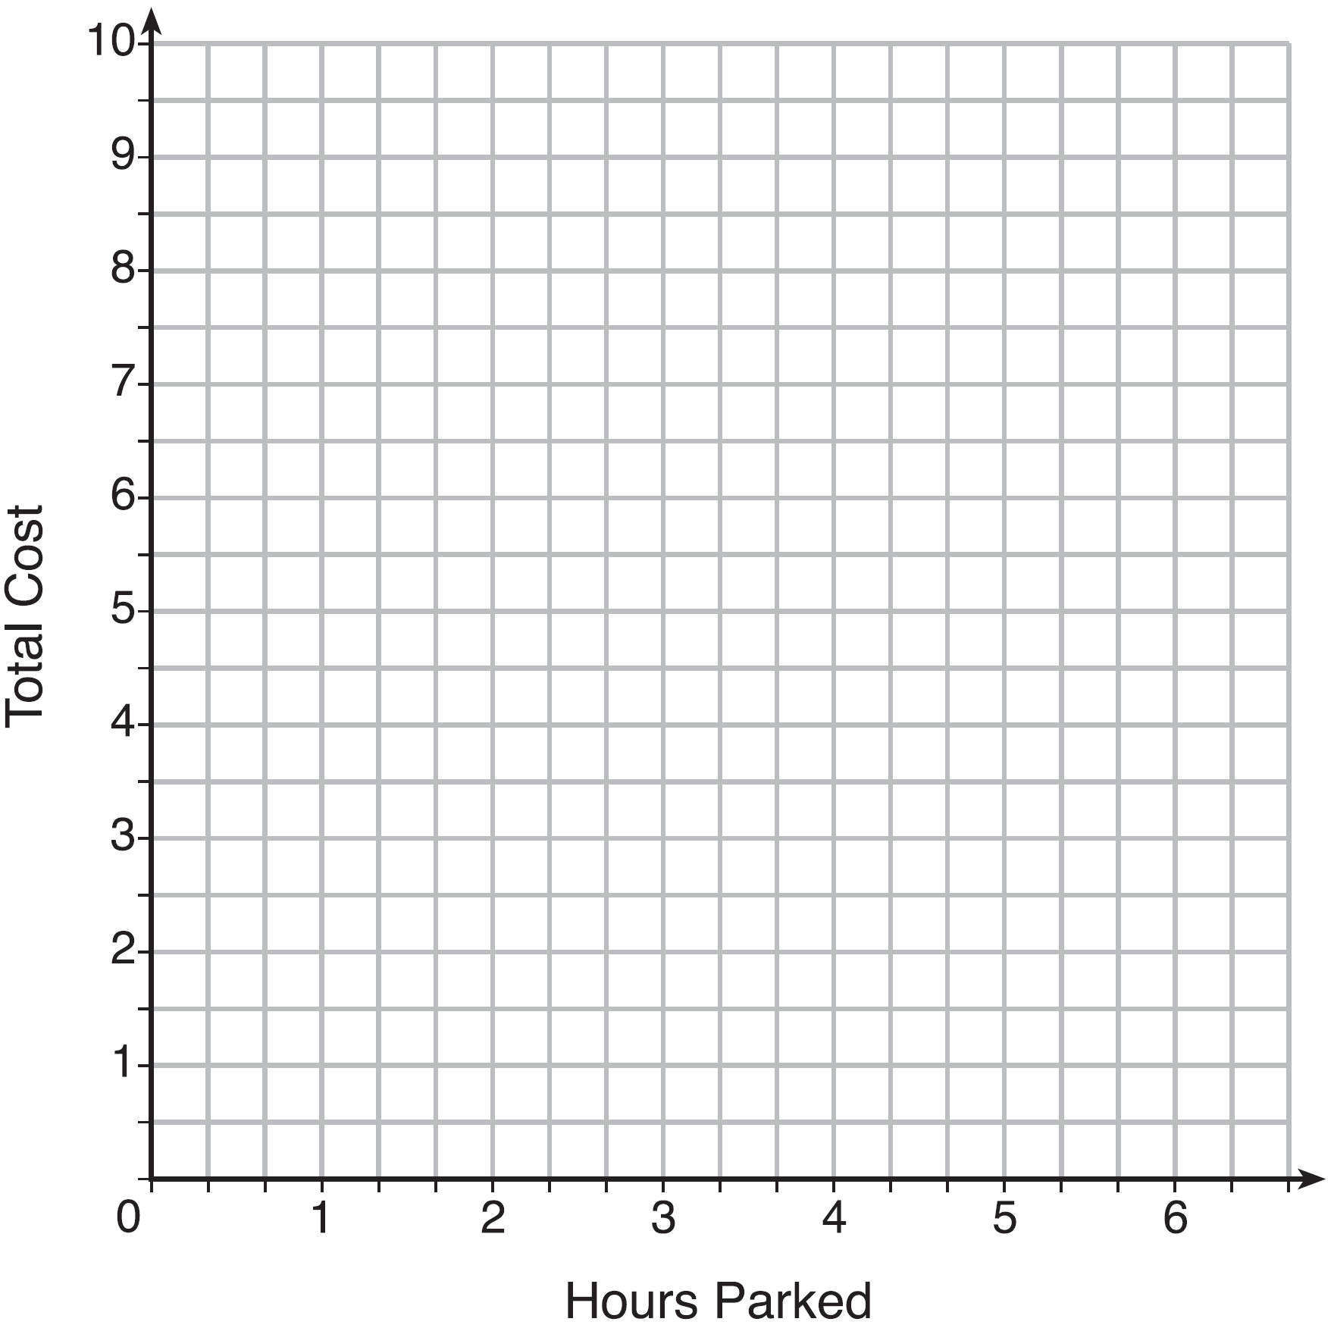

Explain how the cost per hour to park changes over the six-hour period.

1 ANS: 1 REF: 061507ai

2 ANS:
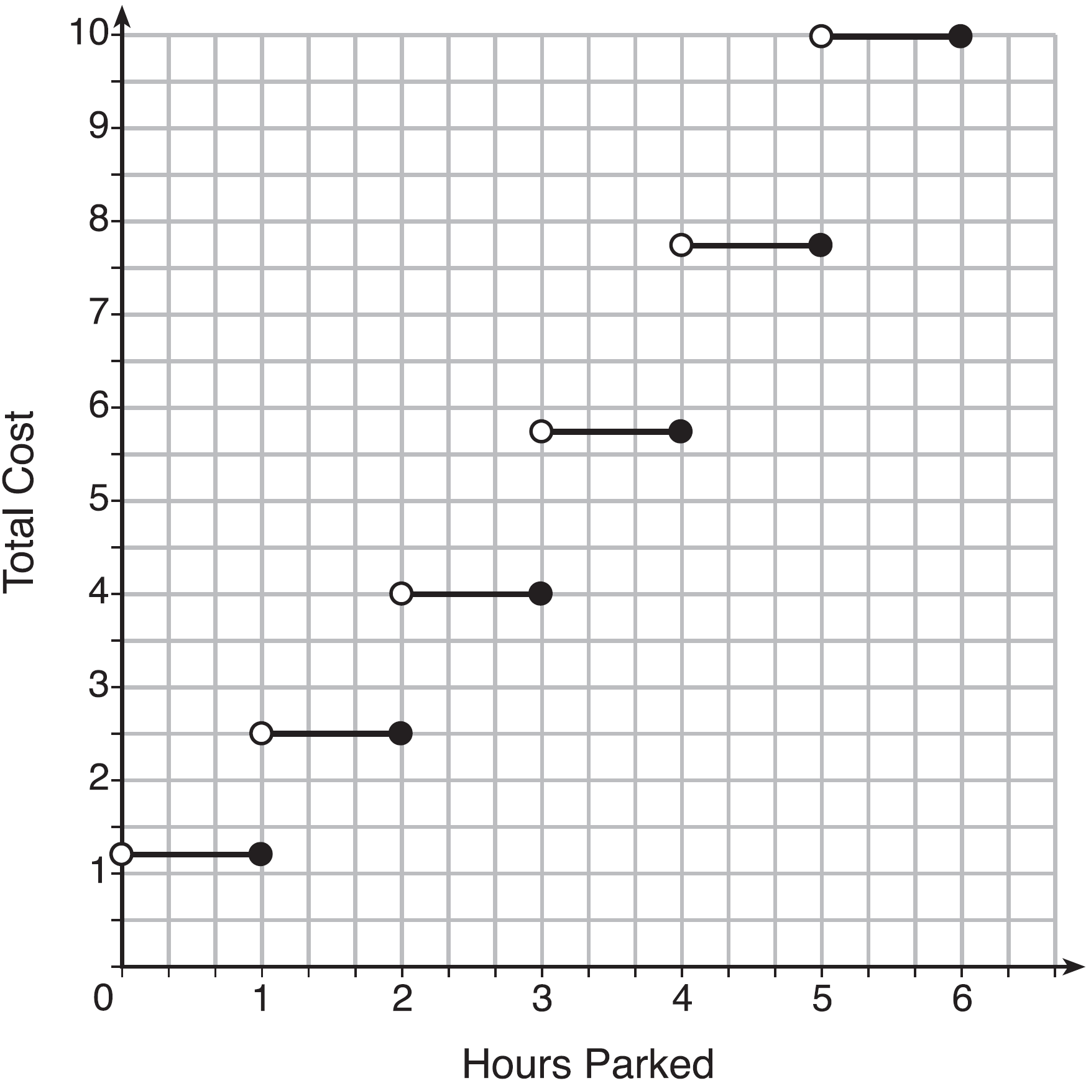 The cost for each additional hour increases after the first 2 hours.

REF: fall1311ai

