1 The quadratic functions and are given below.
x | r(x)
0
1 | 7

The function with the smaller minimum value is
1) | , and the value is | 3) | , and the value is
2) | , and the value is | 4) | , and the value is

2 Which statement is true about the quadratic functions , shown in the table below, and ?
x | g(x)
0 | 4
1
2
3
4
5
6 | 4

1) | They have the same vertex. | 3) | They have the same axis of symmetry.
2) | They have the same zeros. | 4) | They intersect at two points.

3 Given the following quadratic functions:
and

x |  |  |  | 0 | 1 | 2 | 3 | 4 | 5
n(x) |  | 0 | 5 | 8 | 9 | 8 | 5 | 0

Which statement about these functions is true?
1) | Over the interval , the average rate of change for is less than that for . | 3) | The function has a greater maximum value than .
2) | The y-intercept of is greater than the y-intercept for . | 4) | The sum of the roots of is greater than the sum of the roots of .

4 The function , which is graphed below, and the function are given.

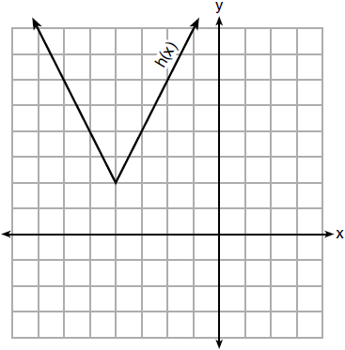

Which statements about these functions are true?
I. has a lower minimum value than .
II. For all values of x, .
III. For any value of x, .
1) | I and II, only | 3) | II and III, only
2) | I and III, only | 4) | I, II, and III

5 Which function has the greatest y-intercept?
1) |  | 3) | the line that has a slope of 2 and passes through
2) |  | 4) | 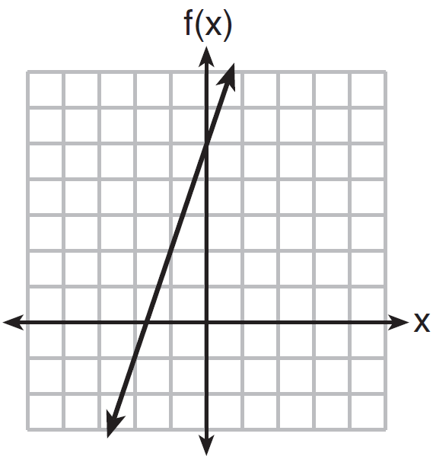

6 Which statement is true about the functions and , given below?
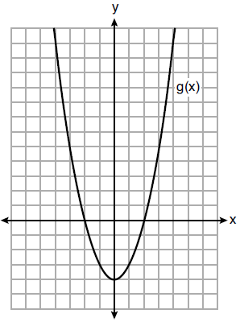

1) | The minimum value of is greater than the maximum value of . | 3) | and have the same roots.
2) | and have the same y-intercept. | 4) | when .

7 Nancy works for a company that offers two types of savings plans. Plan A is represented on the graph below.
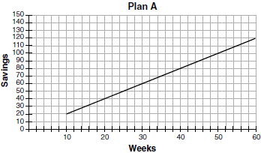
Plan B is represented by the function , where x is the number of weeks. Nancy wants to have the highest savings possible after a year. Nancy picks Plan B. Her decision is
1) | correct, because Plan B is an exponential function and will increase at a faster rate | 3) | incorrect, because Plan A will have a higher value after 1 year
2) | correct, because Plan B is a quadratic function and will increase at a faster rate | 4) | incorrect, because Plan B is a quadratic function and will increase at a slower rate

8 Three functions are shown below.
A: 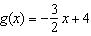
B:
C: 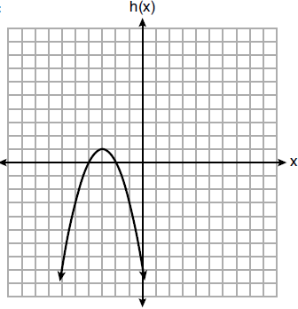
Which statement is true?
1) | B and C have the same zeros. | 3) | B has a minimum and C has a maximum.
2) | A and B have the same y-intercept. | 4) | C has a maximum and A has a minimum.

9 The functions and are shown below.
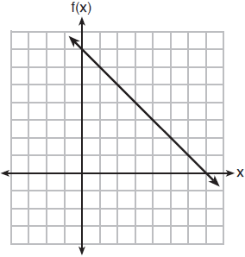
x | p(x)
2 | 5
3 | 4
4 | 3
5 | 4
6 | 5
When the input is 4, which functions have the same output value?
1) | and only | 3) | and , only
2) | and , only | 4) | and

10 Three functions are shown below.

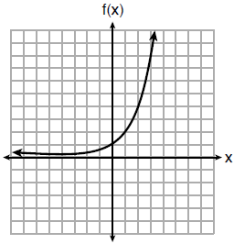

x | h(x)
 | 30
 | 14
 | 6
 | 2
 | 0
0
1
2

Which statement is true?
1) | The y-intercept for is greater than the y-intercept for . | 3) | The y-intercept for is greater than the y-intercept for both and .
2) | The y-intercept for is greater than the y-intercept for . | 4) | The y-intercept for is greater than the y-intercept for both and .

11 Which function has the smallest y-intercept?
1) |  | 3)
2) | 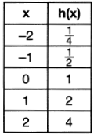 | 4) | 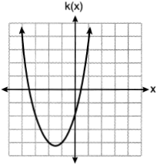

12 Given the functions , , and shown below:

x | f(x)
0 | 1
1 | 2
2 | 5
3 | 7

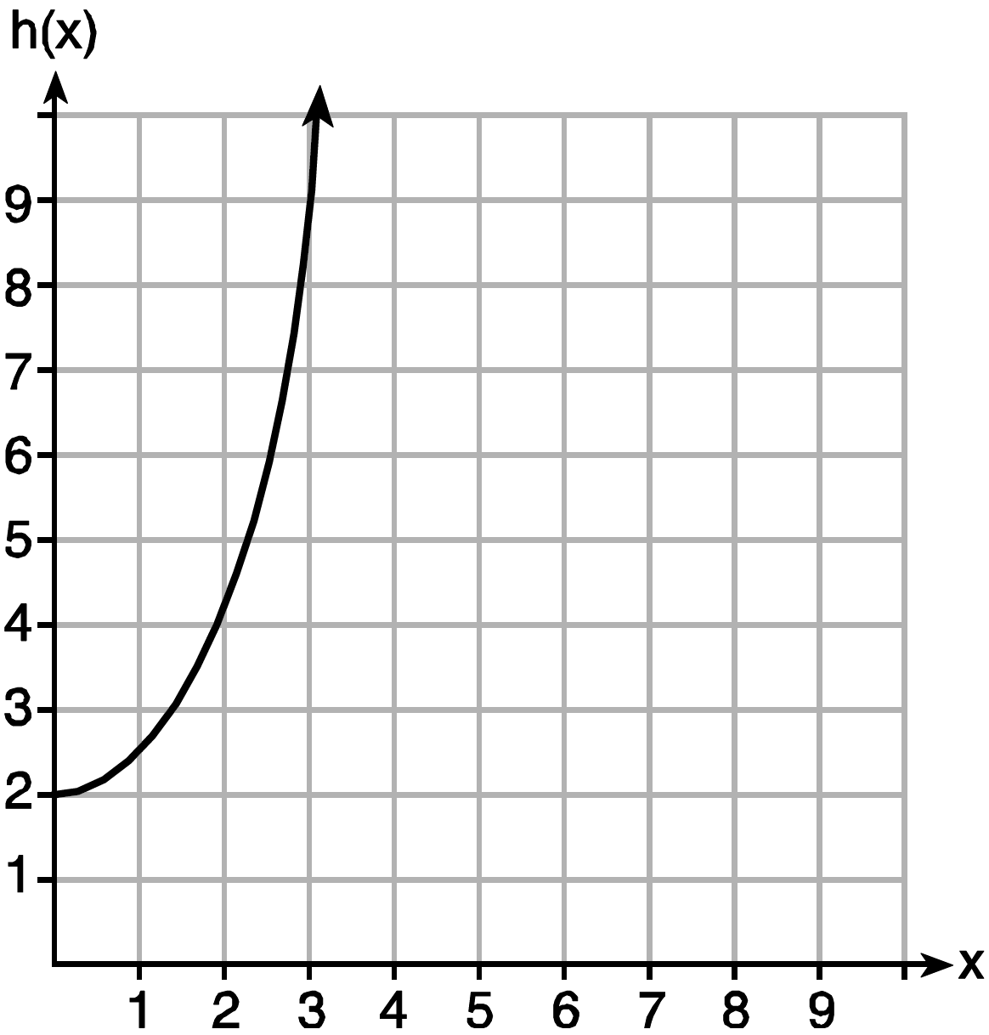

The correct list of functions ordered from greatest to least by average rate of change over the interval is
1) | , , | 3) | , ,
2) | , , | 4) | , ,

13 Which graph does not represent a function that is always increasing over the entire interval ?
1) | 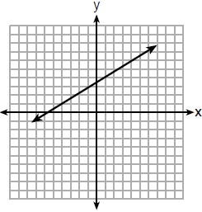 | 3) | 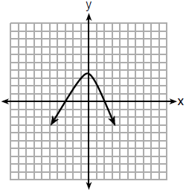
2) | 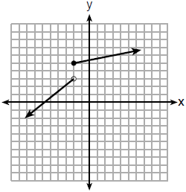 | 4) | 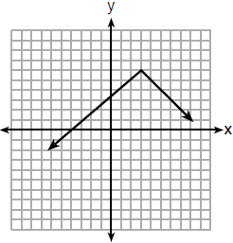

14 Which function has a constant rate of change equal to ?
1) | 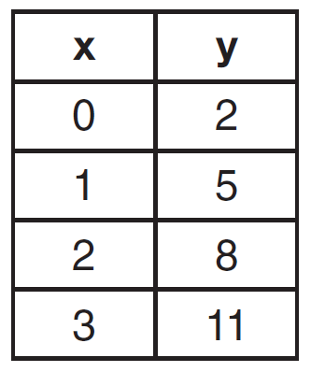 | 3) | 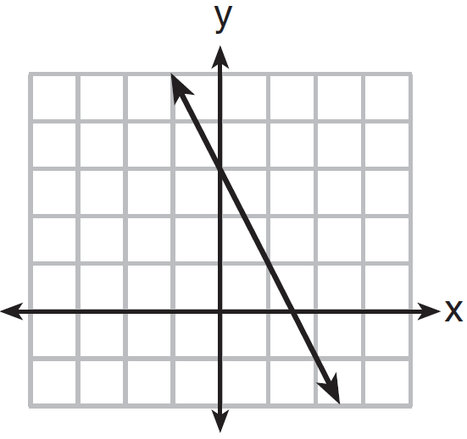
2) |  | 4)

15 Which quadratic function has the largest maximum?
1) |  | 3)
2) | 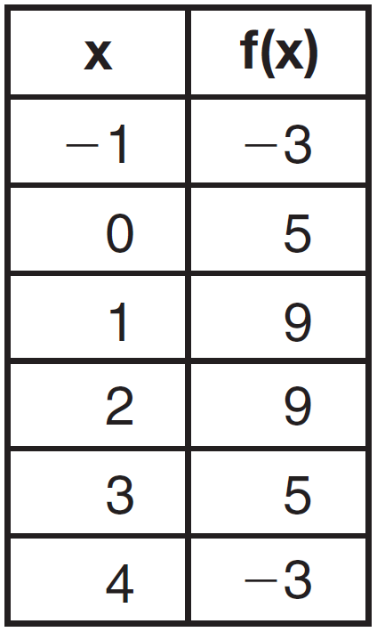 | 4) | 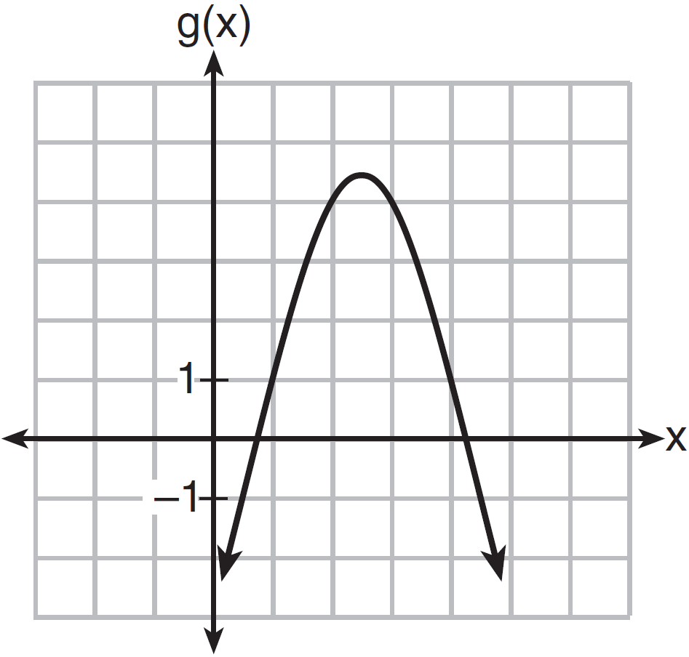

16 Which of the quadratic functions below has the smallest minimum value?
1) |  | 3)
2) | 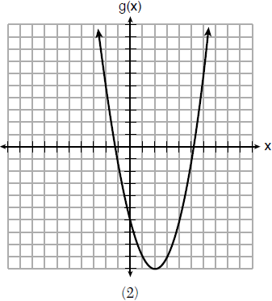 | 4) | 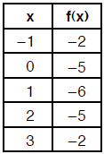

17 Which quadratic function has the largest maximum over the set of real numbers?
1) |  | 3)
2) | 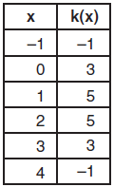 | 4) | 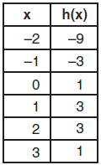

18 The graph representing a function is shown below.

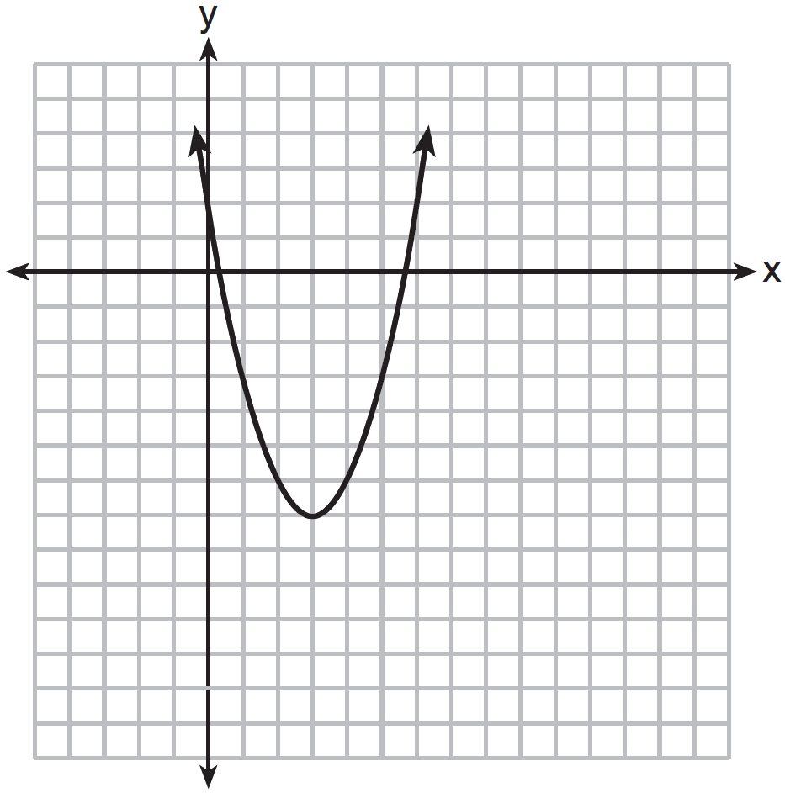

Which function has a minimum that is less than the one shown in the graph?
1) |  | 3)
2) |  | 4)

19 Let f be the function represented by the graph below.

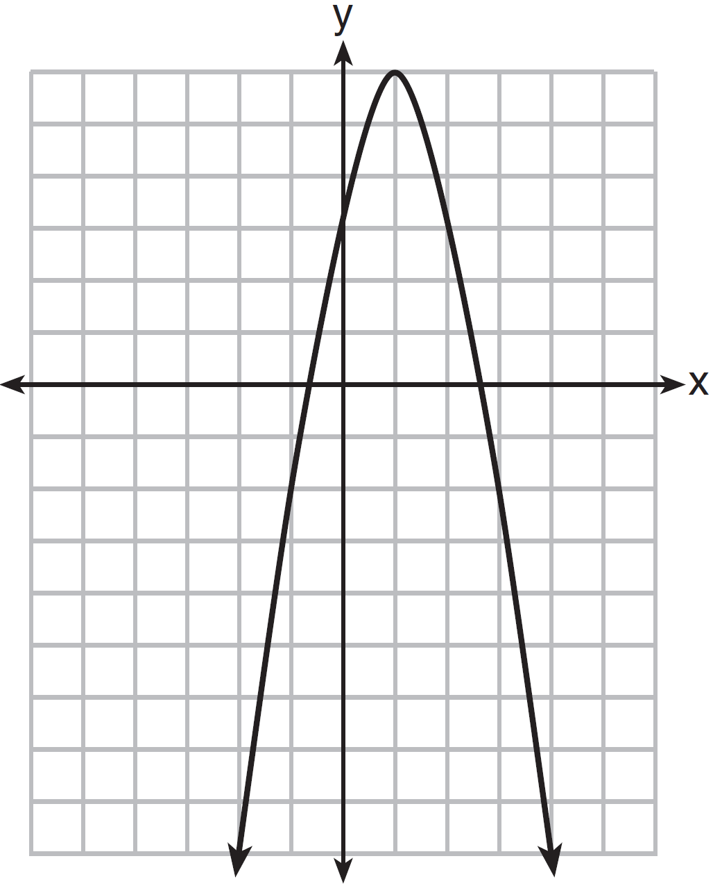

Let g be a function such that 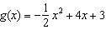. Determine which function has the larger maximum value. Justify your answer.
1 ANS: 3
The minimum of is . The minimum of is 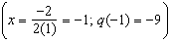.

REF: 081917ai

2 ANS: 3

REF: 061717ai

3 ANS: 4
1) 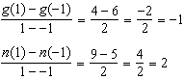 2) 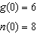 3) 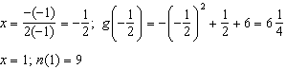
4) 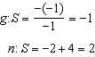

REF: 081521ai

4 ANS: 2
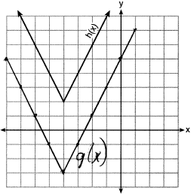

REF: 081718ai

5 ANS: 4
1) ; 2) ; 3) ; 4)

REF: 081611ai

6 ANS: 2
The y-intercept of both and is .

REF: 012013ai

7 ANS: 2 REF: 011723ai

8 ANS: 3
1) B’s zeros are and and C’s zeros are and ; 2) A’s y-intercept is 4 and B’s y-intercept is 12; 3) B in standard form, and C in standard form, ; d) A has no minimum

REF: 061914ai

9 ANS: 4

REF: 011921ai

10 ANS: 4
The y-intercept for is . The y-intercept for is . The y-intercept for is .

REF: 081811ai

11 ANS: 1
1) -6; 2) 1; 3) -2; 4) -2

REF: 062115ai

12 ANS: 4
Over the interval , the average rate of change for 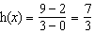, 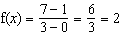, and 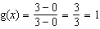.

REF: spr1301ai

13 ANS: 3 REF: 061820ai

14 ANS: 4
1) ; 2) 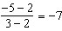; 3) ; 4)

REF: 081615ai

15 ANS: 3
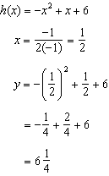Maximum of 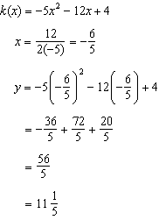 Maximum of

REF: 061514ai

16 ANS: 2
1) 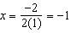, ; 2) ; 3) 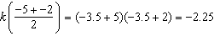; 4)

REF: 061813ai

17 ANS: 2
1) 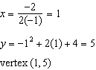; 2) 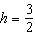 Using , 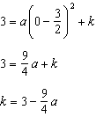; Using , 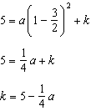 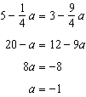 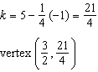; 3) vertex ; 4) Using 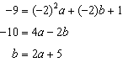 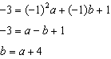 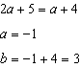 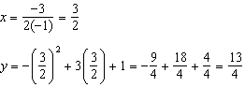 vertex 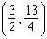

REF: 011823ai

18 ANS: 3 REF: 011622ai

19 ANS:
g. The maximum of f is 6. For g, the maximum is 11. 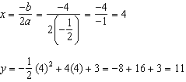

REF: 081429ai

