1 The following conversion was done correctly:
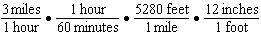
What were the final units for this conversion?
1) | minutes per foot | 3) | feet per minute
2) | minutes per inch | 4) | inches per minute

2 Peyton is a sprinter who can run the 40-yard dash in 4.5 seconds. He converts his speed into miles per hour, as shown below.
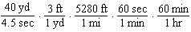
Which ratio is incorrectly written to convert his speed?
1) |  | 3) | 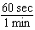
2) | 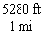 | 4) | 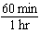

3 Olivia entered a baking contest. As part of the contest, she needs to demonstrate how to measure a gallon of milk if she only has a teaspoon measure. She converts the measurement using the ratios below:
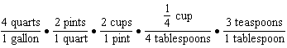
Which ratio is incorrectly written in Olivia's conversion?
1) | 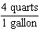 | 3) | 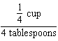
2) | 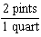 | 4) | 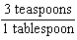

4 A construction worker needs to move 120 ft³ of dirt by using a wheelbarrow. One wheelbarrow load holds 8 ft³ of dirt and each load takes him 10 minutes to complete. One correct way to figure out the number of hours he would need to complete this job is
1) | 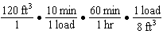 | 3) | 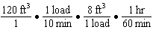
2) | 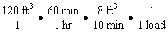 | 4) | 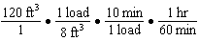

5 Bamboo plants can grow 91 centimeters per day. What is the approximate growth of the plant, in inches per hour?
1) | 1.49 | 3) | 9.63
2) | 3.79 | 4) | 35.83

6 Dan took 12.5 seconds to run the 100-meter dash. He calculated the time to be approximately
1) | 0.2083 minute | 3) | 0.2083 hour
2) | 750 minutes | 4) | 0.52083 hour

7 Sarah travels on her bicycle at a speed of 22.7 miles per hour. What is Sarah's approximate speed, in kilometers per minute?
1) | 0.2 | 3) | 36.5
2) | 0.6 | 4) | 36.6

8 The Utica Boilermaker is a 15-kilometer road race. Sara is signed up to run this race and has done the following training runs:
I. 10 miles
II. 44,880 feet
III. 15,560 yards
Which run(s) are at least 15 kilometers?
1) | I, only | 3) | I and III
2) | II, only | 4) | II and III

9 A news report suggested that an adult should drink a minimum of 4 pints of water per day. Based on this report, determine the minimum amount of water an adult should drink, in fluid ounces, per week.

10 A typical marathon is 26.2 miles. Allan averages 12 kilometers per hour when running in marathons. Determine how long it would take Allan to complete a marathon, to the nearest tenth of an hour. Justify your answer.

11 Faith wants to use the formula  to convert degrees Fahrenheit, f, to degrees Celsius, . If Faith calculated , what would her result be?
1) | 20° Celsius | 3) | 154° Celsius
2) | 20° Fahrenheit | 4) | 154° Fahrenheit

1 ANS:
inches per minute

REF: 011924ai

2 ANS:

REF: 011502ai

3 ANS:

REF: 081812ai

4 ANS:

REF: 061720ai

5 ANS:
1.49
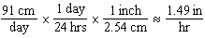

REF: 061924ai

6 ANS:
0.2083 minute
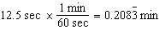

REF: 061608ai

7 ANS:
0.6
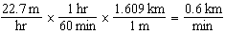

REF: 062123ai

8 ANS:
I, only
I. 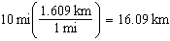; II. 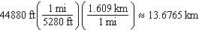; III. 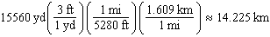

REF: 061815ai

9 ANS:
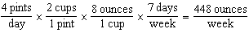

REF: 012027ai

10 ANS:
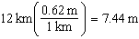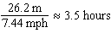

REF: 011726ai

11 ANS:
20° Celsius


REF: 011710ai

