1 About a year ago, Joey watched an online video of a band and noticed that it had been viewed only 843 times. One month later, Joey noticed that the band’s video had 1708 views. Joey made the table below to keep track of the cumulative number of views the video was getting online.

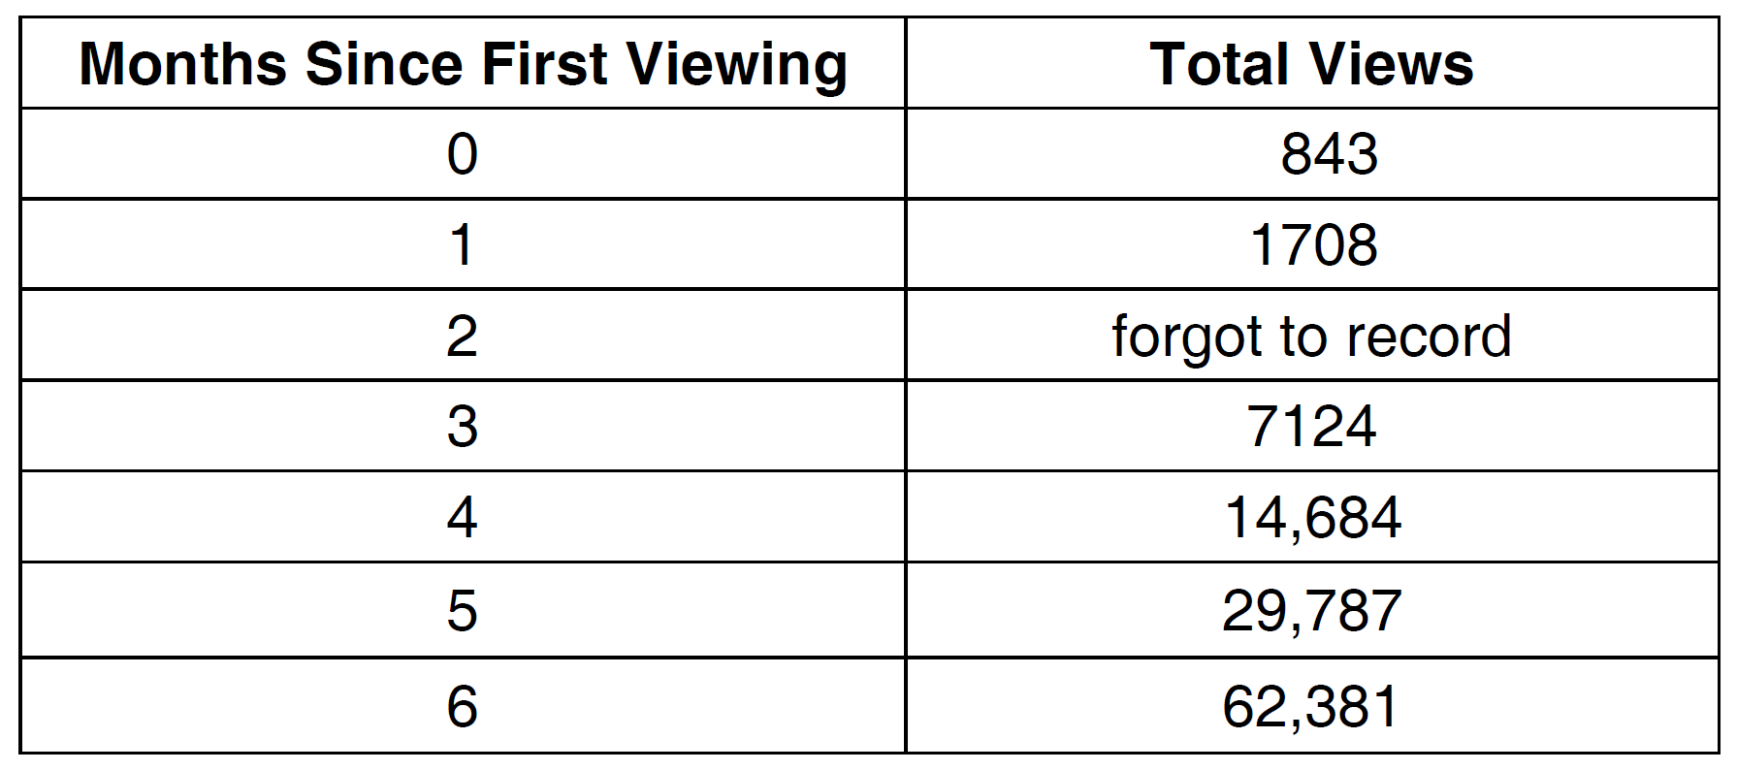

a) Write a regression equation that best models these data. Round all values to the nearest hundredth. Justify your choice of regression equation. b) As shown in the table, Joey forgot to record the number of views after the second month. Use the equation from part a to estimate the number of full views of the online video that Joey forgot to record.

1 ANS:
The data appear to grow at an exponential rate. .

REF: fall1313ai

