1 A student plotted the data from a sleep study as shown in the graph below.

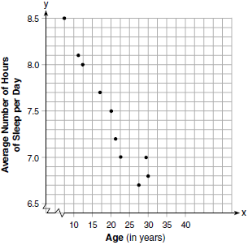

The student used the equation of the line to model the data. What does the rate of change represent in terms of these data?
1) | The average number of hours of sleep per day increases 0.09 hour per year of age. | 3) | The average number of hours of sleep per day increases 9.24 hours per year of age.
2) | The average number of hours of sleep per day decreases 0.09 hour per year of age. | 4) | The average number of hours of sleep per day decreases 9.24 hours per year of age.

2 During a recent snowstorm in Red Hook, NY, Jaime noted that there were 4 inches of snow on the ground at 3:00 p.m., and there were 6 inches of snow on the ground at 7:00 p.m. If she were to graph these data, what does the slope of the line connecting these two points represent in the context of this problem?

3 The table below shows the height in feet, , of a hot-air balloon and the number of minutes, t, the balloon is in the air.

Time (min) | 2 | 5 | 7 | 10 | 12
Height (ft) | 64 | 168 | 222 | 318 | 369

The function can be used to model this data table. Explain the meaning of the slope in the context of the problem. Explain the meaning of the y-intercept in the context of the problem.
1 ANS: 2 REF: 061704ai

2 ANS:
2 inches of snow every 4 hours.

REF: 061630ai

3 ANS:
The height of the balloon increases 30.5 ft per min. The balloon starts at a height of 8.7 ft.

REF: 062127ai

