1 A polynomial function contains the factors x, , and . Which graph(s) below could represent the graph of this function?

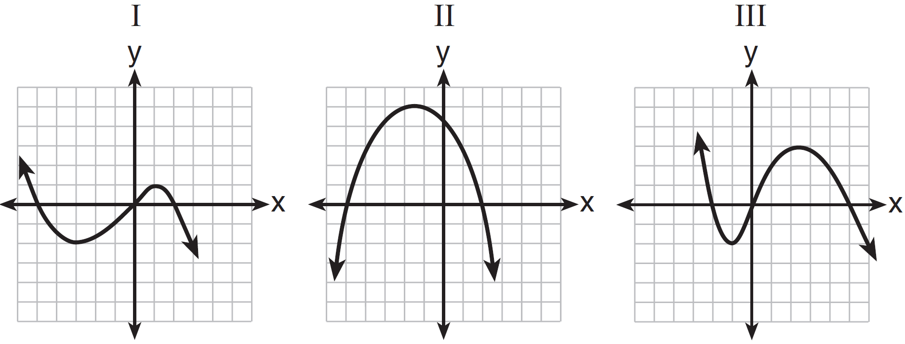
1) | I, only
2) | II, only
3) | I and III
4) | I, II, and III

2 Based on the graph below, which expression is a possible factorization of ?

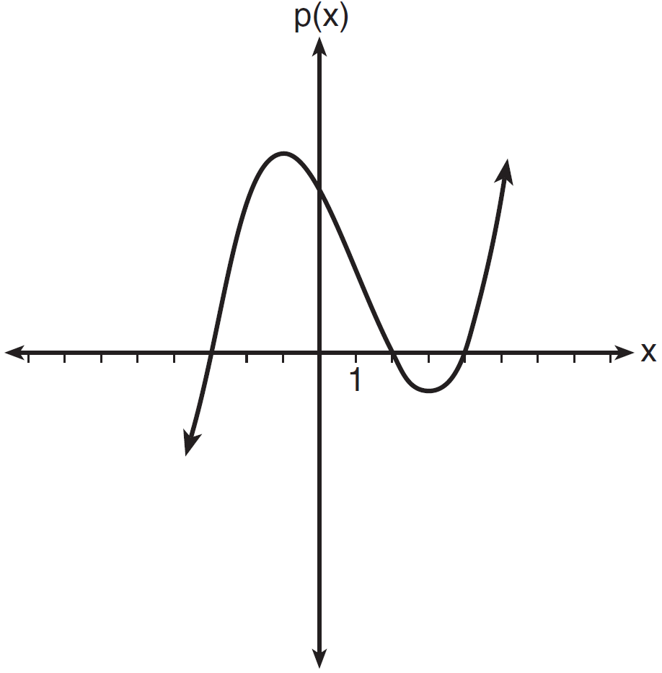
1)
2)
3)
4)

3 A cubic function is graphed on the set of axes below.

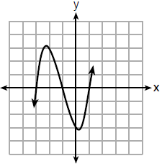

Which function could represent this graph?
1)
2)
3)
4)

4 A polynomial function is graphed below.

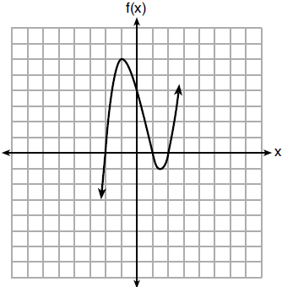

Which function could represent this graph?
1)
2)
3)
4)

5 Wenona sketched the polynomial as shown on the axes below.
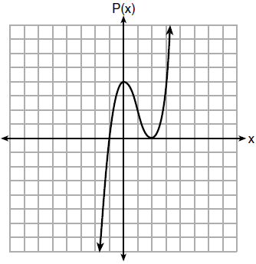
Which equation could represent ?
1)
2)
3)
4)

6 Which equation(s) represent the graph below?
I
II
III
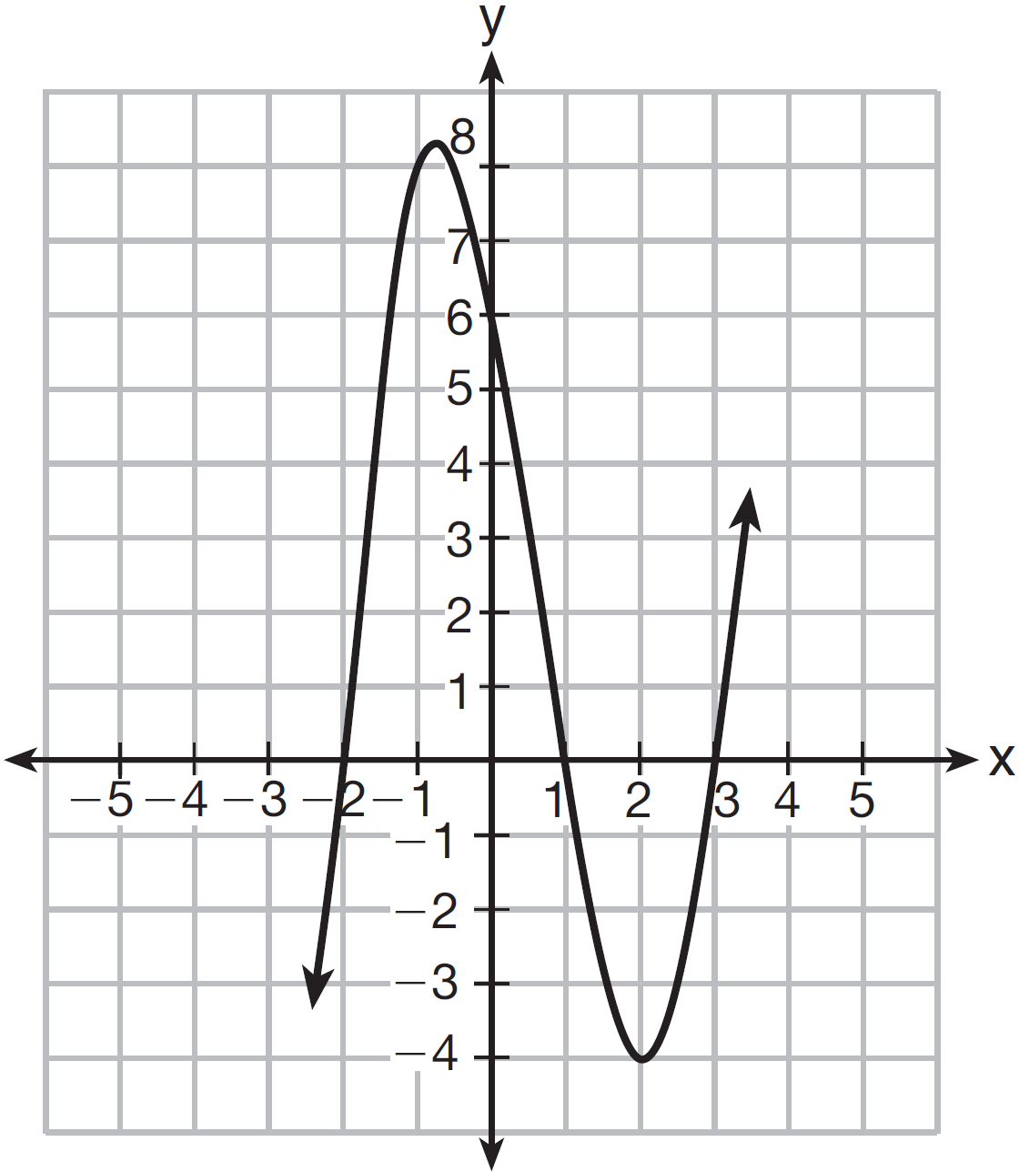
1) | I, only
2) | II, only
3) | I and II
4) | II and III

7 The graph of is shown below.

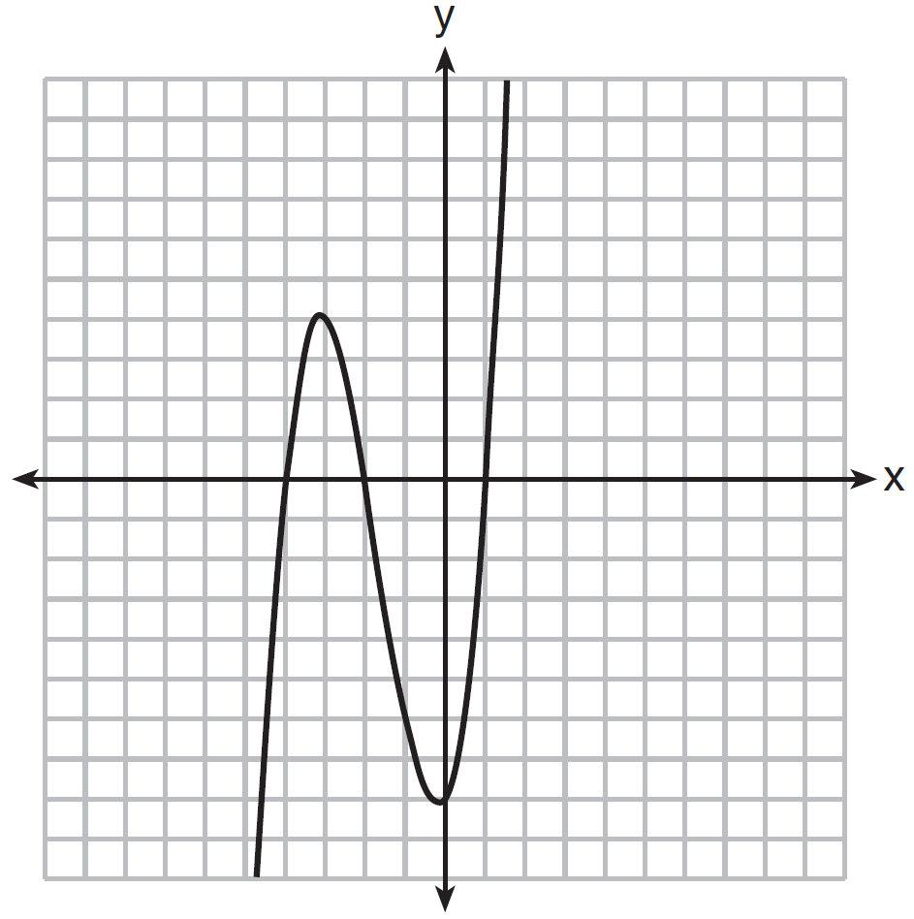

Which function could represent the graph of ?
1)
2)
3)
4)

8 Which sketch represents the polynomial function ?
1) | 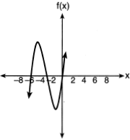
2) | 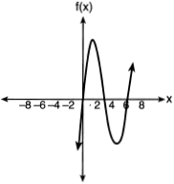
3) | 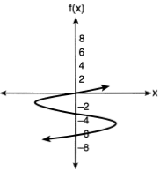
4) | 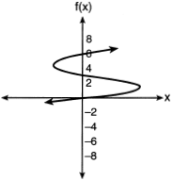

1 ANS: 1 REF: 011524ai

2 ANS: 1 REF: 081623ai

3 ANS: 2 REF: 061818ai

4 ANS: 3

REF: 061908ai

5 ANS: 1 REF: 081707ai

6 ANS: 2

REF: 061512ai

7 ANS: 1

REF: 081504ai

8 ANS: 1
The zeros of f are -6, -3 and 0.

REF: 062112ai

