1 The graphs below represent functions defined by polynomials. For which function are the zeros of the polynomials 2 and ?
1) | 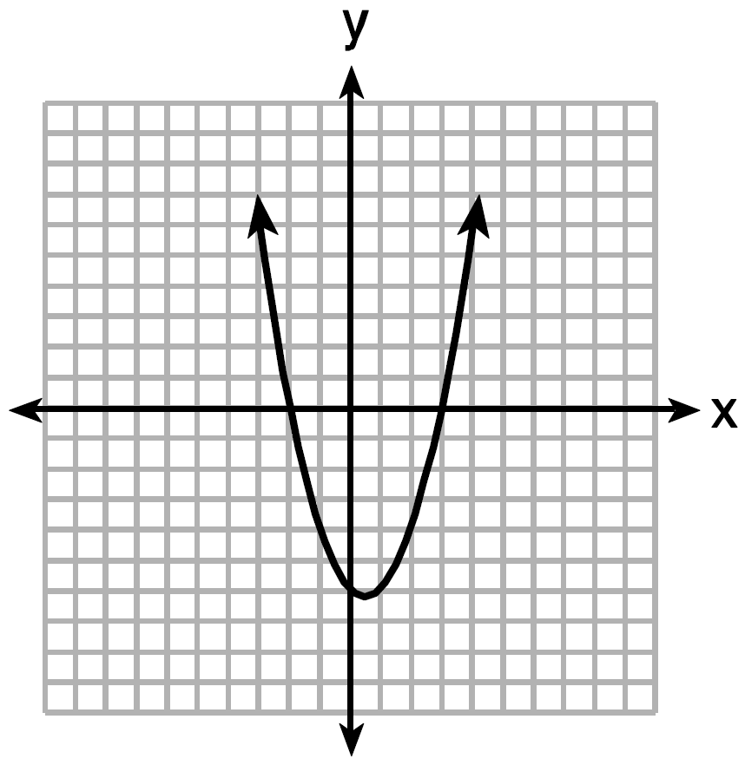
2) | 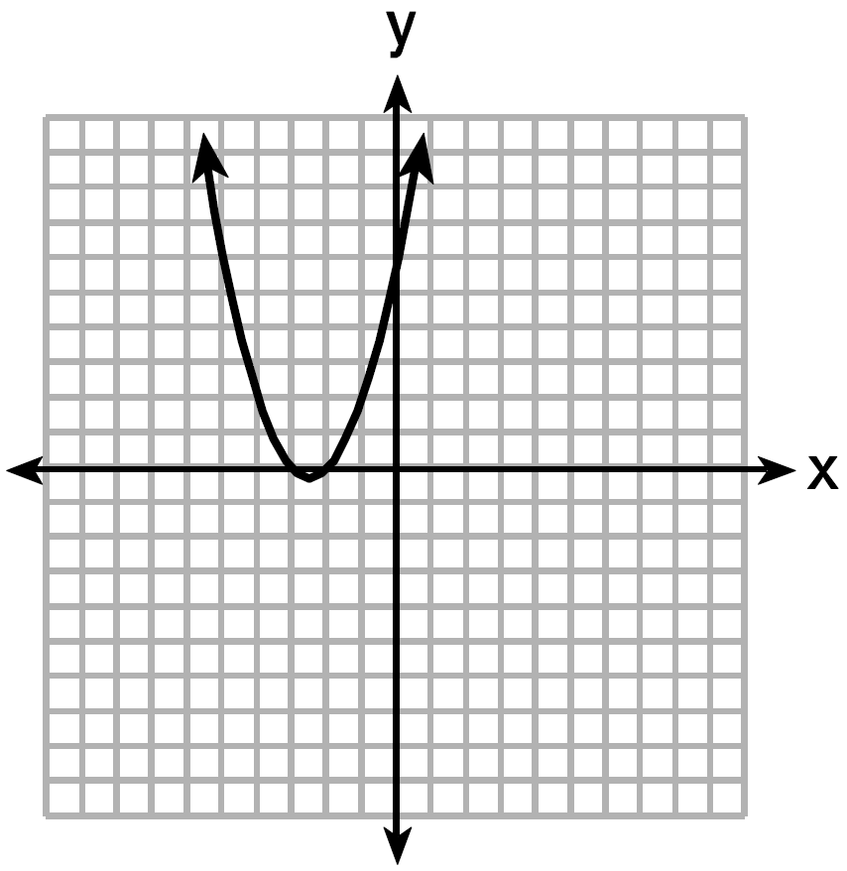
3) | 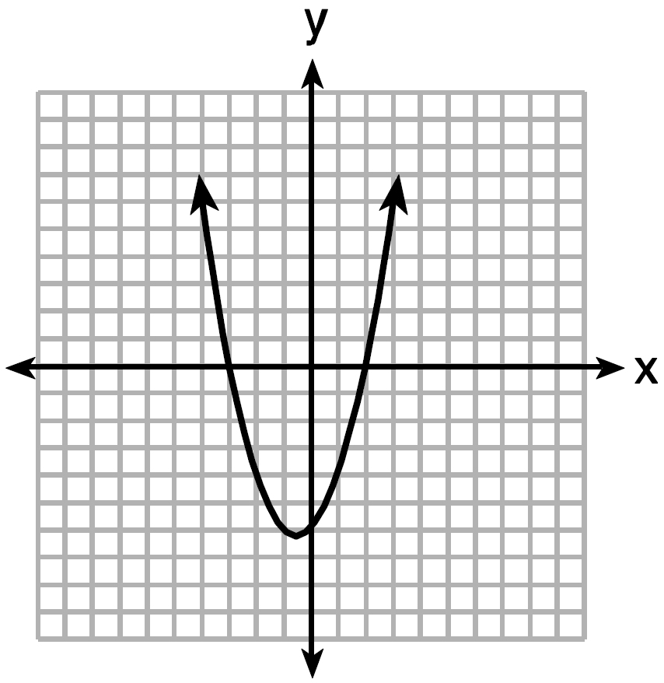
4) | 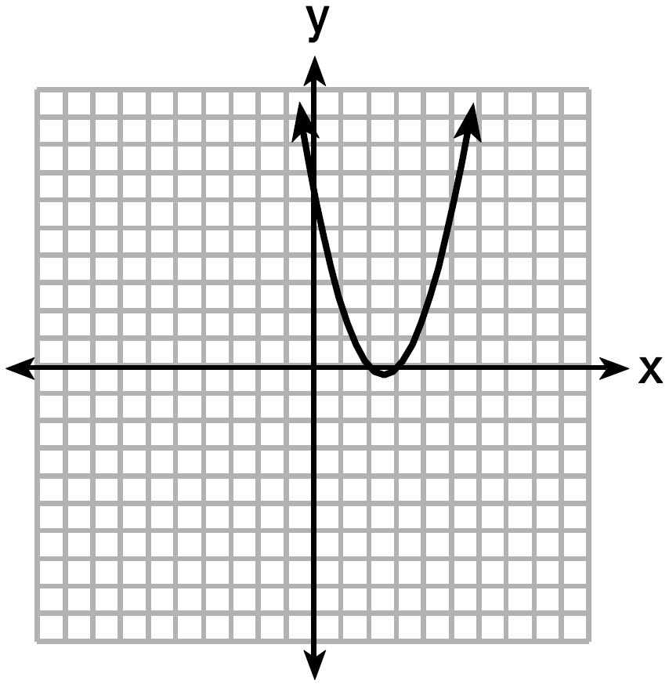

2 The graph of 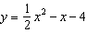 is shown below. The points , , and lie on this graph.

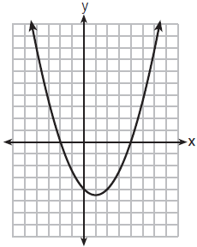

Which of these points can determine the zeros of the equation ?
1) | A, only
2) | B, only
3) | A and C, only
4) | A, B, and C

3 The zeros of the function are
1) | 9, only
2) | 0 and 9
3) | 0 and 3, only
4) | , 0, and 3

4 The zeros of the function are
1) | and 3
2) | and 4
3) | and 6
4) | and 8

5 The zeros of the function are
1) | and 6
2) | 1 and
3) | 2 and
4) | and 3

6 What are the zeros of the function ?
1) | and 3
2) | 10 and
3) | and 2
4) | 15 and

7 The zeros of the function are
1) | 3 and
2) | 3 and 1
3) | and 1
4) | and

8 The zeros of the function are
1) | and
2) | 1 and
3) | 1 and 2
4) | and 2

9 The zeros of the function are
1) | and 5
2) | and 7
3) | and 2
4) | and 3

10 Keith determines the zeros of the function to be and 5. What could be Keith's function?
1)
2)
3)
4)

11 For which function defined by a polynomial are the zeros of the polynomial and ?
1)
2)
3)
4)

12 If , which equation can be used to determine the zeros of the function?
1)
2)
3)
4)

13 Which function has zeros of -4 and 2?
1)
2) | 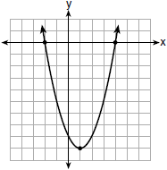
3)
4) | 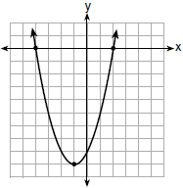

14 Determine all the zeros of , algebraically.

15 The function is defined by the expression . Use factoring to determine the zeros of . Explain what the zeros represent on the graph of .

16 Find the zeros of , algebraically.

17 Ryker is given the graph of the function 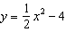. He wants to find the zeros of the function, but is unable to read them exactly from the graph.

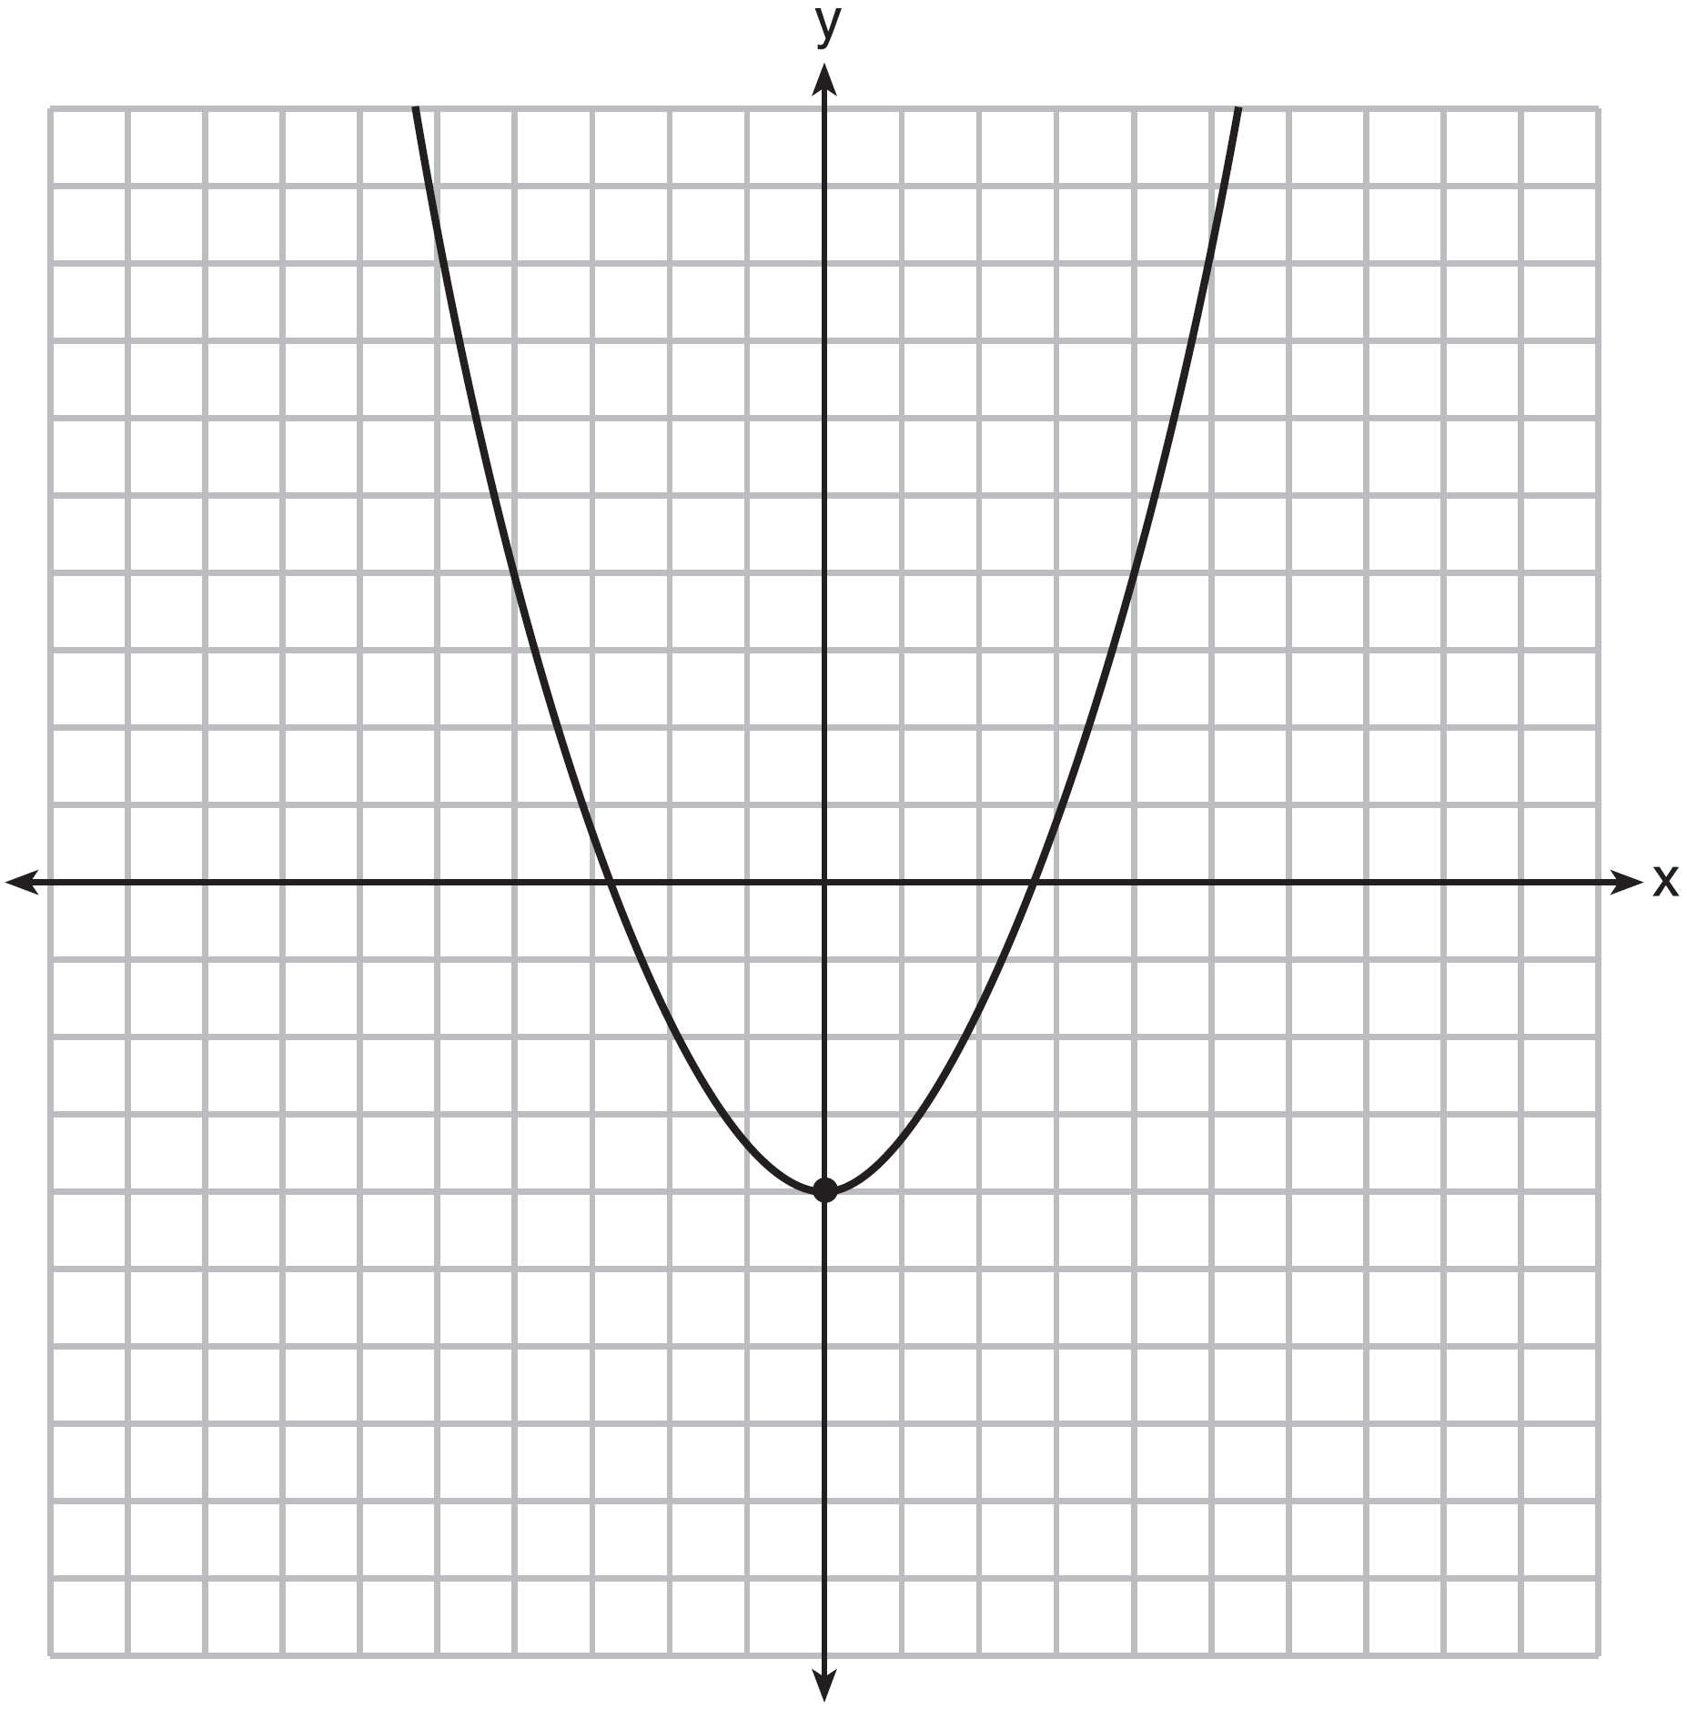

Find the zeros in simplest radical form.

18 Which polynomial function has zeros at , 0, and 4?
1)
2)
3)
4)

19 The zeros of the function are
1)
2)
3)
4)

20 Explain how to determine the zeros of . State the zeros of the function.

21 Determine algebraically the zeros of .
1 ANS: 3 REF: spr1302ai

2 ANS: 3 REF: 011909ai

3 ANS: 2
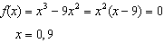

REF: 012009ai

4 ANS: 3
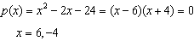

REF: 061804ai

5 ANS: 1
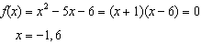

REF: 061612ai

6 ANS: 4
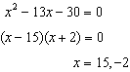

REF: 061510ai

7 ANS: 1
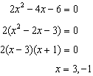

REF: 011609ai

8 ANS: 4
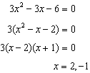

REF: 081513ai

9 ANS: 4
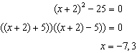

REF: 081418ai

10 ANS: 3 REF: 061412ai

11 ANS: 2
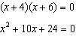

REF: spr1303ai

12 ANS: 2 REF: 081816ai

13 ANS: 4 REF: 011706ai

14 ANS:
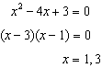

REF: 011826ai

15 ANS:
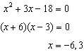 The zeros are the x-intercepts of .

REF: 061733ai

16 ANS:
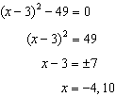

REF: 081631ai

17 ANS:
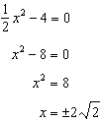

REF: fall1306ai

18 ANS: 3 REF: 061710ai

19 ANS: 3
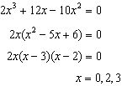

REF: 081719ai

20 ANS:
Graph and find x-intercepts.

REF: 081825ai

21 ANS:
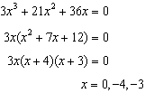

REF: 011930ai

