1 If the domain is the set of real numbers, what is the solution set for the equation ?
1)
2)
3)
4)

2 What is the solution set of the equation ?
1)
2) | {2,8}
3)
4)

3 A solution of the equation 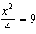 is
1) | 12
2) | 6
3) | 3
4)

4 If , the roots of the equation are
1) | and 25
2) | , only
3) | and 5
4) | , only

5 Solve algebraically.

6 What is the positive solution of the equation ?

7 Solve for the exact values of x.

8 Solve the quadratic equation below for the exact values of x.

9 Which value of x is a solution to the equation ?
1)
2)
3)
4)

10 The solutions to are
1)
2)
3) | and
4) | 1 and 7

11 The solution of the equation is
1)
2)
3)
4)

12 A student is asked to solve the equation . The student's solution to the problem starts as 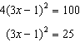
A correct next step in the solution of the problem is
1)
2)
3)
4)

13 What is the solution of the equation ?
1) | 6, only
2) | 2, only
3) | 2 and
4) | 6 and

14 What are the solutions to the equation ?
1) | 1 and 7
2) | and
3)
4)

15 The height, H, in feet, of an object dropped from the top of a building after t seconds is given by . How many feet did the object fall between one and two seconds after it was dropped? Determine, algebraically, how many seconds it will take for the object to reach the ground.
1 ANS: 4 REF: 010324siii

2 ANS: 3
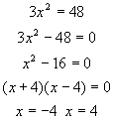

REF: 010215a

3 ANS: 2
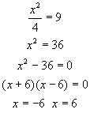

REF: 010808a

4 ANS: 3 REF: 081403ai

5 ANS:
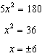

REF: 061928ai

6 ANS:
3. 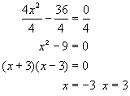

REF: 080733a

7 ANS:
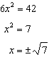

REF: 081931ai

8 ANS:
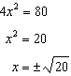

REF: 011932ai

9 ANS: 4
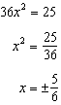

REF: 011715ai

10 ANS: 3
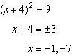

REF: 012015ai

11 ANS: 3 REF: 081523ai

12 ANS: 1 REF: 061521ai

13 ANS: 3
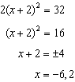

REF: 061619ai

14 ANS: 1
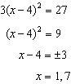

REF: 011814ai

15 ANS:
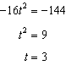
REF: 061633ai

