1 Solve for x:

2 Solve for x:

3 Solve for x:

4 Solve algebraically. Explain the first step you used to solve the given equation.

5 In the equation , b is an integer. Find algebraically all possible values of b.

6 Solve:

7 Solve the equation for y:

8 Write an equation that defines as a trinomial where . Solve for x when .

9 Solve:

10 Solve:

11 Solve the equation algebraically for x.

12 Solve:

13 Solve:

14 Solve:

15 Solve:

16 Solve for m by factoring.

17 Amy solved the equation . She stated that the solutions to the equation were and . Do you agree with Amy's solutions? Explain why or why not.

18 Janice is asked to solve . She begins the problem by writing the following steps:
Line 1
Line 2
Line 3
Use Janice's procedure to solve the equation for x. Explain the method Janice used to solve the quadratic equation.
1 ANS:
and 5. 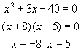

REF: 089926a

2 ANS:
. 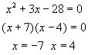

REF: 060229a

3 ANS:
. 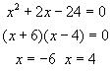

REF: 010637a

4 ANS:
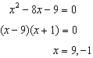 I factored the quadratic.

REF: 011927ai

5 ANS:
6 and 4

REF: 081425ai

6 ANS:
1, 5

REF: 069109al

7 ANS:
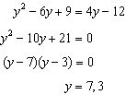

REF: 011627ai

8 ANS:
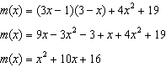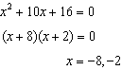

REF: 061433ai

9 ANS:
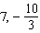

REF: 019805al

10 ANS:
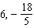

REF: 069805al

11 ANS:
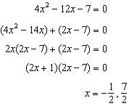

REF: 011529ai

12 ANS:
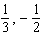

REF: 019607al

13 ANS:
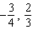

REF: 099805al

14 ANS:
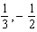

REF: 030005al

15 ANS:
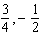

REF: 060005al

16 ANS:
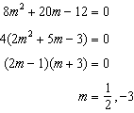

REF: fall1305ai

17 ANS:
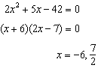 Agree, as shown by solving the equation by factoring.

REF: 061628ai

18 ANS:
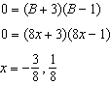 Janice substituted B for , resulting in a simpler quadratic. Once factored, Janice substituted for B.

REF: 081636ai

