1 A relation is graphed on the set of axes below.

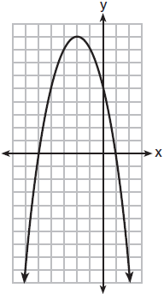

Based on this graph, the relation is
1) | a function because it passes the horizontal line test | 3) | not a function because it fails the horizontal line test
2) | a function because it passes the vertical line test | 4) | not a function because it fails the vertical line test

2 Which table represents a function?
1) | 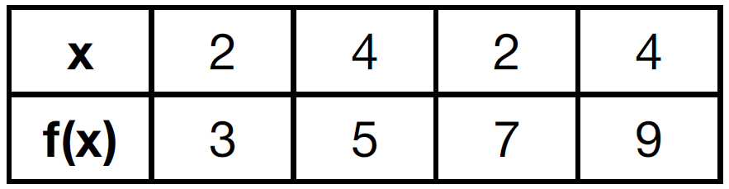 | 3) | 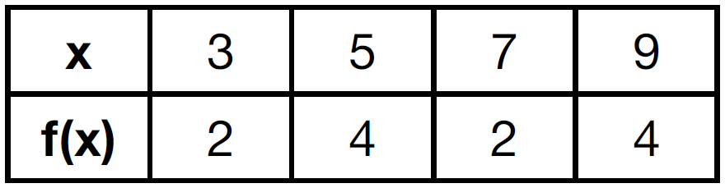
2) | 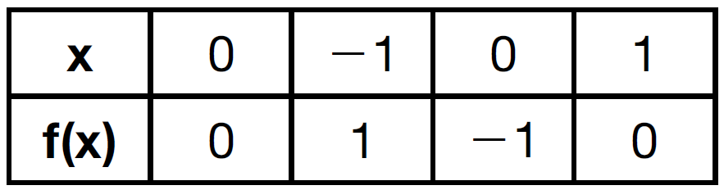 | 4) | 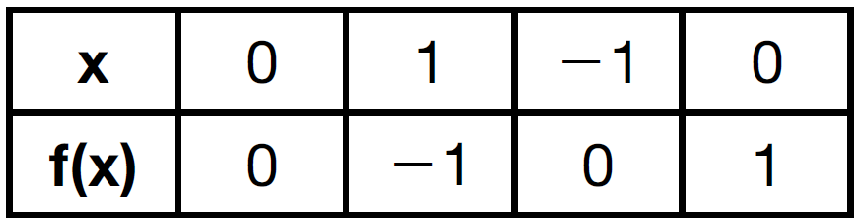

3 Which table represents a function?
1) | 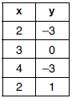 | 3) | 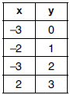
2) | 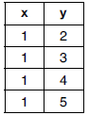 | 4) | 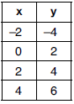

4 Which table could represent a function?
1) | 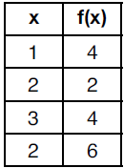 | 3) | 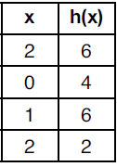
2) | 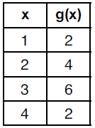 | 4) | 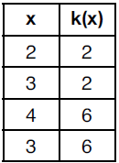

5 A mapping is shown in the diagram below.

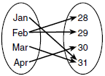

This mapping is
1) | a function, because Feb has two outputs, 28 and 29 | 3) | not a function, because Feb has two outputs, 28 and 29
2) | a function, because two inputs, Jan and Mar, result in the output 31 | 4) | not a function, because two inputs, Jan and Mar, result in the output 31

6 Which relation is not a function?
1) | 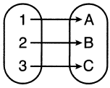 | 3) | 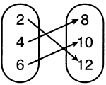
2) | 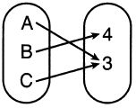 | 4) | 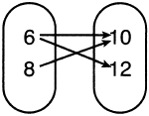

7 Which representations are functions?

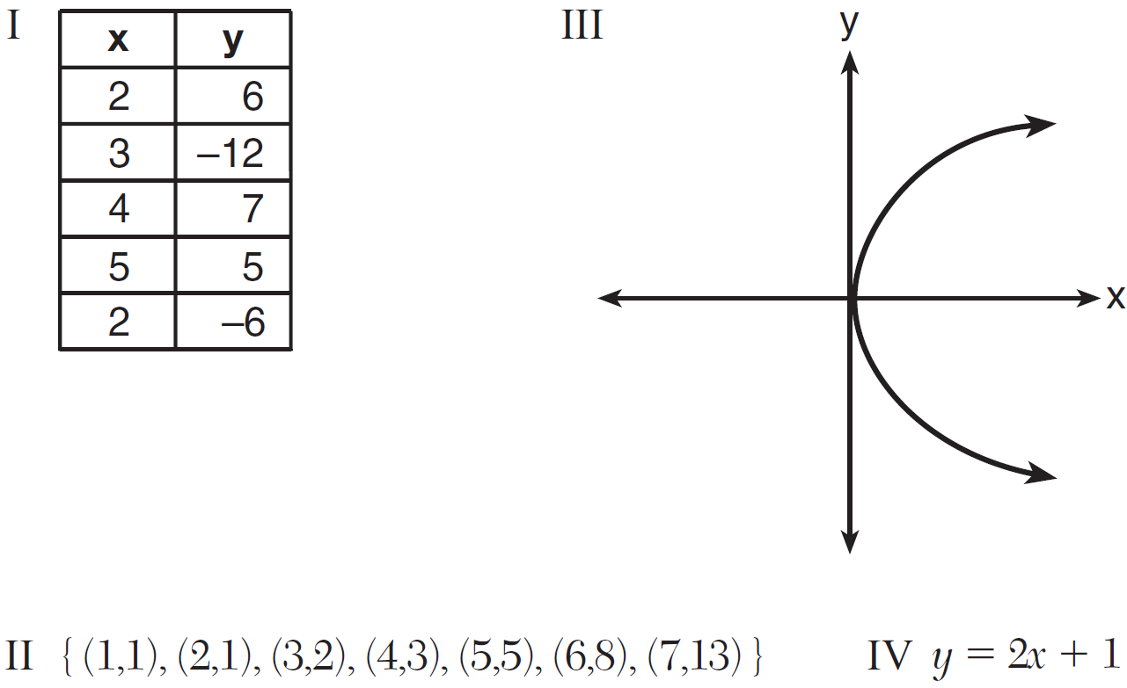
1) | I and II | 3) | III, only
2) | II and IV | 4) | IV, only

8 Which relation does not represent a function?
1) | 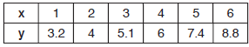 | 3)
2) | 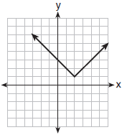 | 4) | 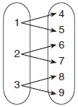

9 Which relation is not a function?
1) | 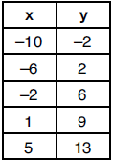 | 3) | 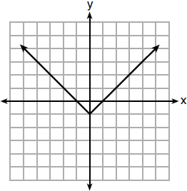
2) |  | 4) | 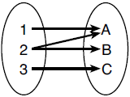

10 A function is defined as . Isaac is asked to create one more ordered pair for the function. Which ordered pair can he add to the set to keep it a function?
1) |  | 3)
2) |  | 4)

11 Marcel claims that the graph below represents a function.

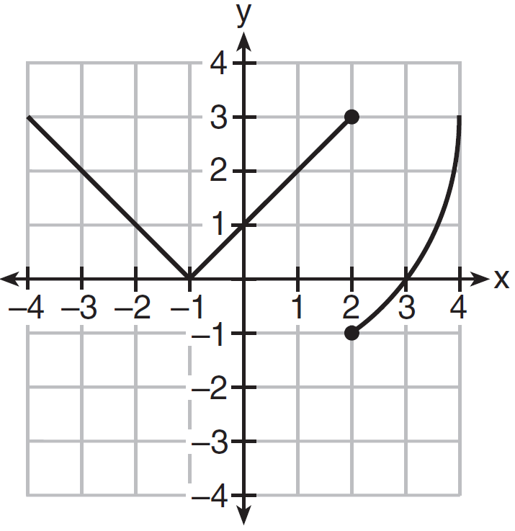

State whether Marcel is correct. Justify your answer.

12 A function is shown in the table below.

x | f(x)
 | 2
0
3 | 16

If included in the table, which ordered pair, or , would result in a relation that is no longer a function? Explain your answer.

13 Four relations are shown below.

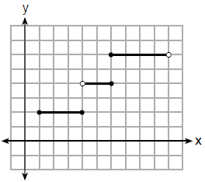
I

II

x | y
 | 1
0 | 3
4 | 5
6 | 6
III

IV

State which relation(s) are functions. Explain why the other relation(s) are not functions.

14 The function f has a domain of and a range of . Could f be represented by ? Justify your answer.

15 Nora says that the graph of a circle is a function because she can trace the whole graph without picking up her pencil. Mia says that a circle graph is not a function because multiple values of x map to the same y-value. Determine if either one is correct, and justify your answer completely.
1 ANS: 2 REF: 011804ai

2 ANS: 3 REF: 061504ai

3 ANS: 4 REF: 081902ai

4 ANS: 2 REF: 012004ai

5 ANS: 3 REF: 061709ai

6 ANS: 4 REF: 062104ai

7 ANS: 2 REF: 081511ai

8 ANS: 4 REF: 011907ai

9 ANS: 4 REF: 061903ai

10 ANS: 4 REF: 061811ai

11 ANS:
No, because the relation does not pass the vertical line test.

REF: 011626ai

12 ANS:
, because then every element of the domain is not assigned one unique element in the range.

REF: 011527ai

13 ANS:
III and IV are functions. I, for , has two y-values. II, for , has two y-values.

REF: 081826ai

14 ANS:
Yes, because every element of the domain is assigned one unique element in the range.

REF: 061430ai

15 ANS:
Neither is correct. Nora’s reason is wrong since a circle is not a function because it fails the vertical line test. Mia is wrong since a circle is not a function because multiple values of y map to the same x-value.

REF: 011732ai

