1 The graph of is shown below.

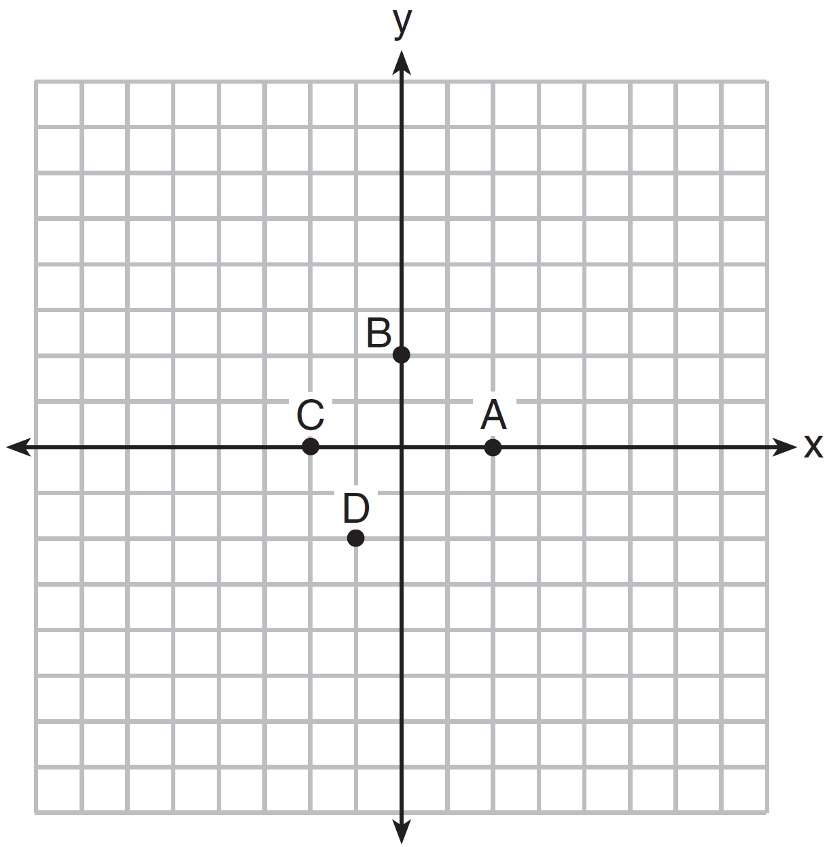

Which point could be used to find ?
1) | A
2) | B
3) | C
4) | D

2 The graph of is shown below.

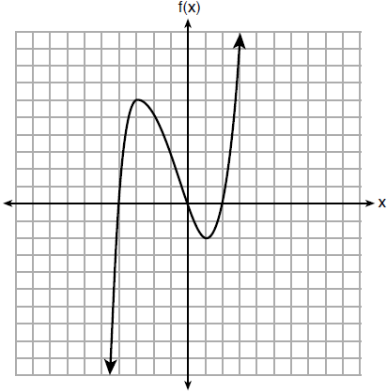

What is the value of ?
1) | 6
2) | 2
3)
4)

3 If , what is the value of ?
1)
2)
3) | 17
4) | 4

4 The function is defined as . The value of is
1)
2)
3) | 27
4) | 45

5 A function is defined as . The value of is
1)
2)
3)
4)

6 If 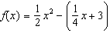, what is the value of ?
1) | 11
2) | 17
3) | 27
4) | 33

7 If , then is
1) | 315
2) | 307
3) | 159
4) | 153

8 If , what is the value of ?
1) | 13
2) | 19
3) | 37
4) | 54

9 If 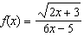, then 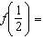
1) | 1
2)
3)
4)

10 If , which statement is true?
1)
2)
3)
4)

11 Lynn, Jude, and Anne were given the function , and they were asked to find . Lynn's answer was 14, Jude's answer was 4, and Anne's answer was ±4. Who is correct?
1) | Lynn, only
2) | Jude, only
3) | Anne, only
4) | Both Lynn and Jude

12 The value in dollars, , of a certain car after x years is represented by the equation . To the nearest dollar, how much more is the car worth after 2 years than after 3 years?
1) | 2589
2) | 6510
3) | 15,901
4) | 18,490

13 If , determine .

14 The equation to determine the weekly earnings of an employee at The Hamburger Shack is given by , where x is the number of hours worked.
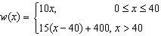
Determine the difference in salary, in dollars, for an employee who works 52 hours versus one who works 38 hours. Determine the number of hours an employee must work in order to earn $445. Explain how you arrived at this answer.
1 ANS: 1 REF: 061420ai

2 ANS: 1 REF: 081805ai

3 ANS: 2

REF: 061902ai

4 ANS: 1

REF: 011902ai

5 ANS: 2

REF: 062103ai

6 ANS: 3
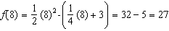

REF: 081704ai

7 ANS: 4

REF: 061802ai

8 ANS: 2

REF: 012001ai

9 ANS: 3
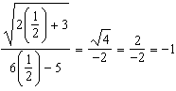

REF: 081512ai

10 ANS: 2

REF: 081605ai

11 ANS: 1

REF: 061705ai

12 ANS: 1

REF: 011508ai

13 ANS:

REF: 081925ai

14 ANS:
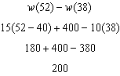 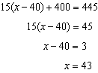 Since , . I substituted 445 for and solved for x.

REF: 061534ai

