1 The first four terms of the sequence with and 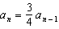 are
1)
2) | 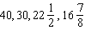
3)
4) | 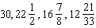

2 A recursively defined sequence is shown below.
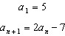
The value of is
1)
2)
3) | 8
4) | 15

3 If and , then equals
1) | 75
2) | 147
3) | 180
4) | 900

4 What is the fourth term of the sequence defined by
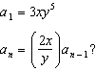
1)
2)
3)
4)

5 The first four terms of the sequence defined by 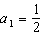 and are
1) | 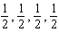
2) | 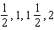
3) | 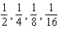
4) | 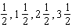

6 A sequence of blocks is shown in the diagram below.

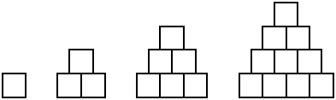

This sequence can be defined by the recursive function and . Assuming the pattern continues, how many blocks will there be when ?
1) | 13
2) | 21
3) | 28
4) | 36

7 What is the third term of the recursive sequence below?
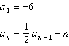
1)
2)
3)
4)

8 If and , what is the value of ?
1) | 5
2) | 20
3) | 120
4) | 720

9 If and , then
1)
2) | 11
3) | 21
4) | 43

10 Given the function defined by the following:
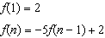
Which set could represent the range of the function?
1)
2)
3)
4)

11 If a sequence is defined recursively by and for , then is equal to
1) | 1
2)
3) | 5
4) | 17

12 Given the recursive formula:

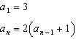

State the values of , , and for the given recursive formula.

13 The recursive formula to describe a sequence is shown below.
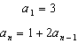
State the first four terms of this sequence. Can this sequence be represented using an explicit geometric formula? Justify your answer.

14 Write the first five terms of the recursive sequence defined below.
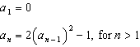

15 Use the recursive sequence defined below to express the next three terms as fractions reduced to lowest terms.
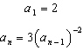

16 Find the first four terms of the recursive sequence defined below.
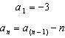

17 Find the third term in the recursive sequence , where .
1 ANS: 2
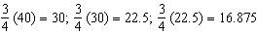

REF: 081608a2

2 ANS: 1

REF: 012023ai

3 ANS: 1

REF: 081919ai

4 ANS: 3
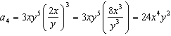

REF: 061512a2

5 ANS: 1 REF: 081520a2

6 ANS: 3
1, 3, 6, 10, 15, 21, 28, ...

REF: 081715ai

7 ANS: 1
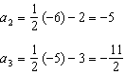

REF: 011623a2

8 ANS: 3
, , ,

REF: 061824ai

9 ANS: 4

REF: 081424ai

10 ANS: 2
; ; ;

REF: 061718ai

11 ANS: 3
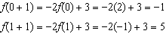

REF: 011520ai

12 ANS:

REF: 061931ai

13 ANS:
; No, because there is no common ratio: 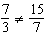

REF: 061830aii

14 ANS:

REF: 081832ai

15 ANS:
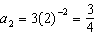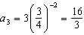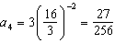

REF: 011537a2

16 ANS:

REF: fall0934a2

17 ANS:
. . .

REF: 061233a2

