1 The roots of a quadratic equation can be found using the graph below.

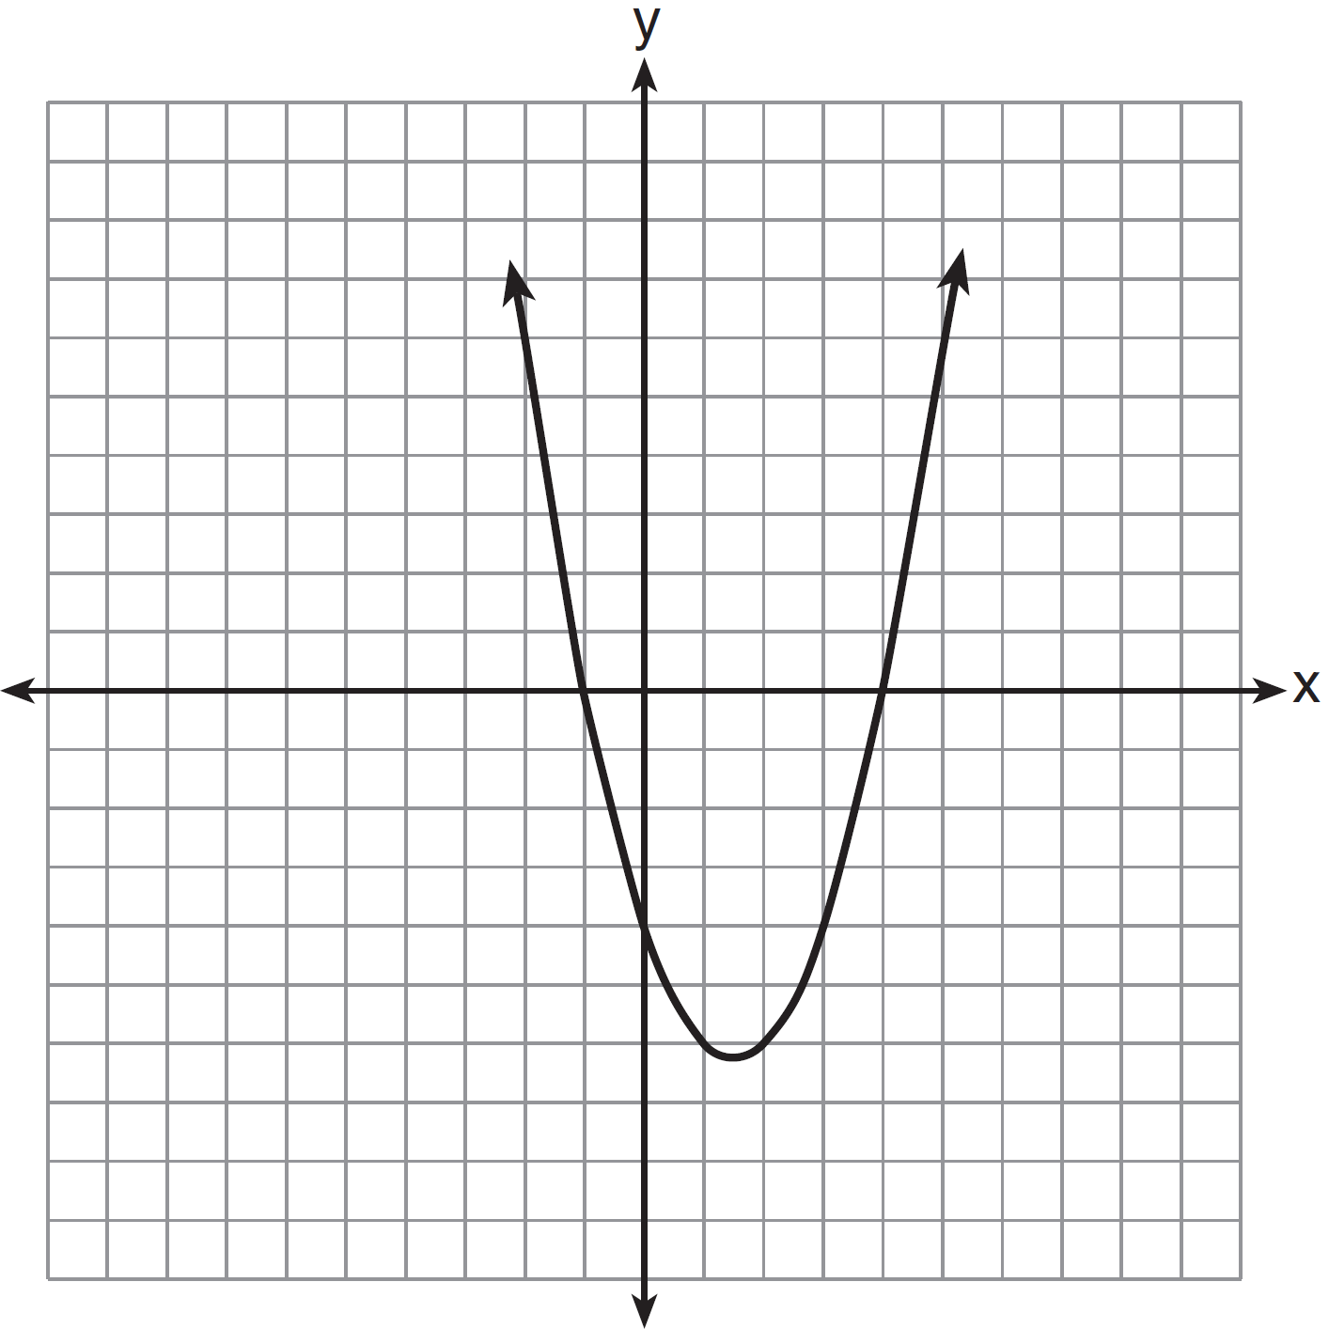

What are the roots of this equation?
1) | , only
2) | and
3) | and 4
4) | , and 4

2 A student correctly graphed the parabola shown below to solve a given quadratic equation.

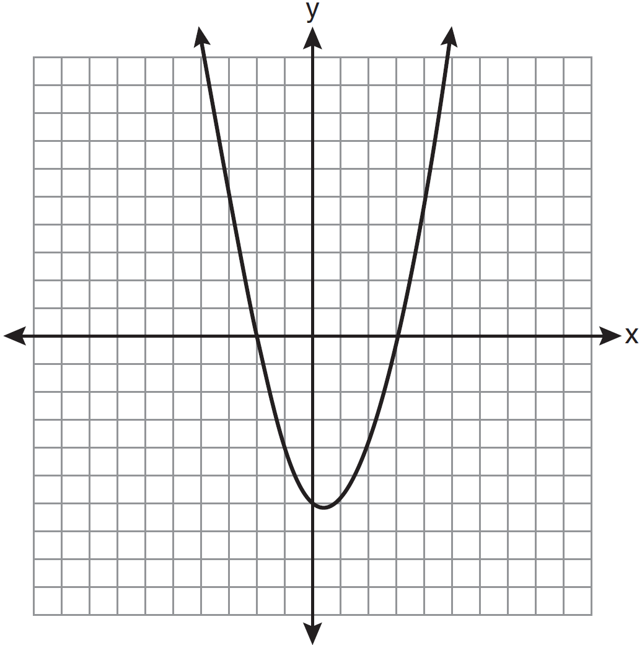

What are the roots of the quadratic equation associated with this graph?
1) | and 3
2) | and 0
3) | and 2
4) | and 3

3 The equation is graphed on the set of axes below.

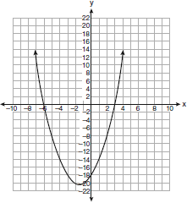

Based on this graph, what are the roots of the equation ?
1) | and 6
2) | 0 and
3) | 3 and
4) | 3 and

4 The equation is graphed on the set of axes below.

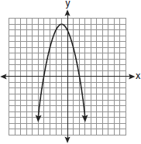

Based on this graph, what are the roots of the equation ?
1) | 8 and 0
2) | 2 and
3) | 9 and
4) | 4 and

5 The equation is graphed on the set of axes below.

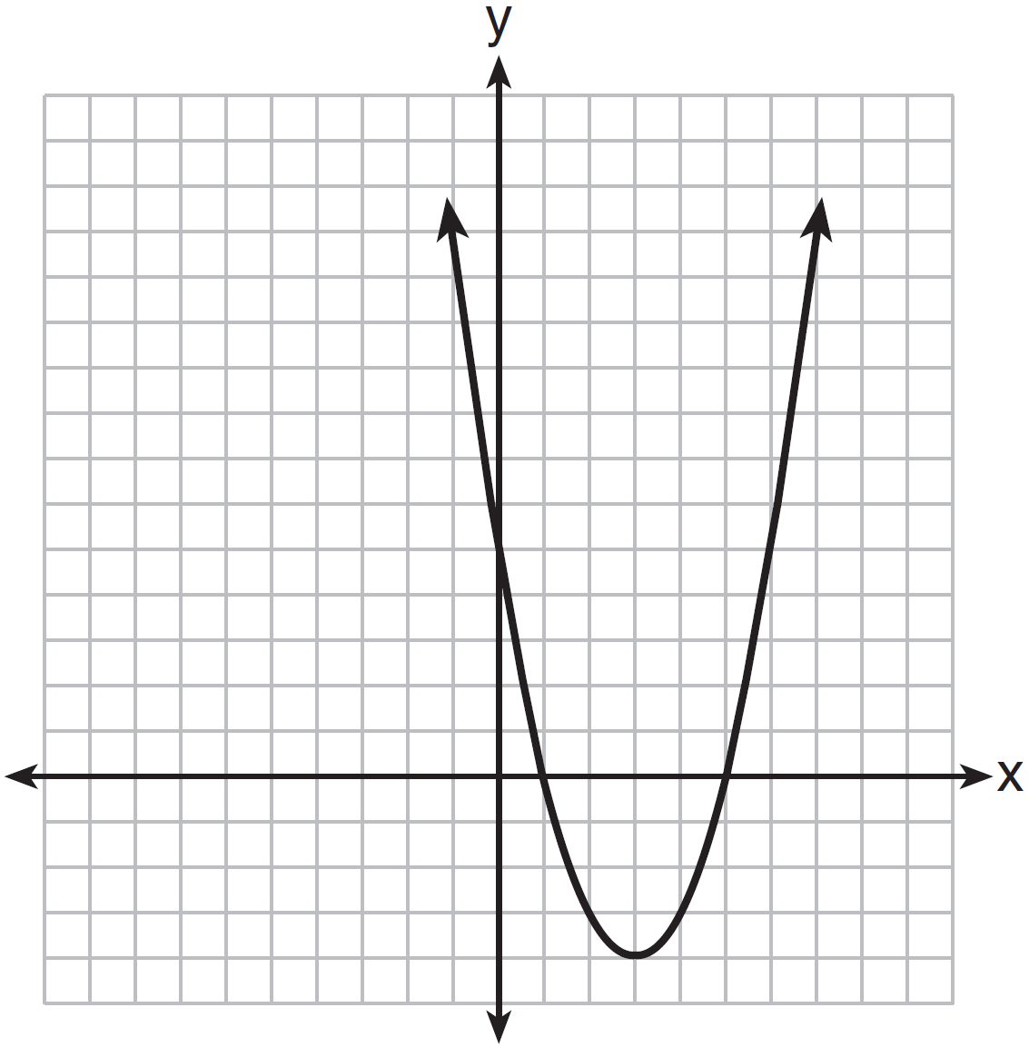

Based on the graph, what are the roots of the equation ?
1) | 0 and 5
2) | 1 and 0
3) | 1 and 5
4) | 3 and

6 The graph of is shown below.

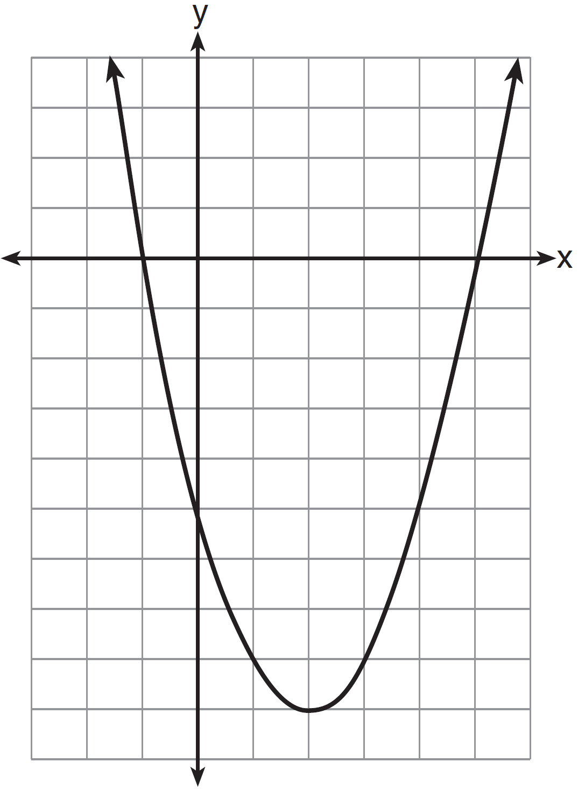

Based on this graph, what are the roots of the equation ?
1) | 1 and
2) | and 5
3) | 2 and
4) | and and 5

7 Graph the equation on the accompanying set of axes. Using the graph, determine the roots of the equation .

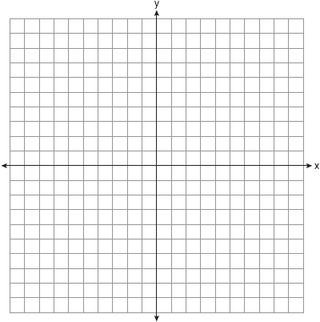

8 On the set of axes below, graph the equation . Using the graph, determine and state the roots of the equation .

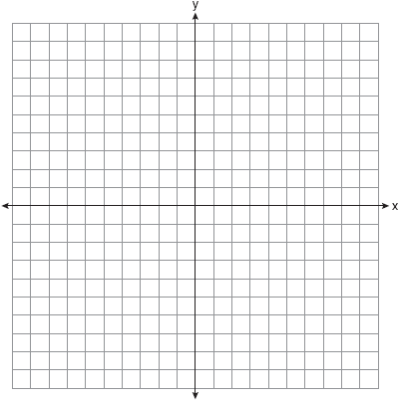

9 On the set of axes below, graph . State the roots of .

10 The graph of the function is given below.

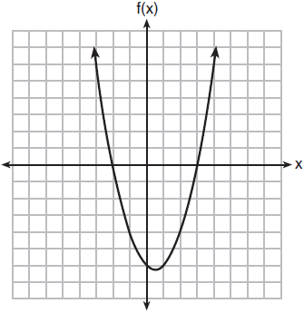

Could the factors of be and ? Based on the graph, explain why or why not.

11 Greg is in a car at the top of a roller-coaster ride. The distance, d, of the car from the ground as the car descends is determined by the equation , where t is the number of seconds it takes the car to travel down to each point on the ride. How many seconds will it take Greg to reach the ground?

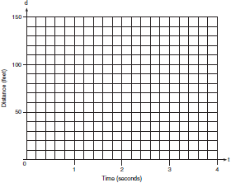

12 An acorn falls from the branch of a tree to the ground 25 feet below. The distance, S, the acorn is from the ground as it falls is represented by the equation , where t represents time, in seconds. Sketch a graph of this situation on the accompanying grid. Calculate, to the nearest hundredth of a second, the time the acorn will take to reach the ground.


1 ANS: 3 REF: 061306ia

2 ANS: 4 REF: 011111ia

3 ANS: 3 REF: 060924ia

4 ANS: 2 REF: 080916ia

5 ANS: 3 REF: 061404ia

6 ANS: 2 REF: 011506ia

7 ANS:
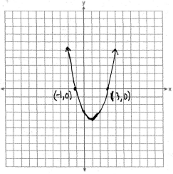

REF: 060836ia

8 ANS:
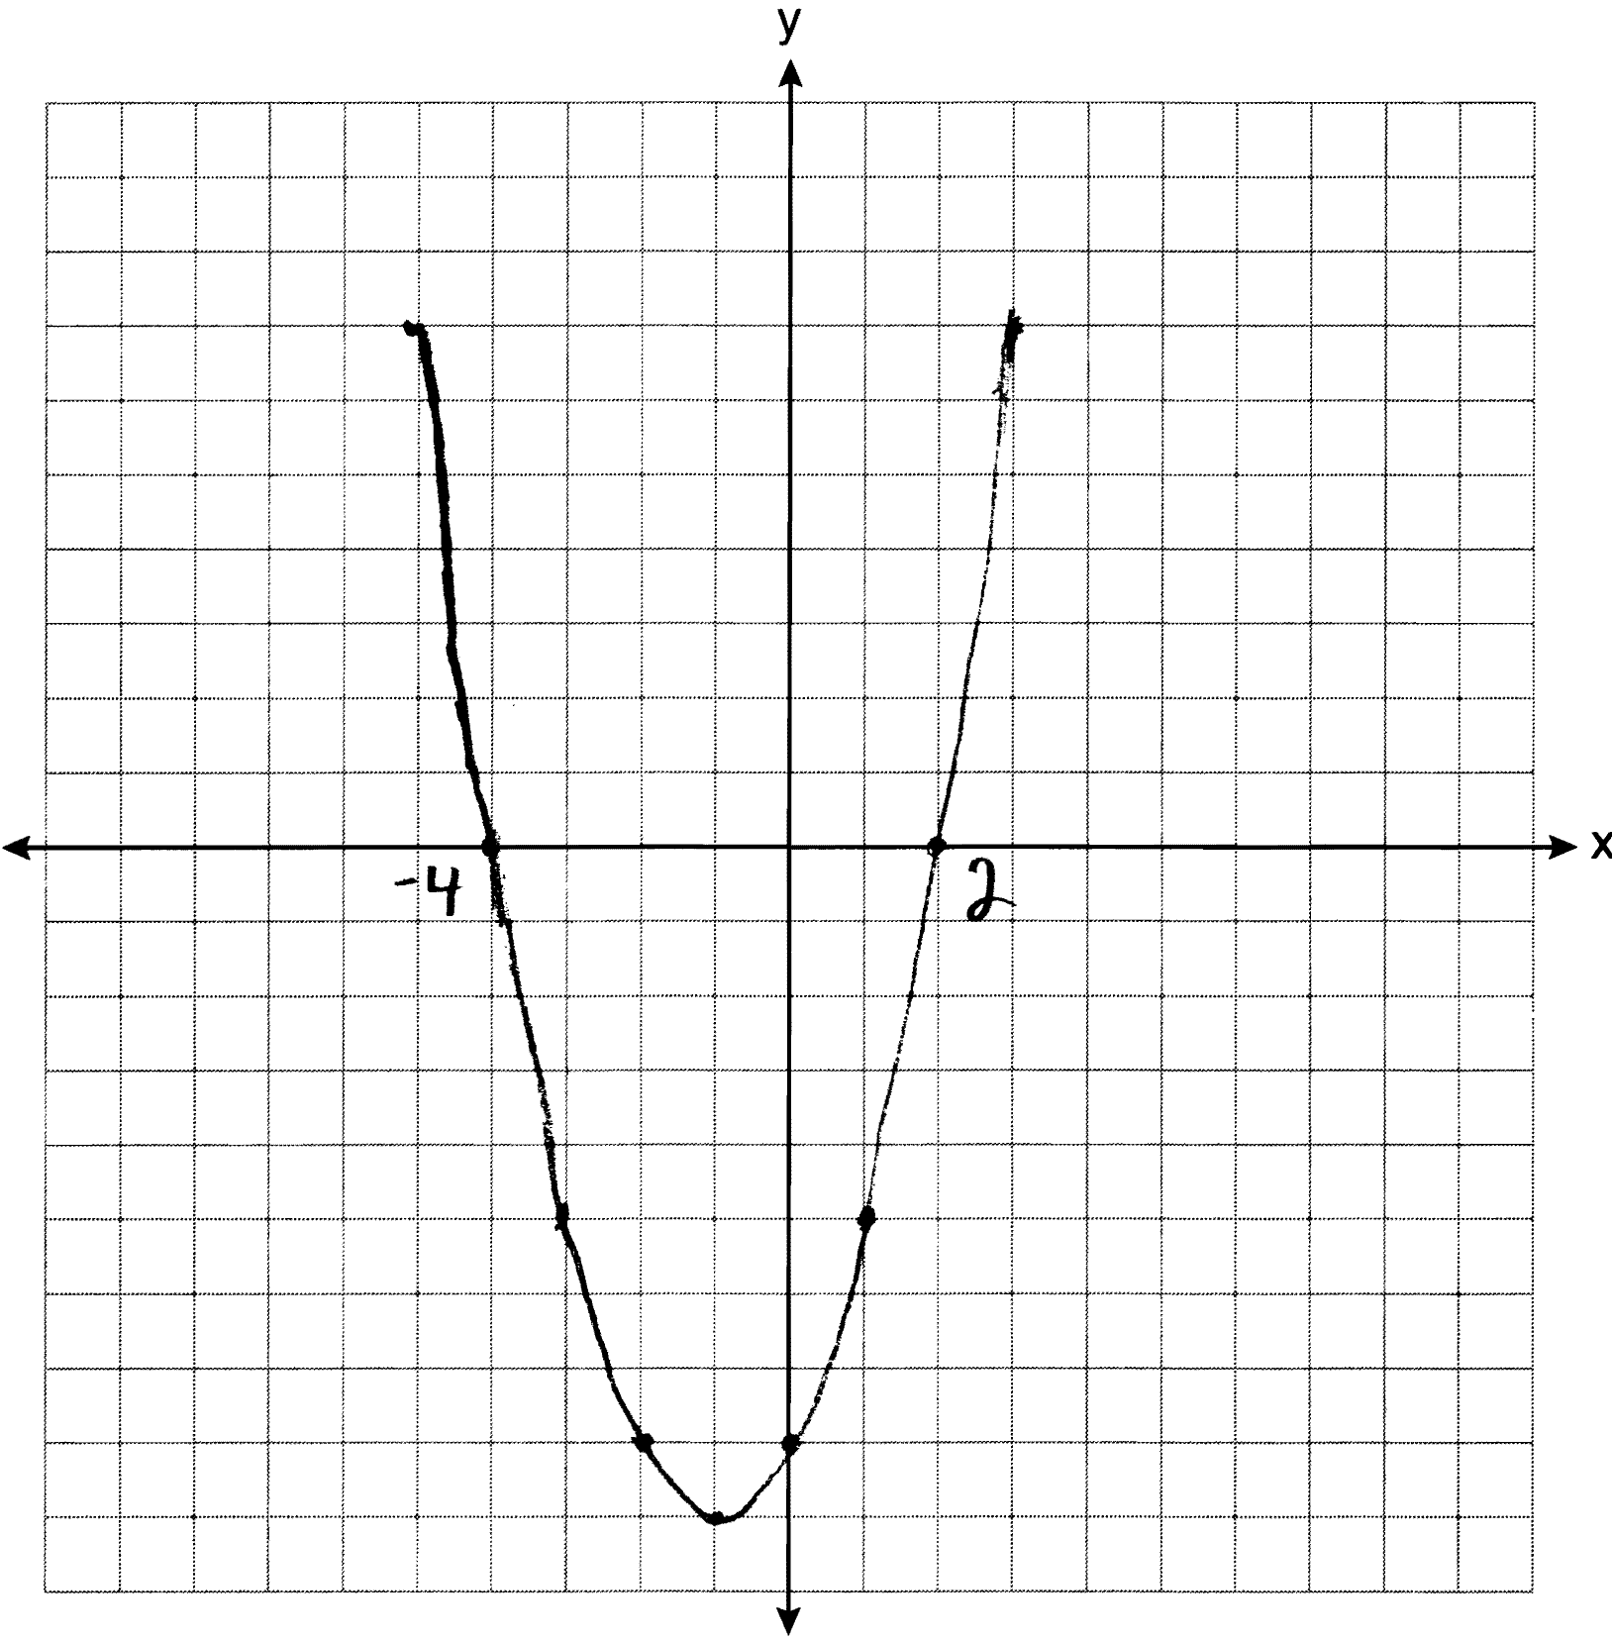

REF: 061234ia

9 ANS:
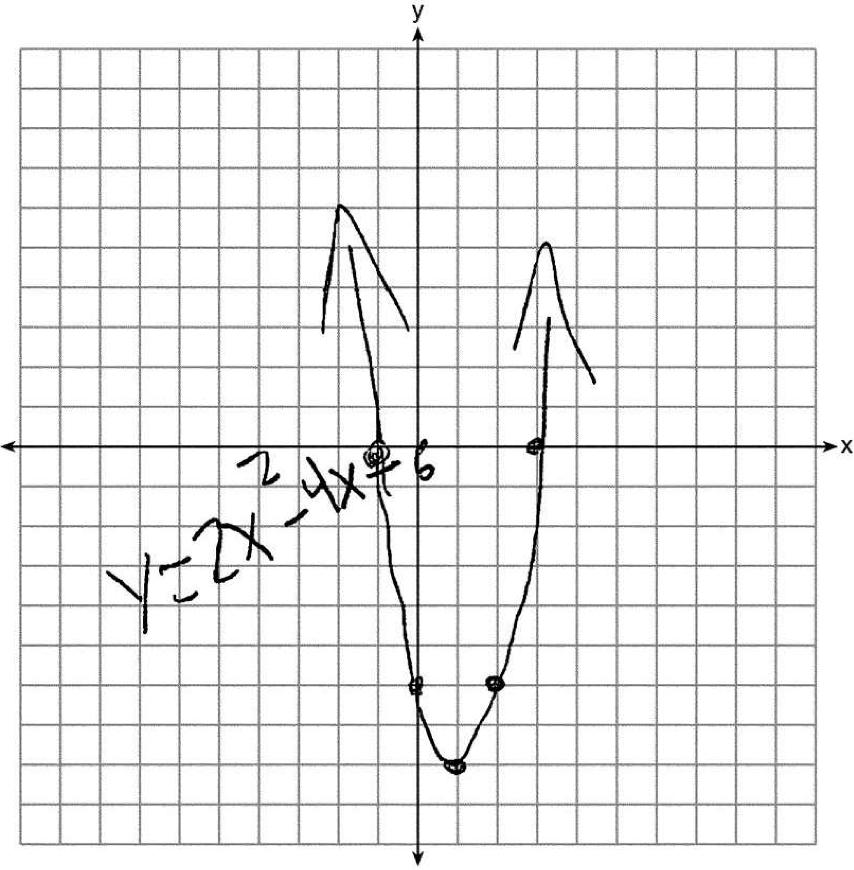3 and .

REF: 061537ia

10 ANS:
Yes, because from the graph the zeroes of are and 3.

REF: 011832ai

11 ANS:
3. 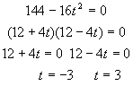. 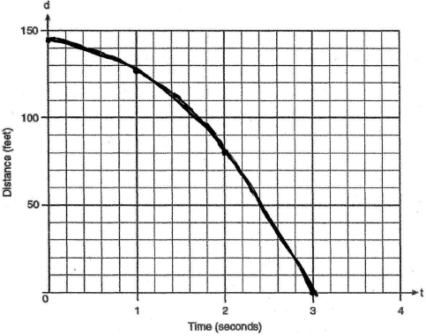. 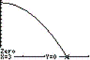

REF: 080234a

12 ANS:
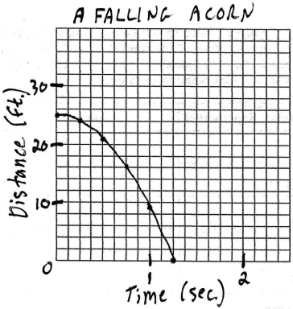 1.25. 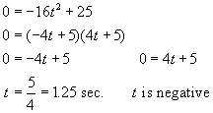

REF: 010431b

