1 One characteristic of all linear functions is that they change by
1) | equal factors over equal intervals | 3) | equal differences over equal intervals
2) | unequal factors over equal intervals | 4) | unequal differences over equal intervals

2 Which situation can be modeled by a linear function?
1) | The population of bacteria triples every day. | 3) | An amusement park allows 50 people to enter every 30 minutes.
2) | The value of a cell phone depreciates at a rate of 3.5% each year. | 4) | A baseball tournament eliminates half of the teams after each round.

3 Which situation could be modeled by using a linear function?
1) | a bank account balance that grows at a rate of 5% per year, compounded annually | 3) | the cost of cell phone service that charges a base amount plus 20 cents per minute
2) | a population of bacteria that doubles every 4.5 hours | 4) | the concentration of medicine in a person’s body that decays by a factor of one-third every hour

4 Which situation could be modeled as a linear equation?
1) | The value of a car decreases by 10% every year. | 3) | Two liters of water evaporate from a pool every day.
2) | The number of fish in a lake doubles every 5 years. | 4) | The amount of caffeine in a person's body decreases by every 2 hours.

5 Which situation is not a linear function?
1) | A gym charges a membership fee of $10.00 down and $10.00 per month. | 3) | A restaurant employee earns $12.50 per hour.
2) | A cab company charges $2.50 initially and $3.00 per mile. | 4) | A $12,000 car depreciates 15% per year.

6 Grisham is considering the three situations below.
I. For the first 28 days, a sunflower grows at a rate of 3.5 cm per day.
II. The value of a car depreciates at a rate of 15% per year after it is purchased.
III. The amount of bacteria in a culture triples every two days during an experiment.
Which of the statements describes a situation with an equal difference over an equal interval?
1) | I, only | 3) | I and III
2) | II, only | 4) | II and III

7 Which scenario represents exponential growth?
1) | A water tank is filled at a rate of 2 gallons/minute. | 3) | A species of fly doubles its population every month during the summer.
2) | A vine grows 6 inches every week. | 4) | A car increases its distance from a garage as it travels at a constant speed of 25 miles per hour.

8 Which of the three situations given below is best modeled by an exponential function?
I. A bacteria culture doubles in size every day.
II. A plant grows by 1 inch every 4 days.
III. The population of a town declines by 5% every 3 years.
1) | I, only | 3) | I and II
2) | II, only | 4) | I and III

9 Ian is saving up to buy a new baseball glove. Every month he puts $10 into a jar. Which type of function best models the total amount of money in the jar after a given number of months?
1) | linear | 3) | quadratic
2) | exponential | 4) | square root

10 The highest possible grade for a book report is 100. The teacher deducts 10 points for each day the report is late. Which kind of function describes this situation?
1) | linear | 3) | exponential growth
2) | quadratic | 4) | exponential decay

11 Sara was asked to solve this word problem: "The product of two consecutive integers is 156. What are the integers?" What type of equation should she create to solve this problem?
1) | linear | 3) | exponential
2) | quadratic | 4) | absolute value

12 Eric deposits $500 in a bank account that pays 3.5% interest, compounded yearly. Which type of function should he use to determine how much money he will have in the account at the end of 10 years?
1) | linear | 3) | absolute value
2) | quadratic | 4) | exponential

13 Which type of function is shown in the graph below?

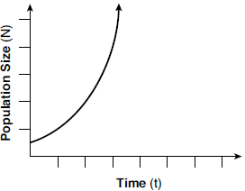
1) | linear | 3) | square root
2) | exponential | 4) | absolute value

14 A population that initially has 20 birds approximately doubles every 10 years. Which graph represents this population growth?
1) | 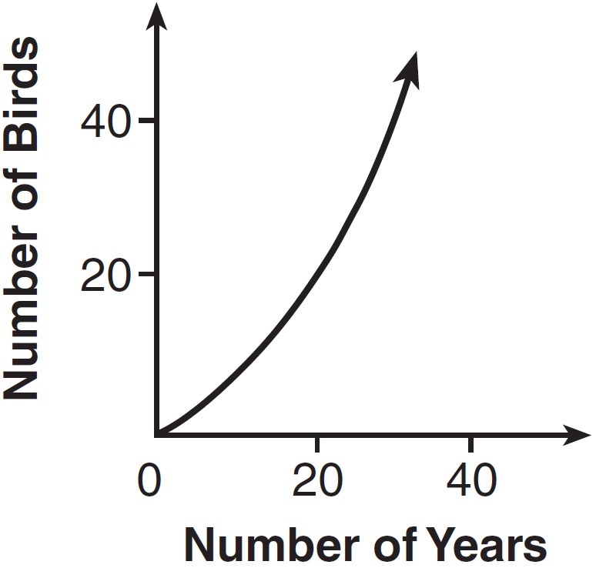 | 3) | 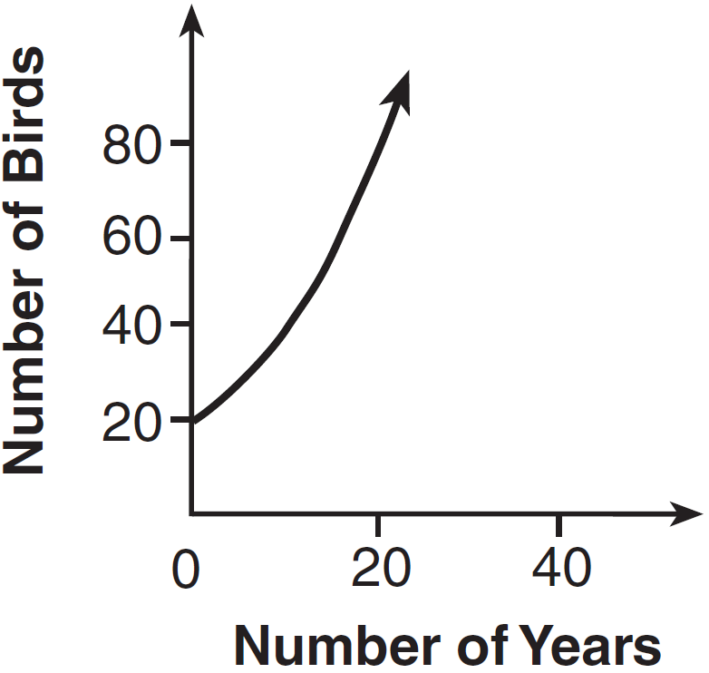
2) | 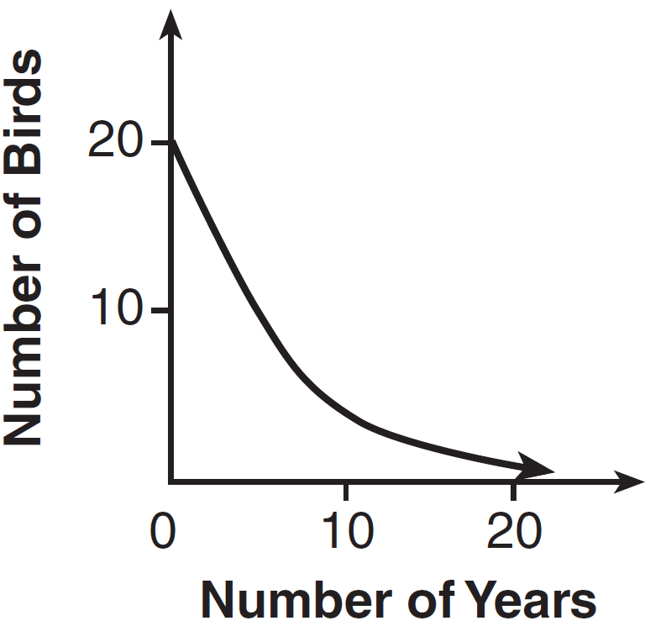 | 4) | 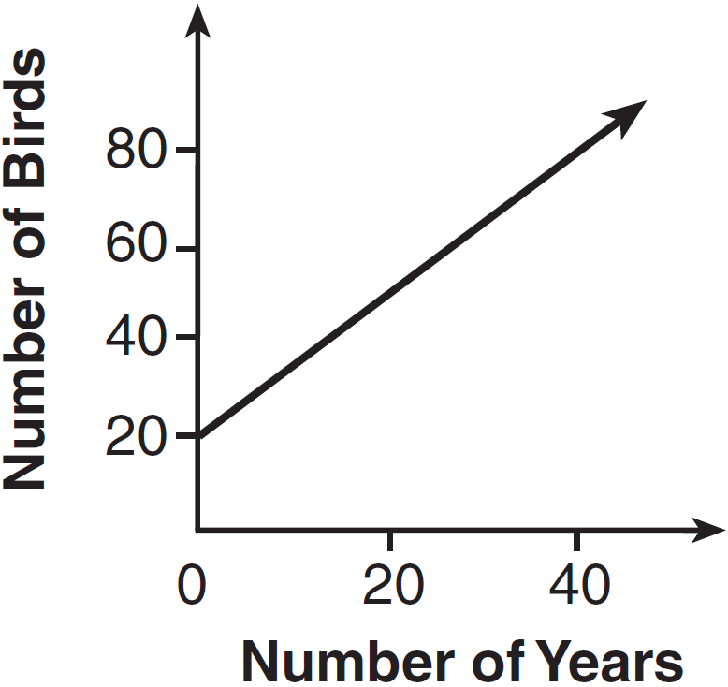

15 The tables below show the values of four different functions for given values of x.

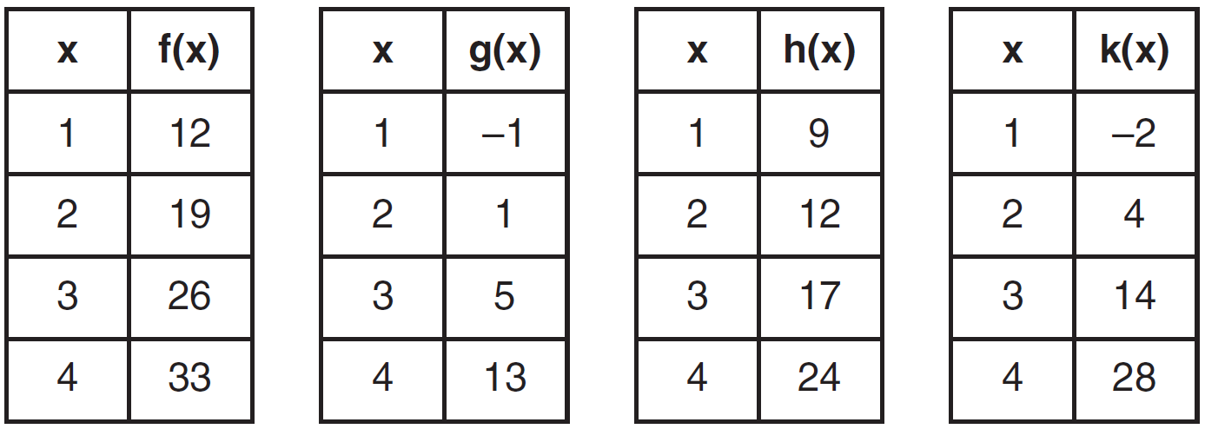

Which table represents a linear function?·
1) |  | 3)
2) |  | 4)

16 Which table of values represents a linear relationship?
1) | 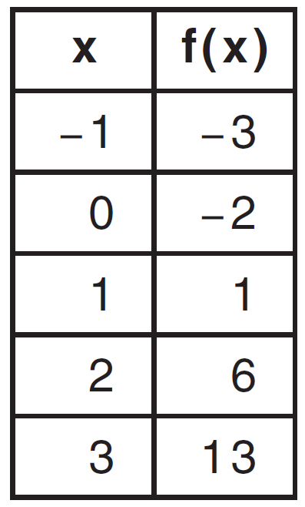 | 3) | 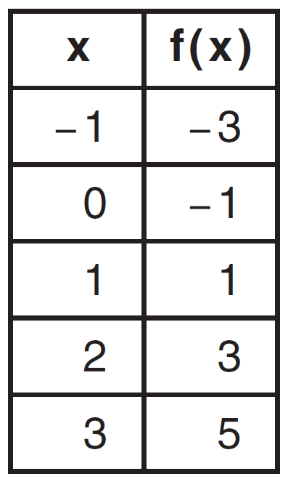
2) | 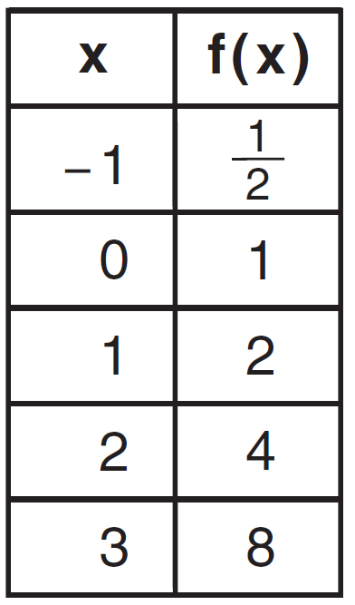 | 4) | 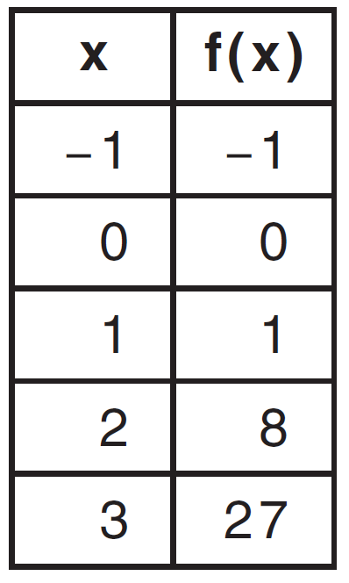

17 During physical education class, Andrew recorded the exercise times in minutes and heart rates in beats per minute (bpm) of four of his classmates. Which table best represents a linear model of exercise time and heart rate?
1) | 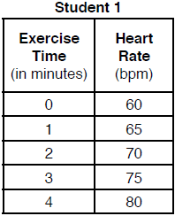 | 3) | 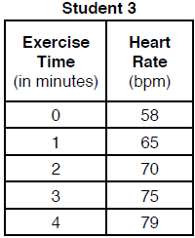
2) | 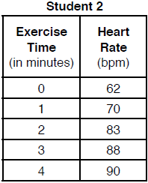 | 4) | 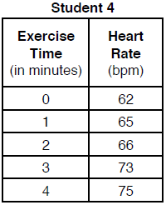

18 The function f is shown in the table below.

x | f(x)
0 | 1
1 | 3
2 | 9
3 | 27

Which type of function best models the given data?
1) | exponential growth function | 3) | linear function with positive rate of change
2) | exponential decay function | 4) | linear function with negative rate of change

19 The table below shows the average yearly balance in a savings account where interest is compounded annually. No money is deposited or withdrawn after the initial amount is deposited.

Year | Balance, in Dollars
0 | 380.00
10 | 562.49
20 | 832.63
30 | 1232.49
40 | 1824.39
50 | 2700.54

Which type of function best models the given data?
1) | linear function with a negative rate of change | 3) | exponential decay function
2) | linear function with a positive rate of change | 4) | exponential growth function

20 Caleb claims that the ordered pairs shown in the table below are from a nonlinear function.

x | f(x)
0 | 2
1 | 4
2 | 8
3 | 16

State if Caleb is correct. Explain your reasoning.

21 The function, , is shown in the table below.

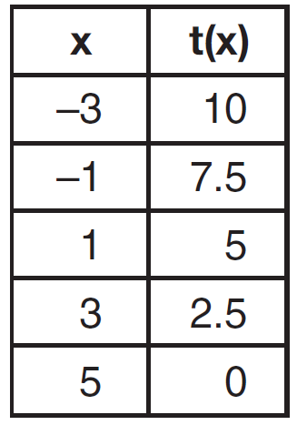

Determine whether is linear or exponential. Explain your answer.

22 Consider the pattern of squares shown below:

Which type of model, linear or exponential, should be used to determine how many squares are in the nth pattern? Explain your answer.

23 Rachel and Marc were given the information shown below about the bacteria growing in a Petri dish in their biology class.

Rachel wants to model this information with a linear function. Marc wants to use an exponential function. Which model is the better choice? Explain why you chose this model.

24 The number of people who attended a school's last six basketball games increased as the team neared the state sectional games. The table below shows the data.

Game | 13 | 14 | 15 | 16 | 17 | 18
Attendance | 348 | 435 | 522 | 609 | 696 | 783

State the type of function that best fits the given data. Justify your choice of a function type.

1 ANS: 3 REF: 061721ai

2 ANS: 3 REF: 061911ai

3 ANS: 3 REF: 081412ai

4 ANS: 3 REF: 012017ai

5 ANS: 4 REF: 061814ai

6 ANS: 1 REF: 011623ai

7 ANS: 3 REF: 011711ai

8 ANS: 4
II is linear.

REF: 081823ai

9 ANS: 1 REF: 011805ai

10 ANS: 1 REF: 081717ai

11 ANS: 2 REF: 061624ai

12 ANS: 4 REF: 062117ai

13 ANS: 2 REF: 081907ai

14 ANS: 3 REF: 081410ai

15 ANS: 1 REF: 061606ai

16 ANS: 3 REF: 011505ai

17 ANS: 1 REF: 081802ai

18 ANS: 1 REF: 061906ai

19 ANS: 4 REF: 061406ai

20 ANS:
Yes, because does not have a constant rate of change.

REF: 061826ai

21 ANS:
Linear, because the function has a constant rate of change.

REF: 011625ai

22 ANS:
Exponential, because the function does not have a constant rate of change.

REF: 081627ai

23 ANS:
Exponential, because the function does not grow at a constant rate.

REF: 081527ai

24 ANS:
Linear, because the function grows at a constant rate.
REF: 011926ai

