1 In the box-and-whisker plot below, what is the 2nd quartile?

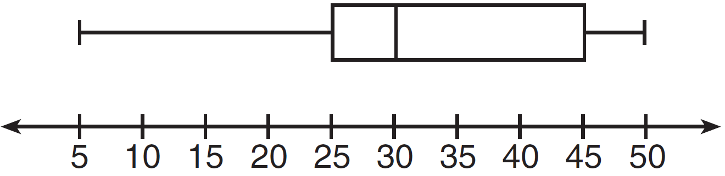
1) | 25
2) | 30
3) | 45
4) | 50

2 What is the value of the third quartile shown on the box-and-whisker plot below?

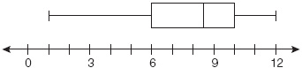
1) | 6
2) | 8.5
3) | 10
4) | 12

3 The box plot below summarizes the data for the average monthly high temperatures in degrees Fahrenheit for Orlando, Florida.

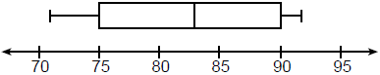

The third quartile is
1) | 92
2) | 90
3) | 83
4) | 71

4 The box-and-whisker plot below represents students' scores on a recent English test.

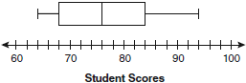

What is the value of the upper quartile?
1) | 68
2) | 76
3) | 84
4) | 94

5 The accompanying diagram shows a box-and-whisker plot of student test scores on last year’s Mathematics A midterm examination.

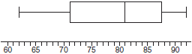

What is the median score?
1) | 62
2) | 71
3) | 81
4) | 92

6 The accompanying box-and-whisker plot represents the scores earned on a science test.

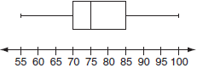

What is the median score?
1) | 70
2) | 75
3) | 77
4) | 85

7 What is the range of the box plot shown below?

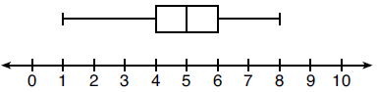
1) | 7
2) | 2
3) | 3
4) | 4

8 The box-and-whisker plot below represents the math test scores of 20 students.

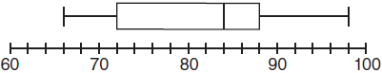

What percentage of the test scores are less than 72?
1) | 25
2) | 50
3) | 75
4) | 100

9 The box-and-whisker plot below represents the ages of 12 people.

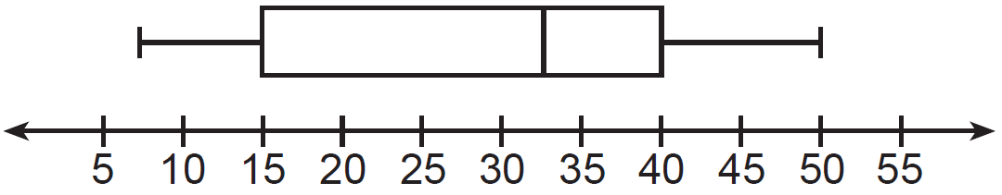

What percentage of these people are age 15 or older?
1) | 25
2) | 35
3) | 75
4) | 85

10 The box-and-whisker plot below represents a set of grades in a college statistics class.

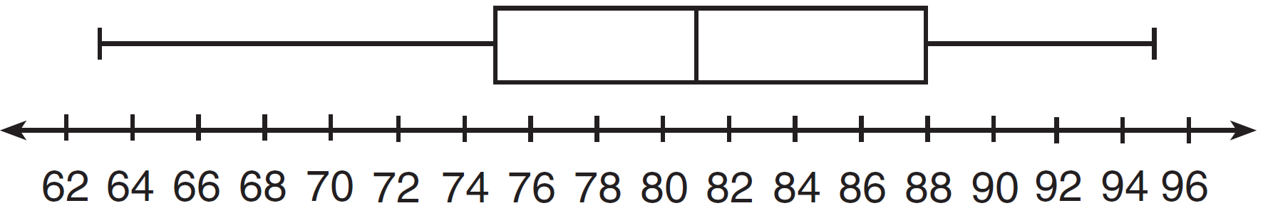

Which interval contains exactly 50% of the grades?
1) | 63-88
2) | 63-95
3) | 75-81
4) | 75-88

11 What is the range of the data represented in the box-and-whisker plot shown below?

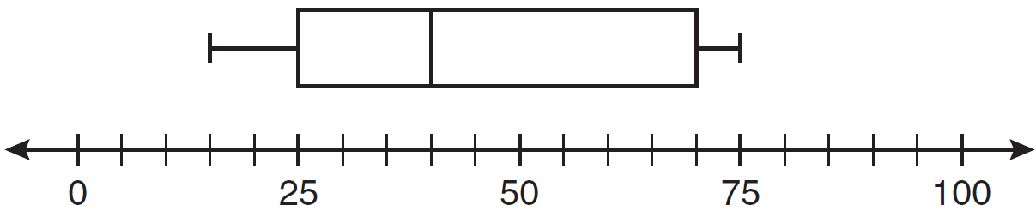
1) | 40
2) | 45
3) | 60
4) | 100

12 The box-and-whisker plot below represents the results of tests scores in a math class.

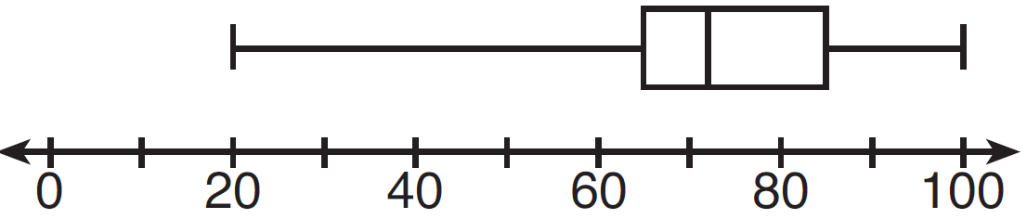

What do the scores 65, 85, and 100 represent?
1) | , median,
2) | , , maximum
3) | median, , maximum
4) | minimum, median, maximum

13 The box-and-whisker plot shown below represents the number of magazine subscriptions sold by members of a club.

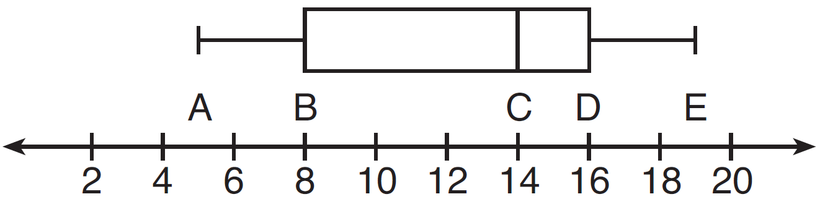

Which statistical measures do points B, D, and E represent, respectively?
1) | minimum, median, maximum
2) | first quartile, median, third quartile
3) | first quartile, third quartile, maximum
4) | median, third quartile, maximum

14 A movie theater recorded the number of tickets sold daily for a popular movie during the month of June. The box-and-whisker plot shown below represents the data for the number of tickets sold, in hundreds.

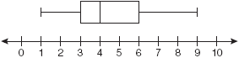

Which conclusion can be made using this plot?
1) | The second quartile is 600.
2) | The mean of the attendance is 400.
3) | The range of the attendance is 300 to 600.
4) | Twenty-five percent of the attendance is between 300 and 400.

15 Based on the box-and-whisker plot below, which statement is false?

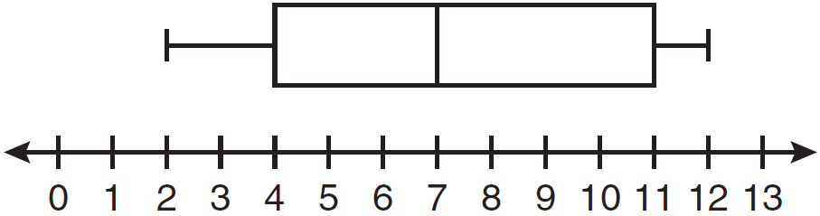
1) | The median is 7.
2) | The range is 12.
3) | The first quartile is 4.
4) | The third quartile is 11.

16 Below are two representations of data.

A:

B: 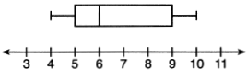

Which statement about A and B is true?
1) | median of A > median of B
2) | range of A < range of B
3) | upper quartile of A < upper quartile of B
4) | lower quartile of A > lower quartile of B

17 Which statistic can not be determined from a box plot representing the scores on a math test in Mrs. DeRidder's algebra class?
1) | the lowest score
2) | the median score
3) | the highest score
4) | the score that occurs most frequently

1 ANS: 2 REF: 011512ia

2 ANS: 3
The value of the third quartile is the last vertical line of the box.

REF: 080818ia

3 ANS: 2 REF: 061805ai

4 ANS: 3
The value of the upper quartile is the last vertical line of the box.

REF: 060915ia

5 ANS: 3
The median score is the vertical line in the center of the box.

REF: 010301a

6 ANS: 2
The median score is the vertical line in the center of the box.

REF: 060610a

7 ANS: 1

REF: 081915ai

8 ANS: 1 REF: 011001ia

9 ANS: 3 REF: 011220ia

10 ANS: 4 REF: 081312ia

11 ANS: 3

REF: 011113ia

12 ANS: 2 REF: 061314ia

13 ANS: 3 REF: 011408ia

14 ANS: 4 REF: 010929ia

15 ANS: 2 REF: 081106ia

16 ANS: 3 REF: 062119ai

17 ANS: 4 REF: 081603ai

