1 If the expression is equivalent to , what is the value of a?
1) | 12
2) | 2
3) | 32
4) | 4

2 Which expression is equivalent to ?
1)
2)
3)
4)

3 Expressed in simplest form, is equivalent to
1)
2)
3)
4)

4 The expression is equivalent to
1)
2)
3)
4)

5 The expression is equivalent to
1)
2)
3)
4)

6 Which expression is equivalent to ?
1)
2)
3)
4)

7 The product of and is
1)
2)
3)
4)

8 If , then 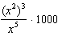 is equivalent to
1)
2)
3) | 1000
4) | 0

9 The expression 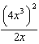 is equivalent to
1)
2)
3)
4)

10 The expression 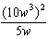 is equivalent to
1)
2)
3)
4)

11 The expression 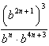 is equivalent to
1)
2)
3)
4)

12 Which equation is true?
1) | 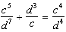
2)
3) | 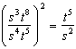
4)

13 Which statement is correct?
1)
2) | 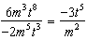
3)
4) | 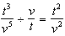

14 If , then is equal to
1)
2)
3)
4)

1 ANS: 2 REF: 061312ia

2 ANS: 4 REF: 080827ia

3 ANS: 4

REF: 010529a

4 ANS: 1 REF: 010728a

5 ANS: 2 REF: 080824a

6 ANS: 3 REF: 062114ai

7 ANS: 4

REF: 010506b

8 ANS: 1
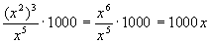

REF: 060518a

9 ANS: 4
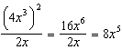

REF: 011216ia

10 ANS: 3
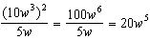

REF: 011124ia

11 ANS: 2
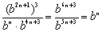

REF: 080415b

12 ANS: 2 REF: 081318ia

13 ANS: 2 REF: 061625ia

14 ANS: 1 REF: 080811b

