1 What is an equation of the line that passes through the points and ?
1)
2)
3)
4)

2 Which equation represents the line whose slope is 2 and whose y-intercept is 6?
1)
2)
3)
4)

3 An equation of the line that has a slope of 3 and a y-intercept of is
1)
2)
3) | 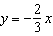
4)

4 Which equation represents a line that has a slope of and passes through the point ?
1)
2)
3)
4)

5 What is an equation of the line that passes through the points and ?
1) | 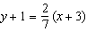
2) | 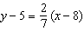
3) | 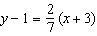
4) | 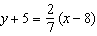

6 How many of the equations listed below represent the line passing through the points and ?
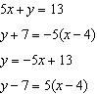
1) | 1
2) | 2
3) | 3
4) | 4

7 Write an equation that represents the line that passes through the points and .

8 Sue and Kathy were doing their algebra homework. They were asked to write the equation of the line that passes through the points and . Sue wrote 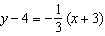 and Kathy wrote 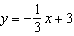. Justify why both students are correct.

9 The graph of a linear equation contains the points and . Which point also lies on the graph?
1)
2)
3)
4)

10 Line contains the points and . Show that the point does or does not lie on line .

11 The accompanying graph represents the yearly cost of playing 0 to 5 games of golf at the Shadybrook Golf Course. What is the total cost of joining the club and playing 10 games during the year?

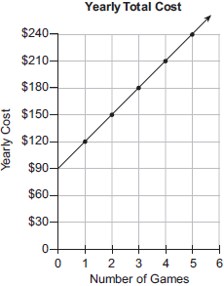

1 ANS: 3 REF: 010910ia

2 ANS: 1 REF: 010905a

3 ANS: 2 REF: 010408a

4 ANS: 3
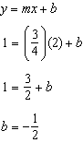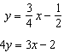

REF: 081219ia

5 ANS: 2
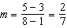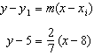

REF: 081029ia

6 ANS: 3
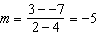 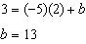 represents the line passing through the points and . The fourth equation may be rewritten as , so is a different line.

REF: 081720ai

7 ANS:
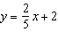. 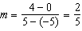. 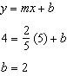.

REF: 080836ia

8 ANS:
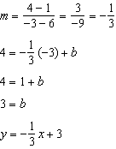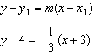

REF: 061629ai

9 ANS: 4
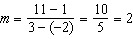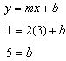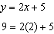

REF: 011511ai

10 ANS:
Find the slope: 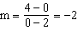; use the given y-intercept to write an equation of the line, and substitute into the equation to show that does not lie on line : 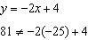

REF: 089929a

11 ANS:
390. The cost of joining the club is the y-intercept, $90, and each game costs $30. This function may be written as , and used to find the total cost of joining the club and playing 10 games during the year. 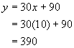

REF: 060025a

