1 Which transformation of moves the graph 7 units to the left and 3 units down?
1)
2)
3)
4)

2 The minimum point on the graph of the equation is . What is the minimum point on the graph of the equation ?
1)
2)
3)
4)

3 The maximum point on the graph of the equation is . What is the maximum point on the graph of the equation ?
1)
2)
3)
4)

4 The graph below represents .

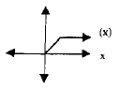

Which of the following is the graph of ?
1) | 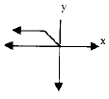
2) | 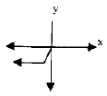
3) | 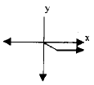
4) | 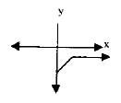

5 The accompanying graph represents the equation .

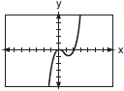

Which graph represents if ?
1) | 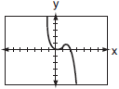
2) | 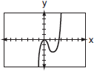
3) | 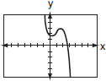
4) | 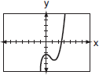

6 The graph below represents .

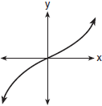

Which graph best represents ?
1) | 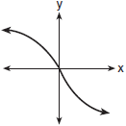
2) | 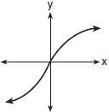
3) | 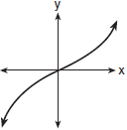
4) | 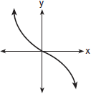

7 The graph below shows the function .

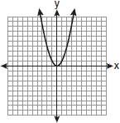

Which graph represents the function ?
1) | 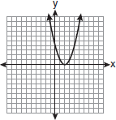
2) | 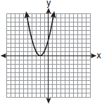
3) | 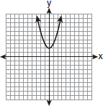
4) | 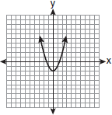

8 The graph of is shown below.

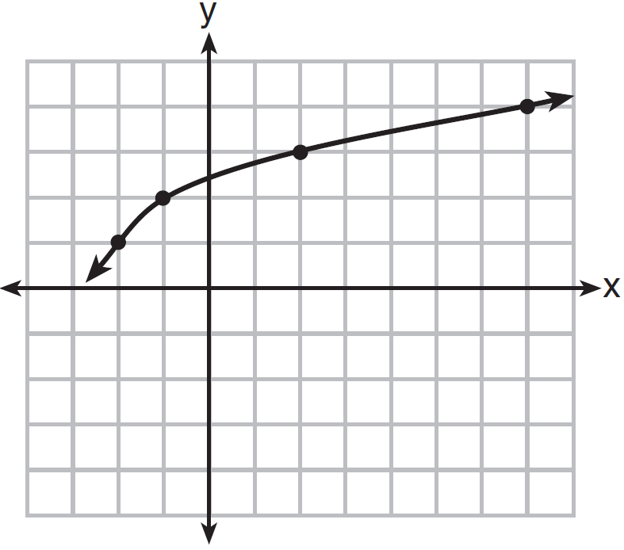

What is the graph of ?
1) | 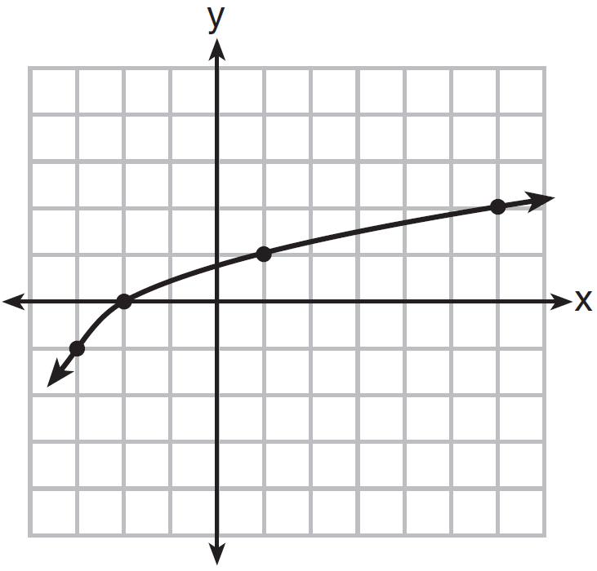
2) | 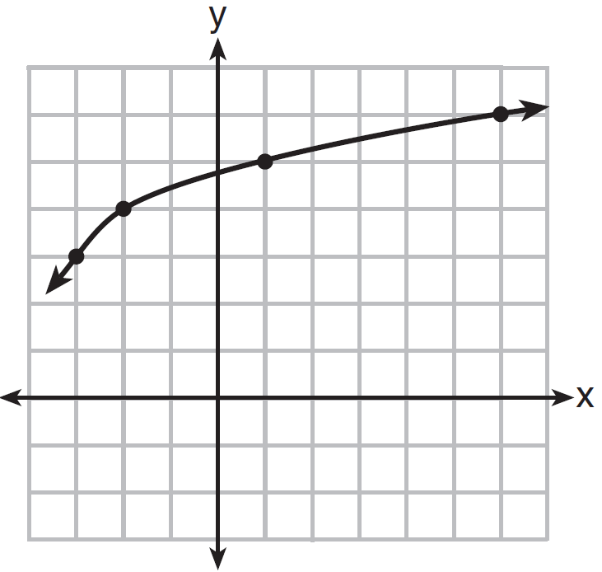
3) | 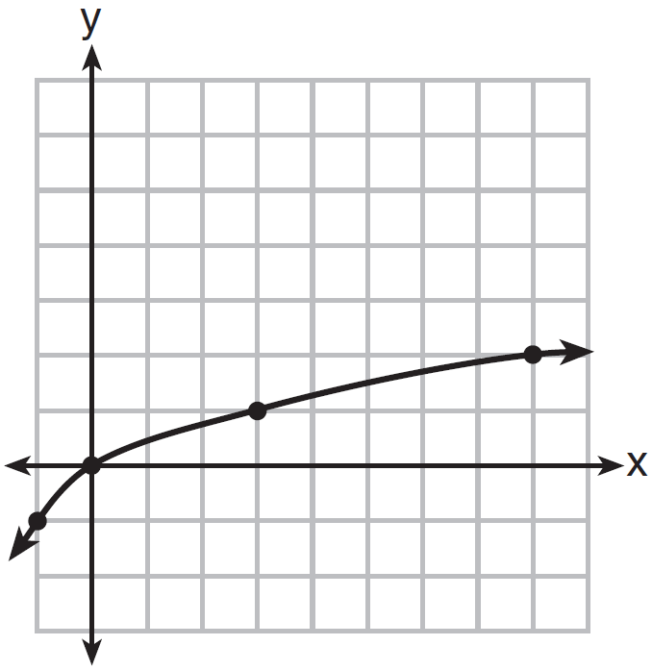
4) | 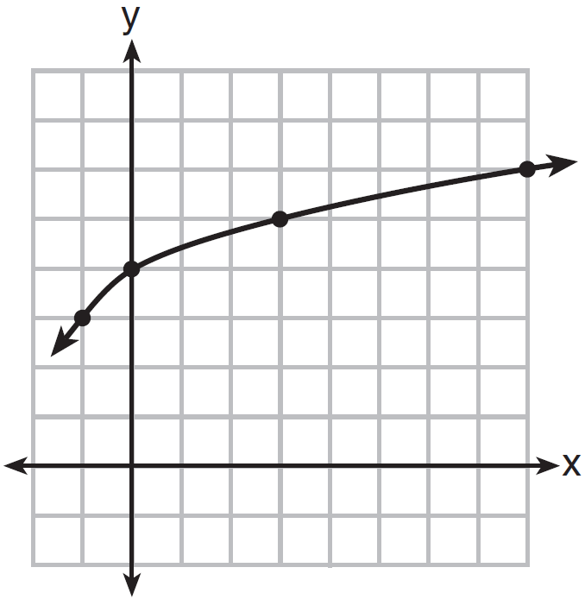

9 The graph below represents national and New York State average gas prices.

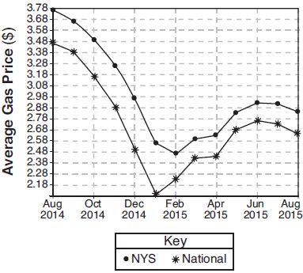

If New York State's gas prices are modeled by and , which expression best approximates the national average x months from August 2014?
1)
2)
3)
4)

10 The entire graph of is symmetric with respect to the origin. If the accompanying graph represents for , sketch, on the same set of axes, the graph of for .

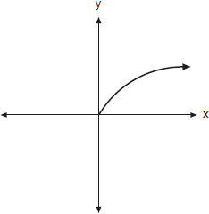

11 The graph of the function is represented below. On the same set of axes, sketch the function .

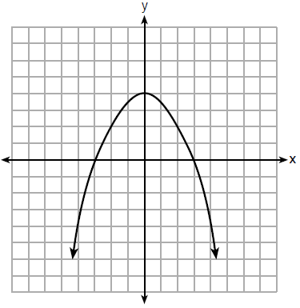

12 The function is graphed on the set of axes below. On the same set of axes, graph .

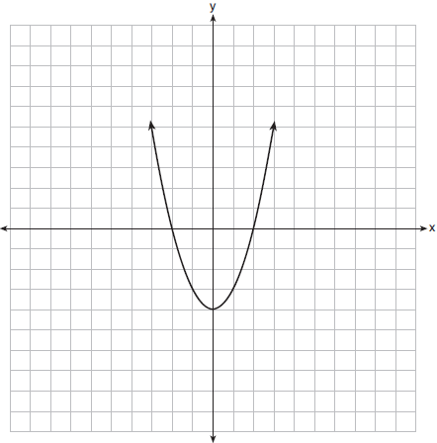

13 Richard is asked to transform the graph of below.

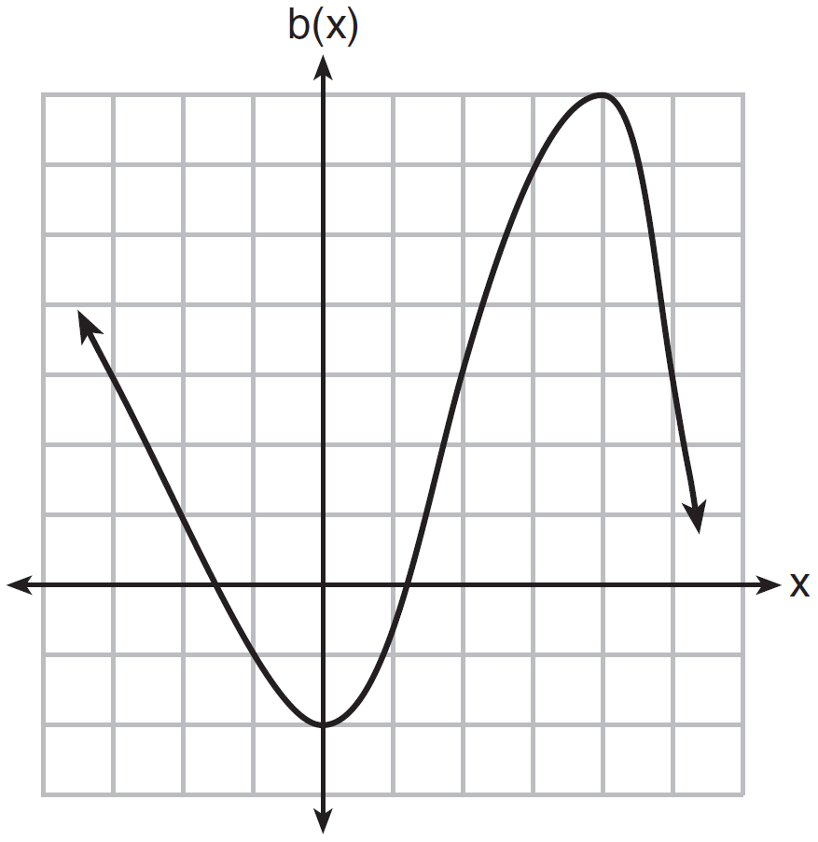

The graph of is transformed using the equation . Describe how the graph of changed to form the graph of .
1 ANS: 1 REF: 061516a2

2 ANS: 1 REF: 081022a2

3 ANS: 4 REF: 011714a2

4 ANS: 3 REF: fall9903b

5 ANS: 1 REF: 060701b

6 ANS: 4 REF: 080406b

7 ANS: 2 REF: fall0926a2

8 ANS: 1 REF: 011620ai

9 ANS: 4 REF: 081817aii

10 ANS:
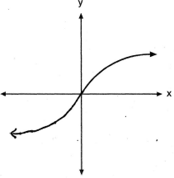

REF: 060821b

11 ANS:
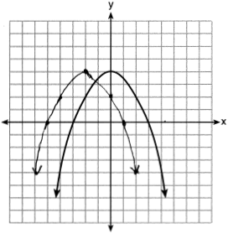

REF: 061828ai

12 ANS:
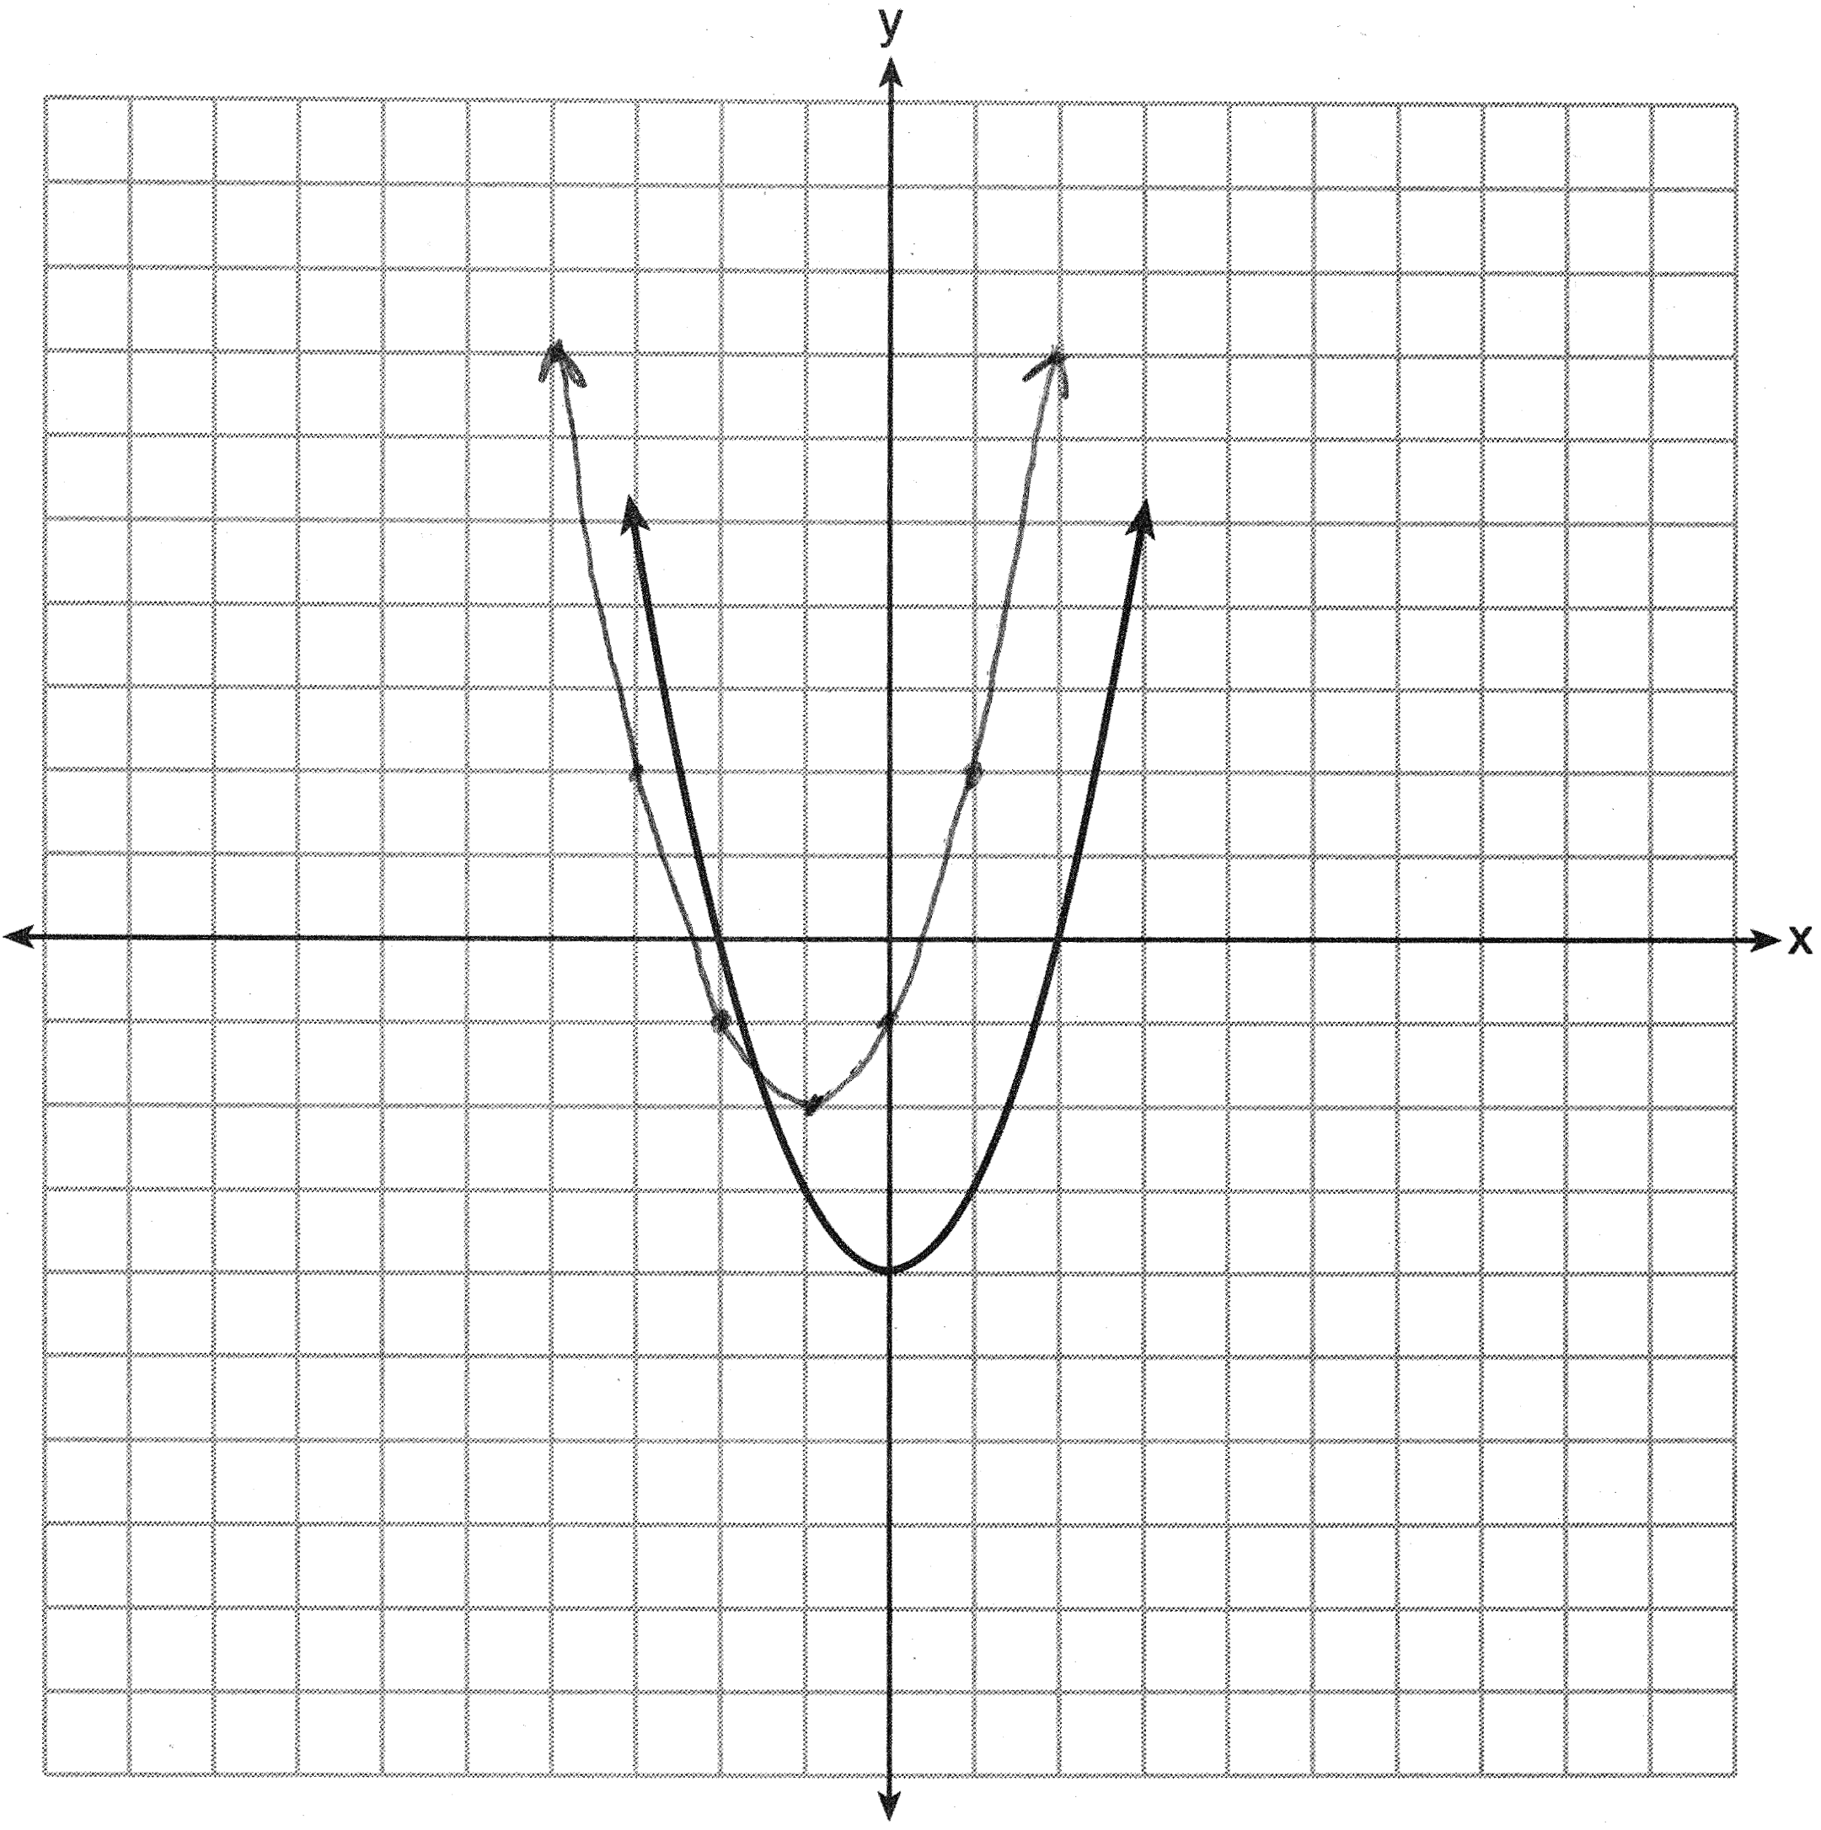

REF: 061435a2

13 ANS:
2 units right and 3 units down.

REF: 081626ai

