1 Which arithmetic sequence has a common difference of 4?
1) 2) 3) 4)

2 Given the sequence:
Which expression can be used to determine the common difference of this sequence?
1) 2) 3) 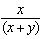 4) 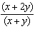

3 What is the common difference of the arithmetic sequence ?
1) 2) 3) 3 4) 9

4 What is the common difference of the arithmetic sequence below?
1) 2) 3) 3 4)

5 What is the common difference in the sequence , , , ?
1) 2) 3) 4)

6 Given the following three sequences:
I.
II.
III.
Which ones are arithmetic sequences?
1) I and II, only 2) I and III, only 3) II and III, only 4) I, II, and III

7 Find the common difference in the arithmetic sequence, , in which and .

8 What is the common ratio of the geometric sequence shown below?
1) 2) 2 3) 4)

9 The common ratio of the sequence 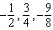 is
1) 2) 3) 4)

10 What is the common ratio of the sequence 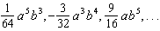?
1) 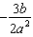 2) 3) 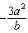 4) 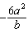

11 What is a common ratio of the geometric sequence whose first term is 5 and third term is 245?
1) 7 2) 49 3) 120 4) 240

12 What is the common ratio of the geometric sequence whose first term is 27 and fourth term is 64?
1) 2) 3) 4)

13 Consider the following patterns:
I.
II.
III.
IV. 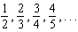
Which pattern is geometric?
1) I 2) II 3) III 4) IV

14 Determine and state whether the sequence displays exponential behavior. Explain how you arrived at your decision.
1 ANS: 3 REF: 011110a2

2 ANS: 2 REF: 011610a2

3 ANS: 3 REF: 061001a2

4 ANS: 4 REF: 061411a2

5 ANS: 1

REF: 011401a2

6 ANS: 2 REF: 061919ai

7 ANS:
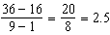

REF: 081630a2

8 ANS: 3
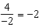

REF: 011304a2

9 ANS: 1
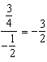

REF: 011508a2

10 ANS: 2
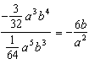

REF: 061326a2

11 ANS: 1
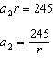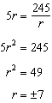

REF: 081924ai

12 ANS: 3
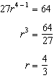

REF: 081025a2

13 ANS: 1
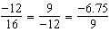

REF: 012017aii

14 ANS:
Yes, because the sequence has a common ratio, 3.

REF: 081726ai

