1 The dot plot shown below represents the number of pets owned by students in a class.
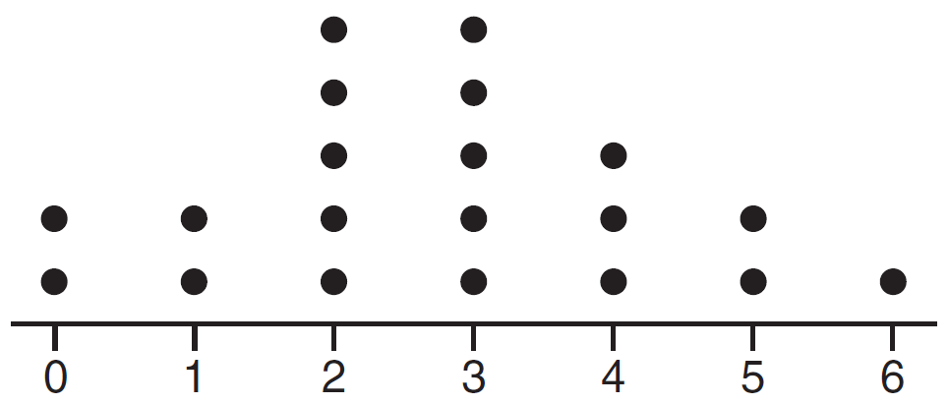
Which statement about the data is not true?
1) | The median is 3.
2) | The interquartile range is 2.
3) | The mean is 3.
4) | The data contain no outliers.

2 Given the following data set:

Which representations are correct for this data set?
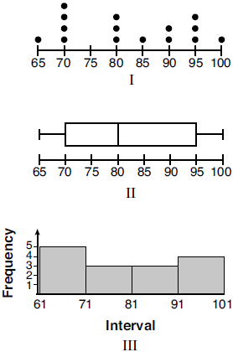
1) | I and II
2) | I and III, only
3) | II and III, only
4) | I, II, and III

1 ANS: 3
, , . An outlier is outside the interval . 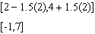

REF: 061620ai

2 ANS: 4 REF: 012022ai

