1 The table below shows the minimum hourly wage, in U.S. dollars, for selected years since 1955.

Years Since  1955 (x) | 0 | 5 | 10 | 15 | 20 | 25 | 30 | 35 | 40 | 45 | 50
Minimum  Wage (y) | .75 | 1.00 | 1.25 | 1.45 | 2.00 | 3.10 | 3.35 | 3.80 | 4.25 | 5.15 | 5.15

Write the linear regression equation for this set of data, rounding all values to three decimal places. State the strength and direction indicated by the correlation coefficient.

2 The table below shows the attendance at a museum in select years from 2007 to 2013.

Attendance at Museum
Year | 2007 | 2008 | 2009 | 2011 | 2013
Attendance (millions) | 8.3 | 8.5 | 8.5 | 8.8 | 9.3

State the linear regression equation represented by the data table when is used to represent the year 2007 and y is used to represent the attendance. Round all values to the nearest hundredth. State the correlation coefficient to the nearest hundredth and determine whether the data suggest a strong or weak association.

3 Erica, the manager at Stellarbeans, collected data on the daily high temperature and revenue from coffee sales. Data from nine days this past fall are shown in the table below.

 | Day  1 | Day  2 | Day  3 | Day  4 | Day  5 | Day  6 | Day  7 | Day  8 | Day  9
High  Temperature, t | 54 | 50 | 62 | 67 | 70 | 58 | 52 | 46 | 48
Coffee Sales, f(t) | $2900 | $3080 | $2500 | $2380 | $2200 | $2700 | $3000 | $3620 | $3720

State the linear regression function, , that estimates the day's coffee sales with a high temperature of t. Round all values to the nearest integer. State the correlation coefficient, r, of the data to the nearest hundredth. Does r indicate a strong linear relationship between the variables? Explain your reasoning.

4 The percentage of students scoring 85 or better on a mathematics final exam and an English final exam during a recent school year for seven schools is shown in the table below.

Percentage of Students Scoring 85 or Better
Mathematics, x | English, y
27 | 46
12 | 28
13 | 45
10 | 34
30 | 56
45 | 67
20 | 42

Write the linear regression equation for these data, rounding all values to the nearest hundredth. State the correlation coefficient of the linear regression equation, to the nearest hundredth. Explain the meaning of this value in the context of these data.

5 The data given in the table below show some of the results of a study comparing the height of a certain breed of dog, based upon its mass.

Mass (kg) | 4.5 | 5 | 4 | 3.5 | 5.5 | 5 | 5 | 4 | 4 | 6 | 3.5 | 5.5
Height (cm) | 41 | 40 | 35 | 38 | 43 | 44 | 37 | 39 | 42 | 44 | 31 | 30

Write the linear regression equation for these data, where x is the mass and y is the height. Round all values to the nearest tenth. State the value of the correlation coefficient to the nearest tenth, and explain what it indicates.

6 The table below shows the number of hours ten students spent studying for a test and their scores.

Hours Spent Studying (x) | 0 | 1 | 2 | 4 | 4 | 4 | 6 | 6 | 7 | 8
Test Scores (y) | 35 | 40 | 46 | 65 | 67 | 70 | 82 | 88 | 82 | 95

Write the linear regression equation for this data set. Round all values to the nearest hundredth. State the correlation coefficient of this line, to the nearest hundredth. Explain what the correlation coefficient suggests in the context of the problem.

7 Stephen collected data from a travel website. The data included a hotel's distance from Times Square in Manhattan and the cost of a room for one weekend night in August. A table containing these data appears below.

Distance From Times Square (city blocks) (x) | 0 | 0 | 1 | 1 | 3 | 4 | 7 | 11 | 14 | 19
Cost of a Room (dollars) (y) | 293 | 263 | 244 | 224 | 185 | 170 | 219 | 153 | 136 | 111

Write the linear regression equation for this data set. Round all values to the nearest hundredth. State the correlation coefficient for this data set, to the nearest hundredth. Explain what the sign of the correlation coefficient suggests in the context of the problem.

8 The following table represents a sample of sale prices, in thousands of dollars, and number of new homes available at that price in 2017.

Sale Price, p  (in thousands of dollars) | 160 | 180 | 200 | 220 | 240 | 260 | 280
Number of New Homes Available  f(p) | 126 | 103 | 82 | 75 | 82 | 40 | 20

State the linear regression function, , that estimates the number of new homes available at a specific sale price, p. Round all values to the nearest hundredth. State the correlation coefficient of the data to the nearest hundredth. Explain what this means in the context of the problem.

9 Joey recorded his heart rate, in beats per minute (bpm), after doing different numbers of jumping jacks. His results are shown in the table below.

Number of Jumping Jacks  x | Heart Rate  (bpm)  y
0 | 68
10 | 84
15 | 104
20 | 100
30 | 120

State the linear regression equation that estimates the heart rate per number of jumping jacks. State the correlation coefficient of the linear regression equation, rounded to the nearest hundredth. Explain what the correlation coefficient suggests in the context of this problem.

10 Two different tests were designed to measure understanding of a topic. The two tests were given to ten students with the following results:

Test x | 75 | 78 | 88 | 92 | 95 | 67 | 58 | 72 | 74 | 81
Test y | 81 | 73 | 85 | 88 | 89 | 73 | 66 | 75 | 70 | 78

Construct a scatter plot for these scores, and then write an equation for the line of best fit (round slope and intercept to the nearest hundredth). Find the correlation coefficient. Predict the score, to the nearest integer, on test y for a student who scored 87 on test x.


1 ANS:
high, positive correlation

REF: 011736a2

2 ANS:
, which suggests a strong association.

REF: 081536ai

3 ANS:
This indicates a strong linear relationship because r is close to -1.

REF: 011635ai

4 ANS:
, 0.92, high, positive correlation between scores 85 or better on the math and English exams.

REF: 061836ai

5 ANS:
This indicates a weak relationship between a dog’s height and mass.

REF: 011934ai

6 ANS:
high, positive correlation between hours spent studying and test scores

REF: 061935ai

7 ANS:
, As the distance from Times Square increases, the cost of a room decreases.

REF: 081935ai

8 ANS:
There is a strong negative correlation as the higher the sales price, the fewer number of new homes available.

REF: 012035ai

9 ANS:
, 0.97, high, positive correlation between the number of jumping jacks and heart rate

REF: 062133ai

10 ANS:
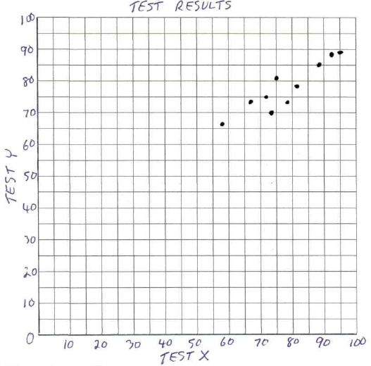 , , 83. 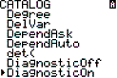 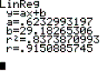 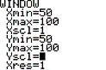 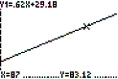

REF: 010234b

