**STUDENT VERSION (Week-4)**

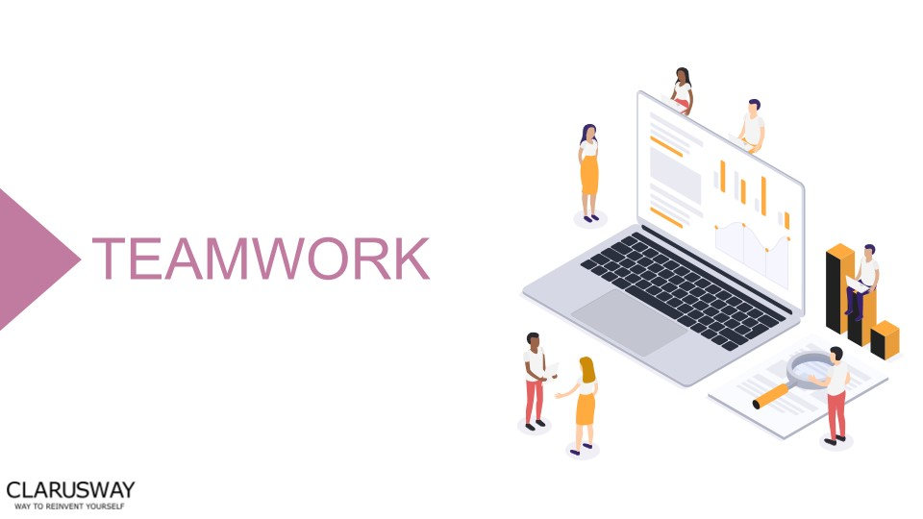

# Meeting Agenda

▶ Icebreaking

▶ Questions

▶ Interview Questions

▶ Coding Challenge

▶ Video of the week

▶ Retro meeting

▶ Case study / project

# Teamwork Schedule

|  |  |
| --- | --- |
| **Ice-breaking** | **5m** |

Personal Questions (Stay at home & Corona, Study Environment, Kids etc.)

Any challenges (Classes, Coding, studying, etc.) Ask how they’re studying, give personal advice.

Remind that practice makes perfect.

|  |  |
| --- | --- |
| **Team work** | **5m** |

Ask what exactly each student does for the team, if they know each other, if they care for each other, if they follow and talk with each other etc.

## Ask Questions 15m

**1. Which operator returns true if the two compared values are not equal?**

1. <>
2. ~
3. ==!
4. !==

**2. You need to match a time value such as 12:00:32. Which of the following regular expressions would work for your code?**

1. /[0-9]{2,}:[0-9]{2,}:[0-9]{2,}/
2. /\d\d:\d\d:\d\d/
3. /[0-9]+:[0-9]+:[0-9]+/
4. / : : /

**3.How would you reference the text 'avenue' in the code shown?**

let

roadTypes = [

'street'

,

'road'

,

'avenue'

,

'circle'

]

;

1. roadTypes.2
2. roadTypes[3]
3. roadTypes.3
4. roadTypes[2]

**4. What is the result of running this statement?**

console

.log(

typeof

(

42

))

;

1. float
2. value
3. number
4. integer

**5. When would you use a conditional statement?**

**A.** When you want to reuse a set of statements multiple times.

**B.**When you want your code to choose between multiple options

**C.** When you want to group data together

**D.**When you want to loop through a group of statement

**6. What would be the result in the console of running this code?**

for

(

var

i=

0

; i<

5

; i++){

console

.log(i);

}

1. 12345
2. 1234
3. 021345
4. 01234

**7. After the following code, what is the value of a.length?**

var

a = [

'dog'

,

'cat'

,

'hen'

]

;

a[

100

]

=

'fox'

;

1. 101
2. 3
3. 4
4. 100

**8. Which Variable-defining keyword allows its variable to be accessed (as undefined) before the line that defines it?**

1. var
2. let
3. const
4. all of them

**9.Which of the following values is not a Boolean false?**

1. Boolean(0)
2. Boolean("")
3. Boolean(NaN)
4. Boolean("false")

**10. What will the value of y be in this code:**

const

x =

6

%

2

;

const

y = x ?

'One'

:

'Two'

;

1. One
2. undefined
3. TRUE

**D.**Two

## Interview Questions 15m

1. **How are JavaScript and Java different from each other?**
2. **What is JavaScript?**
3. **What data types do JavaScript support?**
4. **In JavaScript, what are the scopes of a variable?**

**5.Explain the meaning of each of these CSS units for expressing length:** cm/em/in/mm/pc/pt/px

**6.What is mean by NULL in JavaScript?**

1. **What are the pop-ups available in JavaScript?**
2. **What is the Different between Null and Undefined?**

## Coding Challenge 20m

[Coding Challenge: Forms (HC-CC-03)](https://github.com/clarusway/clarusway-full-stack-6-20/blob/master/html-css/coding-challenges/cc-003/README.md)

## Video of the Week 5m

[Popular JavaScript Libraries](https://www.youtube.com/watch?v=qugY8axtvWY)

## Retro Meeting on a personal and team level 5m

Ask the questions below:

What went well?

What could be improved?

What will we commit to do better in the next week?

|  |  |
| --- | --- |
| **Case study/Project** | **15m** |

**Case study should be explained to the students during the weekly meeting and has to be completed in one weeks by the students. Students should work in small teams to complete the case study.**

[Project-005 : Find The Number (JS01)](https://github.com/clarusway/clarusway-full-stack-6-20/blob/master/javascript/projects/001-find-the-number/README.md)

[Project-006 : CW Calculator (JS02)](https://github.com/clarusway/clarusway-full-stack-6-20/blob/master/javascript/projects/002-cw-calculator/README.md)

## Closing 5m

-Next week’s plan

-QA Session