SPHERE’s Issues (w/ add’l IB5k comments in red)

1. There is no summary just the results from the final year after you have completed the game.

A. I wrote this concern to you last week, so you probably already saw it or became busy doing other edits – but they are wondering why the data from the whole game would not be aggregated onto this final page.

{ \*email from July 18th-“ At the very end of the game (Level 10) the notification only says “You've won" but without a run-down of all specs.” }

B. Also – they are upset that Bonus Points for Jobs Creation was removed. They ask for an explanation more comprehensive than “it does not make sense with game flow” because they told CNH this would be part of it – would show CNH they had a soul, and so CNH got excited and expected it. So now they are upset and would like to understand why it wasn’t put in (bonus suitcase)? Would this ever be something you could add?

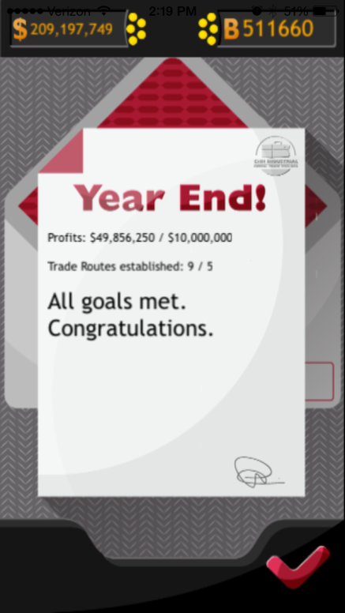

1. Got stuck with the build a plant notification. Had to quit to get rid of it.

A. Yup – this has also happened for me. It’s gotten stuck a few times. Seems to occur most often (for all of us) when the Dealer Representative pops up. Also when International Trade Route comes on screen and you run out of time. There is some lag time and sometimes you actually have to totally force quit the game because the screen loses response-ivity.

1. Top of the game is too close to top information on phone (carrier, time, battery, etc)

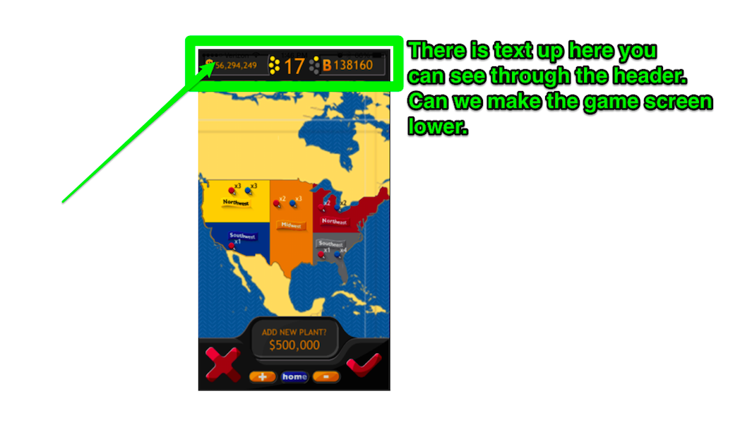

1. No image for deluxe, seems like standard and premium buckets are same graphic (see below). Rai sent three different bucket attachments – see below below.

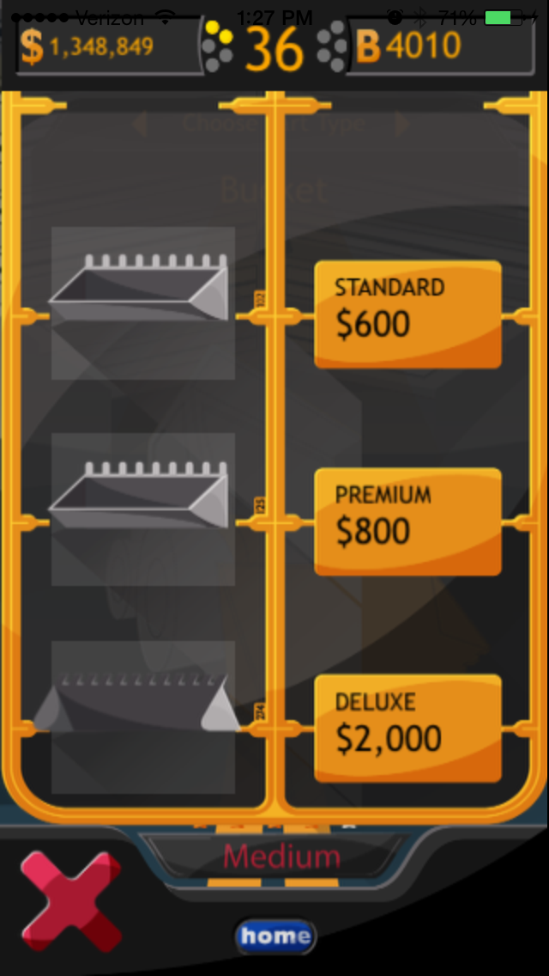 

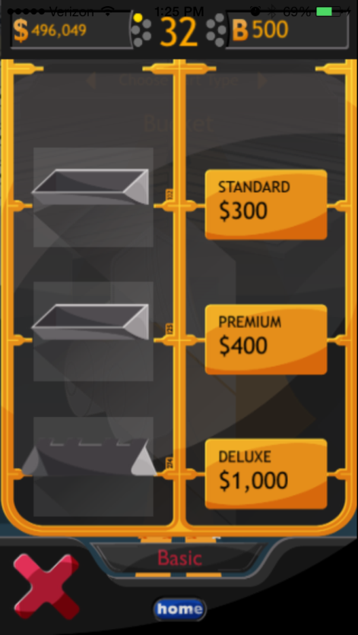

1. Experiencing Freezing and screen glitches on iPhone 4S, such as periodic missing timer shown below.

A. I’m also using an iPhone 4, but one tester is using a 5 and he is having some freezes too, so I don’t think we can assume it’s a phone thing.

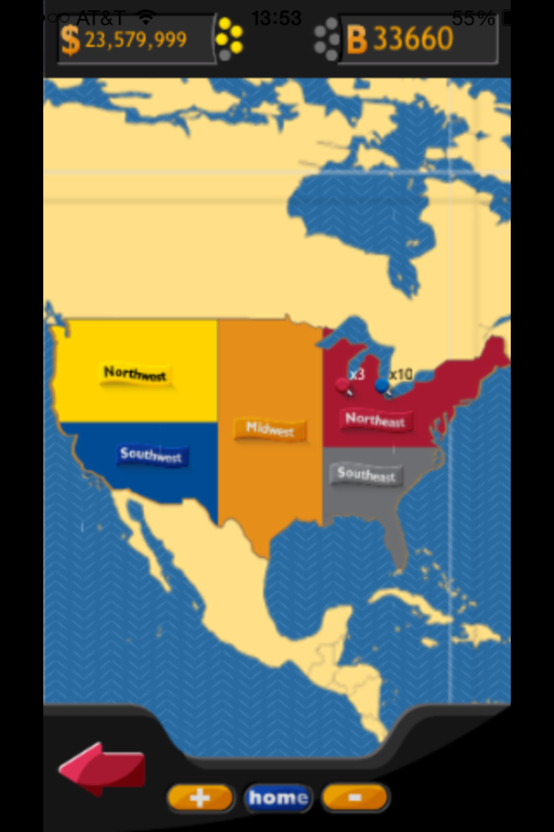

1. Much of this freezing begins when you zoom out to the international view.

A. When there isn’t freezing, sometimes there is just a general slowing down or lag time happening for me.

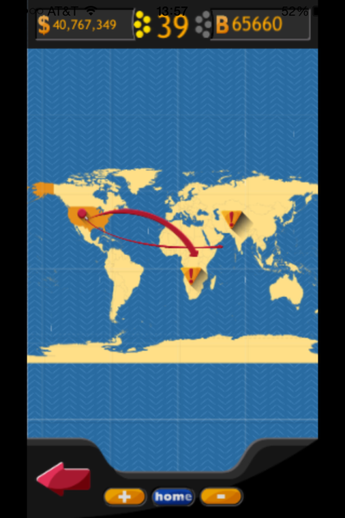

1. Dealer lady became stuck to screen and had to restart to remove.

A. Freezing happens frequently during dealer notifications.

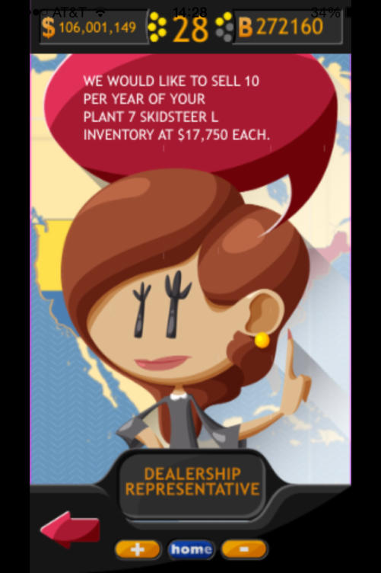

1. Did not find any reference to the desired Ex-Im Bank, TTIP, and TPP “passing bills” “reauthorization” as conditions in game. Art and language was presented but we haven’t seen implementation within the game. (see screenshots below – I’m sorry if you have done these and it’s just that none of us got to this part of the game yet…)

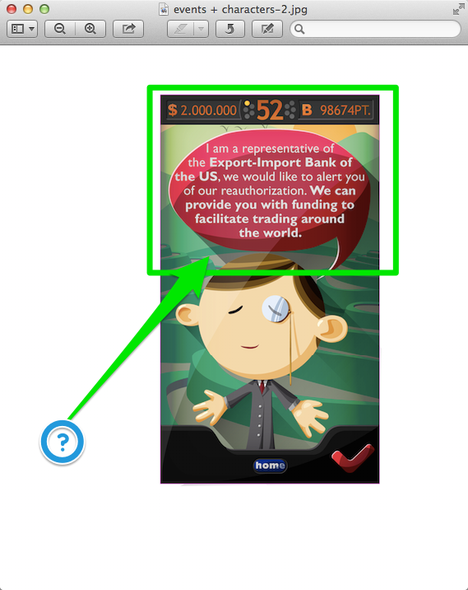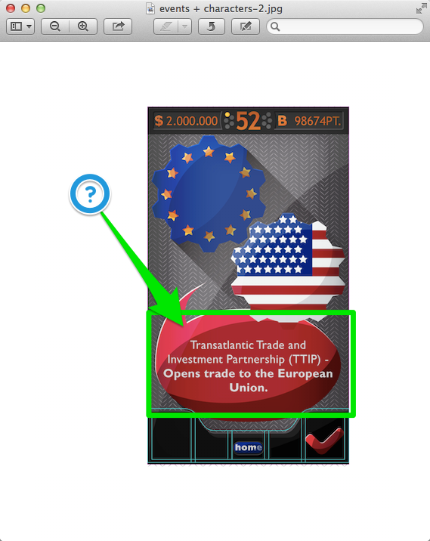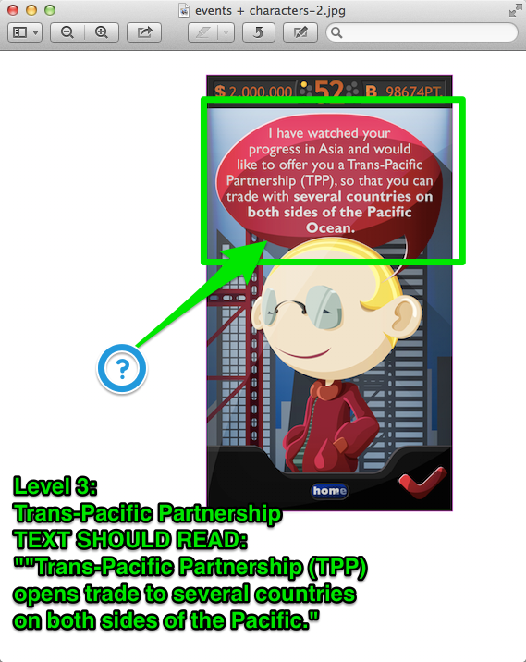

1. CNHI reported instances in which the Supplier/Engine notification would no longer be clickable after it appeared for a while. (see image attached for #11)
2. CNHI reported freezing when the time ran out and an International Trade Route Character was on the screen.

11. Engine/Supplier icon is not totally clear – perhaps it would be better replaced with a little tire?

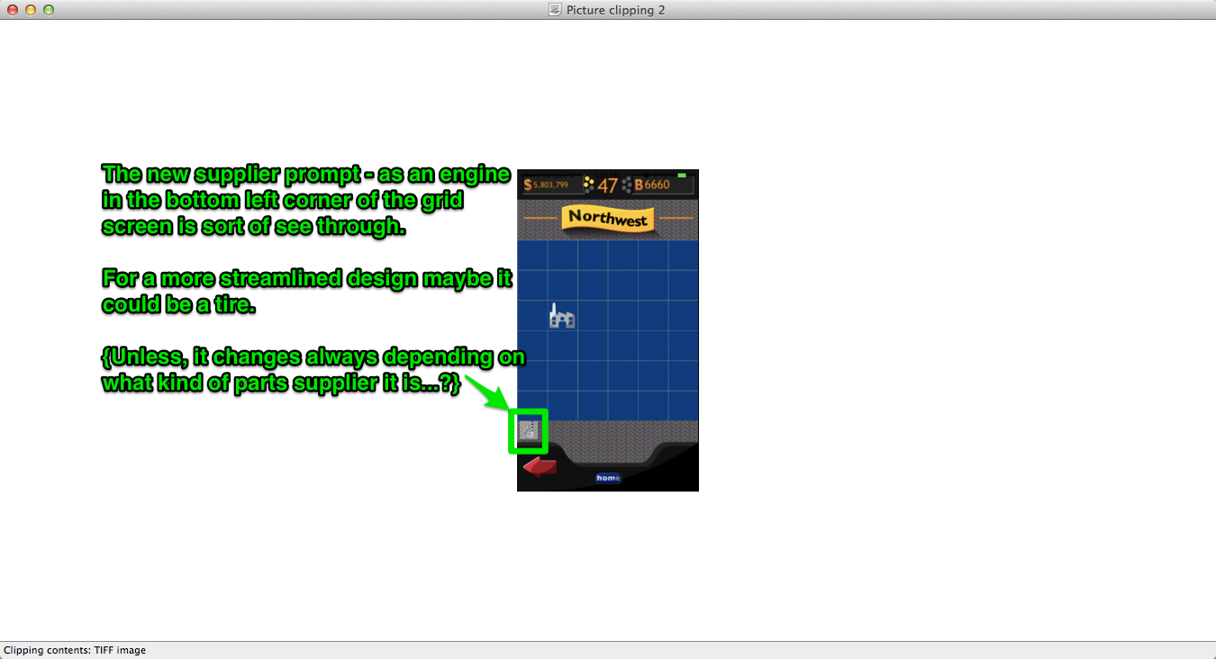

Nicky’s notes:

1. In the tutorial, page 3/7 there is a grammatical error (missing preposition “to”). It should read “The wrench takes you to a list…”

2. The Facebook connection (which you reach via the molecular looking icon in the bottom right hand corner of the ignition screen) is not easy to navigate. Once you are there, you are caught there. You can’t go back to the game. Tom thinks this is the solution: have it open in an external browser, not in Phone Gap.